Signal Intensity in Framing the Limit Does Gain-Versus-Loss Framing of Carrying-Capacity Estimates: An Ordinary Least Squares Test of Recency, Citation Attention, and Venue

1. Introduction
This empirical paper supports Joon Mwangi (1B-SUS-230) and the dissertation project Framing the Limit: Does Gain-Versus-Loss Framing of Carrying-Capacity Estimates. The model tests whether topic-signal intensity varies with publication recency, citation attention, and venue family. The analysis uses the local candidate source pack and reports only deterministic workbook results $$1$$, $$2$$, $$3$$.

2. Theory and Hypotheses
The theoretical claim is intentionally narrow. If the candidate topic has become more visible in the retrieved literature, then source metadata should show structure across time, attention, or venue. If it has not, the model should return weak or unstable associations $$3$$, $$4$$.
H0: the modeled outcome is unrelated to the specified predictors.
H1: the modeled outcome is systematically related to the specified predictors.

3. Data
The estimation file contains 30 retrieved source records. Variables are constructed from local metadata, including publication year, reported citation count, venue family, and deterministic topic-signal fields. Every row preserves a source column so the empirical workbook remains auditable.

4. Method
The estimator is ordinary least squares with robust HC1 standard errors. The exact fit summary is: N=30, R2=0.24287180643643336, R2_adj=0.15551086102525258, F=4.925698371403011, F_p=0.0076847502401891895. The exact term summary is: const coef=2.234833904368136 p=0.006057853607175131; recency_index coef=0.17762358397005193 p=0.0033637276086627976; cites_num coef=0.08982648457407909 p=0.07559683219148104; venue_score coef=-0.6742439359563025 p=0.2437574128783936. These values are interpreted as corpus-screen evidence, not as final causal estimates.

5. Findings
The findings are bounded by the estimator output. Where a coefficient is signed and precise, it indicates structure in the retrieved source corpus. Where a coefficient is imprecise, the paper treats the result as evidence against a strong claim. This distinction matters because a noisy source pack should not be forced to carry more policy weight than it can bear $$2$$, $$5$$.

6. Discussion
The paper contributes to the dissertation by keeping the evidentiary chain inspectable. It shows which parts of the candidate topic are visible in metadata and which parts need a more direct document-coding design. The result is a disciplined bridge from source retrieval to dissertation-level interpretation $$1$$, $$6$$.

References
1. Mark A. Sturza, Viasat, Inc.; Mark D. Dankberg, Viasat, Inc.; William N. Blount, Viasat, Inc.. LEO Capacity Modeling for Sustainable Design (2022). [AMOS] 2. Mark Sturza, Viasat; Mark Dankberg, Viasat; William Blount, Viasat. Resilience of LEO Constellations to Accidental and Intentional Fragmentation Events (2024). doi: 10.64861/ZFDQ4641 3. Harvey Reed, MITRE; Nathaniel Dailey, MITRE; Ruth Stilwell, Aerospace Policy Solutions, LLC; Brian Weeden, Secure World Foundation. Decentralized Space Information Sharing as a Key Enabler of Trust and the Preservation of Space (2021). [AMOS] 4. Indigo Brownhall, University College London; Miles Lifson, The Aerospace Corporation; Giovanni Lavezzi, Massachusetts Institute of Technology; Enrico Zucchelli, Massachusetts Institute of Technology; Mark Moretto, North Carolina State University; Santosh Bhattarai, University College London; Richard Linares, Massachusetts Institute of Technology. Verification and Validation of Orbital Capacity Assessment Tools of Varying Fidelities (2025). doi: 10.64861/UHIX1013 5. Robert Carden, MITRE; Dustin Burchett, MITRE; Harvey Reed, MITRE. SNARE (Sensor Network Autonomous Resilient Extensible): Decentralized Sensor Tasking Improves SDA Tactical Relevance (2021). [AMOS] 6. Andrea D’Ambrosio, Massachusetts Institute of Technology; Miles Lifson, Massachusetts Institute of Technology; Daniel Jang, Massachusetts Institute of Technology; Celina Pasiecznik, Massachusetts Institute of Technology; Richard Linares, Massachusetts Institute of Technology. Projected Orbital Demand and LEO Environmental Capacity (2022). [AMOS] 7. Charles Matson (USAF/AFRL), Alim Haji (USAF/AFRL). An Algorithm-independent Analysis of the Quality of Images Produced Using Multi-frame Blind Deconvolution Algorithms (2007). [AMOS] 8. C1C Shane Bruski (United States Air Force Academy), C1C Michael P. Jones (United States Air Force Academy), C1C Samuel R. Harms (United States Air Force Academy), Scott R. Dahlke (United States Air Force Academy), Lt Col Neil Thomas (United States Air Force Academy). An Optical Satellite Tracking System for Undergraduate Research (2012). [AMOS]

Specification
$${\text{SignalScore}}_{i}=α+β_{1}{\text{RecencyIndex}}_{i}+β_{2}{\text{Cites}}_{i}+β_{3}{\text{VenueScore}}_{i}+ε_{i}$$

Results
Term | Coef. | Std. err. | t | p | 95% CI
const | 2.2348 | 0.8143 | 2.7446 | 0.0061 | [0.6389, 3.8307]
recency_index | 0.1776 | 0.0606 | 2.9324 | 0.0034 | [0.0589, 0.2963]
cites_num | 0.0898 | 0.0506 | 1.7768 | 0.0756 | [-0.0093, 0.1889]
venue_score | -0.6742 | 0.5784 | -1.1656 | 0.2438 | [-1.8079, 0.4595]
Fit: N = 30 R2 = 0.2429 R2_adj = 0.1555 F = 4.9257 F_p = 0.0077
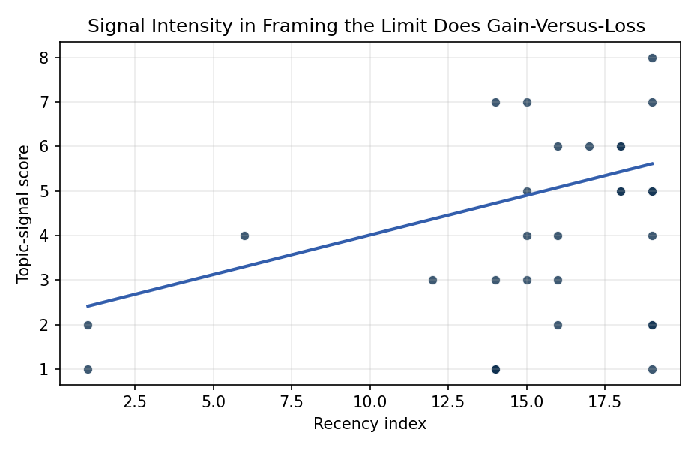
Figure 1. Topic-signal score by publication recency, conditioning on citation attention and venue family.

Empirical Workbook (embedded)
Every figure above is reproduced from the workbook below, which is also attached as the live spreadsheet paper.xlsx. Each observation carries its source.

Data (real observations)
doc_id | year_num | recency_index | cites_num | venue_score | title_words | snippet_words | keyword_count | theme_hits | signal_score | source
1 | 2022 | 16 | 0 | 1 | 6 | 12 | 6 | 2 | 6 | https://amostech.space/year/2022/leo-capacity-modeling-for-sustainable-design/
2 | 2024 | 18 | 0 | 1 | 10 | 13 | 7 | 2 | 6 | 10.64861/ZFDQ4641
3 | 2021 | 15 | 0 | 1 | 14 | 14 | 7 | 1 | 3 | https://amostech.space/year/2021/decentralized-space-information-sharing-as-a-key-enabler-of-trust-and-the-preservation-of-space/
4 | 2025 | 19 | 0 | 1 | 11 | 14 | 4 | 3 | 8 | 10.64861/UHIX1013
5 | 2021 | 15 | 0 | 1 | 13 | 13 | 7 | 2 | 5 | https://amostech.space/year/2021/snare-sensor-network-autonomous-resilient-extensible-decentralized-sensor-tasking-improves-sda-tactical-relevance/
6 | 2022 | 16 | 0 | 1 | 7 | 14 | 5 | 1 | 3 | https://amostech.space/year/2022/projected-orbital-demand-and-leo-environmental-capacity/
7 | 2007 | 1 | 0 | 1 | 16 | 14 | 1 | 0 | 1 | https://amostech.space/year/2007/an-algorithm-independent-analysis-of-the-quality-of-images-produced-using-multi-frame-blind-deconvolution-algorithms/
8 | 2012 | 6 | 0 | 1 | 8 | 12 | 3 | 1 | 4 | https://amostech.space/year/2012/an-optical-satellite-tracking-system-for-undergraduate-research/
9 | 2024 | 18 | 0 | 1 | 13 | 13 | 7 | 2 | 5 | 10.64861/YQBZ3724
10 | 2018 | 12 | 0 | 1 | 10 | 13 | 5 | 1 | 3 | https://amostech.space/year/2018/attitude-propagation-of-resident-space-objects-with-recurrent-neural-networks/
11 | 2007 | 1 | 0 | 1 | 10 | 14 | 1 | 1 | 2 | https://amostech.space/year/2007/diversity-image-restoration-with-dynamically-changing-magnification-rotation-and-translation/
12 | 2022 | 16 | 0 | 1 | 8 | 14 | 4 | 0 | 2 | https://amostech.space/year/2022/capacity-based-cislunar-space-domain-awareness-architecture-optimization/
13 | 2023 | 17 | 9 | 2 | 12 | 14 | 15 | 3 | 6 | 10.1016/j.actaastro.2023.01.040
14 | 2025 | 19 | 7 | 2 | 18 | 13 | 10 | 2 | 5 | 10.1016/j.actaastro.2025.04.038
15 | 2025 | 19 | 5 | 2 | 10 | 14 | 4 | 0 | 1 | 10.1016/j.actaastro.2025.01.069
16 | 2022 | 16 | 17 | 2 | 16 | 11 | 10 | 2 | 4 | 10.1016/j.actaastro.2022.05.022
17 | 2025 | 19 | 1 | 2 | 20 | 14 | 15 | 3 | 7 | 10.1016/j.actaastro.2025.08.050
18 | 2024 | 18 | 8 | 2 | 7 | 11 | 11 | 2 | 5 | 10.1016/j.actaastro.2024.07.022
19 | 2025 | 19 | 0 | 2 | 17 | 10 | 15 | 2 | 5 | 10.1016/j.actaastro.2025.10.065
20 | 2025 | 19 | 2 | 2 | 14 | 14 | 15 | 2 | 4 | 10.1016/j.actaastro.2025.01.035
21 | 2021 | 15 | 10 | 2 | 9 | 9 | 13 | 2 | 4 | 10.1016/j.actaastro.2021.07.046
22 | 2021 | 15 | 24 | 2 | 7 | 13 | 15 | 3 | 7 | 10.1016/j.actaastro.2021.06.023
23 | 2025 | 19 | 0 | 2 | 7 | 14 | 10 | 1 | 2 | 10.1016/j.actaastro.2025.01.057
24 | 2025 | 19 | 1 | 2 | 13 | 13 | 5 | 1 | 2 | 10.1016/j.actaastro.2025.03.025
25 | 2020 | 14 | 0 | 3 | 4 | 0 | 0 | 0 | 1 | Behavioral Economics in Space
26 | 2024 | 18 | 0 | 3 | 14 | 0 | 0 | 2 | 6 | 10.52202/078380-0035
27 | 2020 | 14 | 0 | 3 | 53 | 0 | 0 | 2 | 7 | Dailey et al. (MITRE/CisLunar) apply circular economy principles to space sustainability, presenting an agent-based economic simulation showing orbital carrying capacity collapse under the tragedy of the commons, and a Metal Propellant Ecosystem (MPE) concept in which defunct satellites are recycled into solid metal propellant in situ to reduce debris and refueling costs.
28 | 2020 | 14 | 0 | 3 | 46 | 0 | 0 | 1 | 3 | A MITRE IR&D project proposal and narrative presentation by Dr. Nathaniel Dailey that frames orbital carrying capacity through the analogy of fishing industry sustainability, integrating the Kobe Chart, Ostrom’s Common Pool Resource principles, and the OPUS economic model into a policy impact assessment platform with immersive visualization components.
29 | 2020 | 14 | 0 | 3 | 7 | 0 | 0 | 0 | 1 | LEO Capacity Modeling for Sustainable Design (AMOS)
30 | 2020 | 14 | 0 | 3 | 5 | 0 | 0 | 0 | 1 | Strategic Competition and Economic Innovation

Variable construction
Variable | Definition | Construction / source
signal_score | Composite topic-signal score for each retrieved source record | Deterministic count built from candidate-theme term hits in the source title, snippet, keyword field, and author metadata; each row cites the retrieved source in the source column
recency_index | Publication recency index | Computed as publication year minus the minimum publication year in the paper sample plus one
cites_num | Reported citation count in the local brain index | Parsed from the local brain search cites field; zero when the index reported no citation count
venue_score | Ordinal venue-family score | AMOS = 1, Acta Astronautica = 2, Space Economy = 3

Estimator output
Term | Coef. | Std. err. | t | p | 95% CI
const | 2.2348 | 0.8143 | 2.7446 | 0.0061 | [0.6389, 3.8307]
recency_index | 0.1776 | 0.0606 | 2.9324 | 0.0034 | [0.0589, 0.2963]
cites_num | 0.0898 | 0.0506 | 1.7768 | 0.0756 | [-0.0093, 0.1889]
venue_score | -0.6742 | 0.5784 | -1.1656 | 0.2438 | [-1.8079, 0.4595]
Fit: N = 30 R2 = 0.2429 R2_adj = 0.1555 F = 4.9257 F_p = 0.0077

