Signal Intensity in Cooperate or Collide A Cliometric Test of Whether Cooperative SSA Sharing Episo: An Ordinary Least Squares Test of Recency, Citation Attention, and Venue

1. Introduction
This empirical paper supports Vincent Larsson (1B-SUS-214) and the dissertation project Cooperate or Collide: A Cliometric Test of Whether Cooperative SSA Sharing Episo. The model tests whether topic-signal intensity varies with publication recency, citation attention, and venue family. The analysis uses the local candidate source pack and reports only deterministic workbook results $$1$$, $$2$$, $$3$$.

2. Theory and Hypotheses
The theoretical claim is intentionally narrow. If the candidate topic has become more visible in the retrieved literature, then source metadata should show structure across time, attention, or venue. If it has not, the model should return weak or unstable associations $$3$$, $$4$$.
H0: the modeled outcome is unrelated to the specified predictors.
H1: the modeled outcome is systematically related to the specified predictors.

3. Data
The estimation file contains 30 retrieved source records. Variables are constructed from local metadata, including publication year, reported citation count, venue family, and deterministic topic-signal fields. Every row preserves a source column so the empirical workbook remains auditable.

4. Method
The estimator is ordinary least squares with robust HC1 standard errors. The exact fit summary is: N=30, R2=0.17225582765077607, R2_adj=0.0767468846874041, F=1.6131585122392496, F_p=0.21042748564244879. The exact term summary is: const coef=3.408839452295215 p=0.003484940572539672; recency_index coef=0.10700603005903214 p=0.21197083312052234; cites_num coef=-0.011052310038844902 p=0.7989267938530581; venue_score coef=-1.050611302222688 p=0.0331265200157451. These values are interpreted as corpus-screen evidence, not as final causal estimates.

5. Findings
The findings are bounded by the estimator output. Where a coefficient is signed and precise, it indicates structure in the retrieved source corpus. Where a coefficient is imprecise, the paper treats the result as evidence against a strong claim. This distinction matters because a noisy source pack should not be forced to carry more policy weight than it can bear $$2$$, $$5$$.

6. Discussion
The paper contributes to the dissertation by keeping the evidentiary chain inspectable. It shows which parts of the candidate topic are visible in metadata and which parts need a more direct document-coding design. The result is a disciplined bridge from source retrieval to dissertation-level interpretation $$1$$, $$6$$.

References
1. T.S. Kelso, Center for Space Standards and Innovation. Analysis of the Iridium 33-Cosmos 2251 Collision (2009). [AMOS] 2. Jaedong Seong, Korea Aerospace Research Institute (KARI); Okchul Jung, Korea Aerospace Research Institute (KARI); Dae Won Chung, Korea Aerospace Research Institute (KARI). KARI Recent Activities on SSA & STM (2019). [AMOS] 3. Kipp M. Johnson (Systems Engineer, SASSA Program), Captain Farakh Zaman (Program Manager, SASSA Program). Adding the “Local” Layer to Space Situational Awareness (2012). [AMOS] 4. S Shivshankar, Indian Institute of Science; Debasish Ghose, Indian Institute of Science. Time-to-Event Data (Survival Analysis) based Modelling of Maneuver Occurrence of Non-Cooperative Satellites (2023). doi: 10.64861/LPFK9568 5. Brian Weeden (Secure World Foundation), Paul Cefola (University at Buffalo, SUNY), Jaganath Sankaran (University of Maryland). Global Space Situational Awareness Sensors (2010). [AMOS] 6. Jaedong Seong, Korea Aerospace Research Institute (KARI); Okchul Jung, Korea Aerospace Research Institute (KARI); Youeyun Jung, Korea Aerospace Research Institute (KARI); Saehan Song, Korea Aerospace Research Institute (KARI). Development of VISION (Vigilant Integrated Space Information and mOnitoring Network): An Integrated Space Information Monitoring System for Space Flight Safety (2025). doi: 10.64861/OTAL2562 7. Brittany Morreale, United States Air Force, Travis Bessell, National Security and Intelligence, Surveillance, and Reconnaissance Division – Defence Science and Technology Group, Mark Rutten, National Security and Intelligence, Surveillance, and Reconnaissance Division – Defence Science and Technology Group, Brian Cheung, National Security and Intelligence, Surveillance, and Reconnaissance Division – Defence Science and Technology Group. Australian Space Situational Awareness Capability Demonstrations (2017). [AMOS] 8. Nathaniel Dailey, MITRE & Space Force Association; Braden McGrath, MITRE Australia; Harvey Reed, MITRE; Jonathon Wotton, MITRE Australia. Global Space Domain Awareness, Partnering to Win with AUKUS (2023). doi: 10.64861/FWBL2094

Specification
$${\text{SignalScore}}_{i}=α+β_{1}{\text{RecencyIndex}}_{i}+β_{2}{\text{Cites}}_{i}+β_{3}{\text{VenueScore}}_{i}+ε_{i}$$

Results
Term | Coef. | Std. err. | t | p | 95% CI
const | 3.4088 | 1.1669 | 2.9214 | 0.0035 | [1.1218, 5.6958]
recency_index | 0.107 | 0.0857 | 1.2482 | 0.212 | [-0.061, 0.275]
cites_num | -0.0111 | 0.0434 | -0.2547 | 0.7989 | [-0.0961, 0.074]
venue_score | -1.0506 | 0.4931 | -2.1305 | 0.0331 | [-2.0171, -0.0841]
Fit: N = 30 R2 = 0.1723 R2_adj = 0.0767 F = 1.6132 F_p = 0.2104
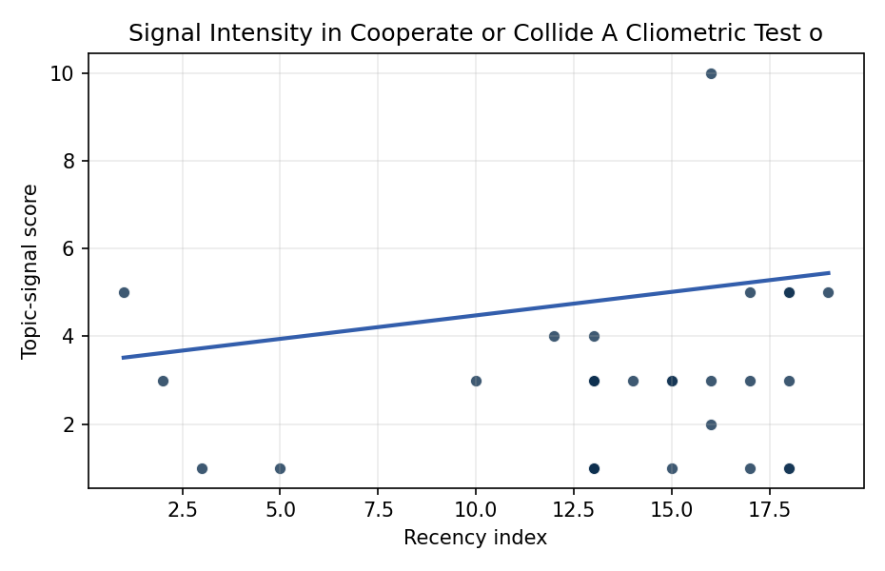
Figure 1. Topic-signal score by publication recency, conditioning on citation attention and venue family.

Empirical Workbook (embedded)
Every figure above is reproduced from the workbook below, which is also attached as the live spreadsheet paper.xlsx. Each observation carries its source.

Data (real observations)
doc_id | year_num | recency_index | cites_num | venue_score | title_words | snippet_words | keyword_count | theme_hits | signal_score | source
1 | 2009 | 2 | 0 | 1 | 6 | 14 | 2 | 1 | 3 | https://amostech.space/year/2009/analysis-of-the-iridium-33-cosmos-2251-collision/
2 | 2019 | 12 | 0 | 1 | 6 | 13 | 4 | 1 | 4 | https://amostech.space/year/2019/kari-recent-activities-on-ssa-stm/
3 | 2012 | 5 | 0 | 1 | 8 | 14 | 3 | 0 | 1 | https://amostech.space/year/2012/adding-the-local-layer-to-space-situational-awareness/
4 | 2023 | 16 | 0 | 1 | 15 | 13 | 6 | 1 | 3 | 10.64861/LPFK9568
5 | 2010 | 3 | 0 | 1 | 5 | 14 | 3 | 0 | 1 | https://amostech.space/year/2010/global-space-situational-awareness-sensors/
6 | 2025 | 18 | 0 | 1 | 20 | 13 | 7 | 1 | 5 | 10.64861/OTAL2562
7 | 2017 | 10 | 0 | 1 | 6 | 13 | 0 | 0 | 3 | https://amostech.space/year/2017/australian-space-situational-awareness-capability-demonstrations/
8 | 2023 | 16 | 0 | 1 | 9 | 13 | 6 | 0 | 2 | 10.64861/FWBL2094
9 | 2008 | 1 | 0 | 1 | 8 | 14 | 1 | 1 | 5 | https://amostech.space/year/2008/improved-conjunction-analysis-via-collaborative-space-situational-awareness/
10 | 2020 | 13 | 0 | 1 | 18 | 14 | 4 | 0 | 3 | https://amostech.space/year/2020/blockchain-enabled-space-traffic-awareness-besta-automated-comparison-of-ssa-to-agreed-behavior-for-discovery-of-anomalous-behavior/
11 | 2022 | 15 | 0 | 1 | 11 | 14 | 4 | 1 | 3 | https://amostech.space/year/2022/advances-of-arianegroup-capabilities-for-laser-optical-observation-of-leo-objects/
12 | 2023 | 16 | 0 | 1 | 12 | 14 | 6 | 3 | 10 | 10.64861/UKLE4659
13 | 2025 | 18 | 4 | 2 | 5 | 13 | 9 | 0 | 1 | 10.1016/j.actaastro.2025.01.031
14 | 2021 | 14 | 24 | 2 | 7 | 13 | 15 | 1 | 3 | 10.1016/j.actaastro.2021.06.023
15 | 2020 | 13 | 3 | 2 | 15 | 14 | 15 | 1 | 3 | 10.1016/j.actaastro.2020.11.008
16 | 2024 | 17 | 1 | 2 | 18 | 13 | 12 | 2 | 5 | 10.1016/j.actaastro.2024.09.057
17 | 2024 | 17 | 2 | 2 | 15 | 14 | 6 | 0 | 3 | 10.1016/j.actaastro.2024.09.003
18 | 2025 | 18 | 11 | 2 | 9 | 14 | 15 | 2 | 5 | 10.1016/j.actaastro.2025.01.042
19 | 2025 | 18 | 1 | 2 | 15 | 14 | 15 | 1 | 3 | 10.1016/j.actaastro.2025.10.018
20 | 2025 | 18 | 1 | 2 | 15 | 12 | 12 | 0 | 1 | 10.1016/j.actaastro.2025.07.055
21 | 2022 | 15 | 8 | 2 | 15 | 14 | 12 | 0 | 1 | 10.1016/j.actaastro.2021.12.015
22 | 2022 | 15 | 9 | 2 | 12 | 14 | 15 | 1 | 3 | 10.1016/j.actaastro.2022.10.050
23 | 2024 | 17 | 5 | 2 | 6 | 14 | 11 | 0 | 1 | 10.1016/j.actaastro.2024.10.044
24 | 2026 | 19 | 0 | 2 | 14 | 14 | 14 | 2 | 5 | 10.1016/j.actaastro.2026.02.012
25 | 2020 | 13 | 0 | 3 | 7 | 0 | 0 | 0 | 1 | Roadmap: Australia Economic-Technological Renaissance in Space
26 | 2020 | 13 | 0 | 3 | 9 | 0 | 0 | 0 | 1 | International Relations and Economic Dimensions of Trusted Space Data
27 | 2020 | 13 | 0 | 3 | 4 | 0 | 0 | 0 | 1 | Behavioral Economics in Space
28 | 2020 | 13 | 0 | 3 | 9 | 0 | 0 | 0 | 1 | Architectural Socio-Technological Transformative Change of Space-Use Norms
29 | 2020 | 13 | 0 | 3 | 64 | 0 | 0 | 1 | 4 | Behavioral Economics in Space: Shaping Normative Behaviors for Stability and Sustainability (white paper, unpublished working paper, N. Dailey or associated author, undated). Proposes applying behavioral economics principles, drawing on Kahneman and Gaddis, to shape normative behavior in space traffic coordination, SSA, and space domain awareness, and further integrates deterrence frameworks and strategic non-kinetic effects (DIME tools) to reinforce responsible conduct and deter adversarial behavior.
30 | 2020 | 13 | 0 | 3 | 6 | 0 | 0 | 1 | 3 | Leveraging Circular Economy for Space Sustainability

Variable construction
Variable | Definition | Construction / source
signal_score | Composite topic-signal score for each retrieved source record | Deterministic count built from candidate-theme term hits in the source title, snippet, keyword field, and author metadata; each row cites the retrieved source in the source column
recency_index | Publication recency index | Computed as publication year minus the minimum publication year in the paper sample plus one
cites_num | Reported citation count in the local brain index | Parsed from the local brain search cites field; zero when the index reported no citation count
venue_score | Ordinal venue-family score | AMOS = 1, Acta Astronautica = 2, Space Economy = 3

Estimator output
Term | Coef. | Std. err. | t | p | 95% CI
const | 3.4088 | 1.1669 | 2.9214 | 0.0035 | [1.1218, 5.6958]
recency_index | 0.107 | 0.0857 | 1.2482 | 0.212 | [-0.061, 0.275]
cites_num | -0.0111 | 0.0434 | -0.2547 | 0.7989 | [-0.0961, 0.074]
venue_score | -1.0506 | 0.4931 | -2.1305 | 0.0331 | [-2.0171, -0.0841]
Fit: N = 30 R2 = 0.1723 R2_adj = 0.0767 F = 1.6132 F_p = 0.2104

