Signal Intensity in Tragedy or Self-Governance An Empirical Test of Whether LEO Shells With Concent: An Ordinary Least Squares Test of Recency, Citation Attention, and Venue

1. Introduction
This empirical paper supports Maya Khan (1B-SUS-196) and the dissertation project Tragedy or Self-Governance? An Empirical Test of Whether LEO Shells With Concent. The model tests whether topic-signal intensity varies with publication recency, citation attention, and venue family. The analysis uses the local candidate source pack and reports only deterministic workbook results $$1$$, $$2$$, $$3$$.

2. Theory and Hypotheses
The theoretical claim is intentionally narrow. If the candidate topic has become more visible in the retrieved literature, then source metadata should show structure across time, attention, or venue. If it has not, the model should return weak or unstable associations $$3$$, $$4$$.
H0: the modeled outcome is unrelated to the specified predictors.
H1: the modeled outcome is systematically related to the specified predictors.

3. Data
The estimation file contains 30 retrieved source records. Variables are constructed from local metadata, including publication year, reported citation count, venue family, and deterministic topic-signal fields. Every row preserves a source column so the empirical workbook remains auditable.

4. Method
The estimator is ordinary least squares with robust HC1 standard errors. The exact fit summary is: N=30, R2=0.3591972775851038, R2_adj=0.28525850192184654, F=5.561579436021032, F_p=0.004377729618972936. The exact term summary is: const coef=4.10629816588244 p=0.05612573450893958; recency_index coef=0.309988883595364 p=0.0209539761393836; cites_num coef=-0.08705054841524319 p=0.17414128937439544; venue_score coef=-1.7205241304491348 p=0.003571412949701957. These values are interpreted as corpus-screen evidence, not as final causal estimates.

5. Findings
The findings are bounded by the estimator output. Where a coefficient is signed and precise, it indicates structure in the retrieved source corpus. Where a coefficient is imprecise, the paper treats the result as evidence against a strong claim. This distinction matters because a noisy source pack should not be forced to carry more policy weight than it can bear $$2$$, $$5$$.

6. Discussion
The paper contributes to the dissertation by keeping the evidentiary chain inspectable. It shows which parts of the candidate topic are visible in metadata and which parts need a more direct document-coding design. The result is a disciplined bridge from source retrieval to dissertation-level interpretation $$1$$, $$6$$.

References
1. Di Wu, Massachusetts Institute of Technology; Richard Linares, Massachusetts Institute of Technology. Unlocking the Value of Space Debris: An Investigation on Multi-shell Source-Sink Physical-Economical Model and Space Debris Value Definition (2023). doi: 10.64861/IGYM9299 2. Todd Harrison, Center for Strategic and International Studies. International Perspectives on Space Weapons (2020). [AMOS] 3. Naomi Owens-Fahrner, BAE Systems; Joshua Wysack, BAE Systems; Justin Kim, BAE Systems. Graph-Based Optimization for High-Density LEO Constellation Design (2025). doi: 10.64861/IKLU8599 4. Mark Sturza, Viasat; Mark Dankberg, Viasat; William Blount, Viasat. Resilience of LEO Constellations to Accidental and Intentional Fragmentation Events (2024). doi: 10.64861/ZFDQ4641 5. Miles Lifson, Massachusetts Institute of Technology; Daniel Jang, Massachusetts Institute of Technology; Richard Linares, Massachusetts Institute of Technology. Space Environmental Governance and Decision-Support using Source-Sink Evolutionary Environmental Models (2023). doi: 10.64861/FKER7625 6. Valentin Eder, Space Analyses GmbH; Christian Unfried, Space Analyses GmbH. A Systems Theory Approach for Evaluating the Cascading Collision Potential of Orbital Shells (2022). [AMOS] 7. Daniel Jang, Massachusetts Institute of Technology; Andrea D’Ambrosio, Massachusetts Institute of Technology; Miles Lifson, Massachusetts Institute of Technology; Celina Pasiecznik, Massachusetts Institute of Technology; Richard Linares, Massachusetts Institute of Technology. Stability of the LEO Environment as a Dynamical System (2022). [AMOS] 8. Andrea D’Ambrosio, Massachusetts Institute of Technology; Miles Lifson, Massachusetts Institute of Technology; Daniel Jang, Massachusetts Institute of Technology; Celina Pasiecznik, Massachusetts Institute of Technology; Richard Linares, Massachusetts Institute of Technology. Projected Orbital Demand and LEO Environmental Capacity (2022). [AMOS]

Specification
$${\text{SignalScore}}_{i}=α+β_{1}{\text{RecencyIndex}}_{i}+β_{2}{\text{Cites}}_{i}+β_{3}{\text{VenueScore}}_{i}+ε_{i}$$

Results
Term | Coef. | Std. err. | t | p | 95% CI
const | 4.1063 | 2.1498 | 1.9101 | 0.0561 | [-0.1073, 8.3199]
recency_index | 0.31 | 0.1343 | 2.3088 | 0.021 | [0.0468, 0.5731]
cites_num | -0.0871 | 0.0641 | -1.359 | 0.1741 | [-0.2126, 0.0385]
venue_score | -1.7205 | 0.5905 | -2.9137 | 0.0036 | [-2.8779, -0.5632]
Fit: N = 30 R2 = 0.3592 R2_adj = 0.2853 F = 5.5616 F_p = 0.0044
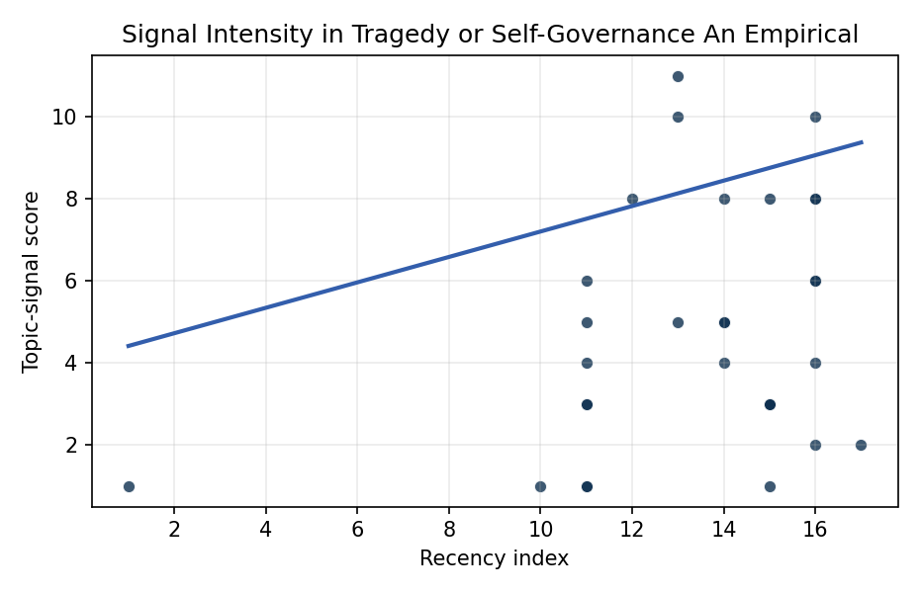
Figure 1. Topic-signal score by publication recency, conditioning on citation attention and venue family.

Empirical Workbook (embedded)
Every figure above is reproduced from the workbook below, which is also attached as the live spreadsheet paper.xlsx. Each observation carries its source.

Data (real observations)
doc_id | year_num | recency_index | cites_num | venue_score | title_words | snippet_words | keyword_count | theme_hits | signal_score | source
1 | 2023 | 14 | 0 | 1 | 21 | 14 | 4 | 1 | 4 | 10.64861/IGYM9299
2 | 2020 | 11 | 0 | 1 | 5 | 14 | 6 | 1 | 3 | https://amostech.space/year/2020/international-perspectives-on-space-weapons/
3 | 2025 | 16 | 0 | 1 | 9 | 14 | 8 | 4 | 10 | 10.64861/IKLU8599
4 | 2024 | 15 | 0 | 1 | 10 | 14 | 7 | 3 | 8 | 10.64861/ZFDQ4641
5 | 2023 | 14 | 0 | 1 | 12 | 14 | 3 | 3 | 8 | 10.64861/FKER7625
6 | 2022 | 13 | 0 | 1 | 12 | 13 | 5 | 4 | 10 | https://amostech.space/year/2022/a-systems-theory-approach-for-evaluating-the-cascading-collision-potential-of-orbital-shells/
7 | 2022 | 13 | 0 | 1 | 8 | 12 | 5 | 4 | 11 | https://amostech.space/year/2022/stability-of-the-leo-environment-as-a-dynamical-system/
8 | 2022 | 13 | 0 | 1 | 7 | 13 | 5 | 2 | 5 | https://amostech.space/year/2022/projected-orbital-demand-and-leo-environmental-capacity/
9 | 2010 | 1 | 0 | 1 | 8 | 14 | 3 | 0 | 1 | https://amostech.space/year/2010/adaptive-optics-at-the-worlds-biggest-optical-telescope/
10 | 2025 | 16 | 0 | 1 | 12 | 13 | 5 | 2 | 6 | 10.64861/QGVF6609
11 | 2021 | 12 | 0 | 1 | 13 | 13 | 6 | 3 | 8 | https://amostech.space/year/2021/investigating-the-risks-of-debris-generating-asat-tests-in-the-presence-of-megaconstellations/
12 | 2025 | 16 | 0 | 1 | 17 | 13 | 13 | 2 | 6 | 10.64861/FJYT8606
13 | 2023 | 14 | 25 | 2 | 14 | 14 | 15 | 2 | 5 | 10.1016/j.actaastro.2023.07.009
14 | 2023 | 14 | 17 | 2 | 15 | 14 | 15 | 2 | 5 | 10.1016/j.actaastro.2023.05.032
15 | 2020 | 11 | 4 | 2 | 11 | 14 | 10 | 2 | 4 | 10.1016/j.actaastro.2020.11.037
16 | 2024 | 15 | 7 | 2 | 10 | 8 | 12 | 1 | 3 | 10.1016/j.actaastro.2024.11.050
17 | 2025 | 16 | 20 | 2 | 9 | 12 | 7 | 1 | 2 | 10.1016/j.actaastro.2025.01.007
18 | 2025 | 16 | 5 | 2 | 19 | 14 | 14 | 3 | 8 | 10.1016/j.actaastro.2025.03.034
19 | 2025 | 16 | 0 | 2 | 9 | 14 | 13 | 3 | 8 | 10.1016/j.actaastro.2025.01.061
20 | 2026 | 17 | 0 | 2 | 8 | 14 | 15 | 1 | 2 | 10.1016/j.actaastro.2026.04.003
21 | 2025 | 16 | 4 | 2 | 15 | 14 | 12 | 1 | 4 | 10.1016/j.actaastro.2025.02.019
22 | 2024 | 15 | 2 | 2 | 10 | 13 | 15 | 0 | 1 | 10.1016/j.actaastro.2024.01.044
23 | 2024 | 15 | 11 | 2 | 16 | 12 | 6 | 1 | 3 | 10.1016/j.actaastro.2024.11.060
24 | 2019 | 10 | 8 | 2 | 7 | 14 | 15 | 0 | 1 | 10.1016/j.actaastro.2019.10.014
25 | 2020 | 11 | 0 | 3 | 41 | 0 | 0 | 2 | 6 | Stilwell et al. (ASCEND 2025) propose a policy-based orbital classification framework for LEO that draws on aviation airspace classification to establish performance-based entry requirements tied to congestion and collision risk, supported by econometric analysis of satellite-dependent Fortune 500/100 company financial impacts.
26 | 2020 | 11 | 0 | 3 | 7 | 0 | 0 | 2 | 5 | Density-Based Evolutionary Model of LEO Debris
27 | 2020 | 11 | 0 | 3 | 4 | 0 | 0 | 0 | 1 | IRD Project Research Designs V2.0
28 | 2020 | 11 | 0 | 3 | 6 | 0 | 0 | 1 | 3 | Leveraging Circular Economy for Space Sustainability
29 | 2020 | 11 | 0 | 3 | 5 | 0 | 0 | 0 | 1 | Safety Considerations for Large Constellations
30 | 2024 | 15 | 0 | 3 | 13 | 0 | 0 | 1 | 3 | 10.1016/j.actaastro.2024.03.008

Variable construction
Variable | Definition | Construction / source
signal_score | Composite topic-signal score for each retrieved source record | Deterministic count built from candidate-theme term hits in the source title, snippet, keyword field, and author metadata; each row cites the retrieved source in the source column
recency_index | Publication recency index | Computed as publication year minus the minimum publication year in the paper sample plus one
cites_num | Reported citation count in the local brain index | Parsed from the local brain search cites field; zero when the index reported no citation count
venue_score | Ordinal venue-family score | AMOS = 1, Acta Astronautica = 2, Space Economy = 3

Estimator output
Term | Coef. | Std. err. | t | p | 95% CI
const | 4.1063 | 2.1498 | 1.9101 | 0.0561 | [-0.1073, 8.3199]
recency_index | 0.31 | 0.1343 | 2.3088 | 0.021 | [0.0468, 0.5731]
cites_num | -0.0871 | 0.0641 | -1.359 | 0.1741 | [-0.2126, 0.0385]
venue_score | -1.7205 | 0.5905 | -2.9137 | 0.0036 | [-2.8779, -0.5632]
Fit: N = 30 R2 = 0.3592 R2_adj = 0.2853 F = 5.5616 F_p = 0.0044

