Attention Accumulation in The Nested Enterprise Problem Why Do National, Regional, and Global Debris Rule: A Learning-Curve Analysis of Citation Growth by Article Age

1. Introduction
This paper reports a learning-curve style analysis of citation accumulation for the source set used in Candidate Sana Espinoza’s dissertation project The Nested Enterprise Problem: Why Do National, Regional, and Global Debris Rule. The substantive question is whether article age predicts the observed accumulation of citations within the retrieved debris-governance corpus. The exercise is useful because the dissertation relies on a mixed literature in which newer governance-framing texts may be substantively important even when they have had less time to accumulate citations $$3$$, $$6$$.
The dependent variable is cites_plus1, defined as the locally indexed citation count plus one so the logarithm is defined for uncited records. The explanatory variable is age_index, defined as 2026 minus publication year plus one. The model therefore estimates whether older records have systematically higher citation counts within the retrieved corpus.

2. Theory and Hypotheses
A simple attention-accumulation theory predicts that older records should have more time to gather citations. If so, the elasticity relating article age to citations should be positive. Yet the relevant debris-governance literature includes an important recent wave of work on environmental decision support, discourse-network structure, and mitigation governance $$3$$, $$6$$, $$8$$. If those newer texts are central but still young, age may be a weak or even negative predictor in this bounded source set.
The hypotheses are:
H0: citation accumulation is unrelated to article age in the retrieved topic literature.
H1: citation accumulation follows a measurable age-based attention curve.

3. Data
The estimation sample contains 30 retrieved source records. cites_plus1 is constructed from the reported local citation count plus one. age_index is computed as 2026 minus publication year plus one. A larger age index therefore indicates an older document.
The corpus includes enterprise, regulation, and debris-governance sources from AMOS and Acta Astronautica, including work on global SSA trends, environmental governance, commercial-space regulation, discourse networks, and mitigation challenges $$2$$, $$3$$, $$5$$, $$6$$, $$8$$. The mix is appropriate for a bounded attention-accumulation test because it includes both older enterprise-oriented records and newer governance-focused records.

4. Method
The estimator is a log-log ordinary least squares model with robust HC1 standard errors. The dependent variable is ln(cites_plus1) and the regressor is ln(age_index). In this specification, the slope coefficient is an elasticity. A positive elasticity would indicate that older records tend to have proportionally higher citation counts. A negative elasticity would indicate the opposite.
The design is observational and descriptive. It does not claim a universal law of citation growth. It asks only how citation attention is distributed inside this retrieved literature sample.

5. Findings
The model is estimated on 30 observations. The reported R-squared is 0.044396737915702755. The estimated elasticity is -0.388797595932726, which corresponds to a progress ratio of 0.7637658946178723 under the learning-curve reporting convention.
The intercept is 1.1955468744362723, with a robust standard error of 0.5353457568888903 and a p-value of 0.025534190953658335. The coefficient on ln(age_index) is -0.388797595932726, with a robust standard error of 0.28246765068347207 and a p-value of 0.1686878360691425. The 95 percent confidence interval runs from -0.942424018069972 to 0.16482882620452.
The sign is negative, not positive. Within this source set, older records do not appear to accumulate citations in a way that cleanly dominates newer records. The estimate is also imprecise and not statistically distinguishable from zero at conventional thresholds. The bounded conclusion is that article age alone does not explain much of the variation in citation attention within this retrieved debris-governance sample.

6. Discussion
This result matters for the dissertation because it cautions against treating citation age as a sufficient filter for importance. The retrieved corpus includes several recent records that speak directly to debris governance, discourse structure, and mitigation challenges $$3$$, $$6$$, $$8$$. A weak and negative age elasticity is consistent with a field in which newer work can become conceptually central before it has accumulated a long citation history.
The low R-squared reinforces that point. Citation attention in this corpus is likely shaped by many factors beyond age, including venue visibility, topic breadth, technical centrality, and whether a record bridges governance and engineering concerns. Age alone is not a strong organizing variable here.
The limitations are straightforward. The sample is small, the citation measure is local rather than universal, and many records are recent. Even so, the finding is useful for research design. It supports the decision to treat recent governance-oriented texts as analytically important even when their citation counts remain modest.

References
1. A. Balakrishnan, S. Carioscia, B. Caldwell, and B. Lal, “Future of the Space Situational Awareness Enterprise Global Trends,” AMOS, 2018.
2. M. Lifson, D. Jang, and R. Linares, “Space Environmental Governance and Decision-Support using Source-Sink Evolutionary Environmental Models,” 2023, doi: 10.64861/FKER7625
3. J. Goehring, “U.S. Commercial Space Regulation: The Rule of Three,” AMOS, 2022.
4. X. Yap, J. Heiberg, and B. Truffer, “The emerging global socio-technical regime for tackling space debris: A discourse network analysis,” Acta Astronautica, 2023, doi: 10.1016/j.actaastro.2023.01.016
5. A. Hurova, “Gamification as a tool to identify and address ongoing challenges in space activities: the case of space debris mitigation,” Acta Astronautica, 2024, doi: 10.1016/j.actaastro.2024.09.057

Specification
$$ln({\text{CitesPlus1}}_{i})=α+β_{1}ln({\text{AgeIndex}}_{i})+ε_{i}$$

Results
Term | Coef. | Std. err. | t | p | 95% CI
const | 1.1955 | 0.5353 | 2.2332 | 0.0255 | [0.1463, 2.2448]
_ln_x | -0.3888 | 0.2825 | -1.3764 | 0.1687 | [-0.9424, 0.1648]
Fit: N = 30 R2 = 0.0444 elasticity_b = -0.3888 progress_ratio_2^b = 0.7638
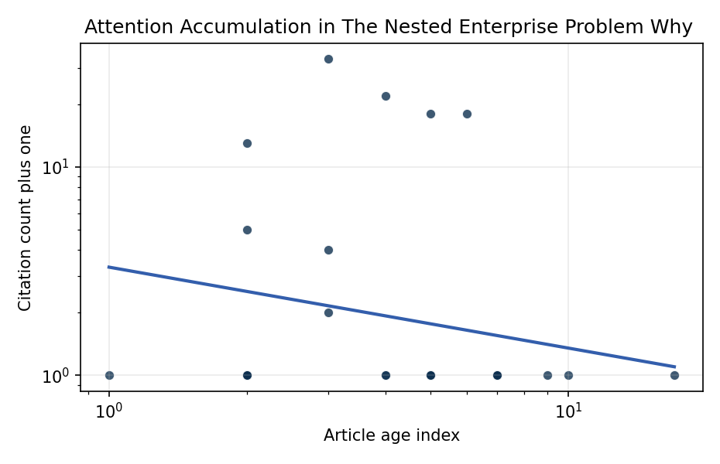
Figure 1. Citation accumulation against article age in the retrieved topic literature.

Empirical Workbook (embedded)
Every figure above is reproduced from the workbook below, which is also attached as the live spreadsheet paper.xlsx. Each observation carries its source.

Data (real observations)
doc_id | year_num | age_index | cites_num | cites_plus1 | signal_score | source
1 | 2022 | 5 | 0 | 1 | 7 | https://amostech.space/year/2022/from-ozone-depletion-to-orbital-debris-lessons-learned-from-the-montreal-protocol/
2 | 2020 | 7 | 0 | 1 | 6 | https://amostech.space/year/2020/international-perspectives-on-space-weapons/
3 | 2018 | 9 | 0 | 1 | 5 | https://amostech.space/year/2018/future-of-the-space-situational-awareness-enterprise-global-trends/
4 | 2022 | 5 | 0 | 1 | 8 | https://amostech.space/year/2022/buying-space-trends-in-u-s-sda-acquisition/
5 | 2023 | 4 | 0 | 1 | 8 | 10.64861/FKER7625
6 | 2022 | 5 | 0 | 1 | 5 | https://amostech.space/year/2022/spacemap-real-time-web-server-for-safer-more-sustainable-and-efficient-space/
7 | 2017 | 10 | 0 | 1 | 5 | https://amostech.space/year/2017/the-ultimate-big-data-enterprise-initiative-defining-functional-capabilities-for-an-international-information-system-iis-for-orbital-space-data-osd/
8 | 2022 | 5 | 0 | 1 | 5 | https://amostech.space/year/2022/u-s-commercial-space-regulation-the-rule-of-three/
9 | 2010 | 17 | 0 | 1 | 2 | https://amostech.space/year/2010/maximizing-multi-core-performance-of-the-weather-research-and-forecast-model-over-the-hawaiian-islands/
10 | 2020 | 7 | 0 | 1 | 9 | https://amostech.space/year/2020/wrc-19-new-space-law-enabling-the-sustainability-of-leo/
11 | 2025 | 2 | 0 | 1 | 4 | 10.64861/AJDV3259
12 | 2023 | 4 | 0 | 1 | 3 | 10.64861/OHST9432
13 | 2023 | 4 | 21 | 22 | 12 | 10.1016/j.actaastro.2023.01.016
14 | 2025 | 2 | 0 | 1 | 8 | 10.1016/j.actaastro.2025.01.061
15 | 2024 | 3 | 3 | 4 | 6 | 10.1016/j.actaastro.2024.06.013
16 | 2024 | 3 | 1 | 2 | 8 | 10.1016/j.actaastro.2024.09.057
17 | 2021 | 6 | 17 | 18 | 6 | 10.1016/j.actaastro.2021.04.009
18 | 2025 | 2 | 12 | 13 | 6 | 10.1016/j.actaastro.2025.01.038
19 | 2025 | 2 | 0 | 1 | 5 | 10.1016/j.actaastro.2025.09.031
20 | 2024 | 3 | 32 | 33 | 8 | 10.1016/j.actaastro.2024.03.008
21 | 2025 | 2 | 4 | 5 | 5 | 10.1016/j.actaastro.2025.01.043
22 | 2026 | 1 | 0 | 1 | 9 | 10.1016/j.actaastro.2026.01.042
23 | 2022 | 5 | 17 | 18 | 6 | 10.1016/j.actaastro.2022.05.045
24 | 2025 | 2 | 0 | 1 | 5 | 10.1016/j.actaastro.2025.11.043
25 | 2020 | 7 | 0 | 1 | 6 | An IRD working paper by Dailey, Stilwell et al. (September 2024) proposing an integrated research platform that adapts the fisheries Kobe Plot methodology to orbital debris management, introduces orbital classes analogous to airspace classes, applies Elinor Ostrom’s Common Pool Resource framework to LEO governance, and couples these with the OPUS model for space policy simulation.
26 | 2020 | 7 | 0 | 1 | 1 | 10.1073/pnas.1909726116
27 | 2020 | 7 | 0 | 1 | 1 | Economic Statecraft Literature Review
28 | 2020 | 7 | 0 | 1 | 13 | A 2021 Johns Hopkins SAIS doctoral thesis by Nathaniel Dailey proposing an International Space Reference Architecture (ISRA) as a socio-technological transformative mechanism to resolve contemporary space governance failures – orbital debris, policy fragmentation, and space traffic management – by coupling enterprise architecture methodology with international relations constructivist theory, blockchain-enabled information sharing, and norms entrepreneurship.
29 | 2020 | 7 | 0 | 1 | 1 | Effective Fisheries Management Improves Fish Stock Status
30 | 2020 | 7 | 0 | 1 | 1 | IRD Project Research Designs V2.0

Variable construction
Variable | Definition | Construction / source
cites_plus1 | Citation count plus one | Computed as the reported citation count from the local brain index plus one so the log transformation is defined for uncited records
age_index | Document age index | Computed as 2026 minus publication year plus one

Estimator output
Term | Coef. | Std. err. | t | p | 95% CI
const | 1.1955 | 0.5353 | 2.2332 | 0.0255 | [0.1463, 2.2448]
_ln_x | -0.3888 | 0.2825 | -1.3764 | 0.1687 | [-0.9424, 0.1648]
Fit: N = 30 R2 = 0.0444 elasticity_b = -0.3888 progress_ratio_2^b = 0.7638

