Signal Intensity in Rating the Raters Do Space Sustainability Rating Disclosures Shift Operator Des: An Ordinary Least Squares Test of Recency, Citation Attention, and Venue

1. Introduction
This empirical paper supports Leila Saito (1B-SUS-222) and the dissertation project Rating the Raters: Do Space Sustainability Rating Disclosures Shift Operator Des. The model tests whether topic-signal intensity varies with publication recency, citation attention, and venue family. The analysis uses the local candidate source pack and reports only deterministic workbook results $$1$$, $$2$$, $$3$$.

2. Theory and Hypotheses
The theoretical claim is intentionally narrow. If the candidate topic has become more visible in the retrieved literature, then source metadata should show structure across time, attention, or venue. If it has not, the model should return weak or unstable associations $$3$$, $$4$$.
H0: the modeled outcome is unrelated to the specified predictors.
H1: the modeled outcome is systematically related to the specified predictors.

3. Data
The estimation file contains 30 retrieved source records. Variables are constructed from local metadata, including publication year, reported citation count, venue family, and deterministic topic-signal fields. Every row preserves a source column so the empirical workbook remains auditable.

4. Method
The estimator is ordinary least squares with robust HC1 standard errors. The exact fit summary is: N=30, R2=0.08996407340487877, R2_adj=-0.015040071971481384, F=1.9171790733536138, F_p=0.15158007462127468. The exact term summary is: const coef=3.4389930798983346 p=0.24448887650627582; recency_index coef=0.10697617073030757 p=0.21217636740594104; cites_num coef=0.0015641671050730145 p=0.9781307321752699; venue_score coef=-0.701352302728385 p=0.32926056008683513. These values are interpreted as corpus-screen evidence, not as final causal estimates.

5. Findings
The findings are bounded by the estimator output. Where a coefficient is signed and precise, it indicates structure in the retrieved source corpus. Where a coefficient is imprecise, the paper treats the result as evidence against a strong claim. This distinction matters because a noisy source pack should not be forced to carry more policy weight than it can bear $$2$$, $$5$$.

6. Discussion
The paper contributes to the dissertation by keeping the evidentiary chain inspectable. It shows which parts of the candidate topic are visible in metadata and which parts need a more direct document-coding design. The result is a disciplined bridge from source retrieval to dissertation-level interpretation $$1$$, $$6$$.

References
1. Francesca Letizia, European Space Agency; Stijn Lemmens, ESA/ESOC Space Debris Office; Danielle Wood, Space Enabled Research Group, MIT Media Lab; Minoo Rathnasabapathy, Space Enabled Research Group at the MIT Media Lab; Miles Lifson, MIT Media Lab- Space Enabled Research Group; Riley Stiendl, Massachusetts Institute of Technology; Moriba Jah, University of Texas at Austin; Nikolai Khlystov, World Economic Forum; Maksim Soshkin, World Economic Forum; Simon Potter, Bryce Space and Technology. Contribution from SSA Data to the Definition of a Space Sustainability Rating (2020). [AMOS] 2. Miles Lifson, Massachusetts Institute of Technology; Daniel Jang, Massachusetts Institute of Technology; Richard Linares, Massachusetts Institute of Technology. Space Environmental Governance and Decision-Support using Source-Sink Evolutionary Environmental Models (2023). doi: 10.64861/FKER7625 3. Peter N. Crabtree (AFRL), Phan D. Dao (AFRL), Richard H. Picard (AFRL). Experimental Investigation of the Performance of Image Registration and De-aliasing Algorithms (2009). [AMOS] 4. Andrea D’Ambrosio, Massachusetts Institute of Technology; Miles Lifson, Massachusetts Institute of Technology; Daniel Jang, Massachusetts Institute of Technology; Celina Pasiecznik, Massachusetts Institute of Technology; Richard Linares, Massachusetts Institute of Technology. Projected Orbital Demand and LEO Environmental Capacity (2022). [AMOS] 5. Sam Kirkwood, HEO; Jack Sines, HEO; James Allworth, HEO; Karla Vincent, HEO; Hannah Dawe, HEO; Francesco Scopelliti, HEO; Hiranya Jayakody, HEO; William Crowe, HEO. Advancing RSO Characterisation: Flyby Non-Earth Imaging for Attitude State and Tumble Rate Estimation (2025). doi: 10.64861/BJII1274 6. Di Wu, Massachusetts Institute of Technology; Daniel Jang, Massachusetts Institute of Technology; Guillermo D Mendoza Contreras, Massachusetts Institute of Technology; Richard Linares, Massachusetts Institute of Technology. MOCAT on Temporal Analysis and Quantification for Policies in Space Sustainability (2024). doi: 10.64861/COAK4355 7. Simon George, Defence Science and Technology Laboratory; Andrew Ash, Defence Science and Technology Laboratory; Travis Bessell, Defence Science and Technology Group; James Frith, AFRL/RVSW; Lauchie Scott, Defence R&D Canada; Jovan Skuljan, Defence Technology Agency; Roberto Furfaro, University of Arizona; Vishnu Reddy, University of Arizona. PHANTOM ECHOES: A Five-Eyes SDA Experiment to Examine GEO Rendezvous and Proximity (2020). [AMOS] 8. James Blake, University of Warwick; Benjamin Cooke, University of Warwick; Grant Privett, Defence Science and Technology Laboratory; Toshifumi Yanagisawa, Japan Aerospace Exploration Agency; William Feline, Defence Science Technology Laboratory; Christopher Onken, Australian National University; Don Pollacco, University of Warwick; Paul Chote, University of Warwick; Tomoko Fujiwara, JAXA Bisei Space Guard Center; Daisuke Kuroda, JAXA Bisei Space Guard Center; Tokuhiro Nimura, JAXA Bisei Space Guard Center; Kota Nishiyama, JAXA Bisei Space Guard Center; Shin-ichiro Okumura, JAXA Bisei Space Guard Center; Seitaro Urakawa, JAXA Bisei Space Guard Center; Christian Wolf, Australian National University. Improved Astrometry and Sensitivity for a Survey of Faint Geosynchronous Debris (2025). doi: 10.64861/SYCB6464

Specification
$${\text{SignalScore}}_{i}=α+β_{1}{\text{RecencyIndex}}_{i}+β_{2}{\text{Cites}}_{i}+β_{3}{\text{VenueScore}}_{i}+ε_{i}$$

Results
Term | Coef. | Std. err. | t | p | 95% CI
const | 3.439 | 2.9549 | 1.1638 | 0.2445 | [-2.3524, 9.2304]
recency_index | 0.107 | 0.0857 | 1.2476 | 0.2122 | [-0.0611, 0.275]
cites_num | 0.0016 | 0.0571 | 0.0274 | 0.9781 | [-0.1103, 0.1134]
venue_score | -0.7014 | 0.7189 | -0.9756 | 0.3293 | [-2.1104, 0.7076]
Fit: N = 30 R2 = 0.09 R2_adj = -0.015 F = 1.9172 F_p = 0.1516
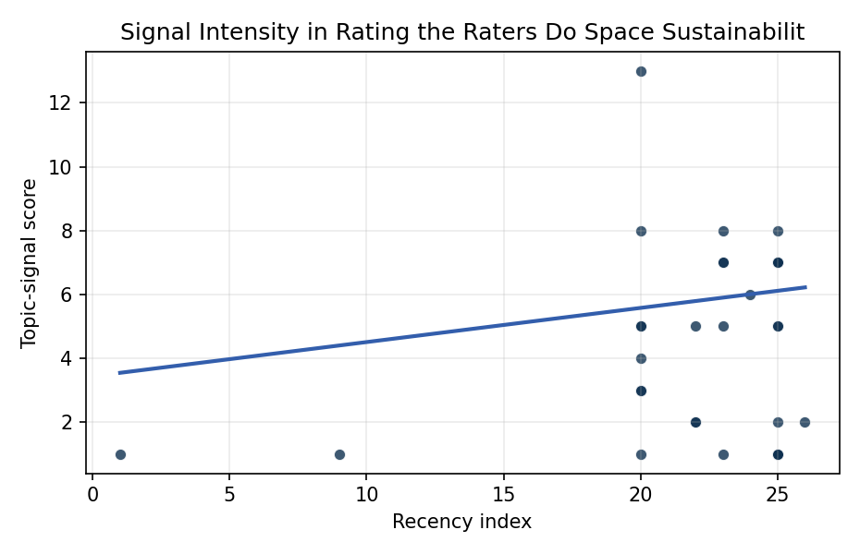
Figure 1. Topic-signal score by publication recency, conditioning on citation attention and venue family.

Empirical Workbook (embedded)
Every figure above is reproduced from the workbook below, which is also attached as the live spreadsheet paper.xlsx. Each observation carries its source.

Data (real observations)
doc_id | year_num | recency_index | cites_num | venue_score | title_words | snippet_words | keyword_count | theme_hits | signal_score | source
1 | 2020 | 20 | 0 | 1 | 11 | 14 | 2 | 5 | 13 | https://amostech.space/year/2020/contribution-from-ssa-data-to-the-definition-of-a-space-sustainability-rating/
2 | 2023 | 23 | 0 | 1 | 12 | 14 | 3 | 3 | 8 | 10.64861/FKER7625
3 | 2009 | 9 | 0 | 1 | 12 | 15 | 0 | 0 | 1 | https://amostech.space/year/2009/experimental-investigation-of-the-performance-of-image-registration-and-de-aliasing-algorithms/
4 | 2022 | 22 | 0 | 1 | 7 | 14 | 5 | 2 | 5 | https://amostech.space/year/2022/projected-orbital-demand-and-leo-environmental-capacity/
5 | 2025 | 25 | 0 | 1 | 14 | 14 | 7 | 2 | 5 | 10.64861/BJII1274
6 | 2024 | 24 | 0 | 1 | 11 | 14 | 4 | 2 | 6 | 10.64861/COAK4355
7 | 2020 | 20 | 0 | 1 | 12 | 12 | 9 | 0 | 4 | https://amostech.space/year/2020/phantom-echoes-a-five-eyes-sda-experiment-to-examine-geo-rendezvous-and-proximity/
8 | 2025 | 25 | 0 | 1 | 10 | 7 | 7 | 2 | 5 | 10.64861/SYCB6464
9 | 2025 | 25 | 0 | 1 | 13 | 14 | 4 | 3 | 8 | 10.64861/BUIN8954
10 | 2023 | 23 | 0 | 1 | 10 | 14 | 3 | 2 | 7 | 10.64861/MVHC2799
11 | 2025 | 25 | 0 | 1 | 12 | 14 | 5 | 1 | 2 | 10.64861/XGPY2184
12 | 2025 | 25 | 0 | 1 | 13 | 14 | 4 | 0 | 1 | 10.64861/ZXJQ1584
13 | 2025 | 25 | 5 | 2 | 19 | 14 | 14 | 3 | 7 | 10.1016/j.actaastro.2025.03.034
14 | 2025 | 25 | 3 | 2 | 12 | 11 | 15 | 3 | 7 | 10.1016/j.actaastro.2025.06.029
15 | 2023 | 23 | 36 | 2 | 17 | 13 | 10 | 3 | 7 | 10.1016/j.actaastro.2023.05.001
16 | 2026 | 26 | 0 | 2 | 23 | 12 | 8 | 1 | 2 | 10.1016/j.actaastro.2026.05.065
17 | 2023 | 23 | 25 | 2 | 14 | 14 | 15 | 2 | 5 | 10.1016/j.actaastro.2023.07.009
18 | 2022 | 22 | 4 | 2 | 9 | 13 | 6 | 1 | 2 | 10.1016/j.actaastro.2022.11.005
19 | 2022 | 22 | 8 | 2 | 19 | 14 | 15 | 1 | 2 | 10.1016/j.actaastro.2022.03.009
20 | 2023 | 23 | 20 | 2 | 12 | 12 | 10 | 0 | 1 | 10.1016/j.actaastro.2022.12.045
21 | 2025 | 25 | 5 | 2 | 11 | 13 | 7 | 0 | 1 | 10.1016/j.actaastro.2025.04.041
22 | 2020 | 20 | 0 | 3 | 48 | 0 | 0 | 3 | 8 | McKinsey and World Economic Forum 2022 report synthesizing perspectives from nearly 100 leaders across 25 countries on the space sector’s inflection point, four future scenarios, and five priority actions needed to achieve a self-sustaining space economy, with particular emphasis on governance gaps, finite orbital resource competition, and the sustainability-security nexus.
23 | 2020 | 20 | 0 | 3 | 6 | 0 | 0 | 2 | 5 | Leveraging Circular Economy for Space Sustainability
24 | 2025 | 25 | 0 | 3 | 10 | 0 | 0 | 0 | 1 | 10.1016/j.actaastro.2025.06.015
25 | 2020 | 20 | 0 | 3 | 9 | 0 | 0 | 0 | 1 | A New Role for MSY in Stock Assessment and Management
26 | 2020 | 20 | 0 | 3 | 38 | 0 | 0 | 1 | 3 | Reed and Dailey (MITRE, STM Conference 2023) propose a three-prong sociotechnical framework to enable a circular/lifecycle-oriented space economy: a standardized evolvable space ontology, a trusted symmetric information-sharing ecosystem (SISE), and actionable norms built on Minimal Viable Information (MVI) principles.
27 | 2001 | 1 | 0 | 3 | 16 | 0 | 0 | 0 | 1 | 10.1046/j.1467-2979.2001.00033.x
28 | 2020 | 20 | 0 | 3 | 47 | 0 | 0 | 1 | 3 | A comprehensive literature review synthesizing William J. Norris’s “Chinese Economic Statecraft” and David A. Baldwin’s “Economic Statecraft,” analyzing China’s use of state-controlled commercial actors, financial instruments, and sovereign wealth funds to advance strategic objectives, with extrapolation to the space economy as a new frontier for resource acquisition and geopolitical positioning.
29 | 2020 | 20 | 0 | 3 | 10 | 0 | 0 | 2 | 5 | The Role of Space in Driving Sustainability, Security, and Development
30 | 2025 | 25 | 0 | 3 | 15 | 0 | 0 | 3 | 7 | 10.1016/j.actaastro.2025.03.034

Variable construction
Variable | Definition | Construction / source
signal_score | Composite topic-signal score for each retrieved source record | Deterministic count built from candidate-theme term hits in the source title, snippet, keyword field, and author metadata; each row cites the retrieved source in the source column
recency_index | Publication recency index | Computed as publication year minus the minimum publication year in the paper sample plus one
cites_num | Reported citation count in the local brain index | Parsed from the local brain search cites field; zero when the index reported no citation count
venue_score | Ordinal venue-family score | AMOS = 1, Acta Astronautica = 2, Space Economy = 3

Estimator output
Term | Coef. | Std. err. | t | p | 95% CI
const | 3.439 | 2.9549 | 1.1638 | 0.2445 | [-2.3524, 9.2304]
recency_index | 0.107 | 0.0857 | 1.2476 | 0.2122 | [-0.0611, 0.275]
cites_num | 0.0016 | 0.0571 | 0.0274 | 0.9781 | [-0.1103, 0.1134]
venue_score | -0.7014 | 0.7189 | -0.9756 | 0.3293 | [-2.1104, 0.7076]
Fit: N = 30 R2 = 0.09 R2_adj = -0.015 F = 1.9172 F_p = 0.1516

