Signal Intensity in Availability and Alarm Do Salient Collision and Fragmentation Events Drive Regu: An Ordinary Least Squares Test of Recency, Citation Attention, and Venue

1. Introduction
This empirical paper supports Margot Dorsey (1B-SUS-179) and the dissertation project Availability and Alarm: Do Salient Collision and Fragmentation Events Drive Regu. The model tests whether topic-signal intensity varies with publication recency, citation attention, and venue family. The analysis uses the local candidate source pack and reports only deterministic workbook results $$1$$, $$2$$, $$3$$.

2. Theory and Hypotheses
The theoretical claim is intentionally narrow. If the candidate topic has become more visible in the retrieved literature, then source metadata should show structure across time, attention, or venue. If it has not, the model should return weak or unstable associations $$3$$, $$4$$.
H0: the modeled outcome is unrelated to the specified predictors.
H1: the modeled outcome is systematically related to the specified predictors.

3. Data
The estimation file contains 30 retrieved source records. Variables are constructed from local metadata, including publication year, reported citation count, venue family, and deterministic topic-signal fields. Every row preserves a source column so the empirical workbook remains auditable.

4. Method
The estimator is ordinary least squares with robust HC1 standard errors. The exact fit summary is: N=30, R2=0.4021056057979949, R2_adj=0.33311779108237893, F=9.421229548544034, F_p=0.0002186159896952205. The exact term summary is: const coef=8.191261562313388 p=0.0005775453452896443; recency_index coef=0.19300623991237786 p=0.15290567587230658; cites_num coef=0.08580803019250725 p=0.00022787724467089138; venue_score coef=-2.697326065463136 p=0.00011621627977365185. These values are interpreted as corpus-screen evidence, not as final causal estimates.

5. Findings
The findings are bounded by the estimator output. Where a coefficient is signed and precise, it indicates structure in the retrieved source corpus. Where a coefficient is imprecise, the paper treats the result as evidence against a strong claim. This distinction matters because a noisy source pack should not be forced to carry more policy weight than it can bear $$2$$, $$5$$.

6. Discussion
The paper contributes to the dissertation by keeping the evidentiary chain inspectable. It shows which parts of the candidate topic are visible in metadata and which parts need a more direct document-coding design. The result is a disciplined bridge from source retrieval to dissertation-level interpretation $$1$$, $$6$$.

References
1. Matthew Stevenson, LeoLabs; Darren McKnight, LeoLabs; Hugh Lewis, University of Southampton; Chris Kunstadter, AXA XL; Rachit Bhatia, LeoLabs. Identifying the Statistically-Most-Concerning Conjunctions in LEO (2021). [AMOS] 2. Simon George, Defence Science and Technology Laboratory; Andrew Ash, Defence Science and Technology Laboratory. Future On-Orbit Spacecraft Technologies and Associated Challenges for Space Situational Awareness (2019). [AMOS] 3. Alejandro Pastor, GMV; Guillermo Escribano-Blázquez, Universidad Carlos III de Madrid; Manuel Sanjurjo-Rivo, Universidad Carlos III de Madrid; Diego Escobar, GMV. Fragmentation Detection via Track-to-Track Association of Optical Observations (2021). [AMOS] 4. Mark Sturza, Viasat; Mark Dankberg, Viasat; William Blount, Viasat. Resilience of LEO Constellations to Accidental and Intentional Fragmentation Events (2024). doi: 10.64861/ZFDQ4641 5. Bhargav Joshi, Digantara; Subramanian Arumugam, Digantara; Siri L., Digantara; Thamim Ansari, Digantara; Tanveer Ahmed, Digantara. Satellite Debris Classification Framework: Using Graph Neural Networks for Explosion and Collision Event Characterization (2025). doi: 10.64861/PHBD6598 6. Alejandro Pastor, GMV; Jan Siminski, ESA/ESOC Space Debris Office; Guillermo Escribano, University Carlos III of Madrid; Manuel Sanjurjo-Rivo, University Carlos III of Madrid; Diego Escobar, GMV. Early Identification and Tracking of Fragments from Break-up Events (2022). [AMOS] 7. Gene Stansbery (NASA Johnson Space Center), Mark Matney (NASA Johnson Space Center), J.C. Liou (NASA Johnson Space Center), Dave Whitlock (ESCG/Hamilton Sundstrand). A Comparison of Catastrophic On-Orbit Collisions (2008). [AMOS] 8. James Jones (Northrop Grumman). Automated Recognition of Type III Solar Radio Bursts using Mathematical Morphology (2014). [AMOS]

Specification
$${\text{SignalScore}}_{i}=α+β_{1}{\text{RecencyIndex}}_{i}+β_{2}{\text{Cites}}_{i}+β_{3}{\text{VenueScore}}_{i}+ε_{i}$$

Results
Term | Coef. | Std. err. | t | p | 95% CI
const | 8.1913 | 2.3798 | 3.4419 | 0.0005775 | [3.5269, 12.8557]
recency_index | 0.193 | 0.135 | 1.4293 | 0.1529 | [-0.0717, 0.4577]
cites_num | 0.0858 | 0.0233 | 3.6859 | 0.0002279 | [0.0402, 0.1314]
venue_score | -2.6973 | 0.6999 | -3.854 | 0.0001162 | [-4.0691, -1.3256]
Fit: N = 30 R2 = 0.4021 R2_adj = 0.3331 F = 9.4212 F_p = 0.0002186
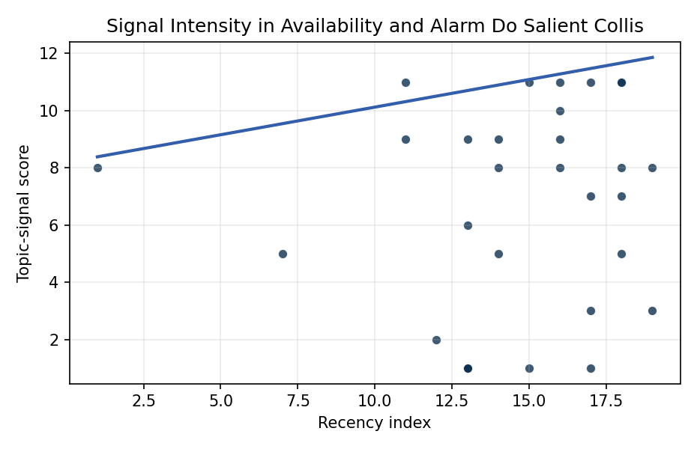
Figure 1. Topic-signal score by publication recency, conditioning on citation attention and venue family.

Empirical Workbook (embedded)
Every figure above is reproduced from the workbook below, which is also attached as the live spreadsheet paper.xlsx. Each observation carries its source.

Data (real observations)
doc_id | year_num | recency_index | cites_num | venue_score | title_words | snippet_words | keyword_count | theme_hits | signal_score | source
1 | 2021 | 14 | 0 | 1 | 8 | 12 | 2 | 3 | 8 | https://amostech.space/year/2021/identifying-the-statistically-most-concerning-conjunctions-in-leo/
2 | 2019 | 12 | 0 | 1 | 12 | 14 | 4 | 0 | 2 | https://amostech.space/year/2019/future-on-orbit-spacecraft-technologies-and-associated-challenges-for-space-situational-awareness/
3 | 2021 | 14 | 0 | 1 | 10 | 13 | 5 | 2 | 5 | https://amostech.space/year/2021/fragmentation-detection-via-track-to-track-association-of-optical-observations/
4 | 2024 | 17 | 0 | 1 | 10 | 14 | 7 | 4 | 11 | 10.64861/ZFDQ4641
5 | 2025 | 18 | 0 | 1 | 14 | 14 | 6 | 4 | 11 | 10.64861/PHBD6598
6 | 2022 | 15 | 0 | 1 | 10 | 14 | 7 | 4 | 11 | https://amostech.space/year/2022/early-identification-and-tracking-of-fragments-from-break-up-events/
7 | 2008 | 1 | 0 | 1 | 6 | 14 | 1 | 3 | 8 | https://amostech.space/year/2008/a-comparison-of-catastrophic-on-orbit-collisions/
8 | 2014 | 7 | 0 | 1 | 11 | 11 | 5 | 2 | 5 | https://amostech.space/year/2014/automated-recognition-of-type-iii-solar-radio-bursts-using-mathematical-morphology/
9 | 2023 | 16 | 0 | 1 | 12 | 10 | 5 | 3 | 9 | 10.64861/DZFF7826
10 | 2018 | 11 | 0 | 1 | 11 | 14 | 4 | 4 | 11 | https://amostech.space/year/2018/fragmentation-event-identification-using-back-propagation-with-variable-ballistic-coefficient-calculation/
11 | 2025 | 18 | 0 | 1 | 7 | 14 | 6 | 2 | 7 | 10.64861/LCET1122
12 | 2024 | 17 | 0 | 1 | 13 | 13 | 5 | 1 | 3 | 10.64861/UQYR6894
13 | 2025 | 18 | 1 | 2 | 8 | 14 | 15 | 3 | 8 | 10.1016/j.actaastro.2025.05.059
14 | 2026 | 19 | 0 | 2 | 10 | 14 | 13 | 3 | 8 | 10.1016/j.actaastro.2026.01.061
15 | 2018 | 11 | 51 | 2 | 9 | 14 | 10 | 3 | 9 | 10.1016/j.actaastro.2018.03.017
16 | 2025 | 18 | 0 | 2 | 10 | 14 | 15 | 4 | 11 | 10.1016/j.actaastro.2025.09.078
17 | 2026 | 19 | 0 | 2 | 10 | 14 | 14 | 1 | 3 | 10.1016/j.actaastro.2026.01.027
18 | 2025 | 18 | 5 | 2 | 16 | 12 | 10 | 1 | 5 | 10.1016/j.actaastro.2024.12.056
19 | 2024 | 17 | 2 | 2 | 15 | 14 | 6 | 2 | 7 | 10.1016/j.actaastro.2024.09.003
20 | 2021 | 14 | 17 | 2 | 7 | 12 | 15 | 3 | 9 | 10.1016/j.actaastro.2021.04.009
21 | 2023 | 16 | 21 | 2 | 14 | 14 | 15 | 4 | 10 | 10.1016/j.actaastro.2023.04.032
22 | 2020 | 13 | 64 | 2 | 13 | 14 | 15 | 3 | 9 | 10.1016/j.actaastro.2020.02.050
23 | 2023 | 16 | 6 | 2 | 11 | 14 | 15 | 3 | 8 | 10.1016/j.actaastro.2023.01.020
24 | 2023 | 16 | 10 | 2 | 6 | 14 | 11 | 4 | 11 | 10.1016/j.actaastro.2023.02.036
25 | 2020 | 13 | 0 | 3 | 5 | 0 | 0 | 0 | 1 | Operators’ Requirements for SSA Services
26 | 2020 | 13 | 0 | 3 | 6 | 0 | 0 | 0 | 1 | Stilwell et al ASCEND 2025 Orbital Classification
27 | 2022 | 15 | 0 | 3 | 5 | 0 | 0 | 0 | 1 | 10.1007/s40295-022-00346-8
28 | 2024 | 17 | 0 | 3 | 7 | 0 | 0 | 0 | 1 | 10.1016/j.jsse.2024.08.001
29 | 2020 | 13 | 0 | 3 | 11 | 0 | 0 | 0 | 1 | D. Martin-Lawson, S. Paladini, K. Saha, and E. Yerushalmi, �The cost of (un)regu
30 | 2020 | 13 | 0 | 3 | 48 | 0 | 0 | 2 | 6 | McKinsey and World Economic Forum 2022 report synthesizing perspectives from nearly 100 leaders across 25 countries on the space sector’s inflection point, four future scenarios, and five priority actions needed to achieve a self-sustaining space economy, with particular emphasis on governance gaps, finite orbital resource competition, and the sustainability-security nexus.

Variable construction
Variable | Definition | Construction / source
signal_score | Composite topic-signal score for each retrieved source record | Deterministic count built from candidate-theme term hits in the source title, snippet, keyword field, and author metadata; each row cites the retrieved source in the source column
recency_index | Publication recency index | Computed as publication year minus the minimum publication year in the paper sample plus one
cites_num | Reported citation count in the local brain index | Parsed from the local brain search cites field; zero when the index reported no citation count
venue_score | Ordinal venue-family score | AMOS = 1, Acta Astronautica = 2, Space Economy = 3

Estimator output
Term | Coef. | Std. err. | t | p | 95% CI
const | 8.1913 | 2.3798 | 3.4419 | 0.0005775 | [3.5269, 12.8557]
recency_index | 0.193 | 0.135 | 1.4293 | 0.1529 | [-0.0717, 0.4577]
cites_num | 0.0858 | 0.0233 | 3.6859 | 0.0002279 | [0.0402, 0.1314]
venue_score | -2.6973 | 0.6999 | -3.854 | 0.0001162 | [-4.0691, -1.3256]
Fit: N = 30 R2 = 0.4021 R2_adj = 0.3331 F = 9.4212 F_p = 0.0002186

