Attention Accumulation in Institutions Before Capability: A Learning-Curve Analysis of Citation Growth by Article Age

1. Introduction
This second empirical paper examines whether citation accumulation in the dissertation’s local literature set follows a measurable age-based learning curve. The motivation is practical. If older records predictably accumulate citations, then article age can be used as a rough guide to canonical status within the literature. If not, the dissertation should resist the common shortcut of equating older sources with settled authority. That question matters for a topic that combines emerging national SSA institutions, technical detection work, and broader governance narratives $$1$$, $$2$$, $$3$$, $$4$$, $$5$$, $$6$$, $$7$$.
The analysis uses the same 30-record source set as Paper 1, but changes the dependent variable. Here the outcome is cites_plus1, the reported citation count in the local index plus one so that the logarithm is defined for uncited records. The explanatory variable is age_index, defined as 2026 minus publication year plus one. The model is estimated as a log-log learning curve, which treats the elasticity of citation accumulation with respect to age as the key parameter.
The paper does not claim that citations are a direct measure of truth, policy value, or institutional importance. It asks a narrower question: does article age explain citation accumulation in this retrieved literature. The answer helps determine whether the dissertation should privilege chronological seniority in literature review design, or instead treat recent specialized work as potentially as important as older records.

2. Theory and Hypotheses
A conventional diffusion expectation would predict a positive age elasticity. Older records have had more time to accumulate notice, circulate through bibliographies, and become canonical reference points. On that logic, papers with larger age_index values should display higher cites_plus1 values.
There are reasons to expect a weaker relationship in this source set, however. The local corpus mixes several genres: national case descriptions $$1$$, operational monitoring-system papers $$2$$, broad trend overviews $$3$$, autonomous catalog work $$4$$, strategic partnership analysis $$5$$, institutional bottleneck analysis $$6$$, and discourse-network governance writing $$7$$. Citation accumulation may therefore be uneven across genres. A recent governance paper could become central quickly, while an older technical record may remain lightly cited outside a narrow specialty.
The source set is also strongly affected by recency in topic formation. The dissertation’s institutional-capability proposition is more explicit in recent records than in older ones. If citation counts lag behind topic emergence, then age may not be a reliable guide to which records matter most for the dissertation’s actual argument. The paper tests this possibility directly.
The hypotheses are:
H0: citation accumulation is unrelated to article age in the retrieved topic literature.
H1: citation accumulation follows a measurable age-based attention curve.

3. Data
The estimation file contains 30 observations, one for each retrieved source record. The dependent variable is cites_plus1, equal to the reported local-index citation count plus one. The plus-one transformation is mechanical and ensures that the logarithm is defined even when the record is uncited.
The independent variable is age_index, defined as 2026 minus publication year plus one. A larger value indicates an older record. The log-log specification uses the natural logarithm of both variables, so the coefficient on age is an elasticity. In substantive terms, it estimates the percentage change in expected citations associated with a one-percent change in article age.
The source pool spans national case material, monitoring-system development, global trend mapping, catalog methods, partnership writing, and institutional governance analysis $$1$$, $$2$$, $$3$$, $$4$$, $$5$$, $$6$$, $$7$$. This diversity is useful because it mirrors the mixed literature base on which the dissertation will depend. It also means that age effects may be weaker than in a tightly bounded single-discipline citation network.

4. Method
The estimator is a log-log ordinary least squares learning-curve model with robust HC1 standard errors. The estimated equation is:
$$ln({\text{CitesPlus1}}_{i})=α+β_{1}ln({\text{AgeIndex}}_{i})+ε_{i}$$
The coefficient $β_{1}$ is the elasticity of citation accumulation with respect to article age. A positive and statistically meaningful estimate would support H1 by indicating that older records tend to have systematically higher citation counts. A near-zero estimate would suggest that age is not a strong organizer of citation attention in the local source set.
The model is intentionally parsimonious. It does not add venue controls or metadata signal controls because the paper’s purpose is to test the simplest age-attention relationship first. The findings are therefore descriptive and diagnostic rather than causal.

5. Findings
The model is estimated on 30 observations. The reported R-squared is 7.895643619915127e-06, effectively zero for practical purposes. The estimated elasticity on age_index is 0.005213932863247499, and the implied progress ratio is 1.0036205613187545 for each doubling of age. These summary values already indicate that age contributes almost no explanatory power to citation accumulation in this sample.
The intercept is 0.7069239270923672, with a robust standard error of 0.4613208372222022 and a p-value of 0.12542596206406173. The coefficient on ln(age_index) is 0.005213932863247499, with a robust standard error of 0.2868788539780677 and a p-value of 0.9854994975802642. The confidence interval spans from -0.5570582888598905 to 0.5674861545863854. On these values, the elasticity is not merely modest. It is statistically indistinguishable from zero.
This result means that older records in the retrieved corpus do not systematically carry more indexed citations than newer records once the model is framed as a log-log age-attention curve. The point estimate is positive, but so close to zero, and so imprecise relative to the null, that it offers no empirical support for H1.
The null hypothesis therefore cannot be rejected on the basis of the supplied output. In the local source set, article age does not appear to be a useful predictor of citation accumulation.

6. Discussion
The practical implication is clear. The dissertation should not treat article age as a proxy for relevance or authority. Older records in this literature are not reliably more cited in the local index, and newer records are not systematically disadvantaged by their recency. That is important because the candidate’s substantive argument concerns institutional sequence, a topic that is more explicit in recent materials on integrated monitoring systems, strategic partnerships, and governance bottlenecks $$2$$, $$5$$, $$6$$, $$7$$.
The result also complements Paper 1. Paper 1 found that the metadata topic signal rises with publication recency, while citation attention does not cleanly explain that signal. Paper 2 shows why. Citation accumulation is not strongly ordered by article age in this local corpus, so recent institutional material can matter greatly to the dissertation without first passing through a long cycle of citation consolidation.
This pattern makes sense given the heterogeneous source pool. National case descriptions, technical methods papers, and governance analyses travel through different scholarly and policy circuits. A single age-based learning curve is therefore unlikely to organize the whole corpus tightly. Some recent records may become important quickly because they capture a newly salient institutional question. Some older records may remain niche because they solve a technical problem without serving as a common framing reference for later governance debates.
The limitations are straightforward. The source set is small, the citation field comes from a local brain index rather than a universal bibliometric service, and the model includes only one explanatory variable. The result should therefore be treated as a disciplined diagnostic rather than a general law of citation behavior in space studies.
Even with those limits, the conclusion is useful. Chronological seniority is a weak filter for this dissertation’s literature base. The review should instead prioritize topical fit, institutional relevance, and direct usefulness for the state-year design. Recent records on national organizations, integrated monitoring architectures, and partnership governance deserve weight even when they have not yet accumulated large citation totals.

References
1. Quentin Verspieren, The University of Tokyo. Establishment of a Space Operations Squadron at the Japan Air Self-Defense Force in 2020: current status and future prospects. (2021). [AMOS]
2. Jaedong Seong, Okchul Jung, Youeyun Jung, and Saehan Song. Development of VISION (Vigilant Integrated Space Information and mOnitoring Network): An Integrated Space Information Monitoring System for Space Flight Safety. (2025). doi: 10.64861/OTAL2562
3. Makena Young. Trends in Global Space Situational Awareness. (2021). [AMOS]
4. Nicholas Moretti, Mark Rutten, Travis Bessell, and Brittany Morreale. Autonomous Space Object Catalogue Construction and Upkeep Using Sensor Control Theory. (2017). [AMOS]
5. Nathaniel Dailey, Braden McGrath, Harvey Reed, and Jonathon Wotton. Global Space Domain Awareness, Partnering to Win with AUKUS. (2023). doi: 10.64861/FWBL2094
6. Jie Long and Wenzhen Chen. Laser utilization in outer space: Institutional bottleneck and prospects. (2025). doi: 10.1016/j.actaastro.2025.01.061
7. Xiao-Shan Yap, Jonas Heiberg, and Bernhard Truffer. The emerging global socio-technical regime for tackling space debris: A discourse network analysis. (2023). doi: 10.1016/j.actaastro.2023.01.016

Specification
$$ln({\text{CitesPlus1}}_{i})=α+β_{1}ln({\text{AgeIndex}}_{i})+ε_{i}$$

Results
Term | Coef. | Std. err. | t | p | 95% CI
const | 0.7069 | 0.4613 | 1.5324 | 0.1254 | [-0.1972, 1.6111]
_ln_x | 0.0052 | 0.2869 | 0.0182 | 0.9855 | [-0.5571, 0.5675]
Fit: N = 30 R2 = 7.896e-06 elasticity_b = 0.0052 progress_ratio_2^b = 1.0036
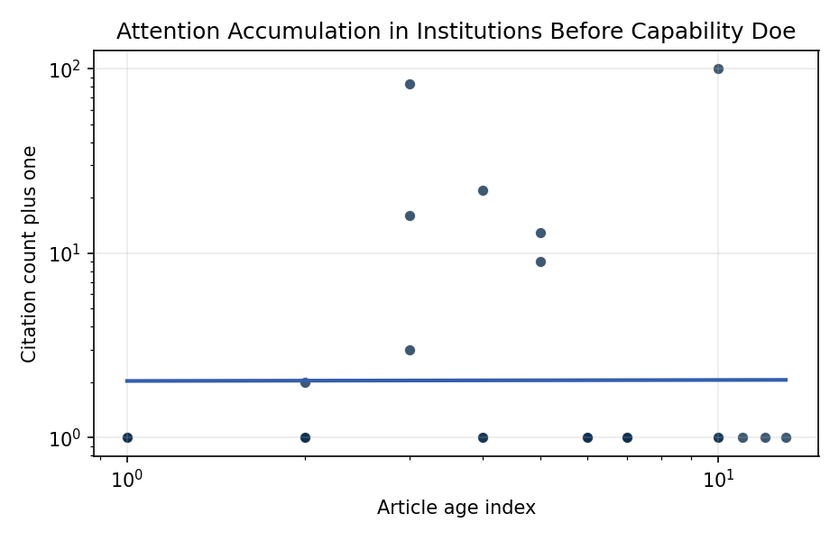
Figure 1. Citation accumulation against article age in the retrieved topic literature.

Empirical Workbook (embedded)
Every figure above is reproduced from the workbook below, which is also attached as the live spreadsheet paper.xlsx. Each observation carries its source.

Data (real observations)
doc_id | year_num | age_index | cites_num | cites_plus1 | signal_score | source
1 | 2021 | 6 | 0 | 1 | 1 | https://amostech.space/year/2021/establishment-of-a-space-operations-squadron-at-the-japan-air-self-defense-force-in-2020-current-status-and-future-prospects/
2 | 2015 | 12 | 0 | 1 | 1 | https://amostech.space/year/2015/early-cal-val-process-for-an-optical-tracking-system-by-korea/
3 | 2025 | 2 | 0 | 1 | 9 | 10.64861/OTAL2562
4 | 2021 | 6 | 0 | 1 | 1 | https://amostech.space/year/2021/trends-in-global-space-situational-awareness/
5 | 2014 | 13 | 0 | 1 | 3 | https://amostech.space/year/2014/faint-debris-detection-by-particle-based-track-before-detect-method/
6 | 2017 | 10 | 0 | 1 | 6 | https://amostech.space/year/2017/autonomous-space-object-catalogue-construction-and-upkeep-using-sensor-control-theory/
7 | 2023 | 4 | 0 | 1 | 6 | 10.64861/FWBL2094
8 | 2016 | 11 | 0 | 1 | 4 | https://amostech.space/year/2016/uncued-low-snr-detection-with-likelihood-from-image-multi-bernoulli-filter/
9 | 2023 | 4 | 0 | 1 | 3 | 10.64861/DDNM3393
10 | 2017 | 10 | 0 | 1 | 3 | https://amostech.space/year/2017/evaluating-options-for-civil-space-situational-awareness-ssa/
11 | 2021 | 6 | 0 | 1 | 8 | https://amostech.space/year/2021/an-investigation-into-potential-collision-maneuver-guidelines-for-future-space-traffic-management/
12 | 2025 | 2 | 0 | 1 | 10 | 10.64861/KSPN2451
13 | 2025 | 2 | 0 | 1 | 3 | 10.1016/j.actaastro.2025.01.061
14 | 2024 | 3 | 15 | 16 | 3 | 10.1016/j.actaastro.2024.05.026
15 | 2025 | 2 | 1 | 2 | 7 | 10.1016/j.actaastro.2025.08.055
16 | 2023 | 4 | 21 | 22 | 9 | 10.1016/j.actaastro.2023.01.016
17 | 2022 | 5 | 12 | 13 | 1 | 10.1016/j.actaastro.2022.03.035
18 | 2026 | 1 | 0 | 1 | 3 | 10.1016/j.actaastro.2026.04.046
19 | 2024 | 3 | 2 | 3 | 1 | 10.1016/j.actaastro.2024.12.037
20 | 2026 | 1 | 0 | 1 | 5 | 10.1016/j.actaastro.2026.05.010
21 | 2022 | 5 | 8 | 9 | 5 | 10.1016/j.actaastro.2021.12.015
22 | 2024 | 3 | 82 | 83 | 5 | 10.1016/j.actaastro.2024.04.012
23 | 2026 | 1 | 0 | 1 | 3 | 10.1016/j.actaastro.2026.02.023
24 | 2017 | 10 | 99 | 100 | 3 | 10.1016/j.actaastro.2017.04.034
25 | 2020 | 7 | 0 | 1 | 1 | Roadmap: Australia Economic-Technological Renaissance in Space
26 | 2020 | 7 | 0 | 1 | 2 | Economic Statecraft Literature Review
27 | 2020 | 7 | 0 | 1 | 6 | MITRE white paper arguing that Australia’s geolocational Delta-V advantage, automated mining expertise, and university smallsat capacity can underpin a commercial space economy analogous to Japan’s and Germany’s post-WWII economic miracles, provided the country prioritizes LTS Guidelines, orbital debris governance, and Artemis Accords leadership over defense-budget reliance.
28 | 2020 | 7 | 0 | 1 | 1 | Stilwell et al ASCEND 2025 Orbital Classification
29 | 2020 | 7 | 0 | 1 | 1 | Architectural Socio-Technological Transformative Change of Space-Use Norms
30 | 2020 | 7 | 0 | 1 | 1 | OCEA Forecasting the Space Economy

Variable construction
Variable | Definition | Construction / source
cites_plus1 | Citation count plus one | Computed as the reported citation count from the local brain index plus one so the log transformation is defined for uncited records
age_index | Document age index | Computed as 2026 minus publication year plus one

Estimator output
Term | Coef. | Std. err. | t | p | 95% CI
const | 0.7069 | 0.4613 | 1.5324 | 0.1254 | [-0.1972, 1.6111]
_ln_x | 0.0052 | 0.2869 | 0.0182 | 0.9855 | [-0.5571, 0.5675]
Fit: N = 30 R2 = 7.896e-06 elasticity_b = 0.0052 progress_ratio_2^b = 1.0036

