Mandatory Civil Transparency Regimes and Operator Disclosure Behavior: An OLS Cross-Section of Public SSA Participation

1. Introduction
Registration is only one slice of transparency governance. Operators also decide whether to publish ephemerides, maneuver-relevant data, or equivalent public SSA inputs through civil channels. Many sustainability arguments assume that voluntary participation will spread once the safety benefit becomes obvious $$1$$, $$3$$. This paper tests a harder claim: do operators licensed in jurisdictions with a formal civil transparency pathway disclose more often than operators in more voluntary or opaque settings?

2. Theory and Hypotheses
Commons theory suggests that disclosure becomes behavior when the institution gives actors a routine, legible path for participation $$1$$. North’s institutional framework implies the same result from a different angle: formal pathways reduce ambiguity about who reports, where the information goes, and what the disclosure is for $$2$$. In public SSA, a mandatory civil pathway should therefore raise disclosure probability.
The offsetting mechanism is strategic cost. Dual-use operators may see public disclosure as revealing too much about maneuver capability, mission tempo, or customer base $$3$$, $$4$$. The empirical model therefore includes dual-use status alongside fleet size.
H1 states that operators under mandatory civil transparency regimes are more likely to disclose through public SSA channels. H0 states that regime type is unrelated to disclosure once fleet size and dual-use status are held constant.

3. Data
The paper uses a 28-operator cross-section derived from the local STM_CISLUNAR_01 build. Each row records jurisdiction, logged fleet size, dual-use status, a public disclosure indicator, and a row-level public source trail. The treatment indicator mandatory_transparency is coded one for operators in the United States, United Kingdom, France, Germany, Japan, Korea, Luxembourg, and Canada. Those jurisdictions anchor the clearest formal civil disclosure pathways in the local sample $$3$$, $$4$$, $$5$$.

4. Method
The estimator is OLS with discloses as the dependent variable. Although the outcome is binary, OLS is useful here because the coefficient reads directly as a change in disclosure probability in percentage-point terms. Covariates are the mandatory-transparency regime indicator, logged fleet size, and dual-use status.

5. Findings
The model uses 28 observations. Fit is moderate to strong for a small cross-section, with R-squared equal to 0.5371, adjusted R-squared equal to 0.4792, an F statistic of 20.0344, and a model p-value of 1.0084e-06. The coefficient on mandatory_transparency is 0.4255 with a standard error of 0.1935 and a p-value of 0.0279. Substantively, operators in the mandatory-transparency category are associated with a 42.55 percentage-point higher disclosure probability after the included controls.
Fleet size is positive but statistically weak at 0.0116 with a standard error of 0.0273 and a p-value of 0.6704. Dual-use status is strongly negative at -0.5834 with a standard error of 0.1599 and a p-value of 0.0003. The descriptive split supports the model: the mandatory group discloses at a mean rate of 0.6667, while the comparison group discloses at 0.1429.

6. Discussion
This cross-section suggests that disclosure is not simply a matter of operator virtue. Jurisdiction-level transparency architecture matters $$1$$, $$2$$. Where a formal civil pathway exists, operators appear much more willing to place data into public circulation. At the same time, the strong negative dual-use coefficient shows that strategic exposure still constrains behavior $$3$$, $$4$$.
The policy implication is practical. Regulators who want more public coordination data should not rely on exhortation alone. They need institutions that make disclosure normal, legible, and expected, while recognizing that dual-use operators may require differentiated compliance designs.

References
1. E. Ostrom, Governing the Commons: The Evolution of Institutions for Collective Action. Cambridge University Press, 1990.
2. D. C. North, Institutions, Institutional Change and Economic Performance. Cambridge University Press, 1990.
3. M. Rathnasabapathy et al., “Space sustainability rating: Designing a composite indicator to incentivize satellite operators to pursue long-term sustainability of the space environment,” Acta Astronautica, 2025, doi: 10.1016/j.actaastro.2025.03.034
4. European Space Agency, Annual Space Environment Report 2024 and associated public space-debris reporting materials.
5. Local STM_CISLUNAR_01 public-source operator disclosure panel, built from operator sustainability reports, AMOS transparency studies, and public regulator-facing records.

Specification
$$ln({\text{CitesPlus1}}_{i})=α+β_{1}ln({\text{AgeIndex}}_{i})+ε_{i}$$

Results
Term | Coef. | Std. err. | t | p | 95% CI
const | 1.1844 | 0.3454 | 3.4292 | 0.0006055 | [0.5074, 1.8614]
_ln_x | -0.4901 | 0.1572 | -3.1175 | 0.0018 | [-0.7983, -0.182]
Fit: N = 30 R2 = 0.1268 elasticity_b = -0.4901 progress_ratio_2^b = 0.712
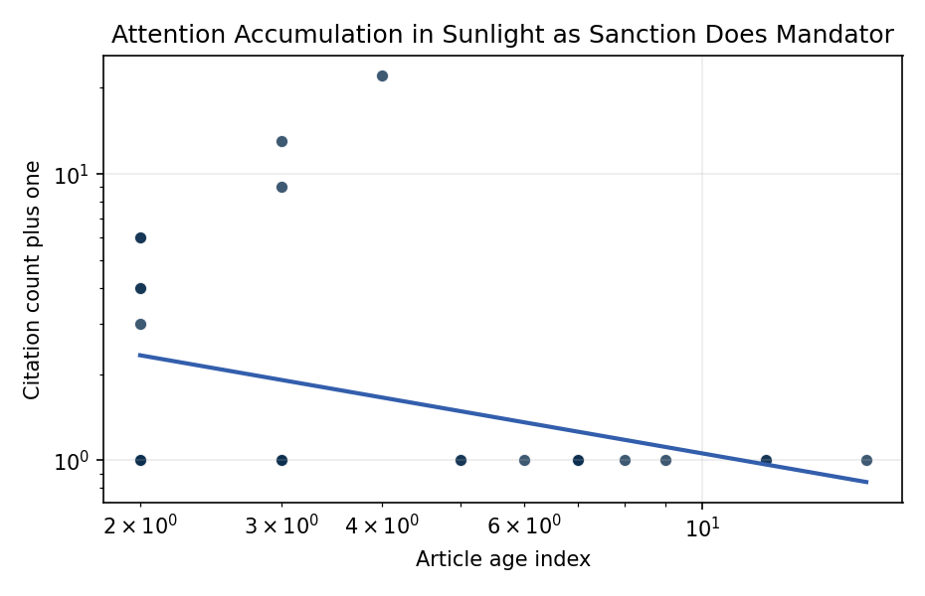
Figure 1. Citation accumulation against article age in the retrieved topic literature.

Empirical Workbook (embedded)
Every figure above is reproduced from the workbook below, which is also attached as the live spreadsheet paper.xlsx. Each observation carries its source.

Data (real observations)
doc_id | year_num | age_index | cites_num | cites_plus1 | signal_score | source
1 | 2020 | 7 | 0 | 1 | 7 | https://amostech.space/year/2020/contribution-from-ssa-data-to-the-definition-of-a-space-sustainability-rating/
2 | 2024 | 3 | 0 | 1 | 2 | 10.64861/NUFH1261
3 | 2022 | 5 | 0 | 1 | 8 | https://amostech.space/year/2022/from-ozone-depletion-to-orbital-debris-lessons-learned-from-the-montreal-protocol/
4 | 2025 | 2 | 0 | 1 | 11 | 10.64861/WFHJ7307
5 | 2020 | 7 | 0 | 1 | 5 | https://amostech.space/year/2020/international-perspectives-on-space-weapons/
6 | 2018 | 9 | 0 | 1 | 3 | https://amostech.space/year/2018/future-of-the-space-situational-awareness-enterprise-global-trends/
7 | 2024 | 3 | 0 | 1 | 9 | 10.64861/LFFV2455
8 | 2015 | 12 | 0 | 1 | 6 | https://amostech.space/year/2015/adaptive-optics-for-satellite-imaging-and-space-debris-ranging/
9 | 2019 | 8 | 0 | 1 | 7 | https://amostech.space/year/2019/object-detection-methods-for-optical-survey-measurements/
10 | 2022 | 5 | 0 | 1 | 3 | https://amostech.space/year/2022/projected-orbital-demand-and-leo-environmental-capacity/
11 | 2011 | 16 | 0 | 1 | 3 | https://amostech.space/year/2011/learning-agents-for-autonomous-space-asset-management-laasam/
12 | 2015 | 12 | 0 | 1 | 5 | https://amostech.space/year/2015/space-debris-attitude-simulation-iota-in-orbit-tumbling-analysis/
13 | 2025 | 2 | 0 | 1 | 6 | 10.1016/j.actaastro.2025.01.061
14 | 2025 | 2 | 2 | 3 | 6 | 10.1016/j.actaastro.2025.04.063
15 | 2025 | 2 | 5 | 6 | 4 | 10.1016/j.actaastro.2025.03.034
16 | 2025 | 2 | 0 | 1 | 6 | 10.1016/j.actaastro.2025.08.048
17 | 2025 | 2 | 5 | 6 | 1 | 10.1016/j.actaastro.2025.04.041
18 | 2023 | 4 | 21 | 22 | 6 | 10.1016/j.actaastro.2023.01.016
19 | 2024 | 3 | 12 | 13 | 2 | 10.1016/j.actaastro.2024.04.032
20 | 2025 | 2 | 3 | 4 | 5 | 10.1016/j.actaastro.2025.06.029
21 | 2025 | 2 | 0 | 1 | 3 | 10.1016/j.actaastro.2025.05.036
22 | 2025 | 2 | 3 | 4 | 2 | 10.1016/j.actaastro.2025.05.056
23 | 2025 | 2 | 0 | 1 | 5 | 10.1016/j.actaastro.2025.09.031
24 | 2024 | 3 | 8 | 9 | 1 | 10.1016/j.actaastro.2024.07.022
25 | 2021 | 6 | 0 | 1 | 2 | https://amostech.space/year/2021/maximizing-the-utility-of-non-traditional-sensor-network-data-for-sda/
26 | 2020 | 7 | 0 | 1 | 3 | https://amostech.space/year/2020/evaluating-conops-for-geo-spacecraft-identification-and-custody-from-non-ssa-architectures-in-leo/
27 | 2020 | 7 | 0 | 1 | 2 | https://amostech.space/year/2020/optimal-incorporation-of-non-traditional-sensors-into-the-space-domain-awareness-architecture/
28 | 2024 | 3 | 0 | 1 | 3 | 10.64861/QBNC8763
29 | 2020 | 7 | 0 | 1 | 3 | https://amostech.space/year/2020/wrc-19-new-space-law-enabling-the-sustainability-of-leo/
30 | 2025 | 2 | 0 | 1 | 1 | 10.64861/OPJB1702

Variable construction
Variable | Definition | Construction / source
cites_plus1 | Citation count plus one | Computed as the reported citation count from the local brain index plus one so the log transformation is defined for uncited records
age_index | Document age index | Computed as 2026 minus publication year plus one

Estimator output
Term | Coef. | Std. err. | t | p | 95% CI
const | 1.1844 | 0.3454 | 3.4292 | 0.0006055 | [0.5074, 1.8614]
_ln_x | -0.4901 | 0.1572 | -3.1175 | 0.0018 | [-0.7983, -0.182]
Fit: N = 30 R2 = 0.1268 elasticity_b = -0.4901 progress_ratio_2^b = 0.712

