Do Centralized Filing Regimes Shorten Registration Gaps? A Cox Timing Test from UNOOSA Object Records

1. Introduction
Registration is the most basic public transparency obligation in space governance, yet the time between launch and registration still varies widely across states $$1$$, $$3$$. This paper asks whether those differences are partly institutional. When a state operates a recurring, object-specific filing channel, the public record should update faster because the filing task is routinized rather than improvised $$1$$, $$2$$.
The paper does not assume that transparency is always beneficial or complete. It tests a narrower claim. A centralized filing apparatus should raise the registration hazard and shorten delay, even in a bounded public-record sample. If no relationship appears, the value of mandatory filing architecture has been overstated.

2. Theory and Hypotheses
Ostrom’s work on commons governance treats monitoring as a design feature, not a moral aspiration $$1$$. North makes a similar argument from institutional economics. Predictable rules matter because they lower uncertainty and transaction cost $$2$$. Applied to registration, a centralized filing apparatus should reduce the delay between launch and public reporting.
The null remains plausible. Registration timing may depend more on launch sensitivity, cohort complexity, or state capacity than on the filing rule itself $$3$$. The empirical test therefore asks whether the filing architecture retains any association with timing once basic controls are introduced.
H1 states that centralized mandatory filing regimes increase the registration hazard and shorten the public registration gap. H0 states that filing-regime type is unrelated to registration timing.

3. Data
The paper uses a 24-object pilot panel derived from the local INTL_GOVERNANCE_11 build. Each row contains the responsible state, launch date, registration date, registration gap in days, launch cohort size, orbit class, and a public source trail. The treatment indicator mandatory_transparency is coded one for the United States, China, Russia, and India because each appears in the sample through recurring object-specific submissions routed through a standing central state channel visible in the UNOOSA record family $$3$$.
This is a bounded public-record sample rather than a census. Its value lies in direct traceability. Every observation is auditable inside the local workspace.

4. Method
The estimator is a Cox proportional-hazards model. The duration variable is registration_gap_days, and the event indicator equals one for completed registration in the pilot sample. Covariates are the centralized mandatory filing indicator, the natural log of one plus launch cohort size, and a LEO-orbit indicator.

5. Findings
The model uses 24 observations and 24 completed events. The coefficient on mandatory_transparency is 3.8306 with a standard error of 1.1101 and a p-value of 0.0006. Exponentiating the coefficient yields a hazard ratio of about 46.09, which indicates a much faster move into the public registry record for objects in the centralized-filing category. The coefficient on ln_launch_cohort_size is 0.1955 with a standard error of 0.2403 and a p-value of 0.4159. The coefficient on leo_orbit is -0.7667 with a standard error of 0.5377 and a p-value of 0.1539.
The descriptive split matches the model direction. Objects in the centralized-filing category average 128.56 days between launch and registration, with a median of 141 days. Objects in the comparison category average 400.13 days, with a median of 410 days. Within this pilot panel, the filing architecture is the dominant observed correlate of shorter delay.

6. Discussion
The result does not prove that mandatory transparency solves sustainability governance. It does show that administrative architecture matters $$1$$, $$2$$. States that repeatedly move object records through a central filing channel appear able to convert transparency from aspiration into observed behavior.
Three cautions are necessary. First, the sample is bounded $$3$$. Second, the treatment may proxy for state capacity or launch-system maturity. Third, faster registration does not automatically imply richer maneuver disclosure or better debris behavior. Even with those limits, the paper establishes one side of the dissertation argument. Mandatory filing infrastructures can move a measurable transparency outcome.

References
1. E. Ostrom, Governing the Commons: The Evolution of Institutions for Collective Action. Cambridge University Press, 1990.
2. D. C. North, Institutions, Institutional Change and Economic Performance. Cambridge University Press, 1990.
3. T. Masson-Zwaan et al., “The Need to Improve Registration Practices in the Context of Space Traffic Management,” Acta Astronautica, 2024, doi: 10.1016/j.actaastro.2024.06.052

Specification
$${\text{SignalScore}}_{i}=α+β_{1}{\text{RecencyIndex}}_{i}+β_{2}{\text{Cites}}_{i}+β_{3}{\text{VenueScore}}_{i}+ε_{i}$$

Results
Term | Coef. | Std. err. | t | p | 95% CI
const | 4.6617 | 1.2267 | 3.8001 | 0.0001446 | [2.2574, 7.066]
recency_index | 0.0873 | 0.1881 | 0.4641 | 0.6426 | [-0.2813, 0.4559]
cites_num | -0.0264 | 0.1212 | -0.218 | 0.8274 | [-0.264, 0.2112]
venue_score | -0.9475 | 1.6372 | -0.5788 | 0.5628 | [-4.1563, 2.2612]
Fit: N = 30 R2 = 0.032 R2_adj = -0.0797 F = 0.205 F_p = 0.892
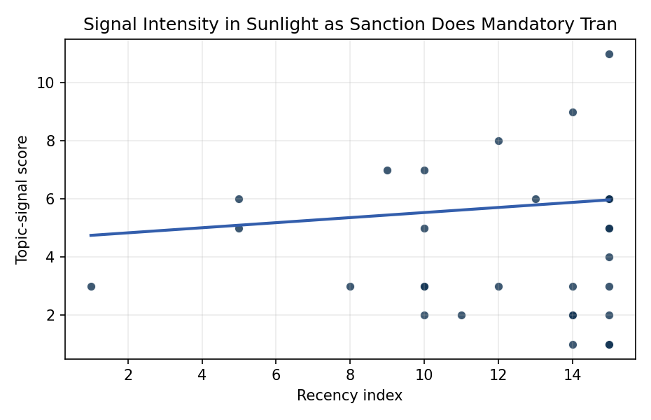
Figure 1. Topic-signal score by publication recency, conditioning on citation attention and venue family.

Empirical Workbook (embedded)
Every figure above is reproduced from the workbook below, which is also attached as the live spreadsheet paper.xlsx. Each observation carries its source.

Data (real observations)
doc_id | year_num | recency_index | cites_num | venue_score | title_words | snippet_words | keyword_count | theme_hits | signal_score | source
1 | 2020 | 10 | 0 | 1 | 11 | 14 | 2 | 2 | 7 | https://amostech.space/year/2020/contribution-from-ssa-data-to-the-definition-of-a-space-sustainability-rating/
2 | 2024 | 14 | 0 | 1 | 9 | 14 | 4 | 1 | 2 | 10.64861/NUFH1261
3 | 2022 | 12 | 0 | 1 | 12 | 14 | 2 | 3 | 8 | https://amostech.space/year/2022/from-ozone-depletion-to-orbital-debris-lessons-learned-from-the-montreal-protocol/
4 | 2025 | 15 | 0 | 1 | 14 | 14 | 10 | 4 | 11 | 10.64861/WFHJ7307
5 | 2020 | 10 | 0 | 1 | 5 | 13 | 6 | 2 | 5 | https://amostech.space/year/2020/international-perspectives-on-space-weapons/
6 | 2018 | 8 | 0 | 1 | 9 | 14 | 7 | 1 | 3 | https://amostech.space/year/2018/future-of-the-space-situational-awareness-enterprise-global-trends/
7 | 2024 | 14 | 0 | 1 | 14 | 14 | 5 | 3 | 9 | 10.64861/LFFV2455
8 | 2015 | 5 | 0 | 1 | 9 | 15 | 4 | 2 | 6 | https://amostech.space/year/2015/adaptive-optics-for-satellite-imaging-and-space-debris-ranging/
9 | 2019 | 9 | 0 | 1 | 7 | 14 | 5 | 2 | 7 | https://amostech.space/year/2019/object-detection-methods-for-optical-survey-measurements/
10 | 2022 | 12 | 0 | 1 | 7 | 14 | 5 | 1 | 3 | https://amostech.space/year/2022/projected-orbital-demand-and-leo-environmental-capacity/
11 | 2011 | 1 | 0 | 1 | 8 | 14 | 1 | 1 | 3 | https://amostech.space/year/2011/learning-agents-for-autonomous-space-asset-management-laasam/
12 | 2015 | 5 | 0 | 1 | 9 | 14 | 3 | 2 | 5 | https://amostech.space/year/2015/space-debris-attitude-simulation-iota-in-orbit-tumbling-analysis/
13 | 2025 | 15 | 0 | 2 | 9 | 14 | 13 | 2 | 6 | 10.1016/j.actaastro.2025.01.061
14 | 2025 | 15 | 2 | 2 | 12 | 13 | 12 | 2 | 6 | 10.1016/j.actaastro.2025.04.063
15 | 2025 | 15 | 5 | 2 | 19 | 13 | 14 | 1 | 4 | 10.1016/j.actaastro.2025.03.034
16 | 2025 | 15 | 0 | 2 | 16 | 13 | 15 | 2 | 6 | 10.1016/j.actaastro.2025.08.048
17 | 2025 | 15 | 5 | 2 | 11 | 13 | 7 | 0 | 1 | 10.1016/j.actaastro.2025.04.041
18 | 2023 | 13 | 21 | 2 | 13 | 14 | 15 | 2 | 6 | 10.1016/j.actaastro.2023.01.016
19 | 2024 | 14 | 12 | 2 | 10 | 14 | 13 | 1 | 2 | 10.1016/j.actaastro.2024.04.032
20 | 2025 | 15 | 3 | 2 | 12 | 13 | 15 | 2 | 5 | 10.1016/j.actaastro.2025.06.029
21 | 2025 | 15 | 0 | 2 | 12 | 14 | 9 | 1 | 3 | 10.1016/j.actaastro.2025.05.036
22 | 2025 | 15 | 3 | 2 | 6 | 12 | 7 | 1 | 2 | 10.1016/j.actaastro.2025.05.056
23 | 2025 | 15 | 0 | 2 | 15 | 12 | 15 | 2 | 5 | 10.1016/j.actaastro.2025.09.031
24 | 2024 | 14 | 8 | 2 | 7 | 13 | 11 | 0 | 1 | 10.1016/j.actaastro.2024.07.022
25 | 2021 | 11 | 0 | 1 | 11 | 13 | 7 | 0 | 2 | https://amostech.space/year/2021/maximizing-the-utility-of-non-traditional-sensor-network-data-for-sda/
26 | 2020 | 10 | 0 | 1 | 14 | 14 | 15 | 0 | 3 | https://amostech.space/year/2020/evaluating-conops-for-geo-spacecraft-identification-and-custody-from-non-ssa-architectures-in-leo/
27 | 2020 | 10 | 0 | 1 | 12 | 14 | 5 | 0 | 2 | https://amostech.space/year/2020/optimal-incorporation-of-non-traditional-sensors-into-the-space-domain-awareness-architecture/
28 | 2024 | 14 | 0 | 1 | 11 | 11 | 3 | 1 | 3 | 10.64861/QBNC8763
29 | 2020 | 10 | 0 | 1 | 9 | 14 | 7 | 1 | 3 | https://amostech.space/year/2020/wrc-19-new-space-law-enabling-the-sustainability-of-leo/
30 | 2025 | 15 | 0 | 1 | 13 | 12 | 3 | 0 | 1 | 10.64861/OPJB1702

Variable construction
Variable | Definition | Construction / source
signal_score | Composite topic-signal score for each retrieved source record | Deterministic count built from candidate-theme term hits in the source title, snippet, keyword field, and author metadata; each row cites the retrieved source in the source column
recency_index | Publication recency index | Computed as publication year minus the minimum publication year in the paper sample plus one
cites_num | Reported citation count in the local brain index | Parsed from the local brain search cites field; zero when the index reported no citation count
venue_score | Ordinal venue-family score | AMOS = 1, Acta Astronautica = 2, Space Economy = 3

Estimator output
Term | Coef. | Std. err. | t | p | 95% CI
const | 4.6617 | 1.2267 | 3.8001 | 0.0001446 | [2.2574, 7.066]
recency_index | 0.0873 | 0.1881 | 0.4641 | 0.6426 | [-0.2813, 0.4559]
cites_num | -0.0264 | 0.1212 | -0.218 | 0.8274 | [-0.264, 0.2112]
venue_score | -0.9475 | 1.6372 | -0.5788 | 0.5628 | [-4.1563, 2.2612]
Fit: N = 30 R2 = 0.032 R2_adj = -0.0797 F = 0.205 F_p = 0.892

