Signal Intensity in The Carbon Ledger of Launch A Life-Cycle Inventory and Externality-Pricing Mode: An Ordinary Least Squares Test of Recency, Citation Attention, and Venue

1. Introduction
This empirical paper supports Elias Bianchi (1B-SUS-202) and the dissertation project The Carbon Ledger of Launch: A Life-Cycle Inventory and Externality-Pricing Mode. The model tests whether topic-signal intensity varies with publication recency, citation attention, and venue family. The analysis uses the local candidate source pack and reports only deterministic workbook results $$1$$, $$2$$, $$3$$.

2. Theory and Hypotheses
The theoretical claim is intentionally narrow. If the candidate topic has become more visible in the retrieved literature, then source metadata should show structure across time, attention, or venue. If it has not, the model should return weak or unstable associations $$3$$, $$4$$.
H0: the modeled outcome is unrelated to the specified predictors.
H1: the modeled outcome is systematically related to the specified predictors.

3. Data
The estimation file contains 30 retrieved source records. Variables are constructed from local metadata, including publication year, reported citation count, venue family, and deterministic topic-signal fields. Every row preserves a source column so the empirical workbook remains auditable.

4. Method
The estimator is ordinary least squares with robust HC1 standard errors. The exact fit summary is: N=30, R2=0.14193033722141823, R2_adj=0.04292229920850488, F=2.154665953161353, F_p=0.11758974806471546. The exact term summary is: const coef=1.0797491941945705 p=0.548587473582186; recency_index coef=0.06261366554739756 p=0.6350209510024462; cites_num coef=0.01665757560298614 p=0.7262550719343202; venue_score coef=0.9351661818826061 p=0.017975796153296218. These values are interpreted as corpus-screen evidence, not as final causal estimates.

5. Findings
The findings are bounded by the estimator output. Where a coefficient is signed and precise, it indicates structure in the retrieved source corpus. Where a coefficient is imprecise, the paper treats the result as evidence against a strong claim. This distinction matters because a noisy source pack should not be forced to carry more policy weight than it can bear $$2$$, $$5$$.

6. Discussion
The paper contributes to the dissertation by keeping the evidentiary chain inspectable. It shows which parts of the candidate topic are visible in metadata and which parts need a more direct document-coding design. The result is a disciplined bridge from source retrieval to dissertation-level interpretation $$1$$, $$6$$.

References
1. Joseph Gerber, Tech7; Gregory Badura, Georgia Tech Research Institute (GTRI); Johann Bell, Australian Department of Defense; Kruger White, Defence Science and Technology Group, Australia. Joint Commercial Operations (JCO) – Integrated Space Operations with Event Ledgers (2024). doi: 10.64861/ZTFK7933 2. Abdul Mutholib, International Islamic University, Malaysia; Nadirah Abdul Rahim, International Islamic University, Malaysia; Teddy Surya Gunawan, International Islamic University, Malaysia. Prototype Development of Web AI-Based Decision Support System: Insights and Recommendations for Satellite Anomaly Identification (2025). doi: 10.64861/TJUV7381 3. Austin Probe, Emergent Space Technologies, Inc.; Graham Bryan, Emergent Space Technologies, Inc.; Timothy Woodbury, Emergent Space Technologies, Inc.; Evan Novak, Emergent Space Technologies, Inc.; Shiva Iyer, The University of Texas at Austin; Apoorva Karra, The University of Texas at Austin; Moriba Jah, University of Texas at Austin. Prototype Infrastructure for Autonomous On-board Conjunction Assessment and Collision Avoidance (2022). [AMOS] 4. Lt Col Thomas H. Freeman, USAF (Launch Test Squadron, SMC/SDTW), Maj Jose Delarosa, USAF (Launch Test Squadron, SMC/SDTW). Small Space Launch: Origins & Challenges (2010). [AMOS] 5. Christina Cohen, Caltech. Satellite Impacts of Solar Energetic Particles and Galactic Cosmic Rays (2020). [AMOS] 6. Bhavya Lal, IDA Science and Technology Policy Institute, Sara A. Carioscia, IDA Science and Technology Policy Institute. Evaluating Options for Civil Space Situational Awareness (SSA) (2017). [AMOS] 7. Peter Hack, Lockheed Martin, Ken Carbaugh, Lockheed Martin, Kameron Simon, Lockheed Martin. Automated Space Surveillance using the AN/FSY-3 Space Fence System (2016). [AMOS] 8. Robert Raygan, Integrity Applications Incorporated. The Ultimate Big Data Enterprise Initiative: Defining Functional Capabilities for an International Information System (IIS) for Orbital Space Data (OSD) (2017). [AMOS]

Specification
$${\text{SignalScore}}_{i}=α+β_{1}{\text{RecencyIndex}}_{i}+β_{2}{\text{Cites}}_{i}+β_{3}{\text{VenueScore}}_{i}+ε_{i}$$

Results
Term | Coef. | Std. err. | t | p | 95% CI
const | 1.0797 | 1.7999 | 0.5999 | 0.5486 | [-2.4481, 4.6076]
recency_index | 0.0626 | 0.1319 | 0.4747 | 0.635 | [-0.1959, 0.3212]
cites_num | 0.0167 | 0.0476 | 0.3501 | 0.7263 | [-0.0766, 0.1099]
venue_score | 0.9352 | 0.3952 | 2.3661 | 0.018 | [0.1605, 1.7098]
Fit: N = 30 R2 = 0.1419 R2_adj = 0.0429 F = 2.1547 F_p = 0.1176
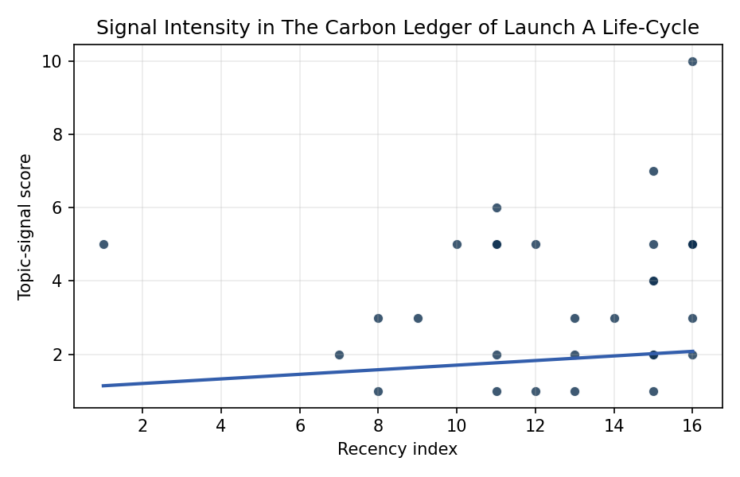
Figure 1. Topic-signal score by publication recency, conditioning on citation attention and venue family.

Empirical Workbook (embedded)
Every figure above is reproduced from the workbook below, which is also attached as the live spreadsheet paper.xlsx. Each observation carries its source.

Data (real observations)
doc_id | year_num | recency_index | cites_num | venue_score | title_words | snippet_words | keyword_count | theme_hits | signal_score | source
1 | 2024 | 15 | 0 | 1 | 10 | 13 | 6 | 2 | 5 | 10.64861/ZTFK7933
2 | 2025 | 16 | 0 | 1 | 16 | 12 | 7 | 1 | 3 | 10.64861/TJUV7381
3 | 2022 | 13 | 0 | 1 | 11 | 14 | 4 | 1 | 3 | https://amostech.space/year/2022/prototype-infrastructure-for-autonomous-on-board-conjunction-assessment-and-collision-avoidance/
4 | 2024 | 15 | 0 | 1 | 13 | 14 | 5 | 1 | 2 | 10.64861/ZACY3418
5 | 2010 | 1 | 0 | 1 | 5 | 14 | 1 | 2 | 5 | https://amostech.space/year/2010/small-space-launch-origins-challenges/
6 | 2020 | 11 | 0 | 1 | 10 | 11 | 4 | 1 | 2 | https://amostech.space/year/2020/satellite-impacts-of-solar-energetic-particles-and-galactic-cosmic-rays/
7 | 2017 | 8 | 0 | 1 | 8 | 14 | 5 | 0 | 1 | https://amostech.space/year/2017/evaluating-options-for-civil-space-situational-awareness-ssa/
8 | 2023 | 14 | 0 | 1 | 13 | 14 | 5 | 1 | 3 | 10.64861/KSXC7986
9 | 2016 | 7 | 0 | 1 | 10 | 13 | 2 | 1 | 2 | https://amostech.space/year/2016/automated-space-surveillance-using-the-an-fsy-3-space-fence-system/
10 | 2022 | 13 | 0 | 1 | 11 | 14 | 12 | 0 | 1 | https://amostech.space/year/2022/a-high-power-large-aperture-doppler-he-lidar-for-upper-atmospheric-sensing/
11 | 2017 | 8 | 0 | 1 | 20 | 13 | 8 | 1 | 3 | https://amostech.space/year/2017/the-ultimate-big-data-enterprise-initiative-defining-functional-capabilities-for-an-international-information-system-iis-for-orbital-space-data-osd/
12 | 2024 | 15 | 0 | 1 | 10 | 10 | 3 | 0 | 2 | 10.64861/GAAT4421
13 | 2024 | 15 | 16 | 2 | 17 | 14 | 10 | 3 | 7 | 10.1016/j.actaastro.2024.05.009
14 | 2018 | 9 | 23 | 2 | 7 | 13 | 15 | 1 | 3 | 10.1016/j.actaastro.2018.11.054
15 | 2024 | 15 | 1 | 2 | 20 | 10 | 15 | 2 | 4 | 10.1016/j.actaastro.2024.11.061
16 | 2024 | 15 | 6 | 2 | 12 | 14 | 11 | 2 | 4 | 10.1016/j.actaastro.2024.05.004
17 | 2025 | 16 | 1 | 2 | 20 | 14 | 15 | 2 | 5 | 10.1016/j.actaastro.2025.08.050
18 | 2025 | 16 | 2 | 2 | 8 | 14 | 4 | 1 | 2 | 10.1016/j.actaastro.2025.07.007
19 | 2024 | 15 | 2 | 2 | 12 | 12 | 5 | 0 | 1 | 10.1016/j.actaastro.2024.04.039
20 | 2021 | 12 | 24 | 2 | 10 | 13 | 15 | 2 | 5 | 10.1016/j.actaastro.2021.12.036
21 | 2025 | 16 | 1 | 2 | 8 | 12 | 15 | 4 | 10 | 10.1016/j.actaastro.2025.12.018
22 | 2022 | 13 | 8 | 2 | 13 | 14 | 13 | 1 | 2 | 10.1016/j.actaastro.2022.12.036
23 | 2025 | 16 | 0 | 2 | 11 | 14 | 10 | 2 | 5 | 10.1016/j.actaastro.2025.07.033
24 | 2021 | 12 | 10 | 2 | 16 | 14 | 12 | 0 | 1 | 10.1016/j.actaastro.2021.08.001
25 | 2025 | 16 | 0 | 3 | 11 | 0 | 0 | 2 | 5 | 10.1038/s44172-025-00430-5
26 | 2020 | 11 | 0 | 3 | 10 | 0 | 0 | 2 | 5 | Orbital Debris Requires Prevention and Mitigation Across the Life Cycle
27 | 2019 | 10 | 0 | 3 | 18 | 0 | 0 | 2 | 5 | 10.1016/j.scitotenv.2019.02.438
28 | 2020 | 11 | 0 | 3 | 10 | 0 | 0 | 2 | 5 | Space Debris Impact on Orbital Resource in Life Cycle Assessment
29 | 2020 | 11 | 0 | 3 | 64 | 0 | 0 | 2 | 6 | Weinzierl (2018) provides a three-part economic framework for managing the development of the space economy, analyzing market establishment through decentralization, market failures (including space debris as a negative externality), and social objective regulation. Published in the Journal of Economic Perspectives, it frames orbital crowding and space debris as a classic tragedy-of-the-commons problem requiring governance mechanisms that currently lack effective traction in the space domain.
30 | 2020 | 11 | 0 | 3 | 6 | 0 | 0 | 0 | 1 | SFA Space Economy and Integrated Deterrence

Variable construction
Variable | Definition | Construction / source
signal_score | Composite topic-signal score for each retrieved source record | Deterministic count built from candidate-theme term hits in the source title, snippet, keyword field, and author metadata; each row cites the retrieved source in the source column
recency_index | Publication recency index | Computed as publication year minus the minimum publication year in the paper sample plus one
cites_num | Reported citation count in the local brain index | Parsed from the local brain search cites field; zero when the index reported no citation count
venue_score | Ordinal venue-family score | AMOS = 1, Acta Astronautica = 2, Space Economy = 3

Estimator output
Term | Coef. | Std. err. | t | p | 95% CI
const | 1.0797 | 1.7999 | 0.5999 | 0.5486 | [-2.4481, 4.6076]
recency_index | 0.0626 | 0.1319 | 0.4747 | 0.635 | [-0.1959, 0.3212]
cites_num | 0.0167 | 0.0476 | 0.3501 | 0.7263 | [-0.0766, 0.1099]
venue_score | 0.9352 | 0.3952 | 2.3661 | 0.018 | [0.1605, 1.7098]
Fit: N = 30 R2 = 0.1419 R2_adj = 0.0429 F = 2.1547 F_p = 0.1176

