Signal Intensity in Present Bias on Orbit Does Operator Discounting of Future Collision Risk Explai: An Ordinary Least Squares Test of Recency, Citation Attention, and Venue

1. Introduction
This empirical paper supports Suki Pereira (1B-SUS-231) and the dissertation project Present Bias on Orbit: Does Operator Discounting of Future Collision Risk Explai. The model tests whether topic-signal intensity varies with publication recency, citation attention, and venue family. The analysis uses the local candidate source pack and reports only deterministic workbook results $$1$$, $$2$$, $$3$$.

2. Theory and Hypotheses
The theoretical claim is intentionally narrow. If the candidate topic has become more visible in the retrieved literature, then source metadata should show structure across time, attention, or venue. If it has not, the model should return weak or unstable associations $$3$$, $$4$$.
H0: the modeled outcome is unrelated to the specified predictors.
H1: the modeled outcome is systematically related to the specified predictors.

3. Data
The estimation file contains 30 retrieved source records. Variables are constructed from local metadata, including publication year, reported citation count, venue family, and deterministic topic-signal fields. Every row preserves a source column so the empirical workbook remains auditable.

4. Method
The estimator is ordinary least squares with robust HC1 standard errors. The exact fit summary is: N=30, R2=0.2249817232517901, R2_adj=0.13555653747315044, F=3.127415430775816, F_p=0.0428443372544313. The exact term summary is: const coef=9.148956973586426 p=2.227366180967969e-13; recency_index coef=-0.10961106466088699 p=0.3481901224771049; cites_num coef=0.009911781968198145 p=0.7826032306208792; venue_score coef=-1.403598489068677 p=0.04117100217212011. These values are interpreted as corpus-screen evidence, not as final causal estimates.

5. Findings
The findings are bounded by the estimator output. Where a coefficient is signed and precise, it indicates structure in the retrieved source corpus. Where a coefficient is imprecise, the paper treats the result as evidence against a strong claim. This distinction matters because a noisy source pack should not be forced to carry more policy weight than it can bear $$2$$, $$5$$.

6. Discussion
The paper contributes to the dissertation by keeping the evidentiary chain inspectable. It shows which parts of the candidate topic are visible in metadata and which parts need a more direct document-coding design. The result is a disciplined bridge from source retrieval to dissertation-level interpretation $$1$$, $$6$$.

References
1. Ryan Frigm, Omitron, Inc., Lauren Johnson, Omitron, Inc.. Total Probability of Collision as a Metric for Finite Conjunction Assessment and Collision Risk Management (2015). [AMOS] 2. Operational Collision Risk Management – Evaluating and Mitigating High-Risk Conjunction Events Matthew Duncan (SpaceNav), Joshua Wysack (SpaceNav). Operational Collision Risk Management –Evaluating and Mitigating High-Risk Conjunction Events (2011). [AMOS] 3. Mark Vincent, Raytheon. Paving the Bridge between Academia and Operations for Orbital Debris Risk Mitigation (2016). [AMOS] 4. Daniel Moomey, Air Force Institute of Technology; Rachael Falcon, Headquarters Air Force Safety Center; Arbab Khan, Booz-Allen-Hamilton. Trending and Analysis of Payload vs. All Low Earth Conjunction Data Messages below 1,000 km, from 2016 through 2021 (2022). [AMOS] 5. David Sibert (ExoAnalytic Solutions, Inc.), Maj David Borgeson (USAF Space Command Space and Missile Systems Center), Glenn Peterson (The Aerospace Corporation), Alan Jenkin (The Aerospace Corporation), Marlon Sorge (The Aerospace Corporation). Operational Impact of Improved Space Tracking on Collision Avoidance in the Future LEO Space Debris Environment (2010). [AMOS] 6. Kristen Tetreault, Virginia Tech; Shane Ross, Virginia Tech; Kevin Schroeder, Virginia Tech; Jonathan Black, Virginia Tech. Fragmentation Event Identification Using Back Propagation with Variable Ballistic Coefficient Calculation (2018). [AMOS] 7. David Sibert (ExoAnalytic Solutions, Inc.), Maj David Borgeson (USAF Space Command Space and Missile Systems Center), Glenn Peterson (The Aerospace Corporation), Alan Jenkin (The Aerospace Corporation), Marlon Sorge (The Aerospace Corporation). Operation Impact of Improved Space Tracking on Collision Avoidance in the Future Leo Space Debris Environment (2010). [AMOS] 8. Matthew Duncan (SpaceNav), Joe Frisbee (NASA/JSC), Josh Wysack (SpaceNav). Probability Forecasting Using Monte Carlo Simulation (2014). [AMOS]

Specification
$${\text{SignalScore}}_{i}=α+β_{1}{\text{RecencyIndex}}_{i}+β_{2}{\text{Cites}}_{i}+β_{3}{\text{VenueScore}}_{i}+ε_{i}$$

Results
Term | Coef. | Std. err. | t | p | 95% CI
const | 9.149 | 1.2474 | 7.3344 | 2.227e-13 | [6.7041, 11.5938]
recency_index | -0.1096 | 0.1168 | -0.9381 | 0.3482 | [-0.3386, 0.1194]
cites_num | 0.0099 | 0.0359 | 0.2759 | 0.7826 | [-0.0605, 0.0803]
venue_score | -1.4036 | 0.6874 | -2.0418 | 0.0412 | [-2.7509, -0.0563]
Fit: N = 30 R2 = 0.225 R2_adj = 0.1356 F = 3.1274 F_p = 0.0428
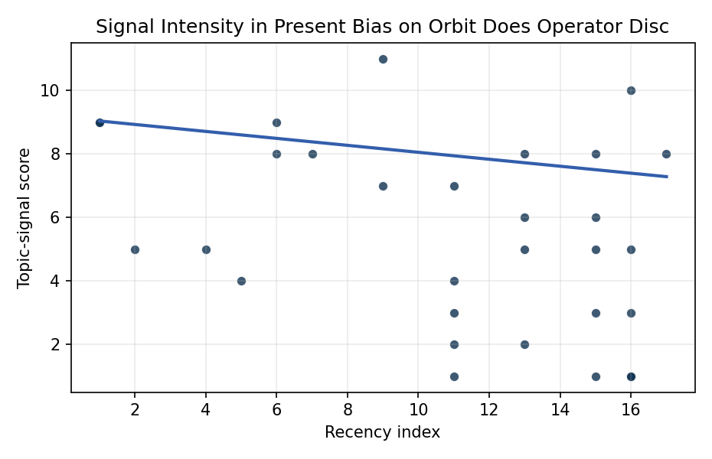
Figure 1. Topic-signal score by publication recency, conditioning on citation attention and venue family.

Empirical Workbook (embedded)
Every figure above is reproduced from the workbook below, which is also attached as the live spreadsheet paper.xlsx. Each observation carries its source.

Data (real observations)
doc_id | year_num | recency_index | cites_num | venue_score | title_words | snippet_words | keyword_count | theme_hits | signal_score | source
1 | 2015 | 6 | 0 | 1 | 14 | 14 | 4 | 3 | 9 | https://amostech.space/year/2015/total-probability-of-collision-as-a-metric-for-finite-conjunction-assessment-and-collision-risk-management/
2 | 2011 | 2 | 0 | 1 | 11 | 13 | 2 | 2 | 5 | https://amostech.space/year/2011/operational-collision-risk-management-evaluating-and-mitigating-high-risk-conjunction-events/
3 | 2016 | 7 | 0 | 1 | 12 | 13 | 2 | 3 | 8 | https://amostech.space/year/2016/paving-the-bridge-between-academia-and-operations-for-orbital-debris-risk-mitigation/
4 | 2022 | 13 | 0 | 1 | 16 | 13 | 6 | 3 | 8 | https://amostech.space/year/2022/trending-and-analysis-of-payload-vs-all-low-earth-conjunction-data-messages-below-1000-km-from-2016-through-2021/
5 | 2010 | 1 | 0 | 1 | 16 | 13 | 1 | 3 | 9 | https://amostech.space/year/2010/operational-impact-of-improved-space-tracking-on-collision-avoidance-in-the-future-leo-space-debris-environment/
6 | 2018 | 9 | 0 | 1 | 11 | 14 | 4 | 4 | 11 | https://amostech.space/year/2018/fragmentation-event-identification-using-back-propagation-with-variable-ballistic-coefficient-calculation/
7 | 2010 | 1 | 0 | 1 | 16 | 13 | 1 | 3 | 9 | https://amostech.space/year/2010/operation-impact-of-improved-space-tracking-on-collision-avoidance-in-the-future-leo-space-debris-environment/
8 | 2014 | 5 | 0 | 1 | 6 | 14 | 3 | 1 | 4 | https://amostech.space/year/2014/probability-forecasting-using-monte-carlo-simulation/
9 | 2022 | 13 | 0 | 1 | 13 | 14 | 1 | 2 | 6 | https://amostech.space/year/2022/data-driven-lifetime-risk-assessment-and-mitigation-planning-for-large-scale-satellite-constellations/
10 | 2024 | 15 | 0 | 1 | 20 | 11 | 4 | 1 | 3 | 10.64861/TUTU2866
11 | 2013 | 4 | 0 | 1 | 6 | 13 | 3 | 2 | 5 | https://amostech.space/year/2013/geo-collision-avoidance-using-a-service-vehicle/
12 | 2015 | 6 | 0 | 1 | 12 | 13 | 2 | 3 | 8 | https://amostech.space/year/2015/bridging-the-gap-between-academia-and-operations-for-orbital-debris-risk-mitigation/
13 | 2026 | 17 | 0 | 2 | 14 | 13 | 13 | 3 | 8 | 10.1016/j.actaastro.2026.04.046
14 | 2022 | 13 | 17 | 2 | 16 | 14 | 10 | 1 | 2 | 10.1016/j.actaastro.2022.05.022
15 | 2024 | 15 | 7 | 2 | 10 | 13 | 12 | 3 | 8 | 10.1016/j.actaastro.2024.11.050
16 | 2025 | 16 | 11 | 2 | 9 | 14 | 15 | 1 | 3 | 10.1016/j.actaastro.2025.01.042
17 | 2025 | 16 | 12 | 2 | 14 | 14 | 13 | 4 | 10 | 10.1016/j.actaastro.2025.01.038
18 | 2018 | 9 | 51 | 2 | 9 | 14 | 10 | 3 | 7 | 10.1016/j.actaastro.2018.03.017
19 | 2025 | 16 | 3 | 2 | 7 | 14 | 6 | 2 | 5 | 10.1016/j.actaastro.2025.01.003
20 | 2025 | 16 | 3 | 2 | 8 | 14 | 9 | 0 | 1 | 10.1016/j.actaastro.2024.12.022
21 | 2025 | 16 | 0 | 2 | 7 | 14 | 10 | 0 | 1 | 10.1016/j.actaastro.2025.11.006
22 | 2024 | 15 | 12 | 2 | 15 | 14 | 9 | 2 | 5 | 10.1016/j.actaastro.2024.09.063
23 | 2022 | 13 | 7 | 2 | 15 | 12 | 14 | 2 | 5 | 10.1016/j.actaastro.2022.09.019
24 | 2024 | 15 | 17 | 2 | 12 | 14 | 15 | 0 | 1 | 10.1016/j.actaastro.2024.01.039
25 | 2020 | 11 | 0 | 3 | 6 | 0 | 0 | 1 | 3 | Leveraging Circular Economy for Space Sustainability
26 | 2024 | 15 | 0 | 3 | 14 | 0 | 0 | 2 | 6 | 10.52202/078380-0035
27 | 2020 | 11 | 0 | 3 | 64 | 0 | 0 | 1 | 4 | Behavioral Economics in Space: Shaping Normative Behaviors for Stability and Sustainability (white paper, unpublished working paper, N. Dailey or associated author, undated). Proposes applying behavioral economics principles, drawing on Kahneman and Gaddis, to shape normative behavior in space traffic coordination, SSA, and space domain awareness, and further integrates deterrence frameworks and strategic non-kinetic effects (DIME tools) to reinforce responsible conduct and deter adversarial behavior.
28 | 2020 | 11 | 0 | 3 | 46 | 0 | 0 | 3 | 7 | A MITRE IR&D project proposal and narrative presentation by Dr. Nathaniel Dailey that frames orbital carrying capacity through the analogy of fishing industry sustainability, integrating the Kobe Chart, Ostrom’s Common Pool Resource principles, and the OPUS economic model into a policy impact assessment platform with immersive visualization components.
29 | 2020 | 11 | 0 | 3 | 5 | 0 | 0 | 0 | 1 | Strategic Competition and Economic Innovation
30 | 2020 | 11 | 0 | 3 | 6 | 0 | 0 | 1 | 2 | Stilwell et al ASCEND 2025 Orbital Classification

Variable construction
Variable | Definition | Construction / source
signal_score | Composite topic-signal score for each retrieved source record | Deterministic count built from candidate-theme term hits in the source title, snippet, keyword field, and author metadata; each row cites the retrieved source in the source column
recency_index | Publication recency index | Computed as publication year minus the minimum publication year in the paper sample plus one
cites_num | Reported citation count in the local brain index | Parsed from the local brain search cites field; zero when the index reported no citation count
venue_score | Ordinal venue-family score | AMOS = 1, Acta Astronautica = 2, Space Economy = 3

Estimator output
Term | Coef. | Std. err. | t | p | 95% CI
const | 9.149 | 1.2474 | 7.3344 | 2.227e-13 | [6.7041, 11.5938]
recency_index | -0.1096 | 0.1168 | -0.9381 | 0.3482 | [-0.3386, 0.1194]
cites_num | 0.0099 | 0.0359 | 0.2759 | 0.7826 | [-0.0605, 0.0803]
venue_score | -1.4036 | 0.6874 | -2.0418 | 0.0412 | [-2.7509, -0.0563]
Fit: N = 30 R2 = 0.225 R2_adj = 0.1356 F = 3.1274 F_p = 0.0428

