Signal Intensity in Limits to Growth in Orbit A System-Dynamics Test of Whether LEO Population Beha: An Ordinary Least Squares Test of Recency, Citation Attention, and Venue

1. Introduction
This empirical paper supports Yara Delgado (1B-SUS-201) and the dissertation project Limits to Growth in Orbit: A System-Dynamics Test of Whether LEO Population Beha. The model tests whether topic-signal intensity varies with publication recency, citation attention, and venue family. The analysis uses the local candidate source pack and reports only deterministic workbook results $$1$$, $$2$$, $$3$$.

2. Theory and Hypotheses
The theoretical claim is intentionally narrow. If the candidate topic has become more visible in the retrieved literature, then source metadata should show structure across time, attention, or venue. If it has not, the model should return weak or unstable associations $$3$$, $$4$$.
H0: the modeled outcome is unrelated to the specified predictors.
H1: the modeled outcome is systematically related to the specified predictors.

3. Data
The estimation file contains 30 retrieved source records. Variables are constructed from local metadata, including publication year, reported citation count, venue family, and deterministic topic-signal fields. Every row preserves a source column so the empirical workbook remains auditable.

4. Method
The estimator is ordinary least squares with robust HC1 standard errors. The exact fit summary is: N=30, R2=0.35649942072531304, R2_adj=0.2822493538859261, F=11.619256728210877, F_p=5.132562702001138e-05. The exact term summary is: const coef=11.591887420029597 p=1.4264061374802343e-10; recency_index coef=-0.13239868079637226 p=0.23762799299803727; cites_num coef=0.07157257230082223 p=1.1278961294234016e-06; venue_score coef=-2.087499168066845 p=0.003263118841996373. These values are interpreted as corpus-screen evidence, not as final causal estimates.

5. Findings
The findings are bounded by the estimator output. Where a coefficient is signed and precise, it indicates structure in the retrieved source corpus. Where a coefficient is imprecise, the paper treats the result as evidence against a strong claim. This distinction matters because a noisy source pack should not be forced to carry more policy weight than it can bear $$2$$, $$5$$.

6. Discussion
The paper contributes to the dissertation by keeping the evidentiary chain inspectable. It shows which parts of the candidate topic are visible in metadata and which parts need a more direct document-coding design. The result is a disciplined bridge from source retrieval to dissertation-level interpretation $$1$$, $$6$$.

References
1. Audrey Allison, Boeing. WRC-19: New Space Law Enabling the Sustainability of LEO (2020). [AMOS] 2. Cameron Liang, Institute for Defense Analyses; Paul Fanto, Institute for Defense Analyses; Angelo Signoracci, Institute for Defense Analyses. On the Increased Risk of Kessler Syndrome by Anti-Satellite Tests (2023). doi: 10.64861/CZGF7141 3. Alinda Mashiku, NASA; Lauri Newman, NASA; Dolan Highsmith, The Aerospace Corporation. NASA Conjunction Assessment Risk Analysis (CARA) Compendium for Artificial Intelligence and Machine Learning for Satellite Collision Avoidance (2025). doi: 10.64861/HKAM1019 4. Jin Choi, Korea Astronomy and Space Science Institute (KASI); Jung Hyun Jo, KASI; Myung-Jin Kim, KASI; Dong-Goo Roh, KASI; Hong-Suh Yim, KASI. Concept of the Korean Optical Space Surveillance Telescope System NSOS_Beta for Monitoring the High-Altitude Orbit Region (2024). doi: 10.64861/YUKJ4448 5. Matthew Stevenson, LeoLabs; Darren McKnight, LeoLabs; Hugh Lewis, University of Southampton; Chris Kunstadter, AXA XL; Rachit Bhatia, LeoLabs. Identifying the Statistically-Most-Concerning Conjunctions in LEO (2021). [AMOS] 6. Ming Jiang (Lawrence Livermore National Laboratory), Willem H. de Vries (Lawrence Livermore National Laboratory), Alexander J. Pertica (Lawrence Livermore National Laboratory), Scot S. Olivier (Lawrence Livermore National Laboratory). Computing and Visualizing Reachable Volumes for Maneuvering Satellites (2011). [AMOS] 7. Tomas Hrobar, Comenius University in Bratislava; Jiri Silha, Comenius University, Faculty of Mathematics, Physics and Informatics; Matej Zigo, Comenius University in Bratislava; Peter Jevcak, Comenius University in Bratislava; Palash Patole, Astronomical Institute of the University of Bern; Thomas Schildknecht, Astronomisches Institut Universität Bern. Attitude determination of cylindrical rocket bodies by using simultaneous bistatic photometric measurements (2023). doi: 10.64861/AYQY6554 8. Geoffrey Reeves (Los Alamos National Laboratory), Reiner H. W. Friedel (Los Alamos National Laboratory), Yue Chen (Los Alamos National Laboratory), Josef Koller (Los Alamos National Laboratory), Michael Henderson (Los Alamos National Laboratory). The Los Alamos Dynamic Radiation Environment Assimilation Model (DREAM) for Space Weather Specification and Forecasting (2008). [AMOS]

Specification
$${\text{SignalScore}}_{i}=α+β_{1}{\text{RecencyIndex}}_{i}+β_{2}{\text{Cites}}_{i}+β_{3}{\text{VenueScore}}_{i}+ε_{i}$$

Results
Term | Coef. | Std. err. | t | p | 95% CI
const | 11.5919 | 1.8075 | 6.413 | 1.426e-10 | [8.0492, 15.1346]
recency_index | -0.1324 | 0.1121 | -1.1809 | 0.2376 | [-0.3521, 0.0873]
cites_num | 0.0716 | 0.0147 | 4.8679 | 1.128e-06 | [0.0428, 0.1004]
venue_score | -2.0875 | 0.7096 | -2.9418 | 0.0033 | [-3.4783, -0.6967]
Fit: N = 30 R2 = 0.3565 R2_adj = 0.2822 F = 11.6193 F_p = 5.133e-05
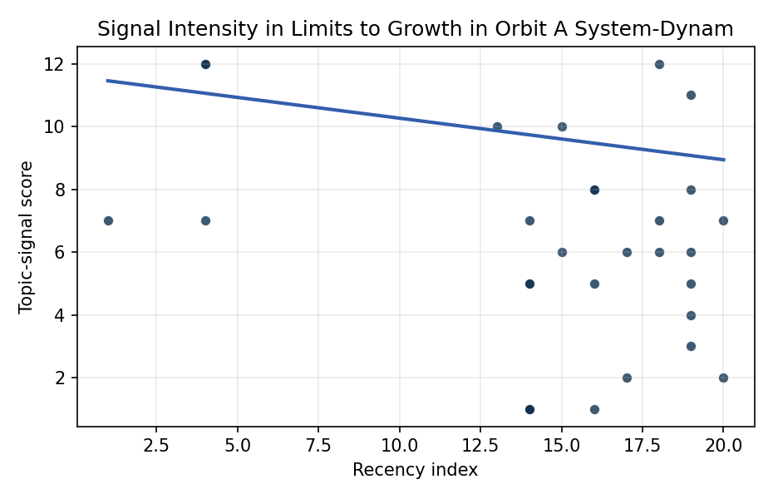
Figure 1. Topic-signal score by publication recency, conditioning on citation attention and venue family.

Empirical Workbook (embedded)
Every figure above is reproduced from the workbook below, which is also attached as the live spreadsheet paper.xlsx. Each observation carries its source.

Data (real observations)
doc_id | year_num | recency_index | cites_num | venue_score | title_words | snippet_words | keyword_count | theme_hits | signal_score | source
1 | 2021 | 15 | 0 | 1 | 8 | 14 | 2 | 2 | 6 | https://amostech.space/year/2021/identifying-the-statistically-most-concerning-conjunctions-in-leo/
2 | 2022 | 16 | 0 | 1 | 12 | 14 | 8 | 2 | 5 | https://amostech.space/year/2022/all-sky-electro-optical-tracking-of-mega-constellations-in-low-earth-orbit/
3 | 2023 | 17 | 0 | 1 | 12 | 8 | 3 | 1 | 2 | 10.64861/AYQY6554
4 | 2025 | 19 | 0 | 1 | 17 | 14 | 5 | 2 | 5 | 10.64861/HKAM1019
5 | 2007 | 1 | 0 | 1 | 12 | 14 | 1 | 3 | 7 | https://amostech.space/year/2007/an-assessment-of-the-january-2007-chinese-asat-test-on-the-leo-environment/
6 | 2019 | 13 | 0 | 1 | 18 | 14 | 4 | 4 | 10 | https://amostech.space/year/2019/development-of-the-slovak-70-cm-optical-passive-system-dedicated-to-space-debris-tracking-on-leo-to-geo-orbits/
7 | 2010 | 4 | 0 | 1 | 17 | 12 | 1 | 3 | 7 | https://amostech.space/year/2010/pay-me-now-or-pay-me-more-later-start-the-development-of-active-orbital-debris-removal-now/
8 | 2022 | 16 | 0 | 1 | 8 | 14 | 3 | 3 | 8 | https://amostech.space/year/2022/a-map-of-the-statistical-collision-risk-in-leo/
9 | 2010 | 4 | 0 | 1 | 16 | 14 | 1 | 5 | 12 | https://amostech.space/year/2010/operational-impact-of-improved-space-tracking-on-collision-avoidance-in-the-future-leo-space-debris-environment/
10 | 2025 | 19 | 0 | 1 | 9 | 14 | 8 | 4 | 11 | 10.64861/IKLU8599
11 | 2010 | 4 | 0 | 1 | 16 | 14 | 1 | 5 | 12 | https://amostech.space/year/2010/operation-impact-of-improved-space-tracking-on-collision-avoidance-in-the-future-leo-space-debris-environment/
12 | 2025 | 19 | 0 | 1 | 14 | 14 | 4 | 1 | 3 | 10.64861/CKQN3841
13 | 2024 | 18 | 5 | 2 | 6 | 12 | 6 | 3 | 6 | 10.1016/j.actaastro.2024.09.045
14 | 2026 | 20 | 0 | 2 | 14 | 11 | 13 | 3 | 7 | 10.1016/j.actaastro.2026.04.046
15 | 2026 | 20 | 0 | 2 | 9 | 14 | 10 | 1 | 2 | 10.1016/j.actaastro.2026.04.055
16 | 2024 | 18 | 0 | 2 | 10 | 12 | 13 | 5 | 12 | 10.1016/j.actaastro.2024.03.002
17 | 2024 | 18 | 12 | 2 | 15 | 14 | 9 | 3 | 7 | 10.1016/j.actaastro.2024.09.063
18 | 2025 | 19 | 4 | 2 | 15 | 13 | 12 | 1 | 4 | 10.1016/j.actaastro.2025.02.019
19 | 2021 | 15 | 71 | 2 | 10 | 14 | 14 | 4 | 10 | 10.1016/j.actaastro.2021.03.030
20 | 2020 | 14 | 6 | 2 | 19 | 13 | 15 | 3 | 7 | 10.1016/j.actaastro.2020.05.005
21 | 2022 | 16 | 4 | 2 | 10 | 12 | 15 | 3 | 8 | 10.1016/j.actaastro.2022.10.021
22 | 2023 | 17 | 17 | 2 | 15 | 14 | 13 | 2 | 6 | 10.1016/j.actaastro.2023.01.021
23 | 2025 | 19 | 5 | 2 | 19 | 14 | 14 | 3 | 8 | 10.1016/j.actaastro.2025.03.034
24 | 2025 | 19 | 2 | 2 | 11 | 14 | 15 | 3 | 6 | 10.1016/j.actaastro.2025.01.048
25 | 2022 | 16 | 0 | 3 | 6 | 0 | 0 | 0 | 1 | LEO Capacity Modeling for Sustainable Design
26 | 2020 | 14 | 0 | 3 | 7 | 0 | 0 | 0 | 1 | LEO Capacity Modeling for Sustainable Design (AMOS)
27 | 2020 | 14 | 0 | 3 | 7 | 0 | 0 | 2 | 5 | 10.1016/j.jsse.2020.06.006
28 | 2020 | 14 | 0 | 3 | 7 | 0 | 0 | 2 | 5 | Understanding Long-Term Orbital Debris Population Dynamics
29 | 2020 | 14 | 0 | 3 | 7 | 0 | 0 | 0 | 1 | Roadmap: Australia Economic-Technological Renaissance in Space
30 | 2020 | 14 | 0 | 3 | 4 | 0 | 0 | 0 | 1 | IRD Project Research Designs V2.0

Variable construction
Variable | Definition | Construction / source
signal_score | Composite topic-signal score for each retrieved source record | Deterministic count built from candidate-theme term hits in the source title, snippet, keyword field, and author metadata; each row cites the retrieved source in the source column
recency_index | Publication recency index | Computed as publication year minus the minimum publication year in the paper sample plus one
cites_num | Reported citation count in the local brain index | Parsed from the local brain search cites field; zero when the index reported no citation count
venue_score | Ordinal venue-family score | AMOS = 1, Acta Astronautica = 2, Space Economy = 3

Estimator output
Term | Coef. | Std. err. | t | p | 95% CI
const | 11.5919 | 1.8075 | 6.413 | 1.426e-10 | [8.0492, 15.1346]
recency_index | -0.1324 | 0.1121 | -1.1809 | 0.2376 | [-0.3521, 0.0873]
cites_num | 0.0716 | 0.0147 | 4.8679 | 1.128e-06 | [0.0428, 0.1004]
venue_score | -2.0875 | 0.7096 | -2.9418 | 0.0033 | [-3.4783, -0.6967]
Fit: N = 30 R2 = 0.3565 R2_adj = 0.2822 F = 11.6193 F_p = 5.133e-05

