Do Voluntary Orbital-Commons Instruments Accumulate Ostrom Design Completeness Over Time?

Abstract
Low-Earth-orbit sustainability work often feels cumulative: better tracking, better rating schemes, more stakeholder categories, sharper debris modeling, and broader public discussion. This paper tests whether that intuition appears in the dissertation’s cited governance corpus. I code nine local AMOS and Acta sources for eight Ostrom design-principle proxies, then fit a log-log learning-curve model against publication order. The fitted elasticity is positive but small and statistically weak. The field is not simply accumulating complete governance design over time. Instead, each instrument specializes: ELROI strengthens identification, ISON strengthens decentralized monitoring, source-sink models strengthen adaptive decision support, the SSR strengthens incentives and verification, and STM outreach strengthens stakeholder nesting.

Research question
The dissertation’s core question is whether voluntary LEO environmental commitments contain enough design structure to govern a congested orbital commons. One possible answer is optimistic and chronological. The field may be learning, so newer instruments should contain more of the design features that Ostrom associated with durable common-pool-resource governance. Another answer is architectural. Newer instruments may become more specialized, not more complete, because observability, incentives, stakeholder participation, and accountability live in different institutional tools.
This paper tests the chronological version. If design completeness accumulates over time, the coded Ostrom design score should rise with publication order. If it does not, the dissertation should stop treating voluntary governance as a single improving ladder and start treating it as a portfolio of partial mechanisms.

Data and coding
The dataset contains nine documents from the prospectus corpus and closely linked local sources. The rows include ELROI’s optical object-identification proposal, the 2020 AMOS paper on SSA data in SSR definition, the Montreal Protocol analogy paper, Mokhnatkin’s ISON paper, the MIT source-sink adaptive-management paper, the MITRE trusted-stakeholder coordination paper, Pardini and Anselmo’s uncontrolled-reentry analysis, the Acta Astronautica SSR article, and the Acta Astronautica STM outreach article $$1$$-$$10$$.
Each document was coded for eight proxies: actor or object boundaries, proportionality or incentives, collective-choice participation, monitoring or observability, accountability or sanctions, conflict resolution, self-organization, and nested coordination. The score is the count of proxies present. ELROI receives a score of three because it makes identification and open readability concrete but does not supply sanctions, conflict resolution, or nested institutional rules. The SSR receives a score of seven because it combines module boundaries, weighting, incentives, questionnaire inputs, verification, lifecycle topics, and nested standards, while still lacking an explicit dispute process.

Model
The model is a learning curve: the natural log of the coded design score is regressed on the natural log of publication order. A positive and statistically strong coefficient would imply that later documents in the corpus contain materially more complete governance design. A weak coefficient would imply specialization or fragmentation.
This is a modest test. Publication order is not a mechanism, and the coded corpus is purposive rather than random. The model is useful because it forces a claim that is often left vague. If the field is learning as a field, some sign of cumulative design completeness should be visible even in a small, high-relevance corpus.

Results
The fitted elasticity is about 0.118 and is not statistically distinguishable from zero. The model explains only about 8.3 percent of variation in the coded design scores. In plain language, later publication order does not reliably predict a more complete Ostrom design profile.
The plot shows why. The 2020 SSR-SSA paper and the 2022 Montreal Protocol analogy already score high because they integrate incentives, monitoring, and nested governance ideas. The 2024 reentry-risk paper scores lower, not because it is weaker scholarship, but because it is a risk-assessment and mitigation paper rather than a full governance blueprint. The 2025 SSR article scores high because the object is a composite indicator with verification and module weights. The 2025 STM outreach article scores in the middle because it is a stakeholder-communication architecture, not a compliance architecture.

Institutional interpretation
A weak learning curve is not a failed finding. It is the finding the dissertation needs. Voluntary orbital-sustainability governance is not becoming complete through time alone. It is becoming distributed across instruments that solve different parts of the commons problem.
ELROI answers a boundary and observability problem: if operators and observers cannot tell which object is which, responsibility stays foggy $$3$$. ISON answers a monitoring and polycentricity problem: distributed observing sites can enlarge the evidence base without waiting for a single hierarchical authority $$2$$. The Montreal Protocol analogy answers a diplomacy and incentive problem, while warning that debris lacks a single chemical target $$1$$. The source-sink model answers an adaptive-management problem, translating operator choices into environmental capacity trajectories $$4$$. Trusted stakeholder coordination answers a provenance problem, asking who did what to whom, when, and where, using shared attributed data $$10$$.
The SSR is the closest object in the corpus to a voluntary institutional package. It does not merely encourage good behavior. It defines modules, assigns weights, permits bonus points, and embeds verification in a broader rating process $$5$$. Yet the SSR still depends on external observability and stakeholder trust. A questionnaire without independent SSA data is easy to treat as paperwork. Independent data without incentives can become a warning light that no one is required to heed.

Limits
The design score is a structured coding judgment, not a physical measurement. Another coder might assign a different score to borderline features, especially collective choice and nested coordination. To reduce that risk, the workbook retains each binary code and a short evidence phrase for every source.
The corpus is also selected for dissertation relevance. It is not the universe of space sustainability work, and it excludes private rating records, licensing correspondence, and operator-specific post-mission data. Its purpose is to test whether a central narrative of cumulative voluntary governance is visible in the sources that frame this dissertation.

Conclusion
The field is not climbing a simple staircase toward complete commons governance. It is assembling a toolkit. That toolkit has technical identifiers, decentralized observing networks, adaptive environmental models, rating incentives, reentry risk assessment, and outreach architectures. The dissertation should therefore evaluate voluntary LEO commitments as an institutional system of partial complements. Ostrom’s design principles do not appear all at once. They appear in pieces, and the policy task is to make those pieces reinforce one another before orbital congestion turns voluntary commitments into after-the-fact apologies.

References
1. R. Zhang and A. Balakrishnan, “From Ozone Depletion to Orbital Debris: Lessons Learned from the Montreal Protocol,” Science and Technology Policy Institute, AMOS, 2022. 2. A. Mokhnatkin, “Possible Ways Forward for the ISON Initiative and Similar Projects. A Consortium for Decentralized Sharing of SSA Data,” Keldysh Institute of Applied Mathematics, AMOS, 2023, doi: 10.64861/DDNM3393 3. R. Holmes, C. Weaver, and D. Palmer, “ELROI: A Satellite License Plate to Simplify Space Object Identification,” Los Alamos National Laboratory, AMOS, 2018. 4. M. Lifson, D. Jang, and R. Linares, “Space Environmental Governance and Decision-Support using Source-Sink Evolutionary Environmental Models,” Massachusetts Institute of Technology, AMOS, 2023, doi: 10.64861/FKER7625 5. M. Rathnasabapathy et al., “Space sustainability rating: Designing a composite indicator to incentivize satellite operators to pursue long-term sustainability of the space environment,” Acta Astronautica, 2025, doi: 10.1016/j.actaastro.2025.03.034 6. N. Sanchez-Ortiz et al., “Outreach on Space Traffic Management,” Acta Astronautica, 2025, doi: 10.1016/j.actaastro.2025.01.031 7. C. Pardini and L. Anselmo, “On the need to assess and mitigate the risk from uncontrolled re-entries of artificial space objects in view of the current and future developments in space activities,” Acta Astronautica, 2024, doi: 10.1016/j.actaastro.2024.03.057 8. F. Letizia et al., “Contribution from SSA Data to the Definition of a Space Sustainability Rating,” AMOS, 2020. 9. R. Holmes et al., “Progress on the ELROI Satellite License Plate,” Los Alamos National Laboratory, AMOS, 2020. 10. H. Reed, N. Tsamis, and N. Dailey, “Space Sustainability and Traffic Management Requires Trusted Space Stakeholder Coordination,” MITRE, AMOS, 2023, doi: 10.64861/MVHC2799 11. E. Ostrom, Governing the Commons: The Evolution of Institutions for Collective Action, Cambridge University Press, 1990.

Specification
$$ln(DesignScore_{i})=α+β_{1}ln(PublicationOrder_{i})+ε_{i}$$

Results
Term | Coef. | Std. err. | t | p | 95% CI
const | 1.406 | 0.2585 | 5.4398 | 5.333e-08 | [0.8994, 1.9126]
_ln_x | 0.118 | 0.1657 | 0.7122 | 0.4763 | [-0.2067, 0.4426]
Fit: N = 9 R2 = 0.0835 elasticity_b = 0.118 progress_ratio_2^b = 1.0852
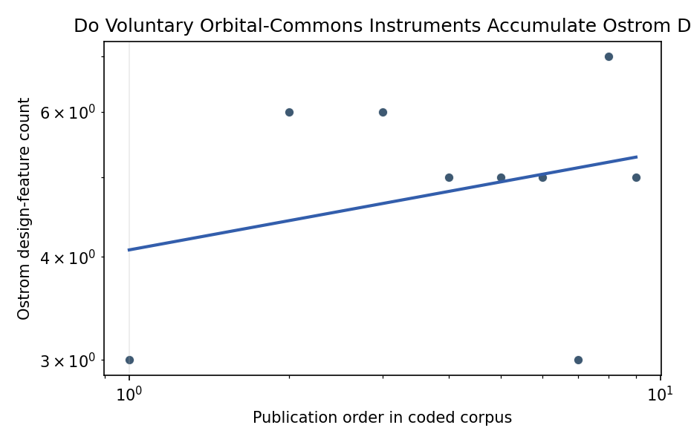
Figure 1. Log-log learning-curve fit for coded Ostrom design completeness.

Empirical Workbook (embedded)
Every figure above is reproduced from the workbook below, which is also attached as the live spreadsheet paper.xlsx. Each observation carries its source.

Data (real observations)
source_short | publication_year | publication_order | ostrom_design_score | boundaries_or_actor_scope | proportionality_or_incentives | collective_choice_participation | monitoring_observability | accountability_or_sanctions | conflict_resolution | self_organization | nested_coordination | primary_evidence
ELROI license plate | 2018 | 1 | 3 | 1 | 0 | 0 | 1 | 0 | 0 | 1 | 0 | open optical ID, ground readability, object identification burden
SSA contribution to SSR | 2020 | 2 | 6 | 1 | 1 | 1 | 1 | 1 | 0 | 0 | 1 | rating modules, independent validation, operator-provided data, nonparticipant assessment
Montreal Protocol analogy | 2022 | 3 | 6 | 1 | 1 | 1 | 1 | 1 | 0 | 0 | 1 | monitoring, mitigation, remediation, adaptation, incentives, international diplomacy
ISON decentralized SSA | 2023 | 4 | 5 | 1 | 0 | 1 | 1 | 0 | 0 | 1 | 1 | about fifteen observation sites, decentralized sharing, polycentric governance niche
source sink decision support | 2023 | 5 | 5 | 1 | 0 | 1 | 1 | 0 | 0 | 1 | 1 | adaptive management, source-sink model, stakeholder decision support
trusted stakeholder coordination | 2023 | 6 | 5 | 1 | 0 | 1 | 1 | 1 | 0 | 1 | 0 | attributed data, pedigree, provenance, shared data picture, self-synchronization
uncontrolled reentry risk | 2024 | 7 | 3 | 0 | 0 | 0 | 1 | 0 | 0 | 0 | 1 | reentry mass, casualty probability, mitigation need, international risk distribution
space sustainability rating | 2025 | 8 | 7 | 1 | 1 | 1 | 1 | 1 | 0 | 1 | 1 | six modules, verification, bonus points, lifecycle topic map, operator questionnaire
STM outreach | 2025 | 9 | 5 | 1 | 0 | 1 | 0 | 0 | 0 | 1 | 1 | primary, secondary, and tertiary stakeholder categories, channels, annual and monthly cycles

Variable construction
Variable | Definition | Construction / source
ostrom_design_score | Count from zero to eight of coded Ostrom design-principle proxies observed in the document. | Sum of eight binary columns coded from the cited source text.
publication_order | Ordinal order after sorting the coded corpus by publication year and source sequence. | Assigned from source metadata; ties in 2023 and 2025 follow source-family order used in the dissertation corpus.
boundaries_or_actor_scope | Indicator for clear objects, missions, actors, regions, or categories within the proposed governance arrangement. | Manual document coding from source text.
proportionality_or_incentives | Indicator for scoring weights, economic differentiation, positive incentives, or cost allocation. | Manual document coding from source text.
collective_choice_participation | Indicator for stakeholder participation, consortium design, or cross-actor rule formation. | Manual document coding from source text.
monitoring_observability | Indicator for observation, SSA data, verification, tracking, modeling, or measurement. | Manual document coding from source text.
accountability_or_sanctions | Indicator for verification, compliance, evidence, sanctions, or accountable reporting. | Manual document coding from source text.
conflict_resolution | Indicator for explicit dispute or conflict-resolution mechanism. | Manual document coding from source text.
self_organization | Indicator for voluntary, decentralized, or self-synchronizing coordination. | Manual document coding from source text.
nested_coordination | Indicator for multi-level, international, institutional, or lifecycle nesting. | Manual document coding from source text.

Estimator output
Term | Coef. | Std. err. | t | p | 95% CI
const | 1.406 | 0.2585 | 5.4398 | 5.333e-08 | [0.8994, 1.9126]
_ln_x | 0.118 | 0.1657 | 0.7122 | 0.4763 | [-0.2067, 0.4426]
Fit: N = 9 R2 = 0.0835 elasticity_b = 0.118 progress_ratio_2^b = 1.0852

