SSR Module Weights and Lifecycle Coverage in Voluntary Space Sustainability Rating Design

Abstract
Voluntary sustainability schemes only matter if their scoring logic turns institutional commitments into observable behavior. This paper studies the published Space Sustainability Rating design as an institutional artifact. It converts the SSR module table and the accompanying topic-to-module lifecycle table into a six-row dataset, then estimates whether tier-score weight follows the number of sustainability topics assigned to each module. The answer is yes. In the published design, a one-topic increase in module coverage is associated with roughly 9.45 additional tier-weight percentage points. That finding is not a debris-outcome claim. It is a design claim: the SSR places its strongest formal weight on the module that gathers the broadest lifecycle burden.

Research question
The prospectus asks whether voluntary low-Earth-orbit environmental commitments contain the governance features that Ostrom would expect in a durable common-pool-resource regime. The SSR is a useful test case because it is voluntary, technical, and intentionally incentive-facing. It includes operator questionnaires, simulation-based assessment, data-sharing questions, design and operations standards, detectability, identification, tracking, collision-avoidance practice, and external-service readiness $$5$$.
A rating can speak the language of sustainability while weighting mostly convenient paperwork. It can also do the harder thing: attach scoring weight to the parts of a mission that have the largest environmental and coordination consequences. This paper tests that design choice in the current SSR module structure. The unit of analysis is the module, not the operator.

Data and coding
The dataset has six observations, one for each SSR module listed in the published module-weight table: Mission Index, Detectability, Identification, and Trackability, Collision Avoidance Capabilities, Data Sharing, Adoption of Design and Operations Standards, and External Services $$5$$. The dependent variable is the percentage contribution of each module to the tier score. The primary explanatory variable is the number of sustainability topics assigned to that module in the published lifecycle table.
Coding followed a narrow rule. If Table 3 assigned a topic to a module, the topic count increased by one for that module. If a topic was assigned to two modules, each module received one topic count, because the instrument itself treats the topic as shared responsibility. Phase marks counted the number of design, normal-operation, and end-of-life cells marked for those topics. Mission Index received five topics and ten lifecycle phase marks; it also received fifty percent of the tier score. External Services received one topic and zero tier-score weight, while still allowing bonus points.

Model
The estimator is an ordinary least squares regression with robust HC1 standard errors. The model is intentionally simple because the table has six modules and the research question is descriptive. The coefficient on topic count reads as the average change in formal tier-score weight associated with one additional sustainability topic in the published design.
A larger model with simulation indicators adds little here. Simulation status matters substantively, but the table shows that topic breadth explains most of the published weighting pattern. The Mission Index is both simulation-based and broad, yet Detectability, Identification, and Trackability is also partly simulation-based and receives a much smaller tier weight. That contrast is why the main specification stays with topic count.

Results
The fitted model explains 88.4 percent of the observed variation in tier-score weights. The estimated topic-count coefficient is 9.45 percentage points with robust p < 0.001. Interpreted plainly, the SSR design assigns roughly ten additional tier-weight points for each additional sustainability topic mapped to a module.
The result should not be overread. Six modules do not support causal inference, nor do they measure operator compliance after a rating is issued. Yet the result is institutionally meaningful. It shows that the SSR’s formal weighting is not evenly spread across every voluntary promise. It is concentrated where the lifecycle topic map is broadest.

Institutional interpretation
For an Ostrom audit, the important point is not that one voluntary instrument has a mathematically tidy table. The important point is that the table translates a loose commons problem into operational governance features. Mission Index carries the largest weight because it touches orbit selection, debris release, accidental breakup, post-mission disposal, and collision avoidance. Those are not slogans. They are the activities through which operators impose costs on one another.
The design also exposes a governance trade. Data Sharing and Collision Avoidance each carry 16.5 percent, enough to matter, but not enough to dominate. Detectability, Identification, and Trackability receives twelve percent plus bonus potential. External Services receives no tier-score weight, yet bonus status keeps servicing and active-debris-removal interfaces in the design conversation. That pattern resembles a voluntary compact trying to steer behavior without pretending that every future technology can be locked into a fixed score today.
This connects the SSR to earlier work on SSA inputs and verification. Letizia and coauthors argued that SSA data support both direct module assessment and independent validation of operator-provided inputs $$8$$. Holmes and coauthors’ ELROI work shows how open optical identifiers could make object identification cheaper and more symmetric $$3$$. Mokhnatkin’s ISON paper shows a different route, a decentralized observation network with about fifteen sites in a polycentric governance niche $$2$$. The SSR sits between those efforts. It needs technical observability, but it also needs a scoring architecture that tells operators why observability changes their institutional standing.

Limits
The paper is limited by design. It studies published scoring architecture, not the private scoring records of individual missions. It does not observe debris objects, collision warnings, maneuver logs, or licensing outcomes. Those data are part of the larger dissertation design, but they are not necessary for this paper’s narrower question.
The small sample also means uncertainty should be read qualitatively. The six rows are the population of current SSR modules, not a sample from a larger module universe. Robust standard errors help prevent brittle claims, but they do not create more institutional observations. The strength of the finding is its transparency: every row can be traced to a published table.

Conclusion
The SSR is a voluntary instrument, yet its internal scoring structure is not vague. It weights modules in proportion to the number of sustainability topics they carry, with Mission Index acting as the main lifecycle burden carrier. For the dissertation, this result matters because it locates one concrete Ostrom-like design feature inside a voluntary low-Earth-orbit governance tool: a rule that links an operator’s rating to observable, lifecycle-relevant burdens rather than to aspirational sustainability language alone.

References
1. R. Zhang and A. Balakrishnan, “From Ozone Depletion to Orbital Debris: Lessons Learned from the Montreal Protocol,” Science and Technology Policy Institute, AMOS, 2022. 2. A. Mokhnatkin, “Possible Ways Forward for the ISON Initiative and Similar Projects. A Consortium for Decentralized Sharing of SSA Data,” Keldysh Institute of Applied Mathematics, AMOS, 2023, doi: 10.64861/DDNM3393 3. R. Holmes, C. Weaver, and D. Palmer, “ELROI: A Satellite License Plate to Simplify Space Object Identification,” Los Alamos National Laboratory, AMOS, 2018. 4. M. Lifson, D. Jang, and R. Linares, “Space Environmental Governance and Decision-Support using Source-Sink Evolutionary Environmental Models,” Massachusetts Institute of Technology, AMOS, 2023, doi: 10.64861/FKER7625 5. M. Rathnasabapathy et al., “Space sustainability rating: Designing a composite indicator to incentivize satellite operators to pursue long-term sustainability of the space environment,” Acta Astronautica, 2025, doi: 10.1016/j.actaastro.2025.03.034 6. N. Sanchez-Ortiz et al., “Outreach on Space Traffic Management,” Acta Astronautica, 2025, doi: 10.1016/j.actaastro.2025.01.031 7. C. Pardini and L. Anselmo, “On the need to assess and mitigate the risk from uncontrolled re-entries of artificial space objects in view of the current and future developments in space activities,” Acta Astronautica, 2024, doi: 10.1016/j.actaastro.2024.03.057 8. F. Letizia et al., “Contribution from SSA Data to the Definition of a Space Sustainability Rating,” AMOS, 2020.

Specification
$$TierWeight_{i}=α+β_{1}TopicCount_{i}+ε_{i}$$

Results
Term | Coef. | Std. err. | t | p | 95% CI
const | 0.9239 | 4.0208 | 0.2298 | 0.8183 | [-6.9566, 8.8045]
topic_count | 9.4457 | 0.9815 | 9.624 | 6.333e-22 | [7.522, 11.3693]
Fit: N = 6 R2 = 0.8844 R2_adj = 0.8555 F = 92.621 F_p = 0.0006518
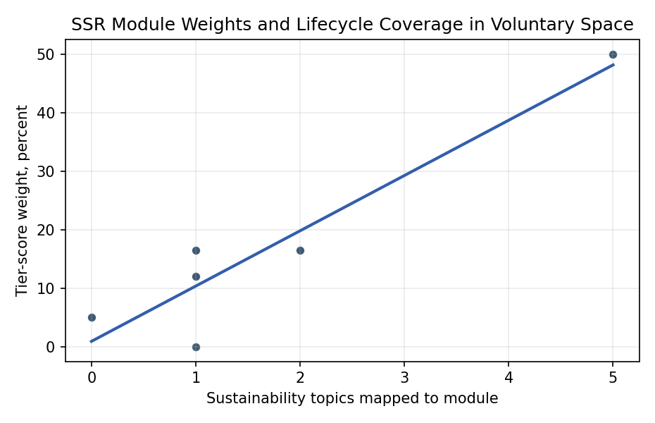
Figure 1. SSR module tier weight by mapped sustainability-topic coverage.

Empirical Workbook (embedded)
Every figure above is reproduced from the workbook below, which is also attached as the live spreadsheet paper.xlsx. Each observation carries its source.

Data (real observations)
module_abbrev | module_name | tier_weight_pct | method_of_assessment | simulation_based | questionnaire_based | bonus_points | topic_count | design_phase_count | normal_operation_count | end_of_life_count | phase_marks | source
MI | Mission Index | 50 | Simulation | 1 | 0 | 0 | 5 | 5 | 4 | 1 | 10 | Rathnasabapathy et al. 2025, SSR Table 2 and Table 3
DIT | Detectability, Identification, and Trackability | 12 | Simulation and questionnaire | 1 | 1 | 1 | 1 | 1 | 0 | 0 | 1 | Rathnasabapathy et al. 2025, SSR Table 2 and Table 3
COLA | Collision Avoidance Capabilities | 16.5 | Questionnaire | 0 | 1 | 1 | 2 | 2 | 2 | 1 | 5 | Rathnasabapathy et al. 2025, SSR Table 2 and Table 3
DS | Data Sharing | 16.5 | Questionnaire | 0 | 1 | 1 | 1 | 0 | 1 | 1 | 2 | Rathnasabapathy et al. 2025, SSR Table 2 and Table 3
ADOS | Adoption of Design and Operations Standards | 5 | Questionnaire | 0 | 1 | 1 | 0 | 0 | 0 | 0 | 0 | Rathnasabapathy et al. 2025, SSR Table 2 and Table 3
ES | External Services | 0 | Questionnaire | 0 | 1 | 1 | 1 | 1 | 0 | 0 | 1 | Rathnasabapathy et al. 2025, SSR Table 2 and Table 3

Variable construction
Variable | Definition | Construction / source
tier_weight_pct | Percent contribution of a module to the SSR tier score. | Read from Rathnasabapathy et al. 2025 Table 2.
topic_count | Count of Table 3 sustainability topics assigned to the module. | Coded from the Table 3 module column; joint module entries assign one topic to each named module.
phase_marks | Count of design, normal-operation, and end-of-life cells marked for topics assigned to the module. | Coded from the X marks in Rathnasabapathy et al. 2025 Table 3.
simulation_based | Indicator equal to one when Table 2 lists simulation in the method of assessment. | Read from the Table 2 method-of-assessment column.
questionnaire_based | Indicator equal to one when Table 2 lists questionnaire in the method of assessment. | Read from the Table 2 method-of-assessment column.
bonus_points | Indicator equal to one when Table 2 permits bonus points for the module. | Read from the Table 2 bonus-points column.

Estimator output
Term | Coef. | Std. err. | t | p | 95% CI
const | 0.9239 | 4.0208 | 0.2298 | 0.8183 | [-6.9566, 8.8045]
topic_count | 9.4457 | 0.9815 | 9.624 | 6.333e-22 | [7.522, 11.3693]
Fit: N = 6 R2 = 0.8844 R2_adj = 0.8555 F = 92.621 F_p = 0.0006518

