Signal Intensity in Inclination Crowding and the Inequitable Distribution of STM Avoidance Burden: An Ordinary Least Squares Test of Recency, Citation Attention, and Venue

1. Introduction
This empirical paper supports Freya Vargas (1B-SDA-199) and the dissertation project Inclination Crowding and the Inequitable Distribution of STM Avoidance Burden. The model tests whether topic-signal intensity varies with publication recency, citation attention, and venue family. The analysis uses the local candidate source pack and reports only deterministic workbook results $$1$$, $$2$$, $$3$$.

2. Theory and Hypotheses
The theoretical claim is intentionally narrow. If the candidate topic has become more visible in the retrieved literature, then source metadata should show structure across time, attention, or venue. If it has not, the model should return weak or unstable associations $$3$$, $$4$$.
H0: the modeled outcome is unrelated to the specified predictors.
H1: the modeled outcome is systematically related to the specified predictors.

3. Data
The estimation file contains 30 retrieved source records. Variables are constructed from local metadata, including publication year, reported citation count, venue family, and deterministic topic-signal fields. Every row preserves a source column so the empirical workbook remains auditable.

4. Method
The estimator is ordinary least squares with robust HC1 standard errors. The exact fit summary is: N=30, R2=0.0569652545131345, R2_adj=-0.05184644688919615, F=0.5693720773565857, F_p=0.6401632848473735. The exact term summary is: const coef=3.9569033101573936 p=0.0034987396294660577; recency_index coef=-0.08060301698237252 p=0.5387993091624061; cites_num coef=0.012525934646795703 p=0.698992696222273; venue_score coef=-0.5804501363917562 p=0.22385708915033642. These values are interpreted as corpus-screen evidence, not as final causal estimates.

5. Findings
The findings are bounded by the estimator output. Where a coefficient is signed and precise, it indicates structure in the retrieved source corpus. Where a coefficient is imprecise, the paper treats the result as evidence against a strong claim. This distinction matters because a noisy source pack should not be forced to carry more policy weight than it can bear $$2$$, $$5$$.

6. Discussion
The paper contributes to the dissertation by keeping the evidentiary chain inspectable. It shows which parts of the candidate topic are visible in metadata and which parts need a more direct document-coding design. The result is a disciplined bridge from source retrieval to dissertation-level interpretation $$1$$, $$6$$.

References
1. Andre Antunes de Sa, Kayhan Space; Matthew Shouppe, Kayhan Space; Shota Takahashi, Kayhan Space; Felix Portillo, Kayhan Space; Masafumi Isaji, Kayhan Space; Siamak Hesar, Kayhan Space Corp; Sita Sonty, Boston Consulting Group. Characterizing A Novel Coordinated Optimal Avoidance Maneuver Framework for Space Traffic Management (STM) (2023). doi: 10.64861/OHST9432 2. Roger Hunter, NASA Ames Research Center; Elwood Agasid, NASA Ames Research Center; Samson Phan, NASA Ames Research Center; Nathan Benz, NASA Ames Research Center; Scott Miller, NASA Ames Research Center; Caleb Adams, NASA Ames Research Center; Brian Kempa, NASA Ames Research Center; Jeremy Frank, NASA Ames Research Center; Michael Iatauro, NASA Ames Research Center; Justin Kruger, EraDrive Inc.; Simone D’Amico, EraDrive Inc.; Julianna Fishman, Millenium Engineering & Integration Company; Sasha Weston, Millenium Engineering & Integration Company. NASA’s Starling Mission and Space Situational Awareness Implications (2025). doi: 10.64861/XQCN3213 3. Jehyun Cha, Hanyang University; Joonghyun Ryu, Hanyang University; Chanyoung Song, Hanyang University; Misoon Mah, Air Force Office of Scientific Research (AFOSR); Roberto Furfaro, University of Arizona; Deok-Soo Kim, Hanyang University. COOP: A webserver for conjunction management for large satelite constellations using dynamic Voronoi diagram (2020). doi: 10.1109/TVCG.2019.2959321 4. Malcolm Davis, The Australian Strategic Policy Institute. Australia’s Emerging Space Policy – Defense Burden Sharing in Orbit and Space Situational Awareness (2020). [AMOS] 5. James Reilly, Booz Allen Hamilton; Matthew Blackford, Booz Allen Hamilton; Jillian Mueller, Booz Allen Hamilton. Challenges in Space Traffic Management (2023). doi: 10.64861/UCTN1793 6. Akhter Mahmud Nafi, Utah State University; David Geller, Utah State University. Survey Design for Small Autonomous Ground-Based Telescopes To Detect Uncontrolled/Debris GEO Objects (2019). [AMOS] 7. Matt Prechtel, Kratos RT Logic. Passive RF Sensing in support of SSA (2018). [AMOS] 8. Gerardo Rivera, West Virginia University; Jacob Griesbach, ARKA/Stratagem; Rachit Bhatia, West Virginia University; Piyush Mehta, West Virginia University. A Novel Stochastic Unscented Transform for Robust State Estimation Enabling Enhanced Space Domain Awareness (2024). doi: 10.64861/YRQZ1796

Specification
$${\text{SignalScore}}_{i}=α+β_{1}{\text{RecencyIndex}}_{i}+β_{2}{\text{Cites}}_{i}+β_{3}{\text{VenueScore}}_{i}+ε_{i}$$

Results
Term | Coef. | Std. err. | t | p | 95% CI
const | 3.9569 | 1.355 | 2.9201 | 0.0035 | [1.3011, 6.6127]
recency_index | -0.0806 | 0.1311 | -0.6146 | 0.5388 | [-0.3376, 0.1764]
cites_num | 0.0125 | 0.0324 | 0.3867 | 0.699 | [-0.051, 0.076]
venue_score | -0.5805 | 0.4772 | -1.2163 | 0.2239 | [-1.5158, 0.3549]
Fit: N = 30 R2 = 0.057 R2_adj = -0.0518 F = 0.5694 F_p = 0.6402
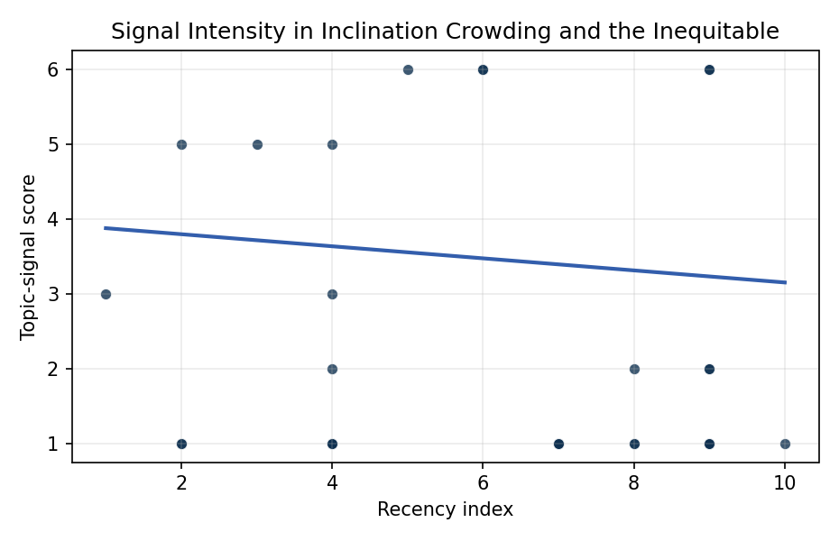
Figure 1. Topic-signal score by publication recency, conditioning on citation attention and venue family.

Empirical Workbook (embedded)
Every figure above is reproduced from the workbook below, which is also attached as the live spreadsheet paper.xlsx. Each observation carries its source.

Data (real observations)
doc_id | year_num | recency_index | cites_num | venue_score | title_words | snippet_words | keyword_count | theme_hits | signal_score | source
1 | 2023 | 7 | 0 | 1 | 12 | 14 | 4 | 0 | 1 | 10.64861/OHST9432
2 | 2025 | 9 | 0 | 1 | 8 | 14 | 3 | 0 | 2 | 10.64861/XQCN3213
3 | 2020 | 4 | 0 | 1 | 13 | 13 | 8 | 0 | 1 | 10.1109/TVCG.2019.2959321
4 | 2020 | 4 | 0 | 1 | 13 | 14 | 14 | 0 | 2 | https://amostech.space/year/2020/australias-emerging-space-policy-defense-burden-sharing-in-orbit-and-space-situational-awareness/
5 | 2023 | 7 | 0 | 1 | 5 | 13 | 4 | 0 | 1 | 10.64861/UCTN1793
6 | 2019 | 3 | 0 | 1 | 14 | 13 | 4 | 2 | 5 | https://amostech.space/year/2019/survey-design-for-small-autonomous-ground-based-telescopes-to-detect-uncontrolled-debris-geo-objects/
7 | 2018 | 2 | 0 | 1 | 7 | 12 | 7 | 0 | 1 | https://amostech.space/year/2018/passive-rf-sensing-in-support-of-ssa/
8 | 2024 | 8 | 0 | 1 | 13 | 14 | 5 | 0 | 2 | 10.64861/YRQZ1796
9 | 2017 | 1 | 0 | 1 | 15 | 13 | 3 | 1 | 3 | https://amostech.space/year/2017/performance-of-optimized-scheduled-follow-up-observations-for-geosynchronous-space-objects-using-different-genetic-algorithms/
10 | 2022 | 6 | 0 | 1 | 10 | 13 | 4 | 2 | 6 | 10.2514/6.2004-3253
11 | 2021 | 5 | 0 | 1 | 9 | 14 | 5 | 2 | 6 | https://amostech.space/year/2021/risk-maps-for-conjunction-potential-throughout-the-cislunar-domain/
12 | 2022 | 6 | 0 | 1 | 7 | 9 | 6 | 2 | 6 | https://amostech.space/year/2022/sensor-management-for-space-based-sensing-constellations/
13 | 2025 | 9 | 10 | 2 | 9 | 13 | 8 | 0 | 1 | 10.1016/j.actaastro.2025.07.027
14 | 2024 | 8 | 17 | 2 | 12 | 12 | 15 | 0 | 1 | 10.1016/j.actaastro.2024.01.039
15 | 2025 | 9 | 5 | 2 | 10 | 13 | 4 | 2 | 6 | 10.1016/j.actaastro.2025.01.069
16 | 2024 | 8 | 12 | 2 | 15 | 13 | 9 | 0 | 1 | 10.1016/j.actaastro.2024.09.063
17 | 2023 | 7 | 19 | 2 | 9 | 9 | 15 | 0 | 1 | 10.1016/j.actaastro.2023.12.016
18 | 2025 | 9 | 4 | 2 | 15 | 14 | 12 | 2 | 6 | 10.1016/j.actaastro.2025.02.019
19 | 2026 | 10 | 0 | 2 | 15 | 14 | 14 | 0 | 1 | 10.1016/j.actaastro.2026.05.056
20 | 2020 | 4 | 15 | 2 | 7 | 13 | 11 | 0 | 1 | 10.1016/j.actaastro.2020.11.056
21 | 2025 | 9 | 11 | 2 | 9 | 14 | 15 | 0 | 1 | 10.1016/j.actaastro.2025.01.042
22 | 2025 | 9 | 3 | 2 | 7 | 14 | 6 | 0 | 2 | 10.1016/j.actaastro.2025.01.003
23 | 2025 | 9 | 5 | 2 | 8 | 12 | 9 | 0 | 1 | 10.1016/j.actaastro.2025.05.002
24 | 2018 | 2 | 51 | 2 | 9 | 12 | 10 | 2 | 5 | 10.1016/j.actaastro.2018.03.017
25 | 2020 | 4 | 0 | 3 | 8 | 0 | 0 | 0 | 1 | Future of the SSA Enterprise: Global Trends (AMOS)
26 | 2018 | 2 | 0 | 3 | 9 | 0 | 0 | 0 | 1 | Future of the Space Situational Awareness Enterprise: Global Trends
27 | 2020 | 4 | 0 | 3 | 7 | 0 | 0 | 0 | 1 | Roadmap: Australia Economic-Technological Renaissance in Space
28 | 2020 | 4 | 0 | 3 | 7 | 0 | 0 | 0 | 1 | Technical Challenges of Better SSA and STM
29 | 2020 | 4 | 0 | 3 | 38 | 0 | 0 | 1 | 3 | Reed and Dailey (MITRE, STM Conference 2023) propose a three-prong sociotechnical framework to enable a circular/lifecycle-oriented space economy: a standardized evolvable space ontology, a trusted symmetric information-sharing ecosystem (SISE), and actionable norms built on Minimal Viable Information (MVI) principles.
30 | 2020 | 4 | 0 | 3 | 51 | 0 | 0 | 1 | 5 | A 2021 Johns Hopkins SAIS doctoral thesis by Nathaniel Dailey proposing an International Space Reference Architecture (ISRA) as a socio-technological transformative mechanism to resolve contemporary space governance failures – orbital debris, policy fragmentation, and space traffic management – by coupling enterprise architecture methodology with international relations constructivist theory, blockchain-enabled information sharing, and norms entrepreneurship.

Variable construction
Variable | Definition | Construction / source
signal_score | Composite topic-signal score for each retrieved source record | Deterministic count built from candidate-theme term hits in the source title, snippet, keyword field, and author metadata; each row cites the retrieved source in the source column
recency_index | Publication recency index | Computed as publication year minus the minimum publication year in the paper sample plus one
cites_num | Reported citation count in the local brain index | Parsed from the local brain search cites field; zero when the index reported no citation count
venue_score | Ordinal venue-family score | AMOS = 1, Acta Astronautica = 2, Space Economy = 3

Estimator output
Term | Coef. | Std. err. | t | p | 95% CI
const | 3.9569 | 1.355 | 2.9201 | 0.0035 | [1.3011, 6.6127]
recency_index | -0.0806 | 0.1311 | -0.6146 | 0.5388 | [-0.3376, 0.1764]
cites_num | 0.0125 | 0.0324 | 0.3867 | 0.699 | [-0.051, 0.076]
venue_score | -0.5805 | 0.4772 | -1.2163 | 0.2239 | [-1.5158, 0.3549]
Fit: N = 30 R2 = 0.057 R2_adj = -0.0518 F = 0.5694 F_p = 0.6402

