Attention Accumulation in The Coordination Tipping Point Critical Mass for Voluntary STM Data-Sharing Net: A Learning-Curve Analysis of Citation Growth by Article Age

1. Introduction
This empirical paper supports Bruno Wren (1B-SDA-174) and the dissertation project The Coordination Tipping Point: Critical Mass for Voluntary STM Data-Sharing Net. The model tests whether citation accumulation is structured by article age inside the retrieved corpus. The analysis uses the local candidate source pack and reports only deterministic workbook results $$1$$, $$2$$, $$3$$.

2. Theory and Hypotheses
The theoretical claim is intentionally narrow. If the candidate topic has become more visible in the retrieved literature, then source metadata should show structure across time, attention, or venue. If it has not, the model should return weak or unstable associations $$3$$, $$4$$.
H0: the modeled outcome is unrelated to the specified predictors.
H1: the modeled outcome is systematically related to the specified predictors.

3. Data
The estimation file contains 30 retrieved source records. Variables are constructed from local metadata, including publication year, reported citation count, venue family, and deterministic topic-signal fields. Every row preserves a source column so the empirical workbook remains auditable.

4. Method
The estimator is a log-log learning-curve model with robust HC1 standard errors. The exact fit summary is: N=30, R2=0.15557180180902042, elasticity_b=-0.877770830490746, progress_ratio_2^b=0.5442076603766843. The exact term summary is: const coef=2.2693788208516903 p=0.0013756484603943836; _ln_x coef=-0.877770830490746 p=0.02919348742061792. These values are interpreted as corpus-screen evidence, not as final causal estimates.

5. Findings
The findings are bounded by the estimator output. Where a coefficient is signed and precise, it indicates structure in the retrieved source corpus. Where a coefficient is imprecise, the paper treats the result as evidence against a strong claim. This distinction matters because a noisy source pack should not be forced to carry more policy weight than it can bear $$2$$, $$5$$.

6. Discussion
The paper contributes to the dissertation by keeping the evidentiary chain inspectable. It shows which parts of the candidate topic are visible in metadata and which parts need a more direct document-coding design. The result is a disciplined bridge from source retrieval to dissertation-level interpretation $$1$$, $$6$$.

References
1. Francesca Letizia, European Space Agency; Stijn Lemmens, ESA/ESOC Space Debris Office; Danielle Wood, Space Enabled Research Group, MIT Media Lab; Minoo Rathnasabapathy, Space Enabled Research Group at the MIT Media Lab; Miles Lifson, MIT Media Lab- Space Enabled Research Group; Riley Stiendl, Massachusetts Institute of Technology; Moriba Jah, University of Texas at Austin; Nikolai Khlystov, World Economic Forum; Maksim Soshkin, World Economic Forum; Simon Potter, Bryce Space and Technology. Contribution from SSA Data to the Definition of a Space Sustainability Rating (2020). [AMOS] 2. W. Thomas Vestrand, Los Alamos National Laboratory; Przemek Wozniak, Los Alamos National Laboratory; Sean Brennan, Los Alamos National Laboratory; Troy McVay, Los Alamos National Laboratory; Lucas Parker, Los Alamos National Laboratory; Rebecca Holmes Sandoval, Los Alamos National Laboratory; Yancey Sechrest, Los Alamos National Laboratory. Artificial Intelligence Enabled Dynamic Coalition Architecture for Space Traffic Management (2021). [AMOS] 3. Todd Harrison, Center for Strategic and International Studies. International Perspectives on Space Weapons (2020). [AMOS] 4. Harvey Reed, MITRE; Nathaniel Dailey, The MITRE Corporation & JHU School of Advanced International Studies; Bob Carden, MITRE; Dave Bryson, The MITRE Corporation. Blockchain Enabled Space Traffic Awareness (BESTA): Automated Comparison of SSA to Agreed Behavior for Discovery of Anomalous Behavior (2020). [AMOS] 5. Michael Bilka, BAE Systems; Raymond Wright, BAE Systems, Space & Mission Systems; Joshua Wysack, BAE Systems. Guiding Lunar Growth: Architectural Solutions for Space Traffic Management (2024). doi: 10.64861/RBTM5104 6. Andre Antunes de Sa, Kayhan Space; Matthew Shouppe, Kayhan Space; Shota Takahashi, Kayhan Space; Felix Portillo, Kayhan Space; Masafumi Isaji, Kayhan Space; Siamak Hesar, Kayhan Space Corp; Sita Sonty, Boston Consulting Group. Characterizing A Novel Coordinated Optimal Avoidance Maneuver Framework for Space Traffic Management (STM) (2023). doi: 10.64861/OHST9432 7. Ralph “Dinz” Dinsley, Northern Space and Security, Reflecting Space; Christopher Newman, Northumbria University and Reflecting Space. The Governance of Space Situational Awareness – Revolution not Evolution (2018). [AMOS] 8. Dylan R. Penn, Virginia Polytechnic Institute and State University; Cameron Harris, Virginia Polytechnic Institute and State University; Kevin Schroeder, Virginia Polytechnic Institute and State University; Jonathan Black, Virginia Polytechnic Institute and State University. Geometry Sensitivity Study of a Recently-Maneuvered Satellite (2022). [AMOS]

Specification
$$ln({\text{CitesPlus1}}_{i})=α+β_{1}ln({\text{AgeIndex}}_{i})+ε_{i}$$

Results
Term | Coef. | Std. err. | t | p | 95% CI
const | 2.2694 | 0.7092 | 3.1997 | 0.0014 | [0.8793, 3.6595]
_ln_x | -0.8778 | 0.4025 | -2.1809 | 0.0292 | [-1.6666, -0.0889]
Fit: N = 30 R2 = 0.1556 elasticity_b = -0.8778 progress_ratio_2^b = 0.5442
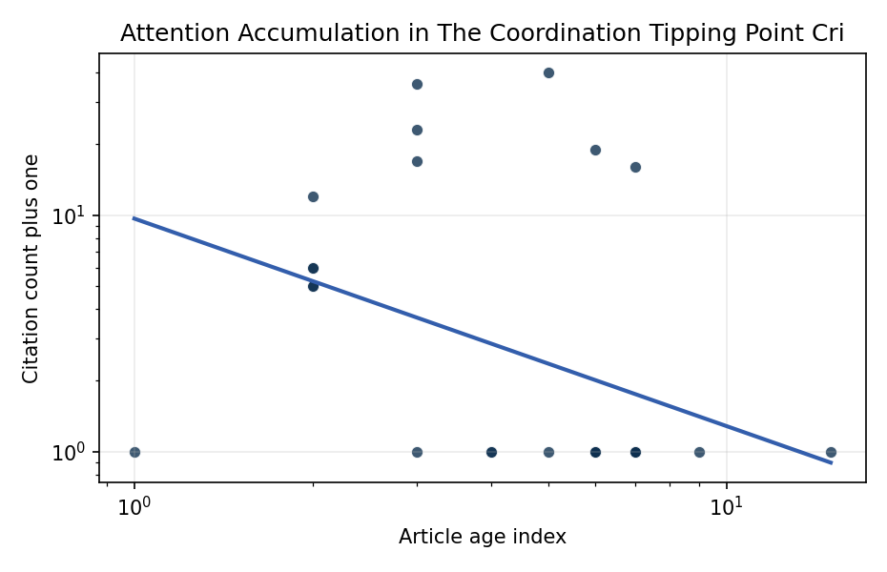
Figure 1. Citation accumulation against article age in the retrieved topic literature.

Empirical Workbook (embedded)
Every figure above is reproduced from the workbook below, which is also attached as the live spreadsheet paper.xlsx. Each observation carries its source.

Data (real observations)
doc_id | year_num | age_index | cites_num | cites_plus1 | signal_score | source
1 | 2020 | 7 | 0 | 1 | 2 | https://amostech.space/year/2020/contribution-from-ssa-data-to-the-definition-of-a-space-sustainability-rating/
2 | 2020 | 7 | 0 | 1 | 3 | https://amostech.space/year/2020/blockchain-enabled-space-traffic-awareness-besta-automated-comparison-of-ssa-to-agreed-behavior-for-discovery-of-anomalous-behavior/
3 | 2021 | 6 | 0 | 1 | 1 | https://amostech.space/year/2021/artificial-intelligence-enabled-dynamic-coalition-architecture-for-space-traffic-management/
4 | 2024 | 3 | 0 | 1 | 8 | 10.64861/RBTM5104
5 | 2021 | 6 | 0 | 1 | 3 | https://amostech.space/year/2021/decentralized-space-information-sharing-as-a-key-enabler-of-trust-and-the-preservation-of-space/
6 | 2023 | 4 | 0 | 1 | 2 | 10.64861/OHST9432
7 | 2018 | 9 | 0 | 1 | 4 | https://amostech.space/year/2018/the-governance-of-space-situational-awareness-revolution-not-evolution/
8 | 2012 | 15 | 0 | 1 | 3 | https://amostech.space/year/2012/data-handling-and-protection-of-need-to-know-data-in-a-need-to-share-net-centric-enterprise/
9 | 2021 | 6 | 0 | 1 | 8 | https://amostech.space/year/2021/risk-maps-for-conjunction-potential-throughout-the-cislunar-domain/
10 | 2020 | 7 | 0 | 1 | 5 | https://amostech.space/year/2020/optimal-incorporation-of-non-traditional-sensors-into-the-space-domain-awareness-architecture/
11 | 2023 | 4 | 0 | 1 | 1 | 10.64861/UCTN1793
12 | 2020 | 7 | 0 | 1 | 5 | https://amostech.space/year/2020/international-perspectives-on-space-weapons/
13 | 2025 | 2 | 4 | 5 | 5 | 10.1016/j.actaastro.2025.01.031
14 | 2020 | 7 | 15 | 16 | 3 | 10.1016/j.actaastro.2020.11.056
15 | 2022 | 5 | 39 | 40 | 5 | 10.1016/j.actaastro.2022.01.027
16 | 2024 | 3 | 16 | 17 | 1 | 10.1016/j.actaastro.2024.09.002
17 | 2025 | 2 | 5 | 6 | 1 | 10.1016/j.actaastro.2025.03.034
18 | 2025 | 2 | 11 | 12 | 1 | 10.1016/j.actaastro.2025.01.042
19 | 2025 | 2 | 4 | 5 | 3 | 10.1016/j.actaastro.2025.07.053
20 | 2025 | 2 | 5 | 6 | 9 | 10.1016/j.actaastro.2024.12.056
21 | 2024 | 3 | 22 | 23 | 2 | 10.1016/j.actaastro.2024.12.017
22 | 2026 | 1 | 0 | 1 | 2 | 10.1016/j.actaastro.2026.03.025
23 | 2021 | 6 | 18 | 19 | 6 | 10.1016/j.actaastro.2021.11.023
24 | 2024 | 3 | 35 | 36 | 1 | 10.1016/j.actaastro.2024.05.007
25 | 2020 | 7 | 0 | 1 | 1 | Sharing Operational Risk Information for Norms Development (AMOS)
26 | 2022 | 5 | 0 | 1 | 1 | Sharing Operational Risk Information in the Space Domain to Facilitate Norms Development and Compliance Monitoring
27 | 2020 | 7 | 0 | 1 | 5 | A 2021 Johns Hopkins SAIS doctoral thesis by Nathaniel Dailey proposing an International Space Reference Architecture (ISRA) as a socio-technological transformative mechanism to resolve contemporary space governance failures – orbital debris, policy fragmentation, and space traffic management – by coupling enterprise architecture methodology with international relations constructivist theory, blockchain-enabled information sharing, and norms entrepreneurship.
28 | 2020 | 7 | 0 | 1 | 1 | IRD Project Research Designs V2.0
29 | 2020 | 7 | 0 | 1 | 1 | The Space Imperative (Whole-of-Nation)
30 | 2020 | 7 | 0 | 1 | 4 | An IRD working paper by Dailey, Stilwell et al. (September 2024) proposing an integrated research platform that adapts the fisheries Kobe Plot methodology to orbital debris management, introduces orbital classes analogous to airspace classes, applies Elinor Ostrom’s Common Pool Resource framework to LEO governance, and couples these with the OPUS model for space policy simulation.

Variable construction
Variable | Definition | Construction / source
cites_plus1 | Citation count plus one | Computed as the reported citation count from the local brain index plus one so the log transformation is defined for uncited records
age_index | Document age index | Computed as 2026 minus publication year plus one

Estimator output
Term | Coef. | Std. err. | t | p | 95% CI
const | 2.2694 | 0.7092 | 3.1997 | 0.0014 | [0.8793, 3.6595]
_ln_x | -0.8778 | 0.4025 | -2.1809 | 0.0292 | [-1.6666, -0.0889]
Fit: N = 30 R2 = 0.1556 elasticity_b = -0.8778 progress_ratio_2^b = 0.5442

