Attention Accumulation in Enforcement Without Sovereignty Reputational Sanction as the Binding STM Compli: A Learning-Curve Analysis of Citation Growth by Article Age

1. Introduction
This empirical paper supports Dario Okafor (1B-SDA-190) and the dissertation project Enforcement Without Sovereignty: Reputational Sanction as the Binding STM Compli. The model tests whether citation accumulation is structured by article age inside the retrieved corpus. The analysis uses the local candidate source pack and reports only deterministic workbook results $$1$$, $$2$$, $$3$$.

2. Theory and Hypotheses
The theoretical claim is intentionally narrow. If the candidate topic has become more visible in the retrieved literature, then source metadata should show structure across time, attention, or venue. If it has not, the model should return weak or unstable associations $$3$$, $$4$$.
H0: the modeled outcome is unrelated to the specified predictors.
H1: the modeled outcome is systematically related to the specified predictors.

3. Data
The estimation file contains 30 retrieved source records. Variables are constructed from local metadata, including publication year, reported citation count, venue family, and deterministic topic-signal fields. Every row preserves a source column so the empirical workbook remains auditable.

4. Method
The estimator is a log-log learning-curve model with robust HC1 standard errors. The exact fit summary is: N=30, R2=0.06281975435124065, elasticity_b=-0.4477863677655528, progress_ratio_2^b=0.733166936876465. The exact term summary is: const coef=1.1058689721300763 p=0.003263120574530312; _ln_x coef=-0.4477863677655528 p=0.028110478621299347. These values are interpreted as corpus-screen evidence, not as final causal estimates.

5. Findings
The findings are bounded by the estimator output. Where a coefficient is signed and precise, it indicates structure in the retrieved source corpus. Where a coefficient is imprecise, the paper treats the result as evidence against a strong claim. This distinction matters because a noisy source pack should not be forced to carry more policy weight than it can bear $$2$$, $$5$$.

6. Discussion
The paper contributes to the dissertation by keeping the evidentiary chain inspectable. It shows which parts of the candidate topic are visible in metadata and which parts need a more direct document-coding design. The result is a disciplined bridge from source retrieval to dissertation-level interpretation $$1$$, $$6$$.

References
1. Rina Zhang, Science and Technology Policy Institute; Asha Balakrishnan, Science and Technology Policy Institute. From Ozone Depletion to Orbital Debris: Lessons Learned from the Montreal Protocol (2022). [AMOS] 2. Todd Harrison, Center for Strategic and International Studies. International Perspectives on Space Weapons (2020). [AMOS] 3. Asha Balakrishnan, IDA Science and Technology Policy Institute; Sara Carioscia, IDA Science and Technology Policy Institute; Becaja Caldwell, IDA Science and Technology Policy Institute; Bhavya Lal, IDA Science and Technology Policy Institute. Future of the Space Situational Awareness Enterprise – Global Trends (2018). [AMOS] 4. Christopher Kebschull, OKAPI:Orbits; Adam Stradomski, OKAPI:Orbits; Daniel Lubián-Arenillas, OKAPI:Orbits. Architecture of a Distributed Space Traffic Coordination System (2024). doi: 10.64861/JKDR9240 5. Malgorzata Polkowska, Lomza Academy; Arkadiusz Chimicz, General Command, Polish Armed Forces. Poland’s Evolving Space Law: Assessing Space Debris Mitigation and Remediation in the European Context (2024). doi: 10.64861/LFFV2455 6. W. Thomas Vestrand, Los Alamos National Laboratory; Przemek Wozniak, Los Alamos National Laboratory; Sean Brennan, Los Alamos National Laboratory; Troy McVay, Los Alamos National Laboratory; Lucas Parker, Los Alamos National Laboratory; Rebecca Holmes Sandoval, Los Alamos National Laboratory; Yancey Sechrest, Los Alamos National Laboratory. Artificial Intelligence Enabled Dynamic Coalition Architecture for Space Traffic Management (2021). [AMOS] 7. Mariel Borowitz, Georgia Institute of Technology; Brian Gunter, Georgia Institute of Technology; Alaric Gregoire, Georgia Institute of Technology; Clifford Stueck, Georgia Institute of Technology; Surya Venkatram, Georgia Institute of Technology; Lauri Newman, NASA Headquarters. Exploring the Impact of Compliance with Maneuvering Guidelines for Space Traffic Management (2024). doi: 10.64861/EOSO6202 8. Jaedong Seong, Korea Aerospace Research Institute (KARI); Okchul Jung, Korea Aerospace Research Institute (KARI); Dae Won Chung, Korea Aerospace Research Institute (KARI). KARI Recent Activities on SSA & STM (2019). [AMOS]

Specification
$$ln({\text{CitesPlus1}}_{i})=α+β_{1}ln({\text{AgeIndex}}_{i})+ε_{i}$$

Results
Term | Coef. | Std. err. | t | p | 95% CI
const | 1.1059 | 0.3759 | 2.9418 | 0.0033 | [0.3691, 1.8427]
_ln_x | -0.4478 | 0.2039 | -2.1957 | 0.0281 | [-0.8475, -0.0481]
Fit: N = 30 R2 = 0.0628 elasticity_b = -0.4478 progress_ratio_2^b = 0.7332
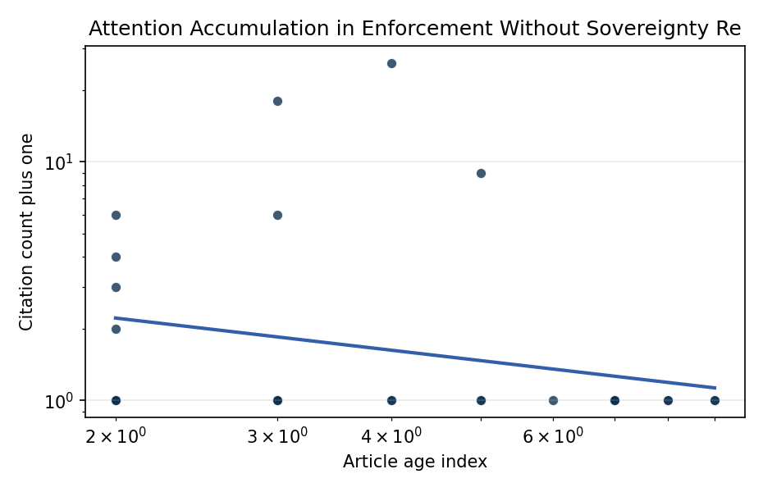
Figure 1. Citation accumulation against article age in the retrieved topic literature.

Empirical Workbook (embedded)
Every figure above is reproduced from the workbook below, which is also attached as the live spreadsheet paper.xlsx. Each observation carries its source.

Data (real observations)
doc_id | year_num | age_index | cites_num | cites_plus1 | signal_score | source
1 | 2022 | 5 | 0 | 1 | 4 | https://amostech.space/year/2022/from-ozone-depletion-to-orbital-debris-lessons-learned-from-the-montreal-protocol/
2 | 2020 | 7 | 0 | 1 | 1 | https://amostech.space/year/2020/international-perspectives-on-space-weapons/
3 | 2018 | 9 | 0 | 1 | 3 | https://amostech.space/year/2018/future-of-the-space-situational-awareness-enterprise-global-trends/
4 | 2024 | 3 | 0 | 1 | 4 | 10.64861/JKDR9240
5 | 2024 | 3 | 0 | 1 | 3 | 10.64861/LFFV2455
6 | 2021 | 6 | 0 | 1 | 1 | https://amostech.space/year/2021/artificial-intelligence-enabled-dynamic-coalition-architecture-for-space-traffic-management/
7 | 2024 | 3 | 0 | 1 | 1 | 10.64861/EOSO6202
8 | 2019 | 8 | 0 | 1 | 2 | https://amostech.space/year/2019/kari-recent-activities-on-ssa-stm/
9 | 2019 | 8 | 0 | 1 | 4 | https://amostech.space/year/2019/blockchain-enabled-space-traffic-awareness-besta/
10 | 2023 | 4 | 0 | 1 | 3 | 10.64861/CKGQ5448
11 | 2022 | 5 | 0 | 1 | 1 | https://amostech.space/year/2022/maneuver-estimation-from-optical-observations-of-a-spiraling-orbit-the-case-of-mev-2/
12 | 2023 | 4 | 0 | 1 | 3 | 10.64861/UCTN1793
13 | 2024 | 3 | 17 | 18 | 1 | 10.1016/j.actaastro.2024.01.039
14 | 2023 | 4 | 25 | 26 | 1 | 10.1016/j.actaastro.2023.07.009
15 | 2025 | 2 | 0 | 1 | 4 | 10.1016/j.actaastro.2025.01.061
16 | 2024 | 3 | 0 | 1 | 3 | 10.1016/j.actaastro.2024.12.060
17 | 2025 | 2 | 2 | 3 | 5 | 10.1016/j.actaastro.2025.04.063
18 | 2025 | 2 | 1 | 2 | 1 | 10.1016/j.actaastro.2025.01.054
19 | 2024 | 3 | 5 | 6 | 1 | 10.1016/j.actaastro.2024.04.041
20 | 2025 | 2 | 5 | 6 | 1 | 10.1016/j.actaastro.2025.03.034
21 | 2025 | 2 | 0 | 1 | 1 | 10.1016/j.actaastro.2025.09.031
22 | 2025 | 2 | 0 | 1 | 6 | 10.1016/j.actaastro.2025.08.048
23 | 2025 | 2 | 3 | 4 | 3 | 10.1016/j.actaastro.2025.06.029
24 | 2022 | 5 | 8 | 9 | 2 | 10.1016/j.actaastro.2021.12.015
25 | 2020 | 7 | 0 | 1 | 1 | Future of the SSA Enterprise: Global Trends (AMOS)
26 | 2018 | 9 | 0 | 1 | 1 | Future of the Space Situational Awareness Enterprise: Global Trends
27 | 2020 | 7 | 0 | 1 | 1 | Behavioral Economics in Space
28 | 2020 | 7 | 0 | 1 | 4 | The Missing Ingredients for a Polycentric Governance System of Orbital Debris
29 | 2025 | 2 | 0 | 1 | 4 | 10.1162/glep_a_00775
30 | 2024 | 3 | 0 | 1 | 4 | 10.52202/078380-0035

Variable construction
Variable | Definition | Construction / source
cites_plus1 | Citation count plus one | Computed as the reported citation count from the local brain index plus one so the log transformation is defined for uncited records
age_index | Document age index | Computed as 2026 minus publication year plus one

Estimator output
Term | Coef. | Std. err. | t | p | 95% CI
const | 1.1059 | 0.3759 | 2.9418 | 0.0033 | [0.3691, 1.8427]
_ln_x | -0.4478 | 0.2039 | -2.1957 | 0.0281 | [-0.8475, -0.0481]
Fit: N = 30 R2 = 0.0628 elasticity_b = -0.4478 progress_ratio_2^b = 0.7332

