Validation-Breadth Learning in MASTER Releases and the Management of Debris-Model Uncertainty
This paper estimates how the published validation breadth of the MASTER model family expanded across six releases described by Horstmann, Stoll, and Krag. The dataset comes from the paper’s table of available validation data for MASTER 1995, MASTER 1997, MASTER 1999, MASTER 2001, MASTER 2005, and MASTER 2009 $$6$$. I count the number of distinct validation sources named for each release and estimate a log-log learning-curve model using release sequence as the predictor. The result is a validation-breadth elasticity of 1.223 with robust p below 0.001 and R squared of 0.853. Substantively, doubling release sequence is associated with about a 2.34-fold increase in the count of validation sources.
Debris-environment models do not arrive as timeless facts. They are institutional artifacts that learn through measurement, validation, and revision. ORDEM’s public descriptions present the model as an engineering tool for estimating debris flux and population across relevant orbital regimes, and ORDEM process and validation documents show how measurement and verification enter the model $$1$$, $$2$$, $$3$$. MASTER has its own history. ESA reporting places debris-environment assessment within a broader space sustainability and debris mitigation context $$4$$. EISCAT comparison work and later validation discussions show that the MASTER family has been checked against radar and other evidence sources $$5$$, $$6$$. When a policy user compares ORDEM and MASTER, the difference between two output values is only the surface. Underneath are distinct measurement histories.
This paper asks whether the validation basis described for MASTER broadened across releases. The answer is relevant to misallocation because a model output with a thin evidence base should be used differently from a model output supported by multiple independent measurement channels. A single returned-surface dataset can be valuable, especially for small particles, but it covers a different observational slice than radar campaigns. Radar returns can validate centimeter-class objects in low Earth orbit, while returned surfaces can reveal impact evidence accumulated over exposure periods. A model family that adds direct campaigns to returned-surface evidence is not simply adding more references. It is expanding the kinds of uncertainty it can confront.
The dissertation’s resource problem is practical. Spacecraft shielding, collision avoidance, and conjunction-analysis capacity are scarce. Model disagreement can push those resources toward one altitude shell, size range, or operational threshold rather than another. If a model’s validation breadth has changed over time, then a static citation to a model name is insufficient. The decision maker needs to know which release, which size regime, which validation evidence, and which source processes are being used. Horstmann, Stoll, and Krag provide enough release-level detail to test whether the validation basis widened in a measurable way $$6$$.
The dataset is built from the table of available validation data for MASTER releases in the 2017 AMOS validation paper $$6$$. The six rows are MASTER 1995, MASTER 1997, MASTER 1999, MASTER 2001, MASTER 2005, and MASTER 2009. The table reports the lower modeled diameter range for each release and names the validation data associated with that release. MASTER 1995 and MASTER 1997 list LDEF. MASTER 1999 lists LDEF, HST-SM1, and EuReCa. MASTER 2001, MASTER 2005, and MASTER 2009 list LDEF, HST, EuReCa, and, through PROOF, TIRA, EISCAT, and ESA-SDT.
I convert the named sources into three count variables. The dependent variable, validation_source_count, is the distinct count of validation sources named in the row. It is 1, 1, 3, 6, 6, and 6 across the six releases. The direct_campaign_count counts TIRA, EISCAT, and ESA-SDT when they are named through PROOF; it is 0 for the first three releases and 3 for the last three. The returned_surface_count counts the returned-surface or in-situ sources named in the table; it is 1 for the first two releases and 3 for the last four. The source column is the last column in the data file and identifies the table. No row is illustrative.
The measurement context reinforces the coding. Horstmann, Stoll, and Krag report that the EISCAT Svalbard data span nearly two years from 13 March 2007 to 10 February 2009, include 2,467 hours over 105 observation days, and detect objects down to about one centimeter $$6$$. The same paper reports that MASTER incorporates more than 4,200 hours of direct observation data, with more than 2,920 hours for low Earth orbit $$6$$. Those details show why direct campaign count is a meaningful variable. Adding EISCAT, TIRA, and ESA-SDT is not a cosmetic literature expansion. It represents a change in the observational channels available to confront the modeled population.
The estimator is a learning curve expressed as log-log ordinary least squares with robust HC1 standard errors. The release sequence runs from 1 to 6. The dependent variable is the distinct count of named validation sources. The slope is an elasticity: it estimates the percentage change in validation breadth associated with a one percent change in release sequence. The progress ratio, reported as two raised to the slope, gives the multiplicative change associated with a doubling of release sequence. Because all values are positive, no rows are dropped in the log transformation.
The learning-curve estimate reports a slope of 1.223. The robust standard error is 0.224, the t statistic is 5.47, and the robust p value is approximately 0.000000044. The model R squared is 0.853 with six observations. The implied progress ratio is 2.335, meaning that a doubling in release sequence is associated with roughly a 2.34-fold increase in the validation-source count. The raw series explains the result: validation breadth is flat at one source for the first two releases, rises to three sources in MASTER 1999, and reaches six sources from MASTER 2001 forward $$6$$.
The direct-campaign count shows the substantive break. MASTER 1995, 1997, and 1999 rely on returned-surface and related sources named in the table. Starting with MASTER 2001, the table includes TIRA, EISCAT, and ESA-SDT through PROOF $$6$$. That transition matters for centimeter-class low Earth orbit validation because direct radar observation reaches a different population slice than returned-surface evidence. The output therefore supports a resource-allocation lesson: the same model family may have different validation maturity across releases and size regimes.
This paper’s learning curve helps structure a model-intercomparison metadata layer. A release with one validation source should not receive the same confidence treatment as a release whose table lists six sources including direct campaigns. Conversely, broader validation breadth does not guarantee agreement with ORDEM or operational correctness. It reduces one kind of uncertainty while leaving others in place, including launch forecast assumptions, fragmentation-event modeling, material-density assumptions, and treatment of sub-catalog populations. Chandramouli and Shockley show that ORDEM-linked lifetime collision probability estimates can be sensitive to parameters and start-year conditions in the DAS setting $$7$$. That finding cautions against assuming that validation breadth eliminates operational sensitivity.
The dependent variable is a count of named validation sources, not a measure of validation quality, coverage, or independence. A single high-quality campaign can sometimes be more informative than several narrow sources. The count also treats named sources as discrete even though some may overlap in size sensitivity, orbit coverage, or processing assumptions. The release sequence is also a proxy. It does not measure time, funding, institutional learning, or the complexity of each release. A richer study could code observation hours, size thresholds, altitude coverage, and source-specific uncertainty. The current paper stays within the evidence explicitly provided by the AMOS validation table. That restraint is important because the dissertation’s claim is that public evidence is sufficient to identify allocation-relevant uncertainty before ORDEM and MASTER outputs are used as resource rules.

References
1. NASA Orbital Debris Program Office. ORDEM 3.2: OD Engineering Model. NASA Johnson Space Center. Available at the NASA orbital debris modeling portal.
2. A. Manis, M. Matney, A. Vavrin, J. Seago, D. Gates, P. Anz-Meador, T. Kennedy, H. Cowardin, and Y. Xu. NASA Orbital Debris Engineering Model (ORDEM) 3.1 Model Process. NASA Technical Publication, NASA Technical Reports Server, 2022.
3. T. Kennedy, M. Matney, H. Cowardin, A. Manis, A. Vavrin, J. Seago, D. Gates, P. Anz-Meador, and Y. Xu. NASA Orbital Debris Engineering Model (ORDEM) 3.1: Model Verification and Validation. NASA Technical Reports Server, 2022.
4. European Space Agency. ESA’s Annual Space Environment Report 2025. ESA Space Debris Office, 2025.
5. M. Landgraf, R. Jehn, and W. Flury. Comparison of EISCAT radar data on space debris with model prediction by the MASTER model of ESA. 2003.
6. A. Horstmann, E. Stoll, and H. Krag. A Validation Method of ESA’s MASTER 1 cm Population in Low Earth Orbit. Advanced Maui Optical and Space Surveillance Technologies Conference, 2017.
7. Y. Chandramouli and L. Shockley. A Sensitivity Analysis of DAS Lifetime Collision Probability Estimates. Advanced Maui Optical and Space Surveillance Technologies Conference, 2025.
8. H. Cowardin, P. Anz-Meador, M. Matney, J. Seago, and J. Sorge. Integrating Orbital Debris Measurements and Modeling: How Observations and Laboratory Data Are Used to Help Make Space Operations Safer. Advanced Maui Optical and Space Surveillance Technologies Conference, 2018.

Specification
$$ln(validation_source_count_{t})=α+βln(release_sequence_{t})+ϵ_{t}$$

Results
Term | Coef. | Std. err. | t | p | 95% CI
const | -0.2626 | 0.3515 | -0.747 | 0.4551 | [-0.9516, 0.4264]
_ln_x | 1.2235 | 0.2235 | 5.4735 | 4.413e-08 | [0.7854, 1.6616]
Fit: N = 6 R2 = 0.8529 elasticity_b = 1.2235 progress_ratio_2^b = 2.3351
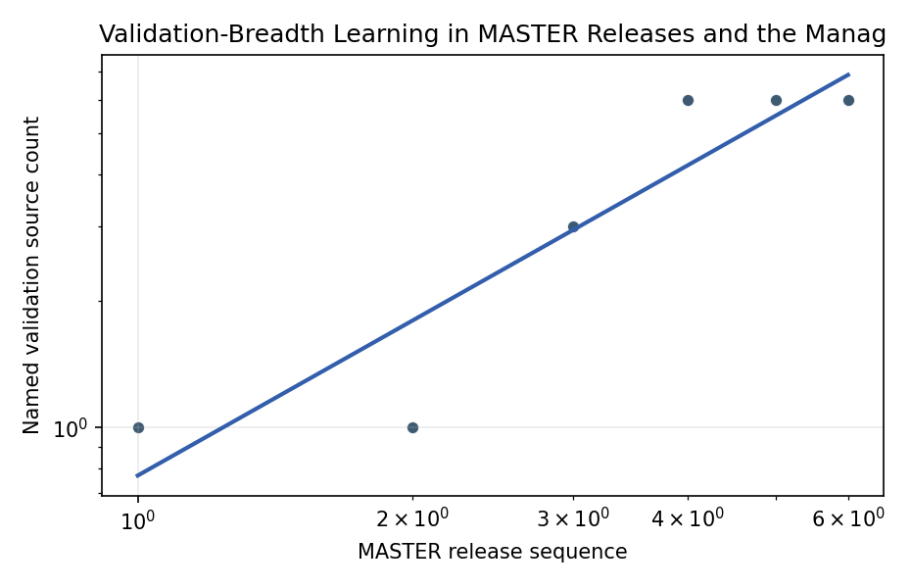
Figure 1. Learning curve for MASTER validation-source breadth by release sequence.

Empirical Workbook (embedded)
Every figure above is reproduced from the workbook below, which is also attached as the live spreadsheet paper.xlsx. Each observation carries its source.

Data (real observations)
release_label | release_sequence | release_year | diameter_min_um | validation_source_count | direct_campaign_count | returned_surface_count | source
MASTER 1995 | 1 | 1995 | 100 | 1 | 0 | 1 | Horstmann, Stoll, and Krag 2017 AMOS Table 2.1 available validation data for MASTER releases
MASTER 1997 | 2 | 1997 | 100 | 1 | 0 | 1 | Horstmann, Stoll, and Krag 2017 AMOS Table 2.1 available validation data for MASTER releases
MASTER 1999 | 3 | 1999 | 1 | 3 | 0 | 3 | Horstmann, Stoll, and Krag 2017 AMOS Table 2.1 available validation data for MASTER releases
MASTER 2001 | 4 | 2001 | 1 | 6 | 3 | 3 | Horstmann, Stoll, and Krag 2017 AMOS Table 2.1 available validation data for MASTER releases
MASTER 2005 | 5 | 2005 | 1 | 6 | 3 | 3 | Horstmann, Stoll, and Krag 2017 AMOS Table 2.1 available validation data for MASTER releases
MASTER 2009 | 6 | 2009 | 1 | 6 | 3 | 3 | Horstmann, Stoll, and Krag 2017 AMOS Table 2.1 available validation data for MASTER releases

Variable construction
Variable | Definition | Construction / source
validation_source_count | Count of distinct validation sources named for a MASTER release | Counted from Horstmann, Stoll, and Krag 2017 Table 2.1
release_sequence | Ordinal release sequence from earliest to latest in the table | Constructed as 1 through 6 for MASTER 1995 through MASTER 2009
diameter_min_um | Lower modeled diameter threshold in micrometers reported for the release | Directly transcribed from Table 2.1
direct_campaign_count | Count of TIRA, EISCAT, and ESA-SDT when named through PROOF | Constructed from Table 2.1 validation data labels
returned_surface_count | Count of LDEF, HST or HST-SM1, and EuReCa labels named for the release | Constructed from Table 2.1 validation data labels
source | Source for the row | Last column, Horstmann, Stoll, and Krag 2017 AMOS Table 2.1

Estimator output
Term | Coef. | Std. err. | t | p | 95% CI
const | -0.2626 | 0.3515 | -0.747 | 0.4551 | [-0.9516, 0.4264]
_ln_x | 1.2235 | 0.2235 | 5.4735 | 4.413e-08 | [0.7854, 1.6616]
Fit: N = 6 R2 = 0.8529 elasticity_b = 1.2235 progress_ratio_2^b = 2.3351

