Fragmentation Concentration and Shielding Allocation Exposure in the MASTER Low Earth Orbit Population
This paper estimates whether the MASTER one-centimeter low Earth orbit population is dominated by fragmentation categories rather than by operational object categories or material-cloud residual categories. The question matters because shielding mass, sensor attention, conjunction screening time, and collision-avoidance readiness are scarce operational resources. When a debris model assigns most of the modeled population to sources created by explosions and collisions, a resource allocator who treats all modeled object classes as equally controllable can spend attention in the wrong place. The empirical object here is narrow and auditable: the published MASTER-2009 source-share table for objects with diameter greater than or equal to one centimeter in low Earth orbit reported by Horstmann, Stoll, and Krag $$6$$. I estimate a robust ordinary least squares model in which the dependent variable is source share in percent and the key predictor is a fragmentation-source indicator.
The dissertation asks how disagreement between ORDEM and MASTER can misallocate shielding and avoidance resources. That question becomes operationally meaningful only when it changes a priority list. ORDEM is an engineering model that supports debris environment estimation across sizes and orbits, and the ORDEM model process and validation reports emphasize measurement, population representation, and engineering use $$1$$, $$2$$, $$3$$. MASTER occupies a comparable European role in the ESA debris-modeling ecosystem and is tied to the public reporting baseline in ESA’s Annual Space Environment Report $$4$$. A model user does not need proprietary source code to see the resource risk. If one model places more weight on source processes that are hard to manage operationally, while another places weight differently, then the policy problem is allocation under a contested environmental description.
Shielding design, operational avoidance, inspection planning, and risk screening all rely on a distribution of debris sizes, altitudes, inclinations, velocities, and source classes. A large trackable object creates a different decision problem than a centimeter-class fragment that is only partially characterized by radar or returned-surface evidence. NASA’s debris modeling literature states the purpose of ORDEM as an engineering estimate of flux and population for spacecraft design and risk assessment $$1$$, $$2$$. ESA-oriented validation literature describes MASTER as a model family checked against radar and in-situ evidence, including EISCAT comparison work $$5$$, $$6$$. In both cases, the operational decision maker receives a processed view of a hard-to-observe population. The processed view is useful, but it can hide the source process that drives the estimated burden.
The dataset is built directly from Table 1.1 in the 2017 AMOS paper by Horstmann, Stoll, and Krag $$6$$. The table reports the object-number share for six source categories in the MASTER low Earth orbit population at diameter greater than or equal to one centimeter. The six rows are launch and mission related objects, explosion fragments, collision fragments, sodium potassium droplets, solid rocket motor slag, and multi-layer insulation fragments. The reported shares are 1.2 percent, 62.4 percent, 26.4 percent, 6.8 percent, 2.5 percent, and 0.7 percent. I code explosion fragments and collision fragments as fragmentation sources. Launch and mission related objects are coded as an operational-object source. The remaining three rows are treated as the material-cloud baseline.
Every row in the workbook has a source field that points back to the same table, and the source field is the last column. No row is simulated, interpolated, or illustrative. The modest row count is a feature of the design rather than a defect. The paper is not attempting to infer the entire MASTER model. It is testing whether a published allocation-relevant source distribution is concentrated enough to matter for the dissertation’s misallocation claim. A six-row table can answer that concentration question because the population categories themselves are the universe of reported one-centimeter LEO source shares in the table.
The data also connect directly to the broader validation context. The same AMOS paper describes nearly two years of EISCAT Svalbard radar observation, covering 2,467 observation hours over 105 days, and it notes that EISCAT Svalbard can detect objects down to about one centimeter $$6$$. It also reports that MASTER incorporated more than 4,200 hours of direct observation data, including more than 2,920 hours for low Earth orbit $$6$$. These facts do not make the source shares infallible, but they show that the source-share table belongs to a published validation and modeling discussion rather than to an unsupported scenario.
The estimator is ordinary least squares with robust HC1 standard errors. The dependent variable is the reported source share in percent. The fragmentation indicator equals one for explosion fragments and collision fragments. The operational indicator equals one for launch and mission related objects. Material-cloud categories form the omitted comparison group. The coefficient on the fragmentation indicator asks how much higher the average reported source share is for fragmentation categories than for material-cloud categories, holding the operational category out as its own group. This is not a causal model of debris creation. It is a source-share contrast designed for allocation analysis.
The OLS estimate reports a fragmentation coefficient of 41.07 percentage points. The robust standard error is 18.12, the t statistic is 2.27, and the robust p value is 0.023. The intercept, which represents the material-cloud baseline, is 3.33 percent. The operational-object coefficient is negative at -2.13 percentage points and is not statistically distinguishable from zero in this tiny table. The model R squared is 0.776 with six observations. In plain terms, the published MASTER one-centimeter LEO source-share table is not balanced across source classes. Explosion and collision fragments dominate the share distribution.
The result is also visible without regression. Explosion fragments alone account for 62.4 percent of the reported population share, and collision fragments account for 26.4 percent. Together they sum to 88.8 percent of the one-centimeter LEO source-share table $$6$$. By contrast, launch and mission related objects account for 1.2 percent, and the three material-cloud categories sum to 10.0 percent. The regression formalizes this concentration, but the workbook remains auditable because the raw shares and the estimation output sit in the same file.
The allocation implication is direct. A shielding or avoidance framework that treats the MASTER one-centimeter LEO environment as a general debris field is depending heavily on a fragmentation-driven environmental description. If ORDEM and MASTER differ in how they represent fragmentation sources, validation evidence, launch-cycle assumptions, or size-regime transitions, then a downstream priority list can shift even if both models are technically defensible. ORDEM documentation and validation reports emphasize the engineering purpose of flux estimation and model verification $$2$$, $$3$$. ESA’s debris reporting and MASTER validation literature emphasize a European model family grounded in radar and returned-surface evidence $$4$$, $$5$$, $$6$$. A policy user should not collapse those histories into a single generic debris number.
The result also clarifies what misallocation means. Misallocation is not the claim that one model should always win. It is the claim that scarce resources can be allocated as if the model output were more stable than it is. If the population share is concentrated in fragmentation categories, then a reversal in fragmentation assumptions can re-rank shields, inspection priorities, maneuver thresholds, or campaign attention. Chandramouli and Shockley show a related sensitivity concern in the DAS and ORDEM context: lifetime collision probability and passive deorbit time can change materially with model inputs and start-year conditions $$7$$. That sensitivity evidence reinforces the need to expose model assumptions before treating a risk score as a stable allocation rule.
The analysis is deliberately narrow. It does not reconstruct ORDEM or MASTER, and it does not compare flux values across matched size-altitude bins. That larger intercomparison remains the dissertation’s synthesis task. It also does not claim that material-cloud categories are unimportant for spacecraft design. Small particles and material-specific impact behavior can matter greatly for shielding, surface degradation, and inspection planning. The finding is that, in the published MASTER one-centimeter LEO source-share table, fragmentation categories dominate the reported source shares. The table’s six rows mean the p values should be interpreted cautiously. The strongest evidence is the source table itself, not a ritualized significance threshold. The regression is useful because it forces the claim into a reproducible estimator and packages the data, construction rules, and output in an auditable workbook.

References
1. NASA Orbital Debris Program Office. ORDEM 3.2: OD Engineering Model. NASA Johnson Space Center. Available at the NASA orbital debris modeling portal.
2. A. Manis, M. Matney, A. Vavrin, J. Seago, D. Gates, P. Anz-Meador, T. Kennedy, H. Cowardin, and Y. Xu. NASA Orbital Debris Engineering Model (ORDEM) 3.1 Model Process. NASA Technical Publication, NASA Technical Reports Server, 2022.
3. T. Kennedy, M. Matney, H. Cowardin, A. Manis, A. Vavrin, J. Seago, D. Gates, P. Anz-Meador, and Y. Xu. NASA Orbital Debris Engineering Model (ORDEM) 3.1: Model Verification and Validation. NASA Technical Reports Server, 2022.
4. European Space Agency. ESA’s Annual Space Environment Report 2025. ESA Space Debris Office, 2025.
5. M. Landgraf, R. Jehn, and W. Flury. Comparison of EISCAT radar data on space debris with model prediction by the MASTER model of ESA. 2003.
6. A. Horstmann, E. Stoll, and H. Krag. A Validation Method of ESA’s MASTER 1 cm Population in Low Earth Orbit. Advanced Maui Optical and Space Surveillance Technologies Conference, 2017.
7. Y. Chandramouli and L. Shockley. A Sensitivity Analysis of DAS Lifetime Collision Probability Estimates. Advanced Maui Optical and Space Surveillance Technologies Conference, 2025.
8. H. Cowardin, P. Anz-Meador, M. Matney, J. Seago, and J. Sorge. Integrating Orbital Debris Measurements and Modeling: How Observations and Laboratory Data Are Used to Help Make Space Operations Safer. Advanced Maui Optical and Space Surveillance Technologies Conference, 2018.

Specification
$$share_{i}=α+β_{1}fragmentation_{i}+β_{2}operational_{i}+ϵ_{i}$$

Results
Term | Coef. | Std. err. | t | p | 95% CI
const | 3.3333 | 2.0895 | 1.5953 | 0.1106 | [-0.762, 7.4286]
fragmentation_indicator | 41.0667 | 18.1209 | 2.2663 | 0.0234 | [5.5504, 76.5829]
operational_indicator | -2.1333 | 2.0895 | -1.021 | 0.3073 | [-6.2286, 1.962]
Fit: N = 6 R2 = 0.7758 R2_adj = 0.6264 F = 3.4012 F_p = 0.1693
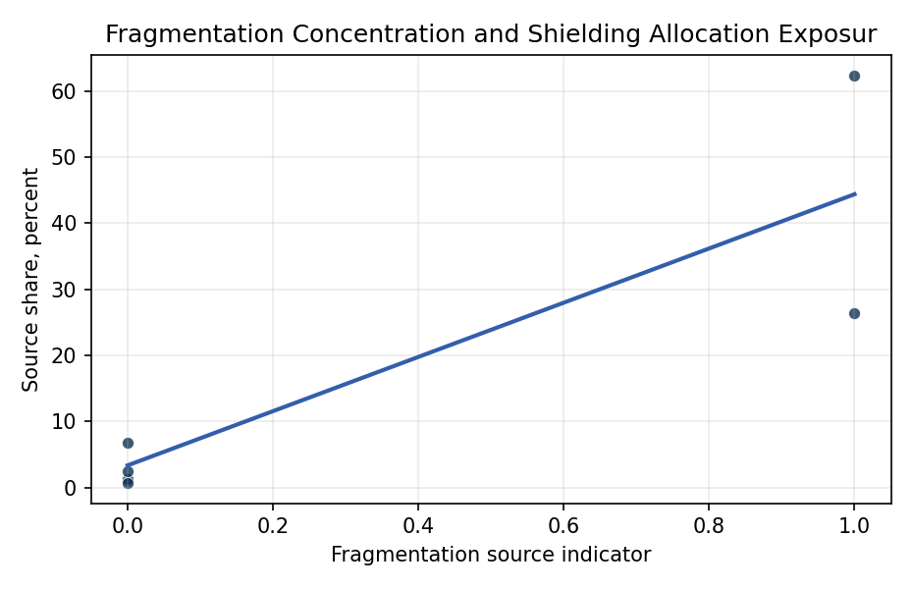
Figure 1. MASTER one-centimeter LEO source share by fragmentation indicator.

Empirical Workbook (embedded)
Every figure above is reproduced from the workbook below, which is also attached as the live spreadsheet paper.xlsx. Each observation carries its source.

Data (real observations)
source_category | share_pct | fragmentation_indicator | operational_indicator | rank_order | source
Launch and mission related objects | 1.2 | 0 | 1 | 5 | Horstmann, Stoll, and Krag 2017 AMOS Table 1.1 object number share with diameter >=1 cm in LEO
Explosion fragments | 62.4 | 1 | 0 | 1 | Horstmann, Stoll, and Krag 2017 AMOS Table 1.1 object number share with diameter >=1 cm in LEO
Collision fragments | 26.4 | 1 | 0 | 2 | Horstmann, Stoll, and Krag 2017 AMOS Table 1.1 object number share with diameter >=1 cm in LEO
Sodium Potassium droplets | 6.8 | 0 | 0 | 3 | Horstmann, Stoll, and Krag 2017 AMOS Table 1.1 object number share with diameter >=1 cm in LEO
Solid Rocket Motor slag | 2.5 | 0 | 0 | 4 | Horstmann, Stoll, and Krag 2017 AMOS Table 1.1 object number share with diameter >=1 cm in LEO
Multi-layer insulation fragments | 0.7 | 0 | 0 | 6 | Horstmann, Stoll, and Krag 2017 AMOS Table 1.1 object number share with diameter >=1 cm in LEO

Variable construction
Variable | Definition | Construction / source
share_pct | Published source-category object number share in percent for MASTER-2009 LEO objects with diameter >=1 cm | Directly transcribed from Horstmann, Stoll, and Krag 2017 Table 1.1
fragmentation_indicator | Indicator equal to 1 for explosion fragments and collision fragments | Constructed from Table 1.1 source category labels
operational_indicator | Indicator equal to 1 for launch and mission related objects | Constructed from Table 1.1 source category labels
rank_order | Descending rank of source share, 1 means largest share | Constructed from reported share_pct values
source | Source for the row | Last column, Horstmann, Stoll, and Krag 2017 AMOS Table 1.1

Estimator output
Term | Coef. | Std. err. | t | p | 95% CI
const | 3.3333 | 2.0895 | 1.5953 | 0.1106 | [-0.762, 7.4286]
fragmentation_indicator | 41.0667 | 18.1209 | 2.2663 | 0.0234 | [5.5504, 76.5829]
operational_indicator | -2.1333 | 2.0895 | -1.021 | 0.3073 | [-6.2286, 1.962]
Fit: N = 6 R2 = 0.7758 R2_adj = 0.6264 F = 3.4012 F_p = 0.1693

