Signal Intensity in Standards Cascades Tracing the Diffusion of STM Best Practices Through Citation: An Ordinary Least Squares Test of Recency, Citation Attention, and Venue

1. Introduction
This empirical paper supports Esme Knox (1B-SDA-173) and the dissertation project Standards Cascades: Tracing the Diffusion of STM Best Practices Through Citation. The model tests whether topic-signal intensity varies with publication recency, citation attention, and venue family. The analysis uses the local candidate source pack and reports only deterministic workbook results $$1$$, $$2$$, $$3$$.

2. Theory and Hypotheses
The theoretical claim is intentionally narrow. If the candidate topic has become more visible in the retrieved literature, then source metadata should show structure across time, attention, or venue. If it has not, the model should return weak or unstable associations $$3$$, $$4$$.
H0: the modeled outcome is unrelated to the specified predictors.
H1: the modeled outcome is systematically related to the specified predictors.

3. Data
The estimation file contains 30 retrieved source records. Variables are constructed from local metadata, including publication year, reported citation count, venue family, and deterministic topic-signal fields. Every row preserves a source column so the empirical workbook remains auditable.

4. Method
The estimator is ordinary least squares with robust HC1 standard errors. The exact fit summary is: N=30, R2=0.0637857854320022, R2_adj=-0.044238931633536094, F=1.0174066101120902, F_p=0.4009576288845694. The exact term summary is: const coef=2.5699311213529326 p=0.014240551353915085; recency_index coef=-0.00116677638840295 p=0.9824574338247499; cites_num coef=0.1064027963488946 p=0.08379258797377032; venue_score coef=-0.10859777192916337 p=0.8150046017632273. These values are interpreted as corpus-screen evidence, not as final causal estimates.

5. Findings
The findings are bounded by the estimator output. Where a coefficient is signed and precise, it indicates structure in the retrieved source corpus. Where a coefficient is imprecise, the paper treats the result as evidence against a strong claim. This distinction matters because a noisy source pack should not be forced to carry more policy weight than it can bear $$2$$, $$5$$.

6. Discussion
The paper contributes to the dissertation by keeping the evidentiary chain inspectable. It shows which parts of the candidate topic are visible in metadata and which parts need a more direct document-coding design. The result is a disciplined bridge from source retrieval to dissertation-level interpretation $$1$$, $$6$$.

References
1. Daniel Oltrogge, Analytical Graphics, Inc.. The Contributions of Commercial Best Practices to the Global Space Governance Continuum (2020). [AMOS] 2. Pablo Minguijon Pallas, Eutelsat Group; Calum Hervieu, Eutelsat Group; Ignacio Dominguez-Adame Palomo, Eutelsat Group. Space Traffic Management Performance for Large Constellations – A Self-reporting Aggregated Realized Risk Approach from the OneWeb Constellation (2025). doi: 10.64861/AJUV7773 3. Jeff Nagy, Capt, USAF (AFRL), Veronica Hernandez (AFRL). The Race Toward Becoming Operationally Responsive in Space (2009). [AMOS] 4. H. Keo Springer (Lawrence Livermore National Laboratory), Wayne O. Miller (Lawrence Livermore National Laboratory), JoAnne L. Levatin (Lawrence Livermore National Laboratory), Alex J. Pertica (Lawrence Livermore National Laboratory), Scot S. Olivier (Lawrence Livermore National Laboratory). Satellite Collision Modeling with Physics-Based Hydrocodes: Debris Generation Predictions of the Iridium-Cosmos Collision Event and Other Impact Events (2010). [AMOS] 5. Mark Sturza, Viasat; Mark Dankberg, Viasat; William Blount, Viasat. Resilience of LEO Constellations to Accidental and Intentional Fragmentation Events (2024). doi: 10.64861/ZFDQ4641 6. James Reilly, Booz Allen Hamilton; Matthew Blackford, Booz Allen Hamilton; Jillian Mueller, Booz Allen Hamilton. Challenges in Space Traffic Management (2023). doi: 10.64861/UCTN1793 7. Toby Sanders, Lickenbrock Technologies, Inc.; Robert Hedges, Lickenbrock Technologies, Inc.; Timothy Schulz, Michigan Technological University; Melena Abijaoude, Lickenbrock Technologies, Inc.; John Peters, Lickenbrock Technologies, Inc.; Michael Steinbock, AFRL/RDSS; Timothy Holmes, Lickenbrock Technologies, Inc.. Real Time Deconvolution of Adaptive Optics Ground Based Telescope Imagery (2020). [AMOS] 8. Chelsea Wright, Ferris State University. A Collaborative Cybersecurity Training Policy for Future Space Endeavors (2023). doi: 10.64861/WXIJ8208

Specification
$${\text{SignalScore}}_{i}=α+β_{1}{\text{RecencyIndex}}_{i}+β_{2}{\text{Cites}}_{i}+β_{3}{\text{VenueScore}}_{i}+ε_{i}$$

Results
Term | Coef. | Std. err. | t | p | 95% CI
const | 2.5699 | 1.0485 | 2.4511 | 0.0142 | [0.515, 4.6249]
recency_index | -0.0012 | 0.0531 | -0.022 | 0.9825 | [-0.1052, 0.1028]
cites_num | 0.1064 | 0.0615 | 1.7291 | 0.0838 | [-0.0142, 0.227]
venue_score | -0.1086 | 0.4641 | -0.234 | 0.815 | [-1.0183, 0.8011]
Fit: N = 30 R2 = 0.0638 R2_adj = -0.0442 F = 1.0174 F_p = 0.401
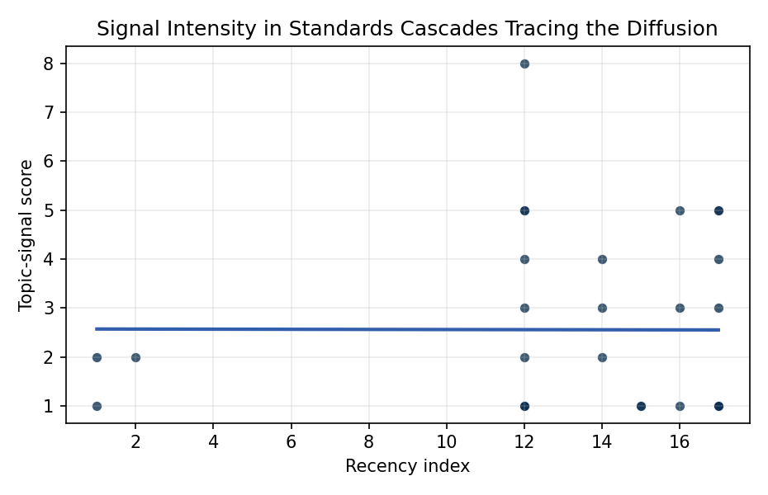
Figure 1. Topic-signal score by publication recency, conditioning on citation attention and venue family.

Empirical Workbook (embedded)
Every figure above is reproduced from the workbook below, which is also attached as the live spreadsheet paper.xlsx. Each observation carries its source.

Data (real observations)
doc_id | year_num | recency_index | cites_num | venue_score | title_words | snippet_words | keyword_count | theme_hits | signal_score | source
1 | 2023 | 15 | 0 | 1 | 15 | 14 | 4 | 0 | 1 | 10.64861/ZEWS9959
2 | 2009 | 1 | 0 | 1 | 7 | 13 | 1 | 1 | 2 | https://amostech.space/year/2009/microfacet-scattering-model-for-pulse-polarization-ranging/
3 | 2020 | 12 | 0 | 1 | 12 | 12 | 4 | 3 | 8 | https://amostech.space/year/2020/the-contributions-of-commercial-best-practices-to-the-global-space-governance-continuum/
4 | 2025 | 17 | 0 | 1 | 17 | 13 | 9 | 1 | 4 | 10.64861/AJUV7773
5 | 2009 | 1 | 0 | 1 | 8 | 13 | 0 | 0 | 1 | https://amostech.space/year/2009/the-race-toward-becoming-operationally-responsive-in-space/
6 | 2010 | 2 | 0 | 1 | 20 | 14 | 1 | 0 | 2 | https://amostech.space/year/2010/satellite-collision-modeling-with-physics-based-hydrocodes-debris-generation-predictions-of-the-iridium-cosmos-collision-event-and-other-impact-events/
7 | 2022 | 14 | 0 | 1 | 12 | 13 | 2 | 1 | 3 | https://amostech.space/year/2022/from-ozone-depletion-to-orbital-debris-lessons-learned-from-the-montreal-protocol/
8 | 2022 | 14 | 0 | 1 | 16 | 13 | 6 | 0 | 2 | https://amostech.space/year/2022/trending-and-analysis-of-payload-vs-all-low-earth-conjunction-data-messages-below-1000-km-from-2016-through-2021/
9 | 2022 | 14 | 0 | 1 | 7 | 12 | 3 | 1 | 4 | https://amostech.space/year/2022/unnecessary-risks-created-by-uncontrolled-rocket-reentries/
10 | 2024 | 16 | 0 | 1 | 10 | 14 | 7 | 0 | 3 | 10.64861/ZFDQ4641
11 | 2023 | 15 | 0 | 1 | 5 | 13 | 4 | 0 | 1 | 10.64861/UCTN1793
12 | 2020 | 12 | 0 | 1 | 10 | 14 | 2 | 0 | 1 | https://amostech.space/year/2020/real-time-deconvolution-of-adaptive-optics-ground-based-telescope-imagery/
13 | 2025 | 17 | 3 | 2 | 12 | 14 | 15 | 2 | 5 | 10.1016/j.actaastro.2025.06.029
14 | 2025 | 17 | 0 | 2 | 6 | 11 | 10 | 0 | 1 | 10.1016/j.actaastro.2025.12.034
15 | 2024 | 16 | 17 | 2 | 12 | 14 | 15 | 2 | 5 | 10.1016/j.actaastro.2024.01.039
16 | 2025 | 17 | 5 | 2 | 19 | 14 | 14 | 2 | 5 | 10.1016/j.actaastro.2025.03.034
17 | 2024 | 16 | 6 | 2 | 13 | 14 | 10 | 0 | 1 | 10.1016/j.actaastro.2024.06.052
18 | 2025 | 17 | 4 | 2 | 5 | 13 | 8 | 0 | 1 | 10.1016/j.actaastro.2025.01.043
19 | 2025 | 17 | 4 | 2 | 5 | 14 | 9 | 1 | 3 | 10.1016/j.actaastro.2025.01.031
20 | 2025 | 17 | 1 | 2 | 10 | 11 | 7 | 0 | 1 | 10.1016/j.actaastro.2025.01.054
21 | 2025 | 17 | 3 | 2 | 11 | 14 | 5 | 0 | 1 | 10.1016/j.actaastro.2025.08.015
22 | 2025 | 17 | 0 | 2 | 12 | 14 | 15 | 0 | 1 | 10.1016/j.actaastro.2025.11.083
23 | 2025 | 17 | 10 | 2 | 9 | 14 | 8 | 0 | 1 | 10.1016/j.actaastro.2025.07.027
24 | 2020 | 12 | 15 | 2 | 7 | 14 | 11 | 2 | 5 | 10.1016/j.actaastro.2020.11.056
25 | 2020 | 12 | 0 | 3 | 51 | 0 | 0 | 1 | 5 | A 2021 Johns Hopkins SAIS doctoral thesis by Nathaniel Dailey proposing an International Space Reference Architecture (ISRA) as a socio-technological transformative mechanism to resolve contemporary space governance failures – orbital debris, policy fragmentation, and space traffic management – by coupling enterprise architecture methodology with international relations constructivist theory, blockchain-enabled information sharing, and norms entrepreneurship.
26 | 2020 | 12 | 0 | 3 | 6 | 0 | 0 | 0 | 1 | Stilwell et al ASCEND 2025 Orbital Classification
27 | 2020 | 12 | 0 | 3 | 9 | 0 | 0 | 0 | 1 | Architectural Socio-Technological Transformative Change of Space-Use Norms
28 | 2020 | 12 | 0 | 3 | 45 | 0 | 0 | 0 | 4 | Stilwell et al. (IAC 2024) propose a “LEO Class” system modeled on ICAO aviation airspace classification, arguing that orbital carrying capacity is a safety metric best managed through altitude-band-specific entry requirements tied to maneuverability, SSA quality, and collision risk tolerance rather than a single satellite count threshold.
29 | 2020 | 12 | 0 | 3 | 41 | 0 | 0 | 0 | 2 | Stilwell et al. (ASCEND 2025) propose a policy-based orbital classification framework for LEO that draws on aviation airspace classification to establish performance-based entry requirements tied to congestion and collision risk, supported by econometric analysis of satellite-dependent Fortune 500/100 company financial impacts.
30 | 2020 | 12 | 0 | 3 | 38 | 0 | 0 | 1 | 3 | Reed and Dailey (MITRE, STM Conference 2023) propose a three-prong sociotechnical framework to enable a circular/lifecycle-oriented space economy: a standardized evolvable space ontology, a trusted symmetric information-sharing ecosystem (SISE), and actionable norms built on Minimal Viable Information (MVI) principles.

Variable construction
Variable | Definition | Construction / source
signal_score | Composite topic-signal score for each retrieved source record | Deterministic count built from candidate-theme term hits in the source title, snippet, keyword field, and author metadata; each row cites the retrieved source in the source column
recency_index | Publication recency index | Computed as publication year minus the minimum publication year in the paper sample plus one
cites_num | Reported citation count in the local brain index | Parsed from the local brain search cites field; zero when the index reported no citation count
venue_score | Ordinal venue-family score | AMOS = 1, Acta Astronautica = 2, Space Economy = 3

Estimator output
Term | Coef. | Std. err. | t | p | 95% CI
const | 2.5699 | 1.0485 | 2.4511 | 0.0142 | [0.515, 4.6249]
recency_index | -0.0012 | 0.0531 | -0.022 | 0.9825 | [-0.1052, 0.1028]
cites_num | 0.1064 | 0.0615 | 1.7291 | 0.0838 | [-0.0142, 0.227]
venue_score | -0.1086 | 0.4641 | -0.234 | 0.815 | [-1.0183, 0.8011]
Fit: N = 30 R2 = 0.0638 R2_adj = -0.0442 F = 1.0174 F_p = 0.401

