Signal Intensity in The Focal-Point Problem in Cislunar Right-of-Way Do Operators Converge on Tacit: An Ordinary Least Squares Test of Recency, Citation Attention, and Venue

1. Introduction
This empirical paper supports Kofi Zhang (1B-SDA-228) and the dissertation project The Focal-Point Problem in Cislunar Right-of-Way: Do Operators Converge on Tacit. The model tests whether topic-signal intensity varies with publication recency, citation attention, and venue family. The analysis uses the local candidate source pack and reports only deterministic workbook results $$1$$, $$2$$, $$3$$.

2. Theory and Hypotheses
The theoretical claim is intentionally narrow. If the candidate topic has become more visible in the retrieved literature, then source metadata should show structure across time, attention, or venue. If it has not, the model should return weak or unstable associations $$3$$, $$4$$.
H0: the modeled outcome is unrelated to the specified predictors.
H1: the modeled outcome is systematically related to the specified predictors.

3. Data
The estimation file contains 30 retrieved source records. Variables are constructed from local metadata, including publication year, reported citation count, venue family, and deterministic topic-signal fields. Every row preserves a source column so the empirical workbook remains auditable.

4. Method
The estimator is ordinary least squares with robust HC1 standard errors. The exact fit summary is: N=30, R2=0.5571375963777085, R2_adj=0.5060380882674441, F=22.001090703174327, F_p=2.6346643909491255e-07. The exact term summary is: const coef=6.587578845419326 p=0.0002265364432012475; recency_index coef=0.35583972995838076 p=0.03057251112915009; cites_num coef=-0.15998128191031466 p=0.00036689851504627245; venue_score coef=-2.5544501166011 p=1.3097091629932064e-09. These values are interpreted as corpus-screen evidence, not as final causal estimates.

5. Findings
The findings are bounded by the estimator output. Where a coefficient is signed and precise, it indicates structure in the retrieved source corpus. Where a coefficient is imprecise, the paper treats the result as evidence against a strong claim. This distinction matters because a noisy source pack should not be forced to carry more policy weight than it can bear $$2$$, $$5$$.

6. Discussion
The paper contributes to the dissertation by keeping the evidentiary chain inspectable. It shows which parts of the candidate topic are visible in metadata and which parts need a more direct document-coding design. The result is a disciplined bridge from source retrieval to dissertation-level interpretation $$1$$, $$6$$.

References
1. Aaron J. Rosengren, University of California San Diego. Cislunar Multiscale Dynamics and Implications for SSA (2021). [AMOS] 2. Juan Ojeda Romero, Johns Hopkins Applied Physics Lab; Wayne Schlei, Johns Hopkins University Applied Physics Laboratory; Gene Whipps, Johns Hopkins University Applied Physics Laboratory; Nicholas LaFarge, Johns Hopkins University Applied Physics Laboratory; Gunner Fritsch, Johns Hopkins University Applied Physics Laboratory; Sean Phillips, Johns Hopkins University Applied Physics Laboratory. An Adaptive Approach to the Initial Orbit Determination Problem in the Cislunar Regime Using Machine Learning (2024). doi: 10.64861/FBSC2978 3. Triet Tran, Braxton Technologies LLC. Application of a COTS Resource Optimization Framework to the SSN Sensor Tasking Domain – Part I: Problem Definition (2015). [AMOS] 4. Sam Wishnek, University of Colorado Boulder; Marcus Holzinger, University of Colorado Boulder; Patrick Handley, Ball Aerospace. Robust Cislunar Initial Orbit Determination (2021). [AMOS] 5. Jonathon Hope, Pennsylvania State University; Puneet Singla, The Pennsylvania State University; Roshan Eapen, Pennsylvania State University; Peter Kent, Peraton; Michael Goodman, Peraton; Joseph Diamond, Peraton. Multi-Order Single Shooting Scheme for Initial Orbit Determination for Cislunar Objects (2025). doi: 10.64861/TKNV3337 6. C. Channing Chow II, Cloudstone Innovations LLC; Charles J. Wetterer, KBR; Jason Baldwin, Complex Futures LLC; Micah Dilley, KBR; Keric Hill, KBR; Paul Billings, KBR; James Frith, AFRL/RVSW. Cislunar Orbit Determination Behavior: Processing Observations of Periodic Orbits with Gaussian Mixture Model Estimation Filters (2021). [AMOS] 7. Casey Heidrich, University of Colorado Boulder; Marcus Holzinger, University of Colorado Boulder. Initial Orbit Determination from Ephemeris Models: Accurate Reconstruction of Maneuvering Cislunar Orbits Using Nonlinear Programming (2025). doi: 10.64861/JDBC3555 8. Reuben Settergren, BAE Systems. Resection of Long-Range Sensor Models for Mono and Stereo Exploitation of Non-Earth Imagery (2024). doi: 10.64861/OAYK5409

Specification
$${\text{SignalScore}}_{i}=α+β_{1}{\text{RecencyIndex}}_{i}+β_{2}{\text{Cites}}_{i}+β_{3}{\text{VenueScore}}_{i}+ε_{i}$$

Results
Term | Coef. | Std. err. | t | p | 95% CI
const | 6.5876 | 1.7865 | 3.6874 | 0.0002265 | [3.0861, 10.0891]
recency_index | 0.3558 | 0.1645 | 2.1626 | 0.0306 | [0.0333, 0.6783]
cites_num | -0.16 | 0.0449 | -3.5628 | 0.0003669 | [-0.248, -0.072]
venue_score | -2.5545 | 0.4211 | -6.0662 | 1.31e-09 | [-3.3798, -1.7291]
Fit: N = 30 R2 = 0.5571 R2_adj = 0.506 F = 22.0011 F_p = 2.635e-07
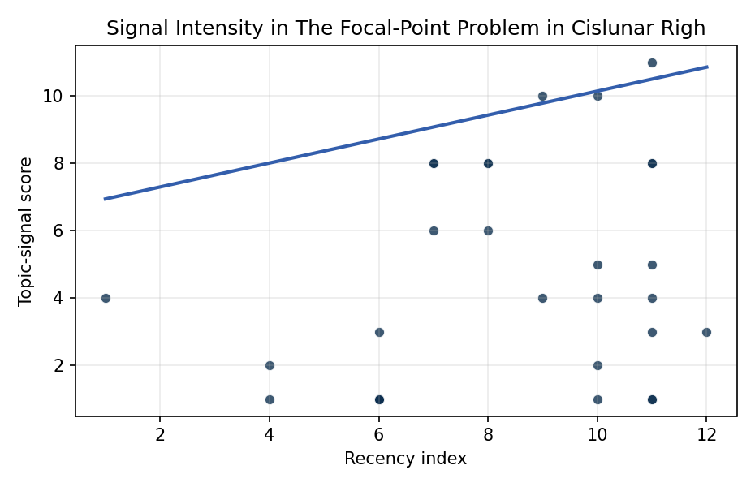
Figure 1. Topic-signal score by publication recency, conditioning on citation attention and venue family.

Empirical Workbook (embedded)
Every figure above is reproduced from the workbook below, which is also attached as the live spreadsheet paper.xlsx. Each observation carries its source.

Data (real observations)
doc_id | year_num | recency_index | cites_num | venue_score | title_words | snippet_words | keyword_count | theme_hits | signal_score | source
1 | 2021 | 7 | 0 | 1 | 7 | 13 | 4 | 3 | 8 | https://amostech.space/year/2021/cislunar-multiscale-dynamics-and-implications-for-ssa/
2 | 2024 | 10 | 0 | 1 | 16 | 13 | 8 | 4 | 10 | 10.64861/FBSC2978
3 | 2015 | 1 | 0 | 1 | 15 | 13 | 5 | 2 | 4 | https://amostech.space/year/2015/application-of-a-cots-resource-optimization-framework-to-the-ssn-sensor-tasking-domain-part-i-problem-definition/
4 | 2021 | 7 | 0 | 1 | 5 | 14 | 3 | 2 | 6 | https://amostech.space/year/2021/robust-cislunar-initial-orbit-determination/
5 | 2025 | 11 | 0 | 1 | 12 | 12 | 6 | 3 | 8 | 10.64861/TKNV3337
6 | 2021 | 7 | 0 | 1 | 15 | 12 | 6 | 3 | 8 | https://amostech.space/year/2021/cislunar-orbit-determination-behavior-processing-observations-of-periodic-orbits-with-gaussian-mixture-model-estimation-filters/
7 | 2025 | 11 | 0 | 1 | 15 | 16 | 4 | 3 | 8 | 10.64861/JDBC3555
8 | 2024 | 10 | 0 | 1 | 15 | 14 | 6 | 2 | 4 | 10.64861/OAYK5409
9 | 2023 | 9 | 0 | 1 | 13 | 14 | 6 | 4 | 10 | 10.64861/JBDG7304
10 | 2022 | 8 | 0 | 1 | 11 | 14 | 5 | 3 | 8 | https://amostech.space/year/2022/cislunar-space-situational-awareness-sensor-tasking-using-deep-reinforcement-learning-agents/
11 | 2018 | 4 | 0 | 1 | 13 | 10 | 5 | 0 | 1 | https://amostech.space/year/2018/satellite-characterization-classification-and-operational-assessment-via-the-exploitation-of-remote-photoacoustic-signatures/
12 | 2022 | 8 | 0 | 1 | 10 | 12 | 4 | 3 | 8 | 10.2514/6.2004-3253
13 | 2025 | 11 | 0 | 2 | 10 | 12 | 15 | 2 | 4 | 10.1016/j.actaastro.2024.12.058
14 | 2024 | 10 | 30 | 2 | 7 | 13 | 13 | 0 | 1 | 10.1016/j.actaastro.2024.06.015
15 | 2024 | 10 | 2 | 2 | 10 | 14 | 10 | 1 | 2 | 10.1016/j.actaastro.2024.11.048
16 | 2022 | 8 | 0 | 2 | 11 | 14 | 14 | 3 | 6 | 10.1016/j.actaastro.2022.01.016
17 | 2025 | 11 | 0 | 2 | 7 | 13 | 10 | 0 | 1 | 10.1016/j.actaastro.2025.01.057
18 | 2025 | 11 | 0 | 2 | 16 | 14 | 13 | 4 | 11 | 10.1016/j.actaastro.2025.04.043
19 | 2025 | 11 | 5 | 2 | 8 | 12 | 9 | 2 | 5 | 10.1016/j.actaastro.2025.05.002
20 | 2025 | 11 | 14 | 2 | 11 | 14 | 14 | 0 | 1 | 10.1016/j.actaastro.2025.01.009
21 | 2025 | 11 | 0 | 2 | 8 | 14 | 11 | 1 | 3 | 10.1016/j.actaastro.2025.03.022
22 | 2018 | 4 | 6 | 2 | 15 | 14 | 7 | 0 | 2 | 10.1016/j.actaastro.2018.10.015
23 | 2023 | 9 | 8 | 2 | 11 | 12 | 12 | 2 | 4 | 10.1016/j.actaastro.2023.03.020
24 | 2024 | 10 | 6 | 2 | 11 | 14 | 15 | 2 | 5 | 10.1016/j.actaastro.2024.11.040
25 | 2020 | 6 | 0 | 3 | 6 | 0 | 0 | 0 | 1 | Leveraging Circular Economy for Space Sustainability
26 | 2020 | 6 | 0 | 3 | 9 | 0 | 0 | 0 | 1 | Architectural Socio-Technological Transformative Change of Space-Use Norms
27 | 2026 | 12 | 0 | 3 | 14 | 0 | 0 | 1 | 3 | 10.3390/world7020018
28 | 2020 | 6 | 0 | 3 | 8 | 0 | 0 | 1 | 3 | The Wicked Problem of Space Debris (System Dynamics)
29 | 2020 | 6 | 0 | 3 | 6 | 0 | 0 | 0 | 1 | The Space Imperative (Whole-of-Nation)
30 | 2020 | 6 | 0 | 3 | 6 | 0 | 0 | 0 | 1 | Weinzierl 2018: Space the Final Economic Frontier

Variable construction
Variable | Definition | Construction / source
signal_score | Composite topic-signal score for each retrieved source record | Deterministic count built from candidate-theme term hits in the source title, snippet, keyword field, and author metadata; each row cites the retrieved source in the source column
recency_index | Publication recency index | Computed as publication year minus the minimum publication year in the paper sample plus one
cites_num | Reported citation count in the local brain index | Parsed from the local brain search cites field; zero when the index reported no citation count
venue_score | Ordinal venue-family score | AMOS = 1, Acta Astronautica = 2, Space Economy = 3

Estimator output
Term | Coef. | Std. err. | t | p | 95% CI
const | 6.5876 | 1.7865 | 3.6874 | 0.0002265 | [3.0861, 10.0891]
recency_index | 0.3558 | 0.1645 | 2.1626 | 0.0306 | [0.0333, 0.6783]
cites_num | -0.16 | 0.0449 | -3.5628 | 0.0003669 | [-0.248, -0.072]
venue_score | -2.5545 | 0.4211 | -6.0662 | 1.31e-09 | [-3.3798, -1.7291]
Fit: N = 30 R2 = 0.5571 R2_adj = 0.506 F = 22.0011 F_p = 2.635e-07

