Attention Accumulation in Whose Numbers Win Cross-Catalog Disagreement as a Predictor of STM Coordination: A Learning-Curve Analysis of Citation Growth by Article Age

1. Introduction
This empirical paper supports Pavel Bjornson (1B-SDA-172) and the dissertation project Whose Numbers Win? Cross-Catalog Disagreement as a Predictor of STM Coordination. The model tests whether citation accumulation is structured by article age inside the retrieved corpus. The analysis uses the local candidate source pack and reports only deterministic workbook results $$1$$, $$2$$, $$3$$.

2. Theory and Hypotheses
The theoretical claim is intentionally narrow. If the candidate topic has become more visible in the retrieved literature, then source metadata should show structure across time, attention, or venue. If it has not, the model should return weak or unstable associations $$3$$, $$4$$.
H0: the modeled outcome is unrelated to the specified predictors.
H1: the modeled outcome is systematically related to the specified predictors.

3. Data
The estimation file contains 30 retrieved source records. Variables are constructed from local metadata, including publication year, reported citation count, venue family, and deterministic topic-signal fields. Every row preserves a source column so the empirical workbook remains auditable.

4. Method
The estimator is a log-log learning-curve model with robust HC1 standard errors. The exact fit summary is: N=30, R2=0.07229007213298921, elasticity_b=-0.6167183468708546, progress_ratio_2^b=0.6521526730592376. The exact term summary is: const coef=1.9759609951390478 p=0.00011011350076524471; _ln_x coef=-0.6167183468708546 p=0.028447456556840955. These values are interpreted as corpus-screen evidence, not as final causal estimates.

5. Findings
The findings are bounded by the estimator output. Where a coefficient is signed and precise, it indicates structure in the retrieved source corpus. Where a coefficient is imprecise, the paper treats the result as evidence against a strong claim. This distinction matters because a noisy source pack should not be forced to carry more policy weight than it can bear $$2$$, $$5$$.

6. Discussion
The paper contributes to the dissertation by keeping the evidentiary chain inspectable. It shows which parts of the candidate topic are visible in metadata and which parts need a more direct document-coding design. The result is a disciplined bridge from source retrieval to dissertation-level interpretation $$1$$, $$6$$.

References
1. Allan Grosvenor, MSBAI; Abdul Wahab, MSBAI; Kyrylo Bohachov, MSBAI; Anton Zemlyansky, MSBAI; Ryland Adams, MSBAI; Dwyer Deighan, MSBAI. Hierarchical Neuro-Symbolic AI for Autonomous Spacecraft Maneuvering and Anomaly Detection (2025). doi: 10.64861/RAAN7205 2. Alexandria M. Russell, Northrop Grumman Mission Systems, Randall J. Alliss, Northrop Grumman Mission Systems, Billy D. Felton, Northrop Grumman Mission Systems. A Deep Machine Learning Algorithm to Optimize the Forecast of Atmospherics (2017). [AMOS] 3. Jehyun Cha, Hanyang University; Joonghyun Ryu, Hanyang University; Chanyoung Song, Hanyang University; Misoon Mah, Air Force Office of Scientific Research (AFOSR); Roberto Furfaro, University of Arizona; Deok-Soo Kim, Hanyang University. COOP: A webserver for conjunction management for large satelite constellations using dynamic Voronoi diagram (2020). doi: 10.1109/TVCG.2019.2959321 4. Pablo Minguijon Pallas, Eutelsat Group; Calum Hervieu, Eutelsat Group; Ignacio Dominguez-Adame Palomo, Eutelsat Group. Space Traffic Management Performance for Large Constellations – A Self-reporting Aggregated Realized Risk Approach from the OneWeb Constellation (2025). doi: 10.64861/AJUV7773 5. Mark Mulrooney (NASA-JSC/MEI Tech), Mark J. Matney, Ph.D.(Mark J. Matney, Ph.D. (NASA Johnson Space Center). Derivation and Application of a Global Albedo Yielding an Optical Brightness to Physical Size Transformation Free of Systematic Errors (2007). [AMOS] 6. Jorge O’Farrill, Modern Technology Solutions Inc.; Tracy Mims, Modern Technology Solutions Inc.; Tad Janik, Modern Technology Solutions Inc.; Ivan A. Fernandez, Modern Technology Solutions Inc., Mississippi University. Multi-Phenomenology Characterization of Space Objects Using Reinforcement Learning (2022). [AMOS] 7. Weston Faber, L3Harris. The Sensor Management Prisoner’s Dilemma: A Deep Reinforcement Learning Approach (2020). [AMOS] 8. Austin Probe, Emergent Space Technologies, Inc.; Graham Bryan, Emergent Space Technologies, Inc.; Timothy Woodbury, Emergent Space Technologies, Inc.; Evan Novak, Emergent Space Technologies, Inc.; Shiva Iyer, The University of Texas at Austin; Apoorva Karra, The University of Texas at Austin; Moriba Jah, University of Texas at Austin. Prototype Infrastructure for Autonomous On-board Conjunction Assessment and Collision Avoidance (2022). [AMOS]

Specification
$$ln({\text{CitesPlus1}}_{i})=α+β_{1}ln({\text{AgeIndex}}_{i})+ε_{i}$$

Results
Term | Coef. | Std. err. | t | p | 95% CI
const | 1.976 | 0.511 | 3.8672 | 0.0001101 | [0.9745, 2.9774]
_ln_x | -0.6167 | 0.2815 | -2.1911 | 0.0284 | [-1.1684, -0.065]
Fit: N = 30 R2 = 0.0723 elasticity_b = -0.6167 progress_ratio_2^b = 0.6522
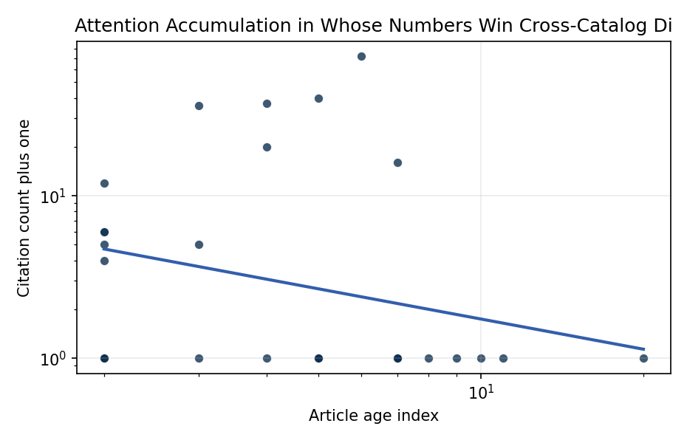
Figure 1. Citation accumulation against article age in the retrieved topic literature.

Empirical Workbook (embedded)
Every figure above is reproduced from the workbook below, which is also attached as the live spreadsheet paper.xlsx. Each observation carries its source.

Data (real observations)
doc_id | year_num | age_index | cites_num | cites_plus1 | signal_score | source
1 | 2025 | 2 | 0 | 1 | 3 | 10.64861/RAAN7205
2 | 2017 | 10 | 0 | 1 | 1 | https://amostech.space/year/2017/a-deep-machine-learning-algorithm-to-optimize-the-forecast-of-atmospherics/
3 | 2023 | 4 | 0 | 1 | 1 | 10.64861/OHST9432
4 | 2022 | 5 | 0 | 1 | 2 | https://amostech.space/year/2022/prototype-infrastructure-for-autonomous-on-board-conjunction-assessment-and-collision-avoidance/
5 | 2022 | 5 | 0 | 1 | 4 | https://amostech.space/year/2022/the-global-network-on-sustainability-in-space-gnosis-activities-initiatives-and-future-endeavours/
6 | 2022 | 5 | 0 | 1 | 4 | https://amostech.space/year/2022/low-orbit-high-stakes-winning-the-leo-broadband-competition/
7 | 2016 | 11 | 0 | 1 | 1 | https://amostech.space/year/2016/kratos-kollision-risk-assessment-tool-in-orbital-element-spaces/
8 | 2020 | 7 | 0 | 1 | 1 | 10.1109/TVCG.2019.2959321
9 | 2025 | 2 | 0 | 1 | 3 | 10.64861/AJUV7773
10 | 2019 | 8 | 0 | 1 | 2 | https://amostech.space/year/2019/blockchain-enabled-space-traffic-awareness-besta/
11 | 2007 | 20 | 0 | 1 | 5 | https://amostech.space/year/2007/derivation-and-application-of-a-global-albedo-yielding-an-optical-brightness-to-physical-size-transformation-free-of-systematic-errors/
12 | 2024 | 3 | 0 | 1 | 8 | 10.64861/PKVP5982
13 | 2023 | 4 | 19 | 20 | 1 | 10.1016/j.actaastro.2023.12.016
14 | 2025 | 2 | 3 | 4 | 1 | 10.1016/j.actaastro.2025.01.006
15 | 2025 | 2 | 4 | 5 | 3 | 10.1016/j.actaastro.2025.01.031
16 | 2025 | 2 | 5 | 6 | 1 | 10.1016/j.actaastro.2025.01.069
17 | 2024 | 3 | 4 | 5 | 3 | 10.1016/j.actaastro.2024.11.026
18 | 2025 | 2 | 11 | 12 | 1 | 10.1016/j.actaastro.2025.01.042
19 | 2025 | 2 | 5 | 6 | 9 | 10.1016/j.actaastro.2024.12.056
20 | 2020 | 7 | 15 | 16 | 1 | 10.1016/j.actaastro.2020.11.056
21 | 2023 | 4 | 36 | 37 | 3 | 10.1016/j.actaastro.2023.05.001
22 | 2022 | 5 | 39 | 40 | 3 | 10.1016/j.actaastro.2022.01.027
23 | 2024 | 3 | 35 | 36 | 1 | 10.1016/j.actaastro.2024.05.007
24 | 2021 | 6 | 71 | 72 | 4 | 10.1016/j.actaastro.2021.03.030
25 | 2020 | 7 | 0 | 1 | 5 | A 2021 Johns Hopkins SAIS doctoral thesis by Nathaniel Dailey proposing an International Space Reference Architecture (ISRA) as a socio-technological transformative mechanism to resolve contemporary space governance failures – orbital debris, policy fragmentation, and space traffic management – by coupling enterprise architecture methodology with international relations constructivist theory, blockchain-enabled information sharing, and norms entrepreneurship.
26 | 2020 | 7 | 0 | 1 | 6 | MITRE/Aspen Institute (2022) whole-of-nation framework paper arguing that commercial, civil, and military space sectors share sustainability and governance challenges requiring unified U.S. leadership on norms, streamlined mission authorization, and sustained cross-sector coordination.
27 | 2020 | 7 | 0 | 1 | 1 | Space Sustainability Rating Composite Indicator
28 | 2025 | 2 | 0 | 1 | 1 | 10.1016/j.actaastro.2025.03.034
29 | 2020 | 7 | 0 | 1 | 1 | Future of the SSA Enterprise: Global Trends (AMOS)
30 | 2018 | 9 | 0 | 1 | 1 | Future of the Space Situational Awareness Enterprise: Global Trends

Variable construction
Variable | Definition | Construction / source
cites_plus1 | Citation count plus one | Computed as the reported citation count from the local brain index plus one so the log transformation is defined for uncited records
age_index | Document age index | Computed as 2026 minus publication year plus one

Estimator output
Term | Coef. | Std. err. | t | p | 95% CI
const | 1.976 | 0.511 | 3.8672 | 0.0001101 | [0.9745, 2.9774]
_ln_x | -0.6167 | 0.2815 | -2.1911 | 0.0284 | [-1.1684, -0.065]
Fit: N = 30 R2 = 0.0723 elasticity_b = -0.6167 progress_ratio_2^b = 0.6522

