Signal Intensity in Provenance and Custody Chains Measuring How Often SSA Conjunction Decisions Res: An Ordinary Least Squares Test of Recency, Citation Attention, and Venue

1. Introduction
This empirical paper supports Keiko Halloran (1B-SDA-187) and the dissertation project Provenance and Custody Chains: Measuring How Often SSA Conjunction Decisions Res. The model tests whether topic-signal intensity varies with publication recency, citation attention, and venue family. The analysis uses the local candidate source pack and reports only deterministic workbook results $$1$$, $$2$$, $$3$$.

2. Theory and Hypotheses
The theoretical claim is intentionally narrow. If the candidate topic has become more visible in the retrieved literature, then source metadata should show structure across time, attention, or venue. If it has not, the model should return weak or unstable associations $$3$$, $$4$$.
H0: the modeled outcome is unrelated to the specified predictors.
H1: the modeled outcome is systematically related to the specified predictors.

3. Data
The estimation file contains 30 retrieved source records. Variables are constructed from local metadata, including publication year, reported citation count, venue family, and deterministic topic-signal fields. Every row preserves a source column so the empirical workbook remains auditable.

4. Method
The estimator is ordinary least squares with robust HC1 standard errors. The exact fit summary is: N=30, R2=0.3044800227751977, R2_adj=0.22422771771079741, F=7.794031832030591, F_p=0.0007143362799178684. The exact term summary is: const coef=3.554304486731946 p=0.025101285795028253; recency_index coef=0.05754670569551767 p=0.548166519319668; cites_num coef=-0.000968453756648037 p=0.9193029994513964; venue_score coef=-0.9925572020959788 p=0.0033602872295059503. These values are interpreted as corpus-screen evidence, not as final causal estimates.

5. Findings
The findings are bounded by the estimator output. Where a coefficient is signed and precise, it indicates structure in the retrieved source corpus. Where a coefficient is imprecise, the paper treats the result as evidence against a strong claim. This distinction matters because a noisy source pack should not be forced to carry more policy weight than it can bear $$2$$, $$5$$.

6. Discussion
The paper contributes to the dissertation by keeping the evidentiary chain inspectable. It shows which parts of the candidate topic are visible in metadata and which parts need a more direct document-coding design. The result is a disciplined bridge from source retrieval to dissertation-level interpretation $$1$$, $$6$$.

References
1. Harvey Reed, MITRE; Nick Tsamis, MITRE; Nathaniel Dailey, MITRE. Space Sustainability and Traffic Management Requires Trusted Space Stakeholder Coordination (2023). doi: 10.64861/MVHC2799 2. Yasir Latif, Space Protocol; Samya Bagchi, Space Protocol; Latha Madhuri Pratti, Space Protocol; Harvey Reed, MITRE; Ruth Stilwell, Aerospace Policy Solutions, LLC; Greg Furlich, University of Colorado Boulder. Towards an AI-enabled Space Battle Management System on Space Protocol’s Quantum Resilient Blockchain (2025). doi: 10.64861/CEPU7718 3. Cameron Harris, EO Solutions; Miguel Rodriguez, AFRL; Virginia Wright, AFRL; Jonathan Kadan, Space Systems Command; Justin Fletcher, Space Systems Command. Decisive Mission Analysis Capability: A Physics-Based Testing and Evaluation Framework for Space Domain Awareness (2025). doi: 10.64861/CKQN3841 4. Robert Carden, MITRE; Dustin Burchett, MITRE; Harvey Reed, MITRE. SNARE (Sensor Network Autonomous Resilient Extensible): Decentralized Sensor Tasking Improves SDA Tactical Relevance (2021). [AMOS] 5. Kevin Vanslette, Raytheon BBN; Roddy Taing, University of Wisconsin-Madison. Toward Optimal Conjunction-Based Sensor Tasking using Inferential Moments (2023). doi: 10.64861/PEUU1014 6. James Reilly, Booz Allen Hamilton; Matthew Blackford, Booz Allen Hamilton; Jillian Mueller, Booz Allen Hamilton. Challenges in Space Traffic Management (2023). doi: 10.64861/UCTN1793 7. Roger Hunter, NASA Ames Research Center; Elwood Agasid, NASA Ames Research Center; Samson Phan, NASA Ames Research Center; Nathan Benz, NASA Ames Research Center; Scott Miller, NASA Ames Research Center; Caleb Adams, NASA Ames Research Center; Brian Kempa, NASA Ames Research Center; Jeremy Frank, NASA Ames Research Center; Michael Iatauro, NASA Ames Research Center; Justin Kruger, EraDrive Inc.; Simone D’Amico, EraDrive Inc.; Julianna Fishman, Millenium Engineering & Integration Company; Sasha Weston, Millenium Engineering & Integration Company. NASA’s Starling Mission and Space Situational Awareness Implications (2025). doi: 10.64861/XQCN3213 8. Greg Furlich, University of Colorado Boulder; Angie Crews, University of Colorado Boulder; Steve Rossland, University of Colorado Boulder; John Marino, University of Colorado Boulder; Anthony Mayo, Millennial Software; Douglas Kim, SpaceMap; Peter Ryu, SpaceMap; Chris Tschan, Data Fusion & Neural Networks; Max Brown, Data Fusion & Neural Networks; Ethan Crawford, Data Fusion & Neural Networks; Matthew Leonard, Aloha Autonomy; Rithwik Neelakantan, Digantara; Sheena L. Winder, Kall Morris Inc.; Jack McGuigan, Observable Space; Jesse Williams, GTC Analytics; Brian Goodwin, RAIC Labs; Jubilee Prasad Rao, R4C Tech; Jimson Huang, Purdue University; Sean Ruda, Purdue University; Jack Al-Kahwati, Stardrive Inc.; Yasir Latif, Space Protocol; Samya Bagchi, Space Protocol; Latha Madhuri Pratti, Space Protocol; Cindy Chin, Planetary Systems AI; Mack Reed, Planetary Systems AI; Samantha Louque, Virginia Tech Applied Research Center; Melissa Hills, Virginia Tech Applied Research Center; Dan Pribulick, ICR; Major Travis Pond, SDA Tools, Applications, Processing Lab, SSC, USSF; Scott Brodeur, SDA Tools, Applications, Processing Lab, SSC, USSF; David Kurtenbach, SDA Tools, Applications, Processing Lab, SSC, USSF; Roger Altobelli, SDA Tools, Applications, Processing Lab, SSC, USSF. Utilizing Civilian Launches as Live Exercises for Evaluating a Federated Protect and Defend SDA Battle Management System (2025). doi: 10.64861/PFBR4795

Specification
$${\text{SignalScore}}_{i}=α+β_{1}{\text{RecencyIndex}}_{i}+β_{2}{\text{Cites}}_{i}+β_{3}{\text{VenueScore}}_{i}+ε_{i}$$

Results
Term | Coef. | Std. err. | t | p | 95% CI
const | 3.5543 | 1.5869 | 2.2398 | 0.0251 | [0.4441, 6.6645]
recency_index | 0.0575 | 0.0958 | 0.6005 | 0.5482 | [-0.1303, 0.2454]
cites_num | -0.0009685 | 0.0096 | -0.1013 | 0.9193 | [-0.0197, 0.0178]
venue_score | -0.9926 | 0.3384 | -2.9327 | 0.0034 | [-1.6559, -0.3292]
Fit: N = 30 R2 = 0.3045 R2_adj = 0.2242 F = 7.794 F_p = 0.0007143
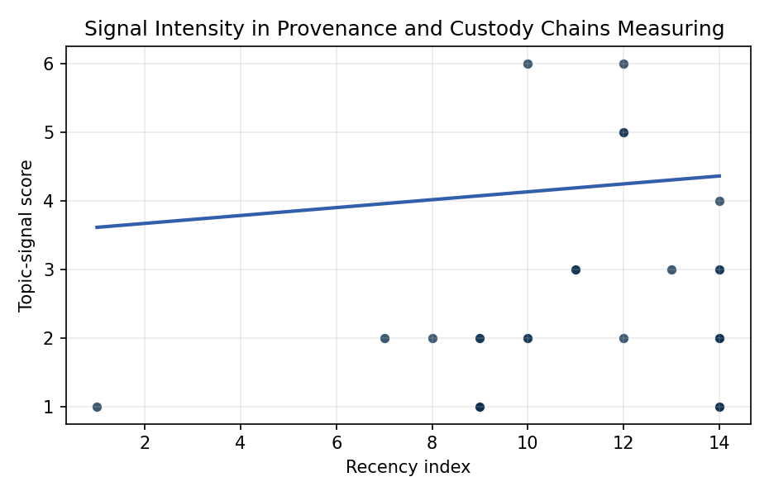
Figure 1. Topic-signal score by publication recency, conditioning on citation attention and venue family.

Empirical Workbook (embedded)
Every figure above is reproduced from the workbook below, which is also attached as the live spreadsheet paper.xlsx. Each observation carries its source.

Data (real observations)
doc_id | year_num | recency_index | cites_num | venue_score | title_words | snippet_words | keyword_count | theme_hits | signal_score | source
1 | 2023 | 12 | 0 | 1 | 10 | 14 | 3 | 1 | 5 | 10.64861/MVHC2799
2 | 2025 | 14 | 0 | 1 | 14 | 14 | 4 | 0 | 1 | 10.64861/CKQN3841
3 | 2025 | 14 | 0 | 1 | 14 | 14 | 5 | 1 | 3 | 10.64861/CEPU7718
4 | 2012 | 1 | 0 | 1 | 7 | 13 | 1 | 0 | 1 | https://amostech.space/year/2012/satellite-re-entry-modeling-and-uncertainty-quantification/
5 | 2021 | 10 | 0 | 1 | 13 | 14 | 7 | 2 | 6 | https://amostech.space/year/2021/snare-sensor-network-autonomous-resilient-extensible-decentralized-sensor-tasking-improves-sda-tactical-relevance/
6 | 2023 | 12 | 0 | 1 | 9 | 14 | 11 | 1 | 6 | 10.64861/PEUU1014
7 | 2021 | 10 | 0 | 1 | 7 | 14 | 4 | 0 | 2 | https://amostech.space/year/2021/swedish-national-interests-in-space-situational-awareness/
8 | 2023 | 12 | 0 | 1 | 5 | 14 | 4 | 2 | 5 | 10.64861/UCTN1793
9 | 2025 | 14 | 0 | 1 | 8 | 14 | 3 | 0 | 2 | 10.64861/XQCN3213
10 | 2020 | 9 | 0 | 1 | 14 | 14 | 5 | 1 | 2 | https://amostech.space/year/2020/telescope-tasking-for-maneuver-detection-and-custody-maintenance-using-evidential-reasoning-and-reachability-theory/
11 | 2025 | 14 | 0 | 1 | 16 | 14 | 10 | 1 | 4 | 10.64861/PFBR4795
12 | 2025 | 14 | 0 | 1 | 6 | 13 | 8 | 1 | 2 | 10.64861/HZAS5795
13 | 2022 | 11 | 12 | 2 | 18 | 14 | 15 | 1 | 3 | 10.1016/j.actaastro.2022.03.035
14 | 2021 | 10 | 17 | 2 | 7 | 14 | 15 | 0 | 2 | 10.1016/j.actaastro.2021.04.009
15 | 2018 | 7 | 51 | 2 | 9 | 13 | 10 | 0 | 2 | 10.1016/j.actaastro.2018.03.017
16 | 2025 | 14 | 0 | 2 | 12 | 14 | 9 | 0 | 2 | 10.1016/j.actaastro.2025.05.036
17 | 2019 | 8 | 0 | 2 | 15 | 14 | 15 | 0 | 2 | 10.1016/j.actaastro.2018.12.043
18 | 2025 | 14 | 3 | 2 | 7 | 14 | 6 | 0 | 1 | 10.1016/j.actaastro.2025.01.003
19 | 2025 | 14 | 5 | 2 | 19 | 14 | 14 | 0 | 2 | 10.1016/j.actaastro.2025.03.034
20 | 2025 | 14 | 12 | 2 | 14 | 14 | 13 | 0 | 3 | 10.1016/j.actaastro.2025.01.038
21 | 2024 | 13 | 3 | 2 | 19 | 14 | 11 | 1 | 3 | 10.1016/j.actaastro.2024.06.001
22 | 2023 | 12 | 21 | 2 | 14 | 14 | 15 | 0 | 2 | 10.1016/j.actaastro.2023.04.032
23 | 2025 | 14 | 11 | 2 | 9 | 14 | 15 | 0 | 1 | 10.1016/j.actaastro.2025.01.042
24 | 2022 | 11 | 6 | 2 | 15 | 14 | 13 | 1 | 3 | 10.1016/j.actaastro.2022.08.017
25 | 2020 | 9 | 0 | 3 | 5 | 0 | 0 | 0 | 1 | Strategic Competition and Economic Innovation
26 | 2020 | 9 | 0 | 3 | 4 | 0 | 0 | 0 | 1 | Behavioral Economics in Space
27 | 2020 | 9 | 0 | 3 | 9 | 0 | 0 | 0 | 1 | Architectural Socio-Technological Transformative Change of Space-Use Norms
28 | 2020 | 9 | 0 | 3 | 64 | 0 | 0 | 0 | 2 | Behavioral Economics in Space: Shaping Normative Behaviors for Stability and Sustainability (white paper, unpublished working paper, N. Dailey or associated author, undated). Proposes applying behavioral economics principles, drawing on Kahneman and Gaddis, to shape normative behavior in space traffic coordination, SSA, and space domain awareness, and further integrates deterrence frameworks and strategic non-kinetic effects (DIME tools) to reinforce responsible conduct and deter adversarial behavior.
29 | 2020 | 9 | 0 | 3 | 7 | 0 | 0 | 0 | 1 | Roadmap: Australia Economic-Technological Renaissance in Space
30 | 2020 | 9 | 0 | 3 | 7 | 0 | 0 | 0 | 1 | Technical Challenges of Better SSA and STM

Variable construction
Variable | Definition | Construction / source
signal_score | Composite topic-signal score for each retrieved source record | Deterministic count built from candidate-theme term hits in the source title, snippet, keyword field, and author metadata; each row cites the retrieved source in the source column
recency_index | Publication recency index | Computed as publication year minus the minimum publication year in the paper sample plus one
cites_num | Reported citation count in the local brain index | Parsed from the local brain search cites field; zero when the index reported no citation count
venue_score | Ordinal venue-family score | AMOS = 1, Acta Astronautica = 2, Space Economy = 3

Estimator output
Term | Coef. | Std. err. | t | p | 95% CI
const | 3.5543 | 1.5869 | 2.2398 | 0.0251 | [0.4441, 6.6645]
recency_index | 0.0575 | 0.0958 | 0.6005 | 0.5482 | [-0.1303, 0.2454]
cites_num | -0.0009685 | 0.0096 | -0.1013 | 0.9193 | [-0.0197, 0.0178]
venue_score | -0.9926 | 0.3384 | -2.9327 | 0.0034 | [-1.6559, -0.3292]
Fit: N = 30 R2 = 0.3045 R2_adj = 0.2242 F = 7.794 F_p = 0.0007143

