Signal Intensity in The Marginal Value of an Additional Sensor Information-Gain Diminishing Returns: An Ordinary Least Squares Test of Recency, Citation Attention, and Venue

1. Introduction
This empirical paper supports Stefan Berger (1B-SDA-221) and the dissertation project The Marginal Value of an Additional Sensor: Information-Gain Diminishing Returns. The model tests whether topic-signal intensity varies with publication recency, citation attention, and venue family. The analysis uses the local candidate source pack and reports only deterministic workbook results $$1$$, $$2$$, $$3$$.

2. Theory and Hypotheses
The theoretical claim is intentionally narrow. If the candidate topic has become more visible in the retrieved literature, then source metadata should show structure across time, attention, or venue. If it has not, the model should return weak or unstable associations $$3$$, $$4$$.
H0: the modeled outcome is unrelated to the specified predictors.
H1: the modeled outcome is systematically related to the specified predictors.

3. Data
The estimation file contains 30 retrieved source records. Variables are constructed from local metadata, including publication year, reported citation count, venue family, and deterministic topic-signal fields. Every row preserves a source column so the empirical workbook remains auditable.

4. Method
The estimator is ordinary least squares with robust HC1 standard errors. The exact fit summary is: N=30, R2=0.09065234926359655, R2_adj=-0.014272379667527035, F=0.8639400576721759, F_p=0.4722236436512923. The exact term summary is: const coef=3.621184401547415 p=0.011508448018924696; recency_index coef=0.08949365494778494 p=0.4398324544979858; cites_num coef=-0.027988626980297145 p=0.7568369190283221; venue_score coef=-0.8470436006239968 p=0.1283043931702309. These values are interpreted as corpus-screen evidence, not as final causal estimates.

5. Findings
The findings are bounded by the estimator output. Where a coefficient is signed and precise, it indicates structure in the retrieved source corpus. Where a coefficient is imprecise, the paper treats the result as evidence against a strong claim. This distinction matters because a noisy source pack should not be forced to carry more policy weight than it can bear $$2$$, $$5$$.

6. Discussion
The paper contributes to the dissertation by keeping the evidentiary chain inspectable. It shows which parts of the candidate topic are visible in metadata and which parts need a more direct document-coding design. The result is a disciplined bridge from source retrieval to dissertation-level interpretation $$1$$, $$6$$.

References
1. Anna Zovaro, Australian National University and the Space Environment Research Centre Ltd., Francis Bennet, Australian National University and the Space Environment Research Centre Ltd., M. Copeland, Australian National University and the Space Environment Research Centre Ltd., Francois Rigaut, Australian National University and the Space Environment Research Centre Ltd., Celine d’Orgeville, Australian National University and the Space Environment Research Centre Ltd., D. Grosse, Australian National University and the Space Environment Research Centre Ltd., Matthew Bold, Lockheed Martin Corporation. Harnessing Adaptive Optics for Space Debris Collision Mitigation (2016). [AMOS] 2. Kevin Vanslette, Raytheon BBN; Roddy Taing, University of Wisconsin-Madison. Toward Optimal Conjunction-Based Sensor Tasking using Inferential Moments (2023). doi: 10.64861/PEUU1014 3. Collin Phillips, Virginia Tech National Security Institute; Aster Saul, Virginia Tech National Security Institute; Kevin Schroeder, Virginia Tech National Security Institute; Jonathan Kadan, Space Systems Command. Luck Is a Skill: Optimizing for Serendipitous Observations with Global Boresight Tasking (2025). doi: 10.64861/GPAR3562 4. Lauri Newman (NASA), Matthew Hejduk (a.i. Solutions, Inc.), Ryan Frigm (a.i. Solutions, Inc.), Matthew Duncan (SpaceNav). Evolution and Implementation of the NASA Robotic Conjunction Assessment Risk Analysis Concept of Operations (2014). [AMOS] 5. Ryan D. Coder, (Georgia Institute of Technology), Marcus J. Holzinger, (Georgia Institute of Technology). Sizing of a Raven-class Telescope Using Performance Sensitivities (2013). [AMOS] 6. Michael Bilka, BAE Systems; Raymond Wright, BAE Systems, Space & Mission Systems; Joshua Wysack, BAE Systems. Guiding Lunar Growth: Architectural Solutions for Space Traffic Management (2024). doi: 10.64861/RBTM5104 7. Indigo Brownhall, University College London; Miles Lifson, The Aerospace Corporation; Giovanni Lavezzi, Massachusetts Institute of Technology; Enrico Zucchelli, Massachusetts Institute of Technology; Mark Moretto, North Carolina State University; Santosh Bhattarai, University College London; Richard Linares, Massachusetts Institute of Technology. Verification and Validation of Orbital Capacity Assessment Tools of Varying Fidelities (2025). doi: 10.64861/UHIX1013 8. Ethan Albrecht, U.S. Air Force Academy; Erik Jensen, U.S. Air Force Academy; Kody Wilson, U.S. Air Force Academy; Joshua Key, U.S. Air Force Academy; Francis Chun, U.S. Air Force Academy; Nikola Ruby, Murray State University; David Strong, Strong EO Imaging, Inc.; Casey Schuetz-Christy, Millennium Engineering & Integration Co.. Photometric and Spectral Calibration of the Falcon Telescope Network (2021). [AMOS]

Specification
$${\text{SignalScore}}_{i}=α+β_{1}{\text{RecencyIndex}}_{i}+β_{2}{\text{Cites}}_{i}+β_{3}{\text{VenueScore}}_{i}+ε_{i}$$

Results
Term | Coef. | Std. err. | t | p | 95% CI
const | 3.6212 | 1.4331 | 2.5269 | 0.0115 | [0.8124, 6.43]
recency_index | 0.0895 | 0.1159 | 0.7725 | 0.4398 | [-0.1376, 0.3166]
cites_num | -0.028 | 0.0904 | -0.3096 | 0.7568 | [-0.2052, 0.1492]
venue_score | -0.847 | 0.557 | -1.5208 | 0.1283 | [-1.9387, 0.2446]
Fit: N = 30 R2 = 0.0907 R2_adj = -0.0143 F = 0.8639 F_p = 0.4722
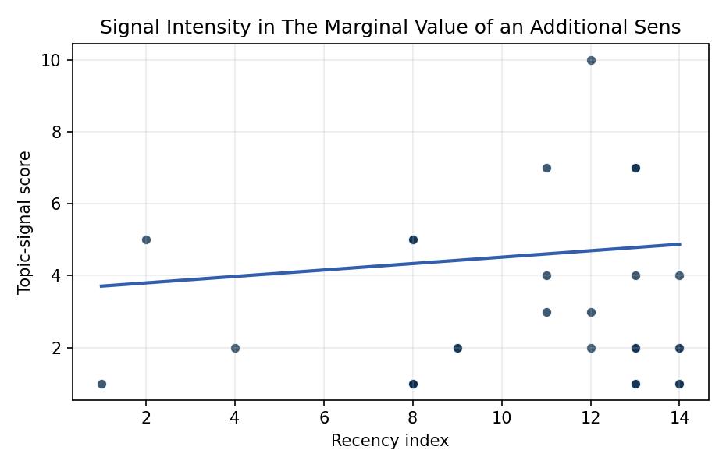
Figure 1. Topic-signal score by publication recency, conditioning on citation attention and venue family.

Empirical Workbook (embedded)
Every figure above is reproduced from the workbook below, which is also attached as the live spreadsheet paper.xlsx. Each observation carries its source.

Data (real observations)
doc_id | year_num | recency_index | cites_num | venue_score | title_words | snippet_words | keyword_count | theme_hits | signal_score | source
1 | 2016 | 4 | 0 | 1 | 8 | 13 | 7 | 0 | 2 | https://amostech.space/year/2016/harnessing-adaptive-optics-for-space-debris-collision-mitigation/
2 | 2023 | 11 | 0 | 1 | 9 | 13 | 11 | 2 | 7 | 10.64861/PEUU1014
3 | 2025 | 13 | 0 | 1 | 11 | 13 | 8 | 0 | 1 | 10.64861/GPAR3562
4 | 2014 | 2 | 0 | 1 | 14 | 14 | 2 | 2 | 5 | https://amostech.space/year/2014/evolution-and-implementation-of-the-nasa-robotic-conjunction-assessment-risk-analysis-concept-of-operations/
5 | 2013 | 1 | 0 | 1 | 8 | 15 | 3 | 0 | 1 | https://amostech.space/year/2013/sizing-of-a-raven-class-telescope-using-performance-sensitivities/
6 | 2024 | 12 | 0 | 1 | 9 | 12 | 5 | 4 | 10 | 10.64861/RBTM5104
7 | 2025 | 13 | 0 | 1 | 11 | 13 | 4 | 0 | 2 | 10.64861/UHIX1013
8 | 2021 | 9 | 0 | 1 | 9 | 14 | 6 | 1 | 2 | https://amostech.space/year/2021/photometric-and-spectral-calibration-of-the-falcon-telescope-network/
9 | 2023 | 11 | 0 | 1 | 11 | 12 | 18 | 1 | 4 | 10.64861/KFLV2709
10 | 2020 | 8 | 0 | 1 | 7 | 14 | 5 | 1 | 5 | https://amostech.space/year/2020/a-constellation-of-sensors-optimized-for-maneuver-tracking/
11 | 2025 | 13 | 0 | 1 | 12 | 12 | 7 | 0 | 1 | 10.64861/YOWY2953
12 | 2021 | 9 | 0 | 1 | 12 | 13 | 4 | 0 | 2 | https://amostech.space/year/2021/an-investigation-into-potential-collision-maneuver-guidelines-for-future-space-traffic-management/
13 | 2025 | 13 | 4 | 2 | 14 | 7 | 10 | 1 | 2 | 10.1016/j.actaastro.2025.03.043
14 | 2026 | 14 | 0 | 2 | 13 | 14 | 13 | 0 | 2 | 10.1016/j.actaastro.2025.12.055
15 | 2025 | 13 | 0 | 2 | 7 | 14 | 10 | 3 | 7 | 10.1016/j.actaastro.2025.11.006
16 | 2026 | 14 | 0 | 2 | 5 | 14 | 0 | 0 | 1 | 10.1016/j.actaastro.2026.05.030
17 | 2026 | 14 | 1 | 2 | 8 | 14 | 9 | 2 | 4 | 10.1016/j.actaastro.2025.12.053
18 | 2026 | 14 | 0 | 2 | 15 | 14 | 14 | 0 | 1 | 10.1016/j.actaastro.2026.05.056
19 | 2025 | 13 | 0 | 2 | 16 | 13 | 15 | 2 | 4 | 10.1016/j.actaastro.2025.11.043
20 | 2024 | 12 | 6 | 2 | 11 | 14 | 14 | 1 | 2 | 10.1016/j.actaastro.2024.04.025
21 | 2024 | 12 | 4 | 2 | 9 | 14 | 8 | 1 | 3 | 10.1016/j.actaastro.2024.11.026
22 | 2025 | 13 | 1 | 2 | 18 | 14 | 8 | 3 | 7 | 10.1016/j.actaastro.2025.07.014
23 | 2023 | 11 | 10 | 2 | 12 | 8 | 15 | 1 | 3 | 10.1016/j.actaastro.2023.07.014
24 | 2026 | 14 | 0 | 2 | 12 | 14 | 15 | 1 | 2 | 10.1016/j.actaastro.2026.05.010
25 | 2020 | 8 | 0 | 3 | 51 | 0 | 0 | 1 | 5 | A 2021 Johns Hopkins SAIS doctoral thesis by Nathaniel Dailey proposing an International Space Reference Architecture (ISRA) as a socio-technological transformative mechanism to resolve contemporary space governance failures – orbital debris, policy fragmentation, and space traffic management – by coupling enterprise architecture methodology with international relations constructivist theory, blockchain-enabled information sharing, and norms entrepreneurship.
26 | 2020 | 8 | 0 | 3 | 9 | 0 | 0 | 0 | 1 | Architectural Socio-Technological Transformative Change of Space-Use Norms
27 | 2020 | 8 | 0 | 3 | 9 | 0 | 0 | 0 | 1 | International Relations and Economic Dimensions of Trusted Space Data
28 | 2020 | 8 | 0 | 3 | 10 | 0 | 0 | 0 | 1 | The Role of Space in Driving Sustainability, Security, and Development
29 | 2020 | 8 | 0 | 3 | 5 | 0 | 0 | 0 | 1 | SFA Space DIME Campaign Plan v3.0
30 | 2020 | 8 | 0 | 3 | 5 | 0 | 0 | 0 | 1 | OCEA Forecasting the Space Economy

Variable construction
Variable | Definition | Construction / source
signal_score | Composite topic-signal score for each retrieved source record | Deterministic count built from candidate-theme term hits in the source title, snippet, keyword field, and author metadata; each row cites the retrieved source in the source column
recency_index | Publication recency index | Computed as publication year minus the minimum publication year in the paper sample plus one
cites_num | Reported citation count in the local brain index | Parsed from the local brain search cites field; zero when the index reported no citation count
venue_score | Ordinal venue-family score | AMOS = 1, Acta Astronautica = 2, Space Economy = 3

Estimator output
Term | Coef. | Std. err. | t | p | 95% CI
const | 3.6212 | 1.4331 | 2.5269 | 0.0115 | [0.8124, 6.43]
recency_index | 0.0895 | 0.1159 | 0.7725 | 0.4398 | [-0.1376, 0.3166]
cites_num | -0.028 | 0.0904 | -0.3096 | 0.7568 | [-0.2052, 0.1492]
venue_score | -0.847 | 0.557 | -1.5208 | 0.1283 | [-1.9387, 0.2446]
Fit: N = 30 R2 = 0.0907 R2_adj = -0.0143 F = 0.8639 F_p = 0.4722

