Signal Intensity in Automation Trust Calibration in Conjunction Assessment When Do Operators Over-: An Ordinary Least Squares Test of Recency, Citation Attention, and Venue

1. Introduction
This empirical paper supports Ananya Quinn (1B-SDA-170) and the dissertation project Automation Trust Calibration in Conjunction Assessment: When Do Operators Over-. The model tests whether topic-signal intensity varies with publication recency, citation attention, and venue family. The analysis uses the local candidate source pack and reports only deterministic workbook results $$1$$, $$2$$, $$3$$.

2. Theory and Hypotheses
The theoretical claim is intentionally narrow. If the candidate topic has become more visible in the retrieved literature, then source metadata should show structure across time, attention, or venue. If it has not, the model should return weak or unstable associations $$3$$, $$4$$.
H0: the modeled outcome is unrelated to the specified predictors.
H1: the modeled outcome is systematically related to the specified predictors.

3. Data
The estimation file contains 30 retrieved source records. Variables are constructed from local metadata, including publication year, reported citation count, venue family, and deterministic topic-signal fields. Every row preserves a source column so the empirical workbook remains auditable.

4. Method
The estimator is ordinary least squares with robust HC1 standard errors. The exact fit summary is: N=30, R2=0.32509354865617957, R2_adj=0.24721972734727715, F=8.051385079367526, F_p=0.0005881722678403994. The exact term summary is: const coef=7.388216144766524 p=2.4378597426753406e-05; recency_index coef=-0.015631008901747026 p=0.8865132381489925; cites_num coef=-0.022344086922061156 p=0.23348930509376353; venue_score coef=-1.8306179798579334 p=8.043404189306764e-06. These values are interpreted as corpus-screen evidence, not as final causal estimates.

5. Findings
The findings are bounded by the estimator output. Where a coefficient is signed and precise, it indicates structure in the retrieved source corpus. Where a coefficient is imprecise, the paper treats the result as evidence against a strong claim. This distinction matters because a noisy source pack should not be forced to carry more policy weight than it can bear $$2$$, $$5$$.

6. Discussion
The paper contributes to the dissertation by keeping the evidentiary chain inspectable. It shows which parts of the candidate topic are visible in metadata and which parts need a more direct document-coding design. The result is a disciplined bridge from source retrieval to dissertation-level interpretation $$1$$, $$6$$.

References
1. James Reilly, Booz Allen Hamilton; Matthew Blackford, Booz Allen Hamilton; Jillian Mueller, Booz Allen Hamilton. Challenges in Space Traffic Management (2023). doi: 10.64861/UCTN1793 2. Garrett Fitzgerald, U. S. Space Force; Rachel Morris, Applied Decision Science; Laura G. Militello, Applied Decision Science; Justin Fletcher, USSF/SSC. Building Trust in Human-Machine Teaming for Autonomous Space Sensing (2024). doi: 10.64861/HWZS9386 3. Ruth Stilwell, Aerospace Policy Solutions, LLC; Kyle Quakenbush, MITRE; John Giles, Space Domain Strategies; Nathaniel Dailey, MITRE & Space Force Association. Human Factors in Space Operators-Leveraging Aviation Safety Frameworks for Enhanced Orbital Domain Resilience (2025). doi: 10.64861/JSGC2795 4. Joe Gorman, Charles River Analytics, Martin Voshell, Charles River Analytics, Amy Sliva, Charles River Analytics. Assessment for Operator Confidence in Automated Space Situational Awareness and Satellite Control Systems (2016). [AMOS] 5. Harvey Reed, MITRE; Nathaniel Dailey, MITRE; Ruth Stilwell, Aerospace Policy Solutions, LLC; Brian Weeden, Secure World Foundation. Decentralized Space Information Sharing as a Key Enabler of Trust and the Preservation of Space (2021). [AMOS] 6. Thomas Kelecy, L3 Harris; Emily Lambert, L3 Harris; Benjamin Sunderland, L3 Harris; Vivek Desai, University of Texas, Austin. Dynamic Calibration of Multiple Data Types (2019). [AMOS] 7. Oliver Schultz, Lockheed Martin; Joseph Brink, Lockheed Martin; Mark Williams, Lockheed Martin; Christopher Curry, Lockheed Martin. Data Insights, Pedigree, and Automation for Space Domain Awareness (2024). doi: 10.64861/NUFH1261 8. Kerstyn Auman, The Aerospace Corporation; Timothy S. Murphy, The Aerospace Corporation; Eric George, The Aerospace Corporation; Patrick Kelly, The Aerospace Corporation; Carson Coursey, The Aerospace Corporation; David Goldstein, SpaceX; Ian Ruh, SpaceX; Kate Hymes, SpaceX. Validation Methodology for TraCSS Conjunction Assessment (2025). doi: 10.64861/GVYB8737

Specification
$${\text{SignalScore}}_{i}=α+β_{1}{\text{RecencyIndex}}_{i}+β_{2}{\text{Cites}}_{i}+β_{3}{\text{VenueScore}}_{i}+ε_{i}$$

Results
Term | Coef. | Std. err. | t | p | 95% CI
const | 7.3882 | 1.7506 | 4.2205 | 2.438e-05 | [3.9572, 10.8193]
recency_index | -0.0156 | 0.1095 | -0.1427 | 0.8865 | [-0.2303, 0.199]
cites_num | -0.0223 | 0.0188 | -1.1914 | 0.2335 | [-0.0591, 0.0144]
venue_score | -1.8306 | 0.4101 | -4.464 | 8.043e-06 | [-2.6344, -1.0269]
Fit: N = 30 R2 = 0.3251 R2_adj = 0.2472 F = 8.0514 F_p = 0.0005882
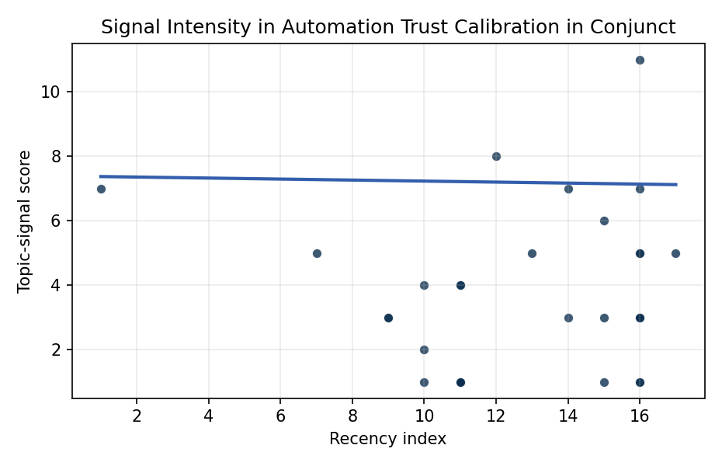
Figure 1. Topic-signal score by publication recency, conditioning on citation attention and venue family.

Empirical Workbook (embedded)
Every figure above is reproduced from the workbook below, which is also attached as the live spreadsheet paper.xlsx. Each observation carries its source.

Data (real observations)
doc_id | year_num | recency_index | cites_num | venue_score | title_words | snippet_words | keyword_count | theme_hits | signal_score | source
1 | 2023 | 14 | 0 | 1 | 5 | 14 | 4 | 3 | 7 | 10.64861/UCTN1793
2 | 2024 | 15 | 0 | 1 | 10 | 14 | 5 | 3 | 6 | 10.64861/HWZS9386
3 | 2025 | 16 | 0 | 1 | 14 | 13 | 11 | 2 | 7 | 10.64861/JSGC2795
4 | 2016 | 7 | 0 | 1 | 13 | 14 | 6 | 2 | 5 | https://amostech.space/year/2016/assessment-for-operator-confidence-in-automated-space-situational-awareness-and-satellite-control-systems/
5 | 2021 | 12 | 0 | 1 | 14 | 14 | 7 | 3 | 8 | https://amostech.space/year/2021/decentralized-space-information-sharing-as-a-key-enabler-of-trust-and-the-preservation-of-space/
6 | 2019 | 10 | 0 | 1 | 6 | 13 | 4 | 1 | 2 | https://amostech.space/year/2019/dynamic-calibration-of-multiple-data-types/
7 | 2024 | 15 | 0 | 1 | 9 | 14 | 4 | 1 | 3 | 10.64861/NUFH1261
8 | 2025 | 16 | 0 | 1 | 6 | 12 | 13 | 1 | 5 | 10.64861/GVYB8737
9 | 2023 | 14 | 0 | 1 | 17 | 14 | 2 | 1 | 3 | 10.64861/KKFT4985
10 | 2010 | 1 | 0 | 1 | 5 | 14 | 4 | 2 | 7 | https://amostech.space/year/2010/advances-in-satellite-conjunction-analysis/
11 | 2022 | 13 | 0 | 1 | 11 | 13 | 3 | 2 | 5 | https://amostech.space/year/2022/decision-support-tool-for-risk-assessment-maneuver-planning-in-collision-avoidance/
12 | 2025 | 16 | 0 | 1 | 20 | 14 | 7 | 1 | 5 | 10.64861/OTAL2562
13 | 2024 | 15 | 17 | 2 | 12 | 14 | 15 | 0 | 1 | 10.1016/j.actaastro.2024.01.039
14 | 2020 | 11 | 15 | 2 | 7 | 12 | 11 | 1 | 4 | 10.1016/j.actaastro.2020.11.056
15 | 2026 | 17 | 1 | 2 | 8 | 14 | 9 | 2 | 5 | 10.1016/j.actaastro.2025.12.053
16 | 2018 | 9 | 7 | 2 | 6 | 14 | 9 | 1 | 3 | 10.1016/j.actaastro.2018.09.030
17 | 2025 | 16 | 5 | 2 | 16 | 14 | 10 | 4 | 11 | 10.1016/j.actaastro.2024.12.056
18 | 2025 | 16 | 11 | 2 | 9 | 14 | 15 | 0 | 1 | 10.1016/j.actaastro.2025.01.042
19 | 2018 | 9 | 51 | 2 | 9 | 11 | 10 | 1 | 3 | 10.1016/j.actaastro.2018.03.017
20 | 2025 | 16 | 5 | 2 | 19 | 14 | 14 | 0 | 1 | 10.1016/j.actaastro.2025.03.034
21 | 2019 | 10 | 0 | 2 | 15 | 14 | 15 | 1 | 4 | 10.1016/j.actaastro.2018.12.043
22 | 2025 | 16 | 5 | 2 | 8 | 14 | 9 | 1 | 3 | 10.1016/j.actaastro.2025.05.002
23 | 2025 | 16 | 10 | 2 | 9 | 14 | 8 | 1 | 3 | 10.1016/j.actaastro.2025.07.027
24 | 2025 | 16 | 0 | 2 | 12 | 13 | 9 | 1 | 3 | 10.1016/j.actaastro.2025.05.036
25 | 2020 | 11 | 0 | 3 | 7 | 0 | 0 | 0 | 1 | Technical Challenges of Better SSA and STM
26 | 2019 | 10 | 0 | 3 | 12 | 0 | 0 | 0 | 1 | 10.1016/j.jsse.2019.05.004
27 | 2020 | 11 | 0 | 3 | 5 | 0 | 0 | 0 | 1 | Prototyping Operational Autonomy for STM
28 | 2020 | 11 | 0 | 3 | 13 | 0 | 0 | 0 | 1 | Blockchain Enabled Space Traffic Awareness (BESTA): Automated Comparison of SSA to Agreed Behavior
29 | 2020 | 11 | 0 | 3 | 7 | 0 | 0 | 0 | 1 | Blockchain Enabled Space Traffic Awareness (BESTA) (AMOS)
30 | 2020 | 11 | 0 | 3 | 54 | 0 | 0 | 1 | 4 | An IRD working paper by Dailey, Stilwell et al. (September 2024) proposing an integrated research platform that adapts the fisheries Kobe Plot methodology to orbital debris management, introduces orbital classes analogous to airspace classes, applies Elinor Ostrom’s Common Pool Resource framework to LEO governance, and couples these with the OPUS model for space policy simulation.

Variable construction
Variable | Definition | Construction / source
signal_score | Composite topic-signal score for each retrieved source record | Deterministic count built from candidate-theme term hits in the source title, snippet, keyword field, and author metadata; each row cites the retrieved source in the source column
recency_index | Publication recency index | Computed as publication year minus the minimum publication year in the paper sample plus one
cites_num | Reported citation count in the local brain index | Parsed from the local brain search cites field; zero when the index reported no citation count
venue_score | Ordinal venue-family score | AMOS = 1, Acta Astronautica = 2, Space Economy = 3

Estimator output
Term | Coef. | Std. err. | t | p | 95% CI
const | 7.3882 | 1.7506 | 4.2205 | 2.438e-05 | [3.9572, 10.8193]
recency_index | -0.0156 | 0.1095 | -0.1427 | 0.8865 | [-0.2303, 0.199]
cites_num | -0.0223 | 0.0188 | -1.1914 | 0.2335 | [-0.0591, 0.0144]
venue_score | -1.8306 | 0.4101 | -4.464 | 8.043e-06 | [-2.6344, -1.0269]
Fit: N = 30 R2 = 0.3251 R2_adj = 0.2472 F = 8.0514 F_p = 0.0005882

