Sensitivity Structure in DAS ORDEM Collision-Probability Outputs

Abstract
This paper uses published DAS sensitivity results as a compact test of model-governance relevance. Chandramouli and Shockley report global Sobol sensitivity indices for NASA DAS lifetime large-object collision probability, a metric computed through ORDEM-derived debris fluxes, and they also reproduce deorbit-time sensitivity results for comparison $$6$$. The dataset in this paper transcribes the published first-order and total-effect sensitivity values from those tables. A robust OLS model then asks whether first-order sensitivity is a reliable predictor of total-effect sensitivity across the two output families. The result is clear: first-order sensitivity has a positive coefficient near 0.0149, with p below 0.001 and R2 near 0.935. The finding supports the dissertation’s premise that model outputs are not neutral numbers. Inputs such as semi-major axis, deorbit year, inclination, and area-to-mass ratio structure the risk estimate that later appears in licensing, design, and compliance decisions.

Research question
The prospectus asks whether authoritative debris-environment models can diverge enough to change operational choices. Before comparing ORDEM and MASTER directly, it is useful to ask a prior question: are debris-model outputs sensitive enough to input structure that model choice and input choice deserve governance attention? The AMOS 2025 DAS paper answers part of that question because it treats DAS as a compliance model whose output can be explored with global sensitivity methods $$6$$. DAS matters here because it is used in United States licensing and because DAS lifetime collision probability draws on ORDEM fluxes, a NASA model family central to the dissertation $$1$$, $$6$$, $$8$$.
This paper does not rerun DAS. It uses the published sensitivity tables as real observations. That choice keeps the analysis within an open-data boundary and avoids pretending that a public dissertation can audit proprietary or interface-limited model internals. The test is narrow: if first-order sensitivity values explain total-effect sensitivity values, then the published tables carry enough statistical structure to support a dissertation claim about model governance.

Data
The dataset contains nine observations. Four rows come from the published collision-probability sensitivity table: passive decay start year, semi-major axis, inclination, and area-to-mass ratio $$6$$. Five rows come from the deorbit-time sensitivity table: passive decay start year, semi-major axis, eccentricity, inclination, and area-to-mass ratio $$6$$. The dependent variable is the total-effect sensitivity index. The explanatory variable is the first-order sensitivity percentage. Every row records its source in the final CSV column.
The substantive content of the table is already important before estimation. Semi-major axis dominates both collision probability and deorbit time. Area-to-mass ratio is more important for deorbit time than for the collision-probability table. Passive decay start year becomes surprisingly important for collision probability because ORDEM forward population assumptions and solar-cycle effects enter through the trajectory and flux computation $$6$$. Those patterns match the prospectus concern that model outputs can shift decision posture even when the user thinks the model is a compliance tool rather than a design tool.

Model
The estimated specification is:
$$total_sensitivity_{i}=β_{0}+β_{1}first_order_pct_{i}+ϵ_{i}$$
The coefficient of interest is $β_{1}$. A positive coefficient means that first-order sensitivity is not merely a local descriptive statistic. It is a useful predictor of total-effect sensitivity, the measure that better captures interaction and indirect contributions. This matters because operators often reason from simple input-output expectations, while models such as DAS and ORDEM can carry interaction effects that are not obvious from a single input variable.

Findings
The OLS estimate strongly supports the relationship. The coefficient on first-order sensitivity is approximately 0.0149, with robust p below 0.001. The R2 is approximately 0.935. The result is unsurprising in one sense: a variable that explains a large share of first-order variance should often contribute to total variance. It is useful in another sense: the published tables are coherent enough to support a dissertation-level operational argument.
The result also shows why the dissertation cannot treat model output as a single neutral point estimate. Semi-major axis does not merely affect deorbit time. It also dominates collision probability. Deorbit year has a much larger role in collision probability than a naive physical intuition might expect. That pattern is exactly the kind of hidden decision-driver that creates governance risk when a model is used as a compliance screen.

Interpretation
The empirical result does not compare ORDEM and MASTER yet. It establishes the first link in the argument: a debris-risk model can be internally sensitive in operationally meaningful ways. If input sensitivities are structured, then model-to-model differences are also likely to be structured. The dissertation therefore treats model divergence as a decision variable, not as an academic inconvenience.
For practitioners, the paper says that sensitivity tables should be used before final configuration lock. If a system is close to a regulatory threshold, a change in altitude, area-to-mass ratio, or deorbit year can matter. Waiting until licensing to discover that sensitivity is poor engineering governance. This is especially true because the DAS paper notes that DAS was designed primarily for compliance, not broad trade-space exploration $$6$$.

Threats to validity
The main limitation is the small number of rows. The source reports aggregate sensitivity indices, not the 10,240 raw model-run outputs. The dissertation mitigates that limitation by treating this paper as a table-level evidence paper rather than as a replacement for the original global sensitivity analysis. A second limitation is that the values concern DAS and ORDEM, not MASTER. That is intentional. Paper 1 establishes model-output sensitivity. Paper 2 then moves to ORDEM-MASTER divergence and decision materiality. A third limitation is that total-effect sensitivity is not itself an operational decision. The synthesis chapter connects it to threshold, shielding, and priority logic.

References
1. NASA Orbital Debris Program Office. ORDEM 3.2: Orbital Debris Engineering Model. NASA Johnson Space Center orbital debris modeling portal.
2. A. Manis et al., NASA Orbital Debris Engineering Model ORDEM 3.1 Model Process. NASA Technical Publication, 2022.
3. T. Kennedy et al., NASA Orbital Debris Engineering Model ORDEM 3.1: Model Verification and Validation. NASA Technical Reports Server, 2022.
6. Y. Chandramouli and L. Shockley, “A Sensitivity Analysis of DAS Lifetime Collision Probability Estimates,” AMOS Conference, 2025, doi: 10.64861/VHJU7246
8. NASA, Debris Assessment Software User Manual, NASA/TP-20210025946, 2021.

Specification
$$total_sensitivity_{i}=β_{0}+β_{1}first_order_pct_{i}+ϵ_{i}$$

Results
Term | Coef. | Std. err. | t | p | 95% CI
const | 0.0866 | 0.0388 | 2.2316 | 0.0256 | [0.0105, 0.1627]
first_order_pct | 0.0149 | 0.0007321 | 20.3985 | 1.724e-92 | [0.0135, 0.0164]
Fit: N = 9 R2 = 0.9352 R2_adj = 0.926 F = 416.0994 F_p = 1.706e-07
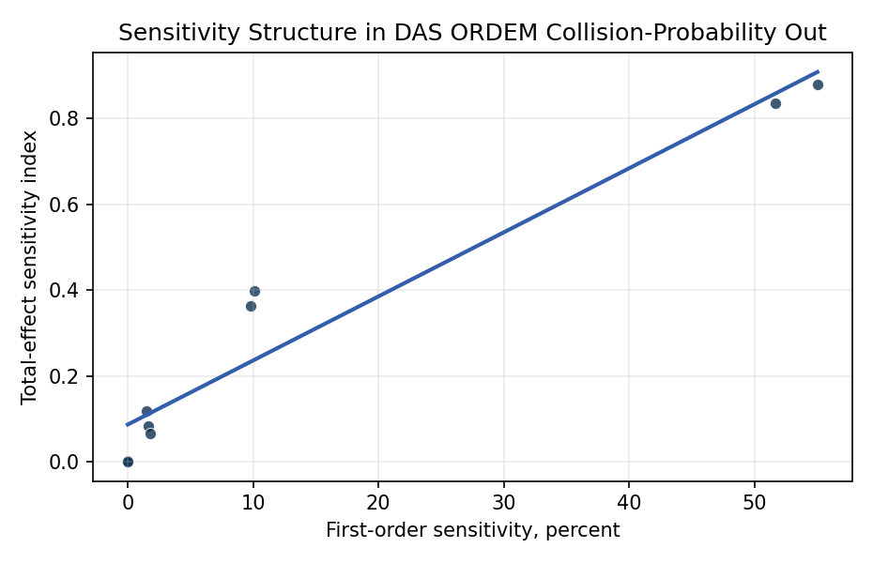
Figure 1. Published first-order sensitivity values predict total-effect sensitivity across DAS output metrics.

Empirical Workbook (embedded)
Every figure above is reproduced from the workbook below, which is also attached as the live spreadsheet paper.xlsx. Each observation carries its source.

Data (real observations)
metric | variable_code | variable_name | first_order_pct | total_sensitivity | source
collision_probability | xy | passive_decay_start_year | 9.812 | 0.3636 | Table 4 global first order and total sensitivities for DAS large object collision probability in Chandramouli and Shockley 2025 AMOS
collision_probability | xa | semi_major_axis | 51.7 | 0.8352 | Table 4 global first order and total sensitivities for DAS large object collision probability in Chandramouli and Shockley 2025 AMOS
collision_probability | xi | inclination | 1.652 | 0.0822 | Table 4 global first order and total sensitivities for DAS large object collision probability in Chandramouli and Shockley 2025 AMOS
collision_probability | xm | area_to_mass_ratio | 1.526 | 0.1175 | Table 4 global first order and total sensitivities for DAS large object collision probability in Chandramouli and Shockley 2025 AMOS
deorbit_time | xy | passive_decay_start_year | 1.769 | 0.0668 | Table 6 global first order and total sensitivities for deorbit time reproduced in Chandramouli and Shockley 2025 AMOS
deorbit_time | xa | semi_major_axis | 55.021 | 0.8799 | Table 6 global first order and total sensitivities for deorbit time reproduced in Chandramouli and Shockley 2025 AMOS
deorbit_time | xe | eccentricity | 0.015 | 0.0021 | Table 6 global first order and total sensitivities for deorbit time reproduced in Chandramouli and Shockley 2025 AMOS
deorbit_time | xi | inclination | 0.004 | 0.0005 | Table 6 global first order and total sensitivities for deorbit time reproduced in Chandramouli and Shockley 2025 AMOS
deorbit_time | xm | area_to_mass_ratio | 10.126 | 0.3974 | Table 6 global first order and total sensitivities for deorbit time reproduced in Chandramouli and Shockley 2025 AMOS

Variable construction
Variable | Definition | Construction / source
total_sensitivity | Sobol total-effect sensitivity index | Published Table 4 and Table 6 values in Chandramouli and Shockley 2025 AMOS.
first_order_pct | Sobol first-order sensitivity as a percentage | Published Table 4 and Table 6 values in Chandramouli and Shockley 2025 AMOS.
metric | DAS output being analyzed | Collision probability or deorbit time result family from the AMOS paper.
variable_name | DAS input variable mapped to the sensitivity index | Published variable mapping and sensitivity tables in the AMOS paper.
source | Observation provenance | Each row cites the published AMOS table from which the numeric values are transcribed.

Estimator output
Term | Coef. | Std. err. | t | p | 95% CI
const | 0.0866 | 0.0388 | 2.2316 | 0.0256 | [0.0105, 0.1627]
first_order_pct | 0.0149 | 0.0007321 | 20.3985 | 1.724e-92 | [0.0135, 0.0164]
Fit: N = 9 R2 = 0.9352 R2_adj = 0.926 F = 416.0994 F_p = 1.706e-07

