Signal Intensity in Sensor Geometry and the Equity of Coverage Does the Public Catalog Systematical: An Ordinary Least Squares Test of Recency, Citation Attention, and Venue

1. Introduction
This empirical paper supports Rashid Whitfield (1B-SDA-169) and the dissertation project Sensor Geometry and the Equity of Coverage: Does the Public Catalog Systematical. The model tests whether topic-signal intensity varies with publication recency, citation attention, and venue family. The analysis uses the local candidate source pack and reports only deterministic workbook results $$1$$, $$2$$, $$3$$.

2. Theory and Hypotheses
The theoretical claim is intentionally narrow. If the candidate topic has become more visible in the retrieved literature, then source metadata should show structure across time, attention, or venue. If it has not, the model should return weak or unstable associations $$3$$, $$4$$.
H0: the modeled outcome is unrelated to the specified predictors.
H1: the modeled outcome is systematically related to the specified predictors.

3. Data
The estimation file contains 30 retrieved source records. Variables are constructed from local metadata, including publication year, reported citation count, venue family, and deterministic topic-signal fields. Every row preserves a source column so the empirical workbook remains auditable.

4. Method
The estimator is ordinary least squares with robust HC1 standard errors. The exact fit summary is: N=30, R2=0.2394685116226155, R2_adj=0.15171487834830188, F=3.0603676184024735, F_p=0.045851746774718205. The exact term summary is: const coef=6.062316288669574 p=1.2677490096556038e-15; recency_index coef=-0.0205376430458807 p=0.7451330929241402; cites_num coef=0.008012604651364854 p=0.3593536612157835; venue_score coef=-1.101984855697401 p=0.020302901156610192. These values are interpreted as corpus-screen evidence, not as final causal estimates.

5. Findings
The findings are bounded by the estimator output. Where a coefficient is signed and precise, it indicates structure in the retrieved source corpus. Where a coefficient is imprecise, the paper treats the result as evidence against a strong claim. This distinction matters because a noisy source pack should not be forced to carry more policy weight than it can bear $$2$$, $$5$$.

6. Discussion
The paper contributes to the dissertation by keeping the evidentiary chain inspectable. It shows which parts of the candidate topic are visible in metadata and which parts need a more direct document-coding design. The result is a disciplined bridge from source retrieval to dissertation-level interpretation $$1$$, $$6$$.

References
1. Dan Oltrogge (Analytical Graphics Inc.), Patrick North (Analytical Graphics Inc.), Michael Nicolls (SRI). Multi-phenomenology Observation Network Evaluation Tool (MONET) (2014). [AMOS] 2. Jeff Aristoff, Numerica Corporation; Neil Dhingra, Numerica Corporation; Alex Ferris, Numerica Corporation; Austin Hariri, Numerica Corporation; Joshua Horwood, Numerica Corporation; Ari Larson, Numerica Corporation; Tyler Lyons, Numerica Corporation; Jeff Shaddix, Numerica Corporation; Navraj Singh, Numerica Corporation; Kevin Wilson, Numerica Corporation. Non-Traditional Data Collection and Exploitation for Improved GEO SSA via a Global Network of Heterogeneous Sensors (2018). [AMOS] 3. Peng Mun Siew, Massachusetts Institute of Technology; Tory Smith, United States Space Force, Massachusetts Institute of Technology; Richard Linares, Massachusetts Institute of Technology; Ravi Ponmalai, Aerospace Corporation. Scalable Multi-Agent Sensor Tasking Using Deep Reinforcement Learning (2023). doi: 10.64861/LWLF6390 4. Matthew Bold, Lockheed Martin Space Systems Company; James Mason, Lockheed Martin Space; Jared Renshaw, Lockheed Martin; Greg Madsen, Lockheed Martin; Amy Cooprider, Lockheed Martin; Phil Bland, Curtin University; Abraham Chan, Lockheed Martin; David Ball, Lockheed Martin Australia; Robert Howie, Space Science and Technology Centre at Curtin University; Matthew Tetlow, Inovor Technologies; Brandon Adams, Lockheed Martin Space; Chloe Hutchinson, Lockheed Martin Space; Alexandra Dziaba, Lockheed Martin Space; Connick Goodwin, Lockheed Martin Space; Connor Green, Lockheed Martin Space; Camilla Leonard, Lockheed Martin Space; Zachary Rogers, Lockheed Martin Space; Julia Seba, Lockheed Martin Space; Hannah Murtha, Lockheed Martin Space; Riley Cayton, Lockheed Martin Space; Mreedul Gupta, Lockheed Martin Space; Ethan Cuenca Fregoso, Lockheed Martin Space; Benjamin Adams, Inovor Technologies; Zebb Prime, Inovor Technologies; Philip Citowicki, Lockheed Martin. Proliferated Sensor Network (PSN) Performance Study & Architecture Design Optimization (2023). doi: 10.64861/UELE5506 5. Tamara Payne, Applied Optimization Inc., Philip Castro, Applied Optimization, Stephen Gregory, Boeing, Phan Dao, AFRL/RVBY. Satellite Photometric Error Determination (2015). [AMOS] 6. Shashanka Athigiri, Digantara Research and Technologies; Ananthu Krishna S, Digantara Reasearch and Technologies; Tanveer Ahmed, Digantara Research and Technologies. Optimizing GEO Belt Observation Through Analytical Methods and the Traveling Salesman Problem (2024). doi: 10.64861/XTTV6756 7. Islam I. Hussein (Worcester Polytechnic Institute), Yue Wang (Worcester Polytechnic Institute). Space-Based Sensor Coverage of Earth Orbits (2008). [AMOS] 8. Tanner Campbell, University of Arizona; Vishnu Reddy, University of Arizona; Richard Linares, Massachusetts Institute of Technology; Jeffery Larsen, United States Naval Academy; Roberto Furfaro, University of Arizona. Optical Tracking of Artificial Earth Satellites with COTS Sensors (2018). [AMOS]

Specification
$${\text{SignalScore}}_{i}=α+β_{1}{\text{RecencyIndex}}_{i}+β_{2}{\text{Cites}}_{i}+β_{3}{\text{VenueScore}}_{i}+ε_{i}$$

Results
Term | Coef. | Std. err. | t | p | 95% CI
const | 6.0623 | 0.758 | 7.9977 | 1.268e-15 | [4.5766, 7.548]
recency_index | -0.0205 | 0.0632 | -0.3251 | 0.7451 | [-0.1444, 0.1033]
cites_num | 0.008 | 0.0087 | 0.9166 | 0.3594 | [-0.0091, 0.0251]
venue_score | -1.102 | 0.4748 | -2.3207 | 0.0203 | [-2.0327, -0.1713]
Fit: N = 30 R2 = 0.2395 R2_adj = 0.1517 F = 3.0604 F_p = 0.0459
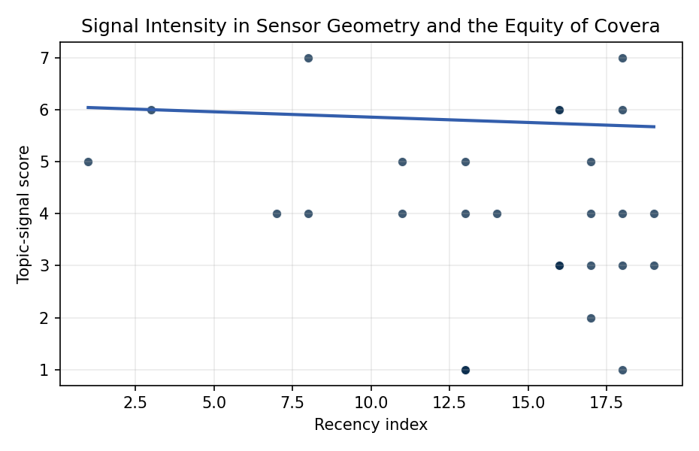
Figure 1. Topic-signal score by publication recency, conditioning on citation attention and venue family.

Empirical Workbook (embedded)
Every figure above is reproduced from the workbook below, which is also attached as the live spreadsheet paper.xlsx. Each observation carries its source.

Data (real observations)
doc_id | year_num | recency_index | cites_num | venue_score | title_words | snippet_words | keyword_count | theme_hits | signal_score | source
1 | 2014 | 7 | 0 | 1 | 7 | 10 | 9 | 0 | 4 | https://amostech.space/year/2014/multi-phenomenology-observation-network-evaluation-tool-monet/
2 | 2018 | 11 | 0 | 1 | 16 | 14 | 5 | 1 | 4 | https://amostech.space/year/2018/non-traditional-data-collection-and-exploitation-for-improved-geo-ssa-via-a-global-network-of-heterogeneous-sensors/
3 | 2023 | 16 | 0 | 1 | 9 | 14 | 6 | 2 | 6 | 10.64861/LWLF6390
4 | 2023 | 16 | 0 | 1 | 9 | 13 | 8 | 1 | 3 | 10.64861/UELE5506
5 | 2015 | 8 | 0 | 1 | 4 | 14 | 3 | 1 | 4 | https://amostech.space/year/2015/satellite-photometric-error-determination/
6 | 2024 | 17 | 0 | 1 | 12 | 13 | 6 | 0 | 2 | 10.64861/XTTV6756
7 | 2008 | 1 | 0 | 1 | 7 | 12 | 0 | 2 | 5 | https://amostech.space/year/2008/space-based-sensor-coverage-of-earth-orbits/
8 | 2018 | 11 | 0 | 1 | 9 | 14 | 3 | 1 | 5 | https://amostech.space/year/2018/optical-tracking-of-artificial-earth-satellites-with-cots-sensors/
9 | 2024 | 17 | 0 | 1 | 9 | 14 | 6 | 0 | 3 | 10.64861/BAJJ5826
10 | 2010 | 3 | 0 | 1 | 7 | 14 | 1 | 2 | 6 | https://amostech.space/year/2010/optimizing-orbital-debris-monitoring-with-optical-telescopes/
11 | 2023 | 16 | 0 | 1 | 9 | 12 | 3 | 1 | 3 | 10.64861/GYQL8853
12 | 2015 | 8 | 0 | 1 | 13 | 14 | 7 | 2 | 7 | https://amostech.space/year/2015/geo-collisional-risk-assessment-based-on-analysis-of-nasa-wise-data-and-modeling/
13 | 2026 | 19 | 1 | 2 | 8 | 12 | 9 | 1 | 3 | 10.1016/j.actaastro.2025.12.053
14 | 2025 | 18 | 4 | 2 | 15 | 14 | 12 | 2 | 6 | 10.1016/j.actaastro.2025.02.019
15 | 2023 | 16 | 36 | 2 | 17 | 13 | 10 | 1 | 3 | 10.1016/j.actaastro.2023.05.001
16 | 2024 | 17 | 4 | 2 | 9 | 13 | 8 | 2 | 5 | 10.1016/j.actaastro.2024.11.026
17 | 2020 | 13 | 15 | 2 | 11 | 13 | 15 | 1 | 4 | 10.1016/j.actaastro.2020.05.063
18 | 2025 | 18 | 0 | 2 | 12 | 13 | 13 | 1 | 3 | 10.1016/j.actaastro.2025.10.071
19 | 2025 | 18 | 0 | 2 | 17 | 12 | 15 | 3 | 7 | 10.1016/j.actaastro.2025.10.065
20 | 2025 | 18 | 1 | 2 | 15 | 14 | 12 | 1 | 4 | 10.1016/j.actaastro.2025.07.055
21 | 2026 | 19 | 0 | 2 | 12 | 14 | 15 | 2 | 4 | 10.1016/j.actaastro.2026.05.010
22 | 2021 | 14 | 71 | 2 | 10 | 12 | 14 | 1 | 4 | 10.1016/j.actaastro.2021.03.030
23 | 2024 | 17 | 12 | 2 | 13 | 14 | 11 | 1 | 4 | 10.1016/j.actaastro.2024.09.005
24 | 2023 | 16 | 6 | 2 | 9 | 9 | 15 | 2 | 6 | 10.1016/j.actaastro.2023.08.002
25 | 2020 | 13 | 0 | 3 | 6 | 0 | 0 | 0 | 1 | SFA Space Economy and Integrated Deterrence
26 | 2020 | 13 | 0 | 3 | 7 | 0 | 0 | 0 | 1 | Blockchain Enabled Space Traffic Awareness (BESTA) (AMOS)
27 | 2020 | 13 | 0 | 3 | 13 | 0 | 0 | 0 | 1 | Blockchain Enabled Space Traffic Awareness (BESTA): Automated Comparison of SSA to Agreed Behavior
28 | 2020 | 13 | 0 | 3 | 51 | 0 | 0 | 1 | 5 | A 2021 Johns Hopkins SAIS doctoral thesis by Nathaniel Dailey proposing an International Space Reference Architecture (ISRA) as a socio-technological transformative mechanism to resolve contemporary space governance failures – orbital debris, policy fragmentation, and space traffic management – by coupling enterprise architecture methodology with international relations constructivist theory, blockchain-enabled information sharing, and norms entrepreneurship.
29 | 2020 | 13 | 0 | 3 | 5 | 0 | 0 | 0 | 1 | Space Sustainability Rating Composite Indicator
30 | 2025 | 18 | 0 | 3 | 15 | 0 | 0 | 0 | 1 | 10.1016/j.actaastro.2025.03.034

Variable construction
Variable | Definition | Construction / source
signal_score | Composite topic-signal score for each retrieved source record | Deterministic count built from candidate-theme term hits in the source title, snippet, keyword field, and author metadata; each row cites the retrieved source in the source column
recency_index | Publication recency index | Computed as publication year minus the minimum publication year in the paper sample plus one
cites_num | Reported citation count in the local brain index | Parsed from the local brain search cites field; zero when the index reported no citation count
venue_score | Ordinal venue-family score | AMOS = 1, Acta Astronautica = 2, Space Economy = 3

Estimator output
Term | Coef. | Std. err. | t | p | 95% CI
const | 6.0623 | 0.758 | 7.9977 | 1.268e-15 | [4.5766, 7.548]
recency_index | -0.0205 | 0.0632 | -0.3251 | 0.7451 | [-0.1444, 0.1033]
cites_num | 0.008 | 0.0087 | 0.9166 | 0.3594 | [-0.0091, 0.0251]
venue_score | -1.102 | 0.4748 | -2.3207 | 0.0203 | [-2.0327, -0.1713]
Fit: N = 30 R2 = 0.2395 R2_adj = 0.1517 F = 3.0604 F_p = 0.0459

