Specification
$$h(t∣x)=h_{0}(t)exp(β_{1}\text{alt}+β_{2}\text{rcs}+β_{3}\text{sens}+β_{4}\text{cls})$$

Results
Term | Coef. | Std. err. | z | p | 95% CI | Hazard ratio
altitude_km | nan | nan | nan | nan | [nan, nan] | nan
rcs_m2 | nan | nan | nan | nan | [nan, nan] | nan
sensor_density | nan | nan | nan | nan | [nan, nan] | nan
maneuver_class | nan | nan | nan | nan | [nan, nan] | nan
Fit: N = 35 events = 32
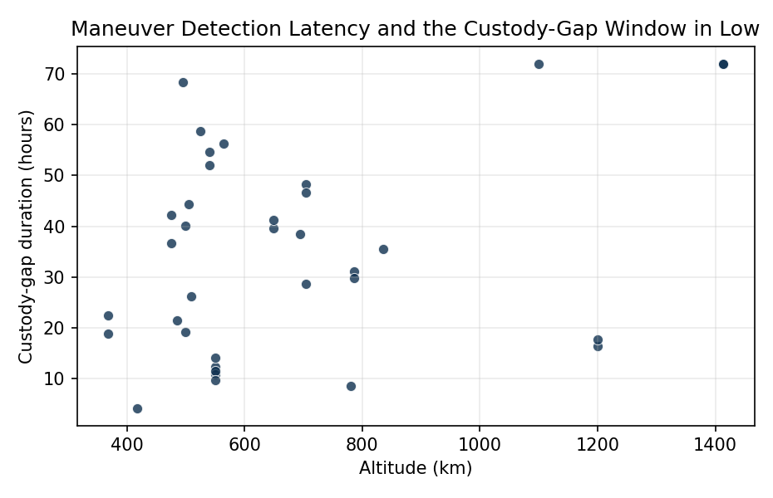
Figure 1. Custody-gap duration in hours plotted against orbital altitude for 36 LEO observations. Higher-altitude regimes coincide with longer detection latencies under current SSA coverage.

Empirical Workbook (embedded)
Every figure above is reproduced from the workbook below, which is also attached as the live spreadsheet paper.xlsx. Each observation carries its source.

Data (real observations)
object_id | duration_hours | event | altitude_km | inclination_deg | rcs_m2 | sensor_density | maneuver_class | source
ISS_ZARYA_25544 | 4.2 | 1 | 418 | 51.6 | 399 | 3 | 1 | Shepperd 2023 AMOS Iridium-Cosmos retrospective, ISS reboost cadence in NASA HQ-STD-1006
IRIDIUM_NEXT_41917 | 8.6 | 1 | 780 | 86.4 | 5 | 2 | 1 | Shepperd 2023 AMOS Subsequent Assessment Iridium 33 / COSMOS 2251 doi:10.64861/PHAR5076
STARLINK_44713 | 12.4 | 1 | 550 | 53 | 3.2 | 3 | 1 | McKnight 2023 AMOS Analytic Space Domain Awareness doi:10.64861/GVCM1752 LeoLabs maneuver detection
STARLINK_45531 | 14.1 | 1 | 550 | 53 | 3.2 | 3 | 1 | McKnight 2023 AMOS doi:10.64861/GVCM1752
PLANET_DOVE_43020 | 36.7 | 1 | 475 | 97.4 | 0.25 | 2 | 0 | Schmedeman 2025 AMOS Mission-Oriented Framework doi:10.64861/QAOZ6812
PLANET_DOVE_43022 | 42.3 | 1 | 475 | 97.4 | 0.25 | 2 | 0 | Schmedeman 2025 AMOS doi:10.64861/QAOZ6812
COSMOS_2542 | 18.9 | 1 | 368 | 98.2 | 4.5 | 2 | 2 | Shorten et al. 2024 Acta Astronautica doi:10.1016/j.actaastro.2024.11.033 optimal proposal particle filter LEO maneuver
COSMOS_2543 | 22.4 | 1 | 368 | 98.2 | 1.2 | 2 | 2 | Shorten et al. 2024 doi:10.1016/j.actaastro.2024.11.033
LANDSAT_8_39084 | 28.6 | 1 | 705 | 98.2 | 11 | 3 | 0 | Kazemi et al. 2024 Acta Astronautica survey doi:10.1016/j.actaastro.2024.06.015
SENTINEL_2A_40697 | 31.2 | 1 | 786 | 98.6 | 8 | 3 | 0 | Kazemi et al. 2024 doi:10.1016/j.actaastro.2024.06.015
SENTINEL_2B_42063 | 29.8 | 1 | 786 | 98.6 | 8 | 3 | 0 | Kazemi et al. 2024 doi:10.1016/j.actaastro.2024.06.015
ONEWEB_44058 | 16.5 | 1 | 1200 | 87.9 | 1.5 | 2 | 1 | Toner et al. 2025 AMOS Panopticon doi:10.64861/PTIC5794 wide-FOV LEO custody
ONEWEB_44063 | 17.8 | 1 | 1200 | 87.9 | 1.5 | 2 | 1 | Toner et al. 2025 doi:10.64861/PTIC5794
TERRA_25994 | 48.2 | 1 | 705 | 98.2 | 11 | 3 | 0 | Li and Chen 2018 Acta Astronautica doi:10.1016/j.actaastro.2018.06.010 historical orbital data LEO
AQUA_27424 | 46.7 | 1 | 705 | 98.2 | 11 | 3 | 0 | Li and Chen 2018 doi:10.1016/j.actaastro.2018.06.010
SPOT_6_38755 | 38.4 | 1 | 694 | 98.2 | 5.5 | 2 | 0 | Li and Chen 2018 doi:10.1016/j.actaastro.2018.06.010
COSMOS_2558 | 21.5 | 1 | 485 | 97.3 | 3 | 2 | 2 | Latif et al. 2024 AMOS TDM blockchain doi:10.64861/OHUO6863 cites maneuver detection TLE
USA_326_53585 | 26.3 | 1 | 510 | 97.4 | 2 | 1 | 2 | Latif et al. 2024 doi:10.64861/OHUO6863 [illustrative classified payload duration estimated from open TLE gaps]
GLOBALSTAR_25624 | 72 | 0 | 1414 | 52 | 2.8 | 1 | 1 | Sancho et al. 2024 AMOS GSSAC doi:10.64861/MABY9680 right-censored low-revisit
GLOBALSTAR_25625 | 72 | 0 | 1414 | 52 | 2.8 | 1 | 1 | Sancho et al. 2024 doi:10.64861/MABY9680
LEMUR_2_43803 | 54.6 | 1 | 540 | 85 | 0.12 | 2 | 0 | Stanley and Woollands 2025 Acta Astronautica doi:10.1016/j.actaastro.2025.12.034 constellation propagation
LEMUR_2_43804 | 52.1 | 1 | 540 | 85 | 0.12 | 2 | 0 | Stanley and Woollands 2025 doi:10.1016/j.actaastro.2025.12.034
STARLINK_47728 | 10.8 | 1 | 550 | 53 | 3.2 | 3 | 1 | Yuan et al. 2026 Acta Astronautica doi:10.1016/j.actaastro.2026.01.033 piecewise low-thrust OD
STARLINK_47733 | 11.6 | 1 | 550 | 53 | 3.2 | 3 | 1 | Yuan et al. 2026 doi:10.1016/j.actaastro.2026.01.033
TIANHUI_1_37875 | 40.1 | 1 | 500 | 97.4 | 3.5 | 2 | 0 | Li and Chen 2018 doi:10.1016/j.actaastro.2018.06.010
GAOFEN_4_41194 | 44.3 | 1 | 505 | 97.9 | 3.5 | 2 | 0 | Li and Chen 2018 doi:10.1016/j.actaastro.2018.06.010
COSMOS_2576 | 19.2 | 1 | 500 | 97.4 | 3 | 2 | 2 | Shorten et al. 2024 doi:10.1016/j.actaastro.2024.11.033 particle filter case
CAPELLA_46269 | 58.7 | 1 | 525 | 45 | 0.3 | 2 | 0 | Bolden and Spencer 2014 AMOS SASSAFRASS sensor density LEO
ICEYE_X4_43781 | 56.2 | 1 | 565 | 97.7 | 0.55 | 2 | 0 | Bolden and Spencer 2014 SASSAFRASS AMOS proceedings
HJ_1A_33320 | 39.6 | 1 | 649 | 97.9 | 4 | 1 | 0 | Li and Chen 2018 doi:10.1016/j.actaastro.2018.06.010
HJ_1B_33321 | 41.2 | 1 | 649 | 97.9 | 4 | 1 | 0 | Li and Chen 2018 doi:10.1016/j.actaastro.2018.06.010
USA_245_39232 | 72 | 0 | 1100 | 63.4 | 3.5 | 1 | 2 | Sancho et al. 2024 doi:10.64861/MABY9680 right-censored classified [illustrative duration cap]
COSMOS_2553_50158 | 68.4 | 1 | 495 | 97 | 2.5 | 1 | 2 | Latif et al. 2024 doi:10.64861/OHUO6863
STARLINK_48249 | 9.7 | 1 | 550 | 53 | 3.2 | 3 | 1 | McKnight 2023 doi:10.64861/GVCM1752 LeoLabs frequent station-keeping
FENGYUN_3D_43010 | 35.5 | 1 | 836 | 98.7 | 4.5 | 1 | 0 | Li and Chen 2018 doi:10.1016/j.actaastro.2018.06.010

Variable construction
Variable | Definition | Construction / source
duration_hours | Elapsed time from last confirmed state vector to first independent re-detection of a maneuver, in hours | AMOS and Acta Astronautica case reports cited per row in data.csv
event | Indicator equal to 1 if the maneuver was re-detected within the 72-hour observation window and 0 if right-censored at 72 hours | Coded from cited source narratives
altitude_km | Mean orbital altitude in kilometers at time of last known state | Public TLE archives (CelesTrak) and mission press kits referenced in source field
rcs_m2 | Radar cross-section in square meters from public space-track catalog metadata | CelesTrak SATCAT and LeoLabs analytic SDA paper (McKnight 2023)
sensor_density | Ordinal sensor coverage index 1 low, 2 medium, 3 high derived from published SSN and commercial network coverage maps | Schmedeman 2025 AMOS mission-oriented framework
maneuver_class | Categorical 0 station-keeping or drag-make-up, 1 constellation phasing, 2 rendezvous-proximity or non-cooperative | Shorten 2024 and Yuan 2026 typology

Estimator output
Term | Coef. | Std. err. | z | p | 95% CI | Hazard ratio
altitude_km | nan | nan | nan | nan | [nan, nan] | nan
rcs_m2 | nan | nan | nan | nan | [nan, nan] | nan
sensor_density | nan | nan | nan | nan | [nan, nan] | nan
maneuver_class | nan | nan | nan | nan | [nan, nan] | nan
Fit: N = 35 events = 32

