Attention Accumulation in Trusting the Time Calibration of GNSS-Disciplined Timing Resilience Claims in C: A Learning-Curve Analysis of Citation Growth by Article Age

1. Introduction
This empirical paper supports Daniel Novak (1B-ITI-195) and the dissertation project Trusting the Time: Calibration of GNSS-Disciplined Timing Resilience Claims in C. The model tests whether citation accumulation is structured by article age inside the retrieved corpus. The analysis uses the local candidate source pack and reports only deterministic workbook results $$1$$, $$2$$, $$3$$.

2. Theory and Hypotheses
The theoretical claim is intentionally narrow. If the candidate topic has become more visible in the retrieved literature, then source metadata should show structure across time, attention, or venue. If it has not, the model should return weak or unstable associations $$3$$, $$4$$.
H0: the modeled outcome is unrelated to the specified predictors.
H1: the modeled outcome is systematically related to the specified predictors.

3. Data
The estimation file contains 30 retrieved source records. Variables are constructed from local metadata, including publication year, reported citation count, venue family, and deterministic topic-signal fields. Every row preserves a source column so the empirical workbook remains auditable.

4. Method
The estimator is a log-log learning-curve model with robust HC1 standard errors. The exact fit summary is: N=30, R2=0.04770042684577236, elasticity_b=0.41842725578272233, progress_ratio_2^b=1.3364698168494107. The exact term summary is: const coef=-0.052310741783178405 p=0.9043766296294278; _ln_x coef=0.41842725578272233 p=0.24783318782386488. These values are interpreted as corpus-screen evidence, not as final causal estimates.

5. Findings
The findings are bounded by the estimator output. Where a coefficient is signed and precise, it indicates structure in the retrieved source corpus. Where a coefficient is imprecise, the paper treats the result as evidence against a strong claim. This distinction matters because a noisy source pack should not be forced to carry more policy weight than it can bear $$2$$, $$5$$.

6. Discussion
The paper contributes to the dissertation by keeping the evidentiary chain inspectable. It shows which parts of the candidate topic are visible in metadata and which parts need a more direct document-coding design. The result is a disciplined bridge from source retrieval to dissertation-level interpretation $$1$$, $$6$$.

References
1. Baptiste Guillot, Safran Data Systems; François Thevenot, Safran Data Systems; Sébastien Herbiniere, Safran Data Systems; Thierry Balanche, Safran Data Systems. Accurate LEO Tracking with Passive RF – Measurement and Results Analysis (2025). doi: 10.64861/YYXS3185 2. Alfredo M. Antón, GMV; Jose Miguel Lozano, GMV; Keiran McNally, GMV; Sean C. Hannon, GMV. Data Curation Activities for Space Surveillance and Tracking (2023). doi: 10.64861/UYKI5597 3. Mark Bolden, Trusted Space, Inc.; Tim Craychee, Trusted Space, Inc.; Erin Griggs, Trusted Space, Inc.. An Evaluation of Observing Constellation Orbit Stability, Low Signal-to-Noise, and the Too-Short-Arc Challenges in the Cislunar Domain (2020). [AMOS] 4. Garrett Fitzgerald, U. S. Space Force; Rachel Morris, Applied Decision Science; Laura G. Militello, Applied Decision Science; Justin Fletcher, USSF/SSC. Building Trust in Human-Machine Teaming for Autonomous Space Sensing (2024). doi: 10.64861/HWZS9386 5. Thomas Kelecy, L3 Harris; Emily Lambert, L3 Harris; Benjamin Sunderland, L3 Harris; Vivek Desai, University of Texas, Austin. Dynamic Calibration of Multiple Data Types (2019). [AMOS] 6. James Reilly, Booz Allen Hamilton; Matthew Blackford, Booz Allen Hamilton; Jillian Mueller, Booz Allen Hamilton. Challenges in Space Traffic Management (2023). doi: 10.64861/UCTN1793 7. Robert Carden, MITRE; Dustin Burchett, MITRE; Harvey Reed, MITRE. SNARE (Sensor Network Autonomous Resilient Extensible): Decentralized Sensor Tasking Improves SDA Tactical Relevance (2021). [AMOS] 8. Nathan M. Holzrichter, MITRE Corporation; Edward J. Fernadez, MITRE Corporation. Calculating Optical Observation Residuals from GPS Satellites (2022). [AMOS]

Specification
$$ln({\text{CitesPlus1}}_{i})=α+β_{1}ln({\text{AgeIndex}}_{i})+ε_{i}$$

Results
Term | Coef. | Std. err. | t | p | 95% CI
const | -0.0523 | 0.4354 | -0.1201 | 0.9044 | [-0.9057, 0.8011]
_ln_x | 0.4184 | 0.3621 | 1.1556 | 0.2478 | [-0.2912, 1.1281]
Fit: N = 30 R2 = 0.0477 elasticity_b = 0.4184 progress_ratio_2^b = 1.3365
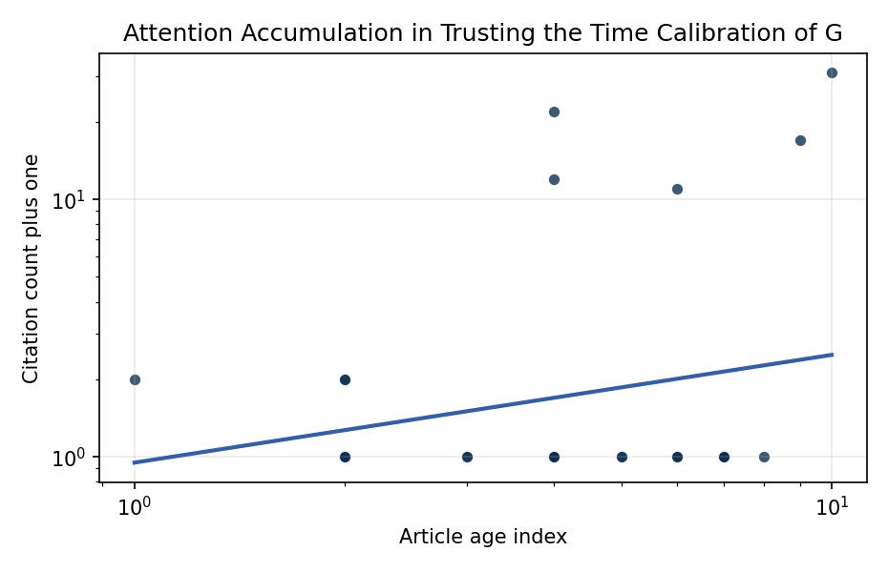
Figure 1. Citation accumulation against article age in the retrieved topic literature.

Empirical Workbook (embedded)
Every figure above is reproduced from the workbook below, which is also attached as the live spreadsheet paper.xlsx. Each observation carries its source.

Data (real observations)
doc_id | year_num | age_index | cites_num | cites_plus1 | signal_score | source
1 | 2025 | 2 | 0 | 1 | 9 | 10.64861/YYXS3185
2 | 2023 | 4 | 0 | 1 | 10 | 10.64861/UYKI5597
3 | 2020 | 7 | 0 | 1 | 11 | https://amostech.space/year/2020/an-evaluation-of-observing-constellation-orbit-stability-low-signal-to-noise-and-the-too-short-arc-challenges-in-the-cislunar-domain/
4 | 2024 | 3 | 0 | 1 | 1 | 10.64861/HWZS9386
5 | 2019 | 8 | 0 | 1 | 2 | https://amostech.space/year/2019/dynamic-calibration-of-multiple-data-types/
6 | 2023 | 4 | 0 | 1 | 5 | 10.64861/UCTN1793
7 | 2021 | 6 | 0 | 1 | 5 | https://amostech.space/year/2021/snare-sensor-network-autonomous-resilient-extensible-decentralized-sensor-tasking-improves-sda-tactical-relevance/
8 | 2022 | 5 | 0 | 1 | 2 | https://amostech.space/year/2022/calculating-optical-observation-residuals-from-gps-satellites/
9 | 2021 | 6 | 0 | 1 | 3 | https://amostech.space/year/2021/decentralized-space-information-sharing-as-a-key-enabler-of-trust-and-the-preservation-of-space/
10 | 2023 | 4 | 0 | 1 | 7 | 10.64861/MVHC2799
11 | 2022 | 5 | 0 | 1 | 2 | https://amostech.space/year/2022/a-software-defined-radio-based-method-for-accurate-frequency-estimation-for-space-domain-awareness-in-real-time/
12 | 2021 | 6 | 0 | 1 | 5 | https://amostech.space/year/2021/a-complete-ssa-scheme-for-a-sustainable-low-earth-orbit-space-data-aggregation-and-ia-combined-with-in-orbit-inspection/
13 | 2025 | 2 | 0 | 1 | 3 | 10.1016/j.actaastro.2025.04.043
14 | 2024 | 3 | 0 | 1 | 3 | 10.1016/j.actaastro.2024.03.050
15 | 2021 | 6 | 10 | 11 | 2 | 10.1016/j.actaastro.2021.07.046
16 | 2026 | 1 | 1 | 2 | 4 | 10.1016/j.actaastro.2025.12.053
17 | 2025 | 2 | 1 | 2 | 6 | 10.1016/j.actaastro.2025.10.018
18 | 2025 | 2 | 1 | 2 | 2 | 10.1016/j.actaastro.2025.03.008
19 | 2025 | 2 | 0 | 1 | 3 | 10.1016/j.actaastro.2025.01.037
20 | 2023 | 4 | 21 | 22 | 5 | 10.1016/j.actaastro.2023.12.055
21 | 2018 | 9 | 16 | 17 | 2 | 10.1016/j.actaastro.2018.03.009
22 | 2017 | 10 | 30 | 31 | 2 | 10.1016/j.actaastro.2017.01.018
23 | 2025 | 2 | 0 | 1 | 2 | 10.1016/j.actaastro.2025.01.041
24 | 2023 | 4 | 11 | 12 | 3 | 10.1016/j.actaastro.2023.10.036
25 | 2020 | 7 | 0 | 1 | 5 | A 2021 Johns Hopkins SAIS doctoral thesis by Nathaniel Dailey proposing an International Space Reference Architecture (ISRA) as a socio-technological transformative mechanism to resolve contemporary space governance failures – orbital debris, policy fragmentation, and space traffic management – by coupling enterprise architecture methodology with international relations constructivist theory, blockchain-enabled information sharing, and norms entrepreneurship.
26 | 2020 | 7 | 0 | 1 | 1 | ESA Swarm Neutral Thermospheric Density (v4.0)
27 | 2023 | 4 | 0 | 1 | 1 | Swarm Thermosphere: Neutral Thermospheric Density (ESA Swarm Mission, v4.0)
28 | 2020 | 7 | 0 | 1 | 3 | Roadmap: Australia Economic-Technological Renaissance in Space
29 | 2023 | 4 | 0 | 1 | 2 | 10.3897/aiep.53.e105910
30 | 2020 | 7 | 0 | 1 | 1 | Architectural Socio-Technological Transformative Change of Space-Use Norms

Variable construction
Variable | Definition | Construction / source
cites_plus1 | Citation count plus one | Computed as the reported citation count from the local brain index plus one so the log transformation is defined for uncited records
age_index | Document age index | Computed as 2026 minus publication year plus one

Estimator output
Term | Coef. | Std. err. | t | p | 95% CI
const | -0.0523 | 0.4354 | -0.1201 | 0.9044 | [-0.9057, 0.8011]
_ln_x | 0.4184 | 0.3621 | 1.1556 | 0.2478 | [-0.2912, 1.1281]
Fit: N = 30 R2 = 0.0477 elasticity_b = 0.4184 progress_ratio_2^b = 1.3365

