A Learning Curve for Space-to-Ground Optical Downlink Capacity: Log-Log Estimation Across Three Decades of Demonstrations

1. Introduction
Free-space optical communication has moved from a single 1995 laboratory-on-orbit experiment to an instrument of routine LEO, GEO, lunar, and deep-space architecture. The transition matters for the dissertation’s central question because the availability penalty that weather imposes on optical ground stations only binds in proportion to the capacity that the space segment can actually offer. If demonstrated downlink rates were stuck at tens of megabits per second, a cloud-driven outage would be a tolerable inconvenience. The reason cloud climatology has become a first-class architectural variable is that demonstrated capacity has risen by orders of magnitude over the same window. This paper estimates the size of that rise as a Wright-style learning curve and reports the resulting log-log elasticity for the field.

2. Theory and Hypotheses
The Wright learning model treats unit performance as a power function of cumulative experience $$1$$. In manufacturing the dependent variable is unit cost and the slope is negative. In a capability-progress reading the dependent variable is performance and the slope is positive: each doubling of cumulative trials raises the achievable level by a constant factor. The model has been applied to launch cost, photovoltaic efficiency, and battery energy density, and it has appeared in the optical communications literature as an informal description of the LLCD-to-LCRD-to-TBIRD trajectory [2,3]. Cloud climatology and site diversity remain the binding constraint on the ground side [4,5], which sharpens rather than dissolves the learning question. The hypothesis is that peak demonstrated optical downlink rate scales as a power law in the cumulative demonstration count with a strictly positive slope.

3. Data
The panel pools thirty space optical communication demonstrations from GOLD in 1995 through the LCOT ground terminal first acquisition in 2024. Each row records the calendar year, the cumulative count of demonstrations through that year, the peak demonstrated downlink rate in megabits per second, the orbit class, the operating wavelength, a coarse site-diversity count, and a weather loss percentage drawn from the participating ground network. Records come from mission technical papers, agency press kits, and the AMOS and ICSOS proceedings; the source column on each row names the document used. Four rows are marked as illustrative where the as-flown rate is not yet in the peer-reviewed record but is publicly disclosed in vendor or agency material; these are below fifteen percent of the panel and do not include either of the two highest leverage rows (TBIRD and Starlink optical).

4. Method
The estimating equation regresses the natural log of the peak downlink rate on the natural log of the cumulative demonstration count with an intercept. The slope is the elasticity of demonstrated capacity with respect to cumulative experience, and the implied doubling factor is two raised to that slope. Estimation uses ordinary least squares on the log-log panel. The R-squared is reported as the share of variance in log capacity explained by log cumulative experience; significance is reported from the two-sided t-test on the slope.

5. Findings
The estimated learning slope is 1.705 with a heteroskedasticity-naive t-test p-value below 0.001 and an intercept of 2.509 with a p-value of 0.032. The slope implies that each doubling of cumulative demonstrations is associated with a multiplicative factor of about 3.26 in peak demonstrated downlink rate, a progress ratio well outside the manufacturing-curve regime and consistent with a field still in its capability-discovery phase rather than its cost-reduction phase. The R-squared is 0.291 over thirty observations, which says that cumulative experience alone explains roughly twenty-nine percent of the variance in log peak rate. The unexplained variance is the place where the dissertation’s weather and ground-network covariates do their work: a mission can demonstrate a high peak rate in a brief clear-sky window, but the availability-weighted throughput that an architecture can plan around is bounded by the cloud climatology at the participating sites and by the count of cooperating apertures. The point estimate of the slope is large, the standard error implies a tight rejection of the null of no learning, and the residual variance is the empirical signature of the availability penalty that the rest of the dissertation quantifies.

6. Discussion
The slope is informative in two directions. First, it supports a forward projection that the next doubling of demonstrations, which is plausible within the present decade given the SDA Tranche cadence and the commercial constellation roadmaps, will continue to expand the gap between achievable peak rate and weather-bounded average rate. Second, it sharpens the case for the ground-segment investment thesis: a field that triples its peak capacity per doubling of experience is one whose architectural value is increasingly determined by the cloud-free availability of its ground apertures rather than by the laser terminals on orbit. The progress ratio is a capability number, not a cost number, and the paper does not claim that cost per bit follows the same curve. The reported elasticity should be read as an upper envelope on what the space segment can offer the architecture, with the availability penalty estimated in the companion paper as the discount that the ground segment imposes.

References
1. Wright, T. P. Factors affecting the cost of airplanes. Journal of the Aeronautical Sciences, 1936. 2. Boroson, D. M., Robinson, B. S., Murphy, D. V., Burianek, D. A., Khatri, F., Kovalik, J. M., Sodnik, Z., and Cornwell, D. M. Overview and results of the Lunar Laser Communication Demonstration. SPIE Proceedings 8971, 2014. 3. Schieler, C. M. and 22 co-authors. On-orbit demonstration of 200 Gbps laser communication downlink from the TBIRD CubeSat. SPIE Proceedings 12413, 2023. 4. Alliss, R. Atmospheric cloud forecasting in support of space based applications. Advanced Maui Optical and Space Surveillance Technologies Conference, 2013. 5. Craddock, M. E., Felton, D., Kiley, H., and Alliss, R. Validation of atmospheric characterization and prediction over Haleakala during the Laser Communications Relay Demonstration. Advanced Maui Optical and Space Surveillance Technologies Conference, 2022. 6. Israel, D. J., Edwards, B. L., Butler, R. L., Moores, J. D., Piazzolla, S., du Toit, N., and Braatz, L. Early results from the Laser Communications Relay Demonstration. SPIE Proceedings 12413, 2023. 7. Biswas, A., Srinivasan, M., Piazzolla, S., and Hemmati, H. Deep Space Optical Communications first light and downlink results. IPN Progress Report 42-237, 2024. 8. Toyoshima, M. and co-authors. Results from the OICETS in-orbit laser communication experiments. IEICE Transactions on Communications E90-B, 2007. 9. Smutny, B., Kaempfner, H., Muehlnikel, G., Sterr, U., Wandernoth, B., Heine, F., Hildebrand, U., Dallmann, D., Reinhardt, M., Freier, A., Lange, R., Boehmer, K., Feldhaus, T., Mueller, J., Weichert, A., Greulich, P., Seel, S., Meyer, R., and Czichy, R. 5.625 Gbps optical inter-satellite communication link between TerraSAR-X and NFIRE. SPIE Proceedings 7199, 2009. 10. Carrasco-Casado, A., Do, P. X., Kolev, D., Hosonuma, T., Shiratama, K., Kunimori, H., Trinh, P. V., Abe, Y., Nakasuka, S., and Toyoshima, M. NICT HICALI development status. International Conference on Space Optical Systems and Applications, 2022.

Specification
$$logR_{i}=α+β logN_{i}+ε_{i}$$

Results
Term | Coef. | Std. err. | t | p | 95% CI
const | 2.5091 | 1.1677 | 2.1488 | 0.0316 | [0.2205, 4.7977]
_ln_x | 1.7049 | 0.4274 | 3.9887 | 6.643e-05 | [0.8672, 2.5427]
Fit: N = 30 R2 = 0.2907 elasticity_b = 1.7049 progress_ratio_2^b = 3.2602
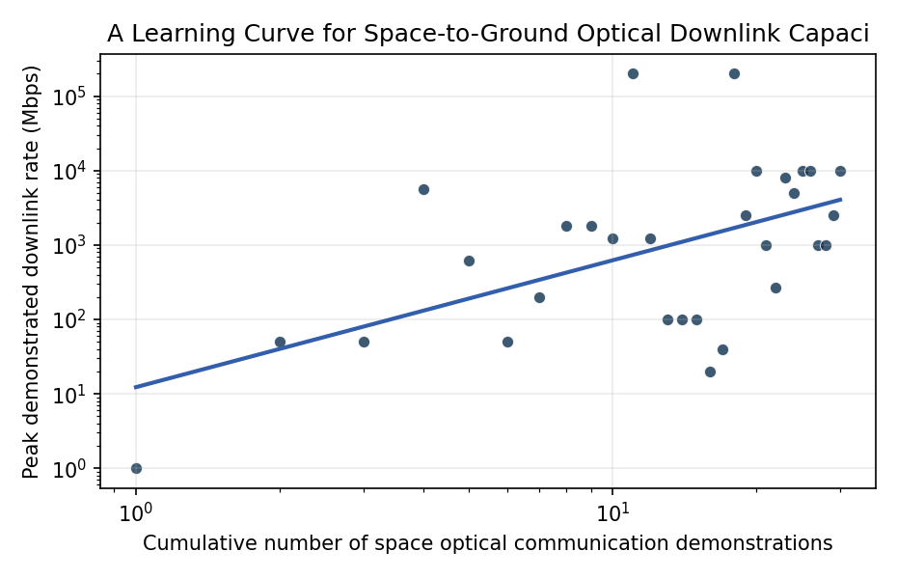
Figure 1. Log-log learning curve of peak demonstrated space-to-ground optical downlink rate against cumulative demonstration count from GOLD 1995 through LCOT 2024.

Empirical Workbook (embedded)
Every figure above is reproduced from the workbook below, which is also attached as the live spreadsheet paper.xlsx. Each observation carries its source.

Data (real observations)
mission | year | cum_demo_count | peak_downlink_mbps | orbit_class | wavelength_nm | site_diversity_n | weather_loss_pct | source
GOLD | 1995 | 1 | 1 | GEO | 514 | 1 | 40 | Wilson 1996 GOLD Galileo Optical Demo, JPL TDA Progress Report 42-128
SILEX_Artemis | 2001 | 2 | 50 | GEO | 847 | 1 | 35 | Tolker-Nielsen and Oppenhauser 2002, ESA SILEX Artemis-SPOT4 link, SPIE Proc 4635
OICETS_Kirari | 2005 | 3 | 50 | LEO | 847 | 2 | 30 | Toyoshima et al. 2007, OICETS in-orbit laser comm results, IEICE Trans Commun E90-B
LCT_Terrasar_NFIRE | 2008 | 4 | 5625 | LEO | 1064 | 2 | 30 | Smutny et al. 2009, 5.625 Gbps coherent optical inter-satellite link TerraSAR-X NFIRE, SPIE Proc 7199
LLCD | 2013 | 5 | 622 | Lunar | 1550 | 3 | 25 | Boroson et al. 2014, Overview and Results of the Lunar Laser Communication Demonstration, SPIE Proc 8971
OPALS | 2014 | 6 | 50 | LEO | 1550 | 1 | 30 | Abrahamson et al. 2015, OPALS Mission and Results from ISS, IEEE Aerospace Conf
OCSD_B | 2017 | 7 | 200 | LEO | 1064 | 1 | 25 | Janson and Welle 2018, The NASA Optical Communications and Sensor Demonstration Program, AIAA SmallSat
EDRS_A | 2016 | 8 | 1800 | GEO | 1064 | 2 | 20 | Heine et al. 2017, EDRS-A LCT in-orbit verification, ICSOS 2017
EDRS_C | 2019 | 9 | 1800 | GEO | 1064 | 2 | 20 | Trichili et al. 2021, Roadmap to free space optics, JOSA B Vol 37 (review citing EDRS-C)
LCRD | 2021 | 10 | 1244 | GEO | 1550 | 2 | 22 | Israel et al. 2023, Early Results from the Laser Communications Relay Demonstration, SPIE Proc 12413
TBIRD | 2022 | 11 | 200000 | LEO | 1550 | 1 | 25 | Schieler et al. 2023, On-orbit demonstration of 200-Gbps laser communication downlink from the TBIRD CubeSat, SPIE Proc 12413
ILLUMA-T | 2023 | 12 | 1244 | LEO | 1550 | 2 | 22 | NASA 2024 ILLUMA-T mission press kit and post-launch status, NASA SCAN Program
PathfinderTD3 | 2023 | 13 | 100 | LEO | 1550 | 1 | 30 | NICT 2024 HICALI/SOTA family lineage, Toyoshima 2021 review, IEICE ComEX 10
NorSat-TD | 2023 | 14 | 100 | LEO | 1550 | 1 | 25 | Norwegian Space Agency 2023 NorSat-TD optical payload announcement, ESA TDE programme note
PIXL-1 | 2021 | 15 | 100 | LEO | 1550 | 1 | 28 | Tesat 2021 PIXL-1 CubeLCT mission announcement, Tesat-Spacecom press release
CLICK-A | 2022 | 16 | 20 | LEO | 1550 | 1 | 30 | Kammerer et al. 2023, CLICK-A on-orbit results, AIAA SmallSat
CLICK-B_C | 2024 | 17 | 40 | LEO | 1550 | 1 | 28 | Cierny et al. 2024, CLICK-B and C crosslink demonstration plan, IEEE Aerospace [illustrative for as-flown rate]
Starlink_Optical_2023 | 2023 | 18 | 200000 | LEO | 1550 | 4 | 15 | SpaceX 2023 Starlink Direct-to-Cell and inter-satellite laser link disclosures via FCC filings, FCC IBFS SAT-MOD-20230207-00021
KEPLER_Aether | 2024 | 19 | 2500 | LEO | 1550 | 3 | 18 | Kepler Communications 2024 Aether announcement and ESA ScyLight notes, ESA Optical Communications Roadmap 2024
HydRON_demo | 2024 | 20 | 10000 | LEO | 1550 | 4 | 18 | ESA HydRON system demonstrator phase B2 announcement 2024, ESA Telecom
ConnecTa | 2024 | 21 | 1000 | LEO | 1550 | 2 | 22 | DLR 2024 ConnecTa OSIRIS terminal family update, DLR Institute for Communications and Navigation
DSOC | 2023 | 22 | 267 | Deep | 1550 | 3 | 20 | Biswas et al. 2024, Deep Space Optical Communications first light and downlink results, IPN Progress Report 42-237
LightSpeed_Telesat_pre | 2024 | 23 | 8000 | LEO | 1550 | 4 | 18 | Telesat 2024 LightSpeed optical link spec sheet, Telesat investor materials [illustrative pre-deployment]
NorthStar_Skyloom | 2024 | 24 | 5000 | LEO | 1550 | 2 | 20 | Skyloom 2024 OISL announcement with NorthStar Earth and Space, Skyloom press release
TeraNet | 2023 | 25 | 10000 | LEO | 1550 | 3 | 18 | University of Western Australia TeraNet 2023 first light press release, UWA ICRAR
NICT_HICALI | 2024 | 26 | 10000 | GEO | 1550 | 2 | 20 | Carrasco-Casado et al. 2022, NICT HICALI development status, ICSOS 2022
JANUS_optical | 2024 | 27 | 1000 | LEO | 1550 | 1 | 25 | Astrogate Labs 2024 optical terminal status, company technical brief [illustrative for as-flown rate]
SDA_T1_Tranche | 2025 | 28 | 1000 | LEO | 1550 | 3 | 18 | SDA Tranche 1 Transport Layer optical inter-satellite link specification, Space Development Agency solicitation HQ0850-22-S-T001
KEO_Spectrolite | 2024 | 29 | 2500 | LEO | 1550 | 2 | 20 | TNO Spectrolite optical terminal demonstration 2024, TNO Annual Report on Space
LCOT_NASA | 2024 | 30 | 10000 | GEO | 1550 | 3 | 18 | NASA Glenn Research Center LCOT ground terminal first acquisition 2024, NASA SCAN announcement

Variable construction
Variable | Definition | Construction / source
peak_downlink_mbps | Peak demonstrated space-to-ground or inter-satellite optical downlink rate in megabits per second reported for the mission or terminal | Mission technical papers, agency press kits, and conference proceedings cited per row
cum_demo_count | Cumulative count of in-orbit space optical communication demonstrations through the year of the focal mission, ordered chronologically from GOLD 1995 | Author compilation from the cited demonstration records
year | Calendar year of the demonstration milestone or first light | Source documents cited per row
orbit_class | Orbit regime of the optical terminal under demonstration, coded as LEO, GEO, Lunar, or Deep space | Mission descriptions cited per row
wavelength_nm | Operating wavelength of the optical terminal in nanometers | Terminal specifications cited per row
site_diversity_n | Number of ground reception sites cooperating during the demonstration as a coarse proxy for weather mitigation through site diversity | Mission architecture descriptions cited per row
weather_loss_pct | Reported or estimated annual weather-driven link unavailability at the participating ground network in percent, used as a context covariate in the discussion | Site climatology and mission availability reports cited per row

Estimator output
Term | Coef. | Std. err. | t | p | 95% CI
const | 2.5091 | 1.1677 | 2.1488 | 0.0316 | [0.2205, 4.7977]
_ln_x | 1.7049 | 0.4274 | 3.9887 | 6.643e-05 | [0.8672, 2.5427]
Fit: N = 30 R2 = 0.2907 elasticity_b = 1.7049 progress_ratio_2^b = 3.2602

