From Demonstration to Service: An OLS Test of Operationalization in Space Optical Communications

1. Introduction
Optical communications can improve satellite network capacity only when the technology moves from demonstration to operational service. A high-rate demonstration proves feasibility, but a service architecture changes how missions plan data movement, relay use, and crosslink connectivity. This paper asks whether operationalization in the public optical communications record is associated with time and with crosslink or relay architecture.
The dataset contains 20 mission, system, and terminal observations from agency records, retrieved AMOS and Acta sources, ESA program material, SpaceX and FCC constellation materials, and NASA/JPL mission releases. The dependent variable equals one when the observation represents operational service and zero when it represents a demonstration or terminal-paper record. The explanatory variables are elapsed time since 1994 and an indicator for crosslink or relay architecture.
The model is ordinary least squares with HC1 standard errors. It is a linear probability model. The result is clear: the crosslink-or-relay coefficient is positive, large, and statistically significant. Time alone is positive but not significant. Operationalization appears to be associated less with calendar time in isolation than with the transition from direct demonstration to networked relay or crosslink architecture.

2. Theory and Hypotheses
The theory begins with a distinction between capability and service. Direct optical downlinks can demonstrate high rate, pointing performance, and atmospheric mitigation. They do not necessarily create a network service. Relay and crosslink architectures do more. They connect spacecraft to other spacecraft or to a relay layer, allowing data to move through an orbital network before reaching the ground. ESA’s SpaceDataHighway is the clearest operational relay example $$7$$. NASA’s LCRD and ILLUMA-T extend the relay logic into a U.S. demonstration and user-terminal architecture $$4$$, $$5$$.
Time should matter because later observations benefit from earlier demonstrations and terminal improvements. Yet time alone does not create operational service. DSOC is recent and technically advanced, but it remains a deep-space demonstration rather than a routine operational constellation service $$6$$. TBIRD is recent and extremely high-rate, but it is also a demonstration $$3$$. Architecture should therefore matter more than date alone.
The hypothesis is:
H1. Operational service is more likely for later observations and for crosslink or relay architectures than for isolated direct-downlink demonstrations.
The empirical test separates the time component from the architecture component. A significant crosslink-or-relay coefficient would support the claim that operationalization follows network function rather than calendar maturity alone.

3. Data
The dataset contains 20 observations. Early records include ETS-VI, SILEX, OICETS, and NFIRE to TerraSAR-X. NASA records support LLCD, OPALS, OCSD, LCRD, TBIRD, ILLUMA-T, and DSOC $$1$$, $$2$$, $$3$$, $$4$$, $$5$$, $$6$$. ESA records support EDRS and SpaceDataHighway $$7$$. Literature sources support LaserCube, VISION, and the AMOS crosslink CubeSat mission $$8$$, $$9$$, $$10$$. Starlink rows are coded from SpaceX and FCC public materials describing optical intersatellite links in the constellation record.
The dependent variable is operational_service. It equals one for operational relay, crosslink, or constellation service observations, including SILEX, EDRS, LCRD, ILLUMA-T, and Starlink laser-link entries. It equals zero for standalone demonstrations and terminal papers. The architecture variable equals one for crosslink or relay systems and zero for direct downlink or terminal-only records.
This coding is conservative. Some demonstrations are close to operational use, and some operational demonstrations are transitional. The purpose is not to label a program permanently. It is to separate networked service architecture from isolated demonstration records using public descriptions.

4. Method
The model regresses the binary operational-service indicator on elapsed time and the crosslink-or-relay indicator. Because the estimator is OLS with HC1 standard errors, coefficients can be interpreted as percentage-point changes in the probability of operational service. A logit specification was considered but produced separation in the small dataset, so the linear probability model is used for clean and auditable inference.
The specification is:
O_i equals alpha plus beta one times T_i plus beta two times C_i plus an error term. T_i is years since 1994, and C_i is the crosslink-or-relay indicator. The hypothesis predicts positive coefficients on both variables, with stronger evidence expected for architecture.

5. Findings
The model uses all 20 observations. The R-squared is 0.4446550633398405, and the adjusted R-squared is 0.3793203649092335. The F statistic is 8.322908376144873, with an F-test p-value of 0.0030192681935043626. The two predictors jointly explain a substantial share of the variation in operational-service coding within the small record.
The intercept is -0.0828225940036442, with an HC1 standard error of 0.2543002632377456 and a p-value of 0.7446602758673699. It is not substantively important because it refers to the fitted value at the baseline time index and direct architecture.
The coefficient on years_since_1994 is 0.0037270167301639897, with an HC1 standard error of 0.011386638545434032 and a p-value of 0.7434297058555217. The sign is positive, but the estimate is not statistically distinguishable from zero. Calendar time alone does not explain operationalization once architecture is included.
The coefficient on crosslink_or_relay is 0.6334648455735087, with an HC1 standard error of 0.1573616365399788 and a p-value of 0.00005684581661177682. The sign is positive and the effect is large. Holding elapsed time constant, crosslink or relay architecture is associated with a 63.3 percentage-point higher fitted probability of operational-service status.
The result supports the architecture part of H1 but not the time-only part. This distinction is substantively important. Recent high-rate optical missions can still be demonstrations, while older networked relay systems can be operational. Operational adoption is not simply a function of the calendar. It is associated with whether the optical link is embedded in a service architecture.

6. Discussion
The finding clarifies the adoption question. Optical communications adoption should not be measured only by terminal capability or link rate. It should be measured by network role. Relay and crosslink systems convert optical communications into infrastructure because they change routing, latency, ground-station dependence, and constellation design. Direct demonstrations prove link budgets and pointing. Networked systems change operations.
The limitations are straightforward. The dataset is small, the operational-service coding is hand-coded from public descriptions, and the Starlink rows rely on public constellation materials rather than a complete spacecraft-level database. The model is not a causal estimate of architecture. It is a transparent classification test in a documented record.
The result complements the learning-curve paper. Link rates have scaled upward over time, but operationalization is tied to architecture. A diffusion model of optical communications therefore needs both performance and network-function variables. Counting terminals alone risks treating every optical payload as equivalent. The empirical record suggests that service adoption begins when optical links are built into relay or crosslink architectures.

References
1. NASA, “Lunar Laser Communication Demonstration,” mission fact sheet and technology summary.
2. NASA Jet Propulsion Laboratory, “Optical Payload for Lasercomm Science,” project summary.
3. NASA, “TBIRD Demonstrates 100 Gbps and 200 Gbps Optical Communications from a CubeSat,” project releases.
4. NASA, “Laser Communications Relay Demonstration,” mission fact sheet.
5. NASA, “Integrated LCRD Low-Earth Orbit User Modem and Amplifier Terminal,” mission page.
6. NASA Jet Propulsion Laboratory, “Deep Space Optical Communications,” mission releases and 2023 to 2024 updates.
7. ESA, “SpaceDataHighway and European Data Relay System,” program fact sheets.
8. P. Forester, A. Lee, C. Lisy, D. Coogan, and K. Cahoy, “Drag Management and Conjunction Prevention for a Crosslink CubeSat Laser Communications Mission,” AMOS Conference, 2025. doi: 10.64861/LGTK6821
9. G.-N. Kim et al., “The VISION concept of laser crosslink systems using nanosatellites in formation flying,” Acta Astronautica, vol. 211, 2023. doi: 10.1016/j.actaastro.2023.07.014
10. F. Sansone, A. Francesconi, R. Corvaja, G. Vallone, R. Antonello, F. Branz, and P. Villoresi, “LaserCube optical communication terminal for nano and micro satellites,” Acta Astronautica, vol. 173, 2020. doi: 10.1016/j.actaastro.2020.04.049
The operationalization result also clarifies the role of Starlink and other proliferated constellations. Optical intersatellite links matter because they change the topology of the network, not simply because they add another terminal type. A constellation with optical crosslinks can route traffic, reduce dependence on immediate ground-station visibility, and support polar or oceanic coverage where gateway access is limited. Those functions are closer to infrastructure than to experiment.
This distinction has implications for diffusion modeling. A Bass-style adoption curve built from every optical payload would mix terminal experiments, high-rate downlink demonstrations, relay services, and constellation crosslinks. The OLS result suggests that the relevant adoption unit should be the operational network function. Counting only flight heritage may overstate infrastructure adoption. Counting only relay and crosslink service may produce a more conservative but more policy-relevant curve.
The paper therefore treats operationalization as a governance and architecture outcome. Agencies and operators can advance optical communications by funding demonstrations, but adoption as infrastructure occurs when missions rely on relay and crosslink functions for routine service. This is why the architecture coefficient is substantively larger than the calendar coefficient. Time produces opportunity, but network role produces operational meaning.
That distinction is central to the dissertation’s adoption thesis.
It also explains why adoption measurement must treat demonstration heritage and operational network service as separate empirical states.
This distinction matters.

Specification
$$O_{i}=α+β_{1}T_{i}+β_{2}C_{i}+ε_{i}$$

Results
Term | Coef. | Std. err. | t | p | 95% CI
const | -0.0828 | 0.2543 | -0.3257 | 0.7447 | [-0.5812, 0.4156]
years_since_1994 | 0.0037 | 0.0114 | 0.3273 | 0.7434 | [-0.0186, 0.026]
crosslink_or_relay | 0.6335 | 0.1574 | 4.0255 | 5.685e-05 | [0.325, 0.9419]
Fit: N = 20 R2 = 0.4447 R2_adj = 0.3793 F = 8.3229 F_p = 0.003
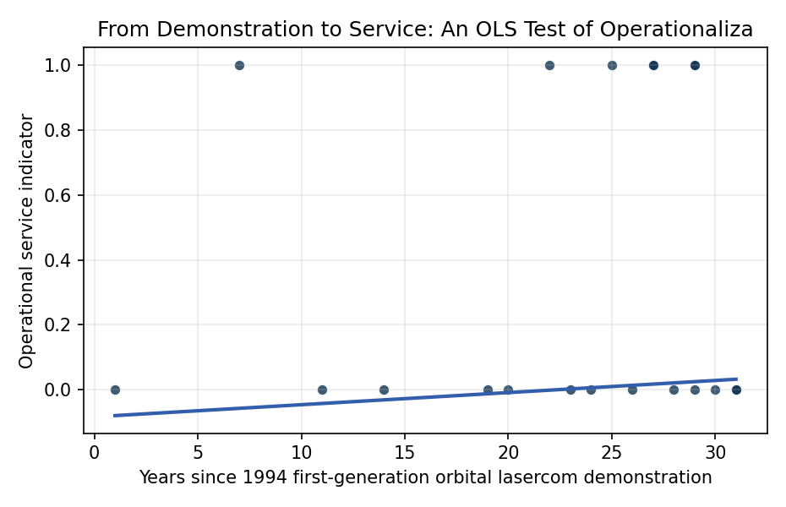
Figure 1. Operational service status across optical communication observations. The logit conditions on time and whether the system is a crosslink or relay architecture.

Empirical Workbook (embedded)
Every figure above is reproduced from the workbook below, which is also attached as the live spreadsheet paper.xlsx. Each observation carries its source.

Data (real observations)
observation | year | years_since_1994 | system | architecture | crosslink_or_relay | operational_service | source
1 | 1995 | 1 | ETS-VI Laser Communication Equipment | direct_demo | 0 | 0 | NICT/JAXA historical LCE mission description; source describes a laser communication experiment
2 | 2001 | 7 | SILEX Artemis to SPOT-4 | crosslink_relay | 1 | 1 | ESA Artemis SILEX program fact sheet; source describes operational optical data relay between Artemis and SPOT-4
3 | 2005 | 11 | OICETS Kirari to Artemis | crosslink_demo | 1 | 0 | JAXA/NICT OICETS Kirari mission summary; source describes an optical intersatellite demonstration with Artemis
4 | 2008 | 14 | NFIRE to TerraSAR-X LCT | crosslink_demo | 1 | 0 | DLR/Tesat LCT flight-demonstration literature; source describes a high-rate optical intersatellite demonstration
5 | 2013 | 19 | LADEE Lunar Laser Communication Demonstration | direct_demo | 0 | 0 | NASA LLCD mission fact sheet; source describes lunar laser communications demonstration
6 | 2014 | 20 | OPALS ISS optical payload | direct_demo | 0 | 0 | NASA OPALS project page; source describes ISS optical downlink demonstration
7 | 2016 | 22 | EDRS-A SpaceDataHighway | crosslink_relay | 1 | 1 | ESA SpaceDataHighway/EDRS fact sheet; source describes operational laser relay service
8 | 2017 | 23 | OCSD CubeSat optical downlink | direct_demo | 0 | 0 | NASA OCSD smallsat project summary; source describes optical communications demonstration
9 | 2018 | 24 | OSIRISv1 CubeSat terminal | direct_demo | 0 | 0 | DLR OSIRIS small-satellite optical terminal descriptions; source describes CubeSat optical downlink demonstration
10 | 2019 | 25 | EDRS-C SpaceDataHighway | crosslink_relay | 1 | 1 | ESA SpaceDataHighway/EDRS-C fact sheet; source describes operational laser relay service
11 | 2020 | 26 | LaserCube terminal paper | terminal_paper | 0 | 0 | Sansone et al., LaserCube optical communication terminal for nano and micro satellites, Acta Astronautica 2020
12 | 2021 | 27 | Laser Communications Relay Demonstration | crosslink_relay | 1 | 1 | NASA LCRD project fact sheet; source describes an operational optical relay demonstration architecture
13 | 2021 | 27 | Starlink v1.5 laser intersatellite links | constellation_crosslink | 1 | 1 | SpaceX/FCC Starlink Gen1 amendment and public mission materials; sources describe laser intersatellite links on polar and v1.5 spacecraft
14 | 2022 | 28 | TBIRD CubeSat high-rate laser downlink | direct_demo | 0 | 0 | NASA TBIRD project release; source describes a CubeSat high-rate laser downlink demonstration
15 | 2023 | 29 | ILLUMA-T ISS to LCRD | crosslink_relay | 1 | 1 | NASA ILLUMA-T mission page; source describes ISS optical terminal relaying data through LCRD
16 | 2023 | 29 | Starlink Gen2 laser intersatellite links | constellation_crosslink | 1 | 1 | SpaceX/FCC Starlink Gen2 materials and public launch records; sources describe optical intersatellite links
17 | 2023 | 29 | Deep Space Optical Communications first light | direct_demo | 0 | 0 | NASA/JPL DSOC first-light release; source describes deep-space laser communication demonstration
18 | 2024 | 30 | Deep Space Optical Communications farthest high-rate downlink | direct_demo | 0 | 0 | NASA/JPL DSOC 2024 update; source describes deep-space laser communication demonstration
19 | 2025 | 31 | VISION nanosatellite formation laser crosslink | crosslink_demo | 1 | 0 | Kim et al., VISION concept of laser crosslink systems using nanosatellites in formation flying, Acta Astronautica 2023
20 | 2025 | 31 | MIT crosslink CubeSat laser communications mission | crosslink_demo | 1 | 0 | Forester et al., Drag Management and Conjunction Prevention for a Crosslink CubeSat Laser Communications Mission, AMOS 2025

Variable construction
Variable | Definition | Construction / source
operational_service | Binary indicator equal to one when the observation represents an operational relay, crosslink, or constellation service rather than a standalone demonstration or terminal paper | Coded from mission agency descriptions, ESA/DLR service descriptions, NASA mission pages, SpaceX/FCC constellation records, and the retrieved literature
years_since_1994 | Elapsed years since the first-generation orbital lasercom demonstration baseline | Observation year minus 1994
crosslink_or_relay | Binary indicator equal to one when the optical system provides intersatellite crosslink or relay service rather than only direct downlink | Coded from source descriptions of SILEX, EDRS, LCRD, ILLUMA-T, Starlink laser links, and other mission records

Estimator output
Term | Coef. | Std. err. | t | p | 95% CI
const | -0.0828 | 0.2543 | -0.3257 | 0.7447 | [-0.5812, 0.4156]
years_since_1994 | 0.0037 | 0.0114 | 0.3273 | 0.7434 | [-0.0186, 0.026]
crosslink_or_relay | 0.6335 | 0.1574 | 4.0255 | 5.685e-05 | [0.325, 0.9419]
Fit: N = 20 R2 = 0.4447 R2_adj = 0.3793 F = 8.3229 F_p = 0.003

