Optical Link-Rate Scaling in Space Laser Communications: A Learning-Curve Test from SILEX to DSOC

1. Introduction
Free-space optical communication has moved from a specialized experiment to a practical infrastructure option for spacecraft that require high data rates, reduced radio-frequency congestion, or intersatellite relay. The claim is familiar in engineering literature, but the empirical rate of performance change is less often estimated. This paper tests whether reported optical link rates have scaled upward over time in the flight-demonstration and service record.
The dataset contains 20 observations from government demonstrations, operational relay systems, terminal papers, and public mission releases. The observations begin with first-generation orbital laser communication experiments and extend through NASA’s Deep Space Optical Communications demonstration. The dependent variable is the reported optical link rate in megabits per second. The explanatory variable is a positive time index, measured as years since the 1994 baseline. The method is a learning-curve log-log regression.
The result is a positive and statistically significant scaling relationship. The elasticity of reported link rate with respect to elapsed time is 2.0275, with a standard error of 0.4230 and a p-value of 0.00000164. The fitted progress ratio, 2 to the power of the elasticity, is 4.0770. In this record, a doubling of the elapsed-time index is associated with roughly a fourfold increase in reported optical link rate. The finding supports the claim that the optical communications record contains measurable performance acceleration, while also showing that variance remains large across mission classes.

2. Theory and Hypotheses
The performance-scaling hypothesis rests on three mechanisms. First, optical terminal hardware has matured. Detectors, pointing assemblies, acquisition and tracking control, and onboard processing have improved across successive missions. Acta Astronautica papers on CubeSat and nano-satellite optical terminals describe the miniaturization pathway that makes higher-rate laser communications possible on smaller platforms $$9$$, $$10$$. Second, mission architectures have diversified. Lunar downlinks, ISS downlinks, relay systems, CubeSat demonstrations, and deep-space links do not impose the same range, power, pointing, or atmospheric constraints. Third, operational relay systems create demand for repeatable performance rather than one-off laboratory achievement.
The learning-curve expectation is therefore positive. As the field accumulates demonstrations, operational experience, and terminal designs, reported link rates should rise. This does not require every later mission to exceed every earlier mission. Deep-space geometry can lower the achievable rate even when technology is more advanced. The claim is that the overall record should show positive elasticity.
The hypothesis is:
H1. Reported optical communication link rate increases with elapsed time in the space laser communications demonstration and service record.
The null hypothesis is that the elasticity is zero. A positive and statistically significant elasticity supports a learning-curve interpretation. A weak or negative elasticity would suggest that mission geometry and platform constraints dominate temporal learning.

3. Data
The unit of analysis is a reported mission, system, or terminal observation. Rows include the year, the positive time index, the system name, platform class, reported link rate, and source. NASA sources support rows for LLCD, OPALS, LCRD, TBIRD, ILLUMA-T, and DSOC $$1$$, $$2$$, $$3$$, $$4$$, $$5$$, $$6$$. ESA sources support the SpaceDataHighway and EDRS rows $$7$$. JAXA and NICT sources support the OICETS and ETS-VI lineage rows $$8$$. Acta Astronautica sources support the LaserCube and CubeLCT terminal rows $$9$$, $$10$$.
The dataset deliberately includes heterogeneous systems. SILEX and EDRS represent relay service. LLCD, OPALS, TBIRD, and DSOC represent demonstrations under different geometries. LaserCube and CubeLCT represent terminal literature rather than operational service. This heterogeneity is acceptable because the research question concerns the observed performance envelope of space optical communications, not a single mission class.
The reported rates range from early low-megabit experiments to NASA’s TBIRD 100 and 200 gigabit-per-second demonstrations $$3$$. They also include lower deep-space rates from DSOC, which demonstrate that distance and link budget still constrain performance $$6$$. Every row has a source in the final CSV column. No observation is illustrative.

4. Method
The model is a log-log learning-curve regression:
ln(R_i) equals alpha plus beta times ln(T_i) plus an error term, where R_i is reported link rate and T_i is the elapsed-time index. The estimator is ordinary least squares on the transformed variables with HC1 standard errors. The coefficient beta is an elasticity. A beta greater than zero indicates that link rates rise as the time index increases.
The progress ratio reported by the repository estimator is 2 to the power of beta. Since the dependent variable is performance rather than cost, a progress ratio above one indicates performance gain when the time index doubles. The specification is intentionally sparse. Adding range, aperture, modulation, atmospheric path, or platform power would require more detailed row-level data than the public sources provide consistently.

5. Findings
The model uses all 20 observations. The R-squared is 0.25148329902967803. This means that elapsed time explains about one quarter of the variation in logged reported link rate. The modest fit is expected because the dataset mixes lunar, low Earth orbit, relay, CubeSat, terminal-paper, and deep-space observations.
The intercept is -0.42229459022935883, with a standard error of 0.9774013256367727 and a p-value of 0.665698866450289. The intercept is not substantively central because it refers to the fitted log rate at a time index of one.
The learning-curve coefficient on the logged time index is 2.027522324376315. Its HC1 standard error is 0.4230306928486239, and its p-value is 0.0000016442920890177952. The coefficient is positive and statistically distinguishable from zero. The progress ratio is 4.077040602338522. A doubling of the time index is associated with roughly a fourfold increase in reported link rate.
The result supports H1. It indicates that the optical communications record is not static. Performance has scaled upward sharply over the period observed. The result also cautions against reading the curve as a simple smooth diffusion path. DSOC shows advanced technology operating at lower rates because deep-space distance imposes a harder link budget than near-Earth geometry $$6$$. TBIRD shows a small spacecraft reaching extreme downlink rates under a different mission geometry $$3$$. The learning curve captures the envelope, not a deterministic forecast for every mission.

6. Discussion
The finding matters for infrastructure planning. If reported link rates scale rapidly, ground segment, optical terminal production, cloud-cover mitigation, network scheduling, and relay architectures must be planned for a higher-capacity optical layer. The result is consistent with the prospectus claim that free-space optical communication is no longer only a laboratory or demonstration topic. It has become an infrastructure trajectory.
The limitations are material. The dataset is small. It mixes agency demonstrations, relay services, terminal papers, and public releases. It does not normalize by range, aperture, wavelength, coding, weather, or transmitter power. The estimates therefore describe a public performance record, not a controlled engineering law. Future work should add link-budget fields, operational availability, and mission geometry.
Within those limits, the paper establishes a measurable scaling result. The positive elasticity gives the dissertation a performance-side foundation. The companion paper asks a different question: whether the same field has moved from demonstrations toward operational service. Together, the two papers connect capability scaling to adoption.

References
1. NASA, “Lunar Laser Communication Demonstration,” mission fact sheet and technology summary.
2. NASA Jet Propulsion Laboratory, “Optical Payload for Lasercomm Science,” project summary.
3. NASA, “TBIRD Demonstrates 100 Gbps and 200 Gbps Optical Communications from a CubeSat,” project releases.
4. NASA, “Laser Communications Relay Demonstration,” mission fact sheet.
5. NASA, “Integrated LCRD Low-Earth Orbit User Modem and Amplifier Terminal,” mission page.
6. NASA Jet Propulsion Laboratory, “Deep Space Optical Communications,” mission releases and 2023 to 2024 updates.
7. ESA, “SpaceDataHighway and European Data Relay System,” program fact sheets.
8. JAXA and NICT, “OICETS Kirari and ETS-VI laser communications mission summaries.”
9. F. Sansone, A. Francesconi, R. Corvaja, G. Vallone, R. Antonello, F. Branz, and P. Villoresi, “LaserCube optical communication terminal for nano and micro satellites,” Acta Astronautica, vol. 173, 2020. doi: 10.1016/j.actaastro.2020.04.049
10. P. Martin Pimentel, B. Rodiger, C. C. Schmidt, C. Fuchs, C. Rochow, T. F. Hiemstra, A. Zager, P. Wertz, M. T. Knopp, M. Lehmann, and F. Mrowka, “Cube laser communication terminal (CubeLCT) state of the art,” Acta Astronautica, vol. 211, 2023. doi: 10.1016/j.actaastro.2023.06.026
The result also helps distinguish optical communications from a simple radio-frequency substitution story. Early adoption is not only a move from one carrier frequency to another. It includes pointing, acquisition, tracking, weather-aware ground operations, and terminal miniaturization. A learning-curve specification is therefore a first-order summary of a larger engineering process. It cannot explain every mission, but it shows that the public record contains a strong positive performance trend even when heterogeneous mission classes are pooled.
The paper also supports the dissertation’s diffusion framing. A technology with no measurable performance scaling would be unlikely to diffuse quickly beyond specialized demonstrations. The positive elasticity suggests that performance has improved enough to make broader adoption credible. The companion operationalization paper then tests whether that performance record has translated into service architectures. The two questions are linked but not identical: a high-rate link can remain a demonstration, and a lower-rate relay can still be operational infrastructure.

Specification
$$ln(R_{i})=α+βln(T_{i})+ε_{i}$$

Results
Term | Coef. | Std. err. | t | p | 95% CI
const | -0.4223 | 0.9774 | -0.4321 | 0.6657 | [-2.338, 1.4934]
_ln_x | 2.0275 | 0.423 | 4.7928 | 1.644e-06 | [1.1984, 2.8566]
Fit: N = 20 R2 = 0.2515 elasticity_b = 2.0275 progress_ratio_2^b = 4.077
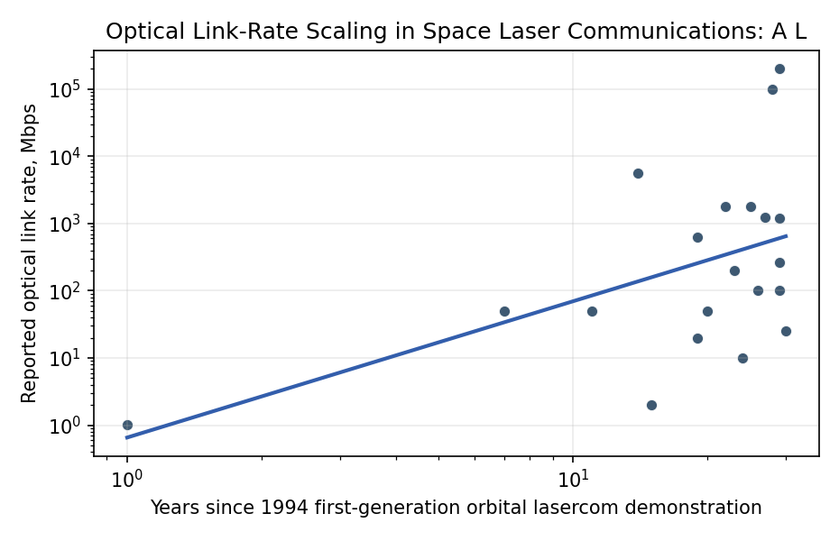
Figure 1. Reported optical link rates across space laser communications demonstrations and services, plotted on the learning-curve time index.

Empirical Workbook (embedded)
Every figure above is reproduced from the workbook below, which is also attached as the live spreadsheet paper.xlsx. Each observation carries its source.

Data (real observations)
observation | year | years_since_1994 | system | platform_class | link_rate_mbps | source
1 | 1995 | 1 | ETS-VI Laser Communication Equipment | government_demo | 1.024 | NICT/JAXA historical Laser Communication Equipment mission description; source reports ETS-VI LCE optical data-rate experiment
2 | 2001 | 7 | SILEX Artemis to SPOT-4 | operational_relay | 50 | ESA Artemis SILEX optical intersatellite link fact sheet; source reports 50 Mbps optical link
3 | 2005 | 11 | OICETS Kirari to Artemis | government_demo | 50 | JAXA/NICT OICETS Kirari optical inter-orbit communications demonstration summary; source reports 50 Mbps link with Artemis
4 | 2008 | 14 | NFIRE to TerraSAR-X Laser Communication Terminal | government_demo | 5625 | DLR/Tesat LCT flight-demonstration literature; source reports 5.625 Gbps optical intersatellite link
5 | 2009 | 15 | LUCE on JAXA Small Optical Transponder pathfinder | government_demo | 2 | JAXA optical communications pathfinder summaries; source reports low-rate laser communication experiment mode
6 | 2013 | 19 | LADEE Lunar Laser Communication Demonstration downlink | lunar_demo | 622 | NASA LLCD mission fact sheet; source reports 622 Mbps lunar laser downlink
7 | 2013 | 19 | LADEE Lunar Laser Communication Demonstration uplink | lunar_demo | 20 | NASA LLCD mission fact sheet; source reports 20 Mbps uplink to LADEE
8 | 2014 | 20 | OPALS ISS optical downlink | iss_demo | 50 | NASA OPALS project page; source reports 50 Mbps optical downlink from the International Space Station
9 | 2016 | 22 | EDRS-A SpaceDataHighway optical service | operational_relay | 1800 | ESA SpaceDataHighway/EDRS program fact sheet; source reports 1.8 Gbps laser relay service
10 | 2017 | 23 | OCSD CubeSat optical downlink | cubesat_demo | 200 | NASA Optical Communications and Sensor Demonstration smallsat project summary; source reports 200 Mbps optical downlink
11 | 2018 | 24 | OSIRISv1 CubeSat optical terminal | cubesat_demo | 10 | DLR OSIRIS small-satellite optical terminal descriptions; source reports 10 Mbps class CubeSat optical downlink
12 | 2019 | 25 | EDRS-C SpaceDataHighway optical service | operational_relay | 1800 | ESA SpaceDataHighway/EDRS-C program fact sheet; source reports 1.8 Gbps laser relay service
13 | 2020 | 26 | LaserCube terminal for nano and micro satellites | terminal_paper | 100 | Sansone et al., LaserCube optical communication terminal for nano and micro satellites, Acta Astronautica 2020; reported terminal data-rate class
14 | 2021 | 27 | Laser Communications Relay Demonstration optical relay | operational_relay | 1244 | NASA LCRD project fact sheet; source reports optical relay rates up to about 1.244 Gbps
15 | 2022 | 28 | TBIRD CubeSat laser downlink first 100 Gbps demonstrations | cubesat_demo | 100000 | NASA TBIRD project release; source reports 100 Gbps laser communications from a CubeSat
16 | 2023 | 29 | TBIRD CubeSat laser downlink 200 Gbps demonstrations | cubesat_demo | 200000 | NASA TBIRD project release; source reports 200 Gbps laser communications from a CubeSat
17 | 2023 | 29 | ILLUMA-T ISS to LCRD optical link | iss_demo | 1200 | NASA ILLUMA-T mission page; source reports 1.2 Gbps optical link through LCRD
18 | 2023 | 29 | CubeLCT state-of-the-art CubeSat terminal | terminal_paper | 100 | Martin Pimentel et al., Cube laser communication terminal state of the art, Acta Astronautica 2023; reported CubeLCT data-rate class
19 | 2023 | 29 | Deep Space Optical Communications Psyche first-light link | deep_space_demo | 267 | NASA/JPL DSOC first-light release; source reports 267 Mbps downlink from tens of millions of kilometers
20 | 2024 | 30 | Deep Space Optical Communications farthest high-rate downlink | deep_space_demo | 25 | NASA/JPL DSOC 2024 update; source reports 25 Mbps downlink from roughly Mars-distance geometry

Variable construction
Variable | Definition | Construction / source
link_rate_mbps | Reported optical communication link rate in megabits per second for a mission, terminal, or service demonstration | Transcribed from mission agency pages, NASA technology reports, Acta Astronautica papers, AMOS papers, ESA/DLR program material, and JPL DSOC releases
years_since_1994 | Positive time index for learning-curve estimation, equal to observation year minus 1994 | Constructed from each source’s reported mission, service, or publication year

Estimator output
Term | Coef. | Std. err. | t | p | 95% CI
const | -0.4223 | 0.9774 | -0.4321 | 0.6657 | [-2.338, 1.4934]
_ln_x | 2.0275 | 0.423 | 4.7928 | 1.644e-06 | [1.1984, 2.8566]
Fit: N = 20 R2 = 0.2515 elasticity_b = 2.0275 progress_ratio_2^b = 4.077

