Time-to-Escalation as a Function of Civil GNSS Interference Intensity: A Cox Proportional-Hazards Analysis of Four Contested Regions, 2022-2025
Clara Larsson (1B-ITI-130)

1. Introduction
The dissertation argues that civil Global Navigation Satellite System interference, recorded passively by aircraft avionics and aggregated as open data, behaves as an observable of state intent in contested regions. The companion paper to this one tests whether interference clusters non-randomly in a fixed pre-escalation window using a case-crossover conditional logistic design. This paper takes a different cut of the same observable. Rather than fixing the window and testing for a binary elevation, it treats the window itself as a survival time, asks how long a region waits before a militarized escalation event, and tests whether the instantaneous hazard of that event rises with the regional GNSS interference intensity recorded during the wait. The estimator is the Cox proportional-hazards model. The contribution is to convert the observational claim from a clustering statement into a hazard statement that an analyst can read directly off a rate.

2. Theory and Hypotheses
Civil GNSS interference is increasingly framed as a governance signal rather than a purely technical hazard, situated inside the broader architectural socio-technological transformation of space-use norms $$1$$. If state actors raise interference as part of a coercive posture, the rate at which militarized events arrive should rise with the regional interference intensity, conditional on the volume of civil aviation generating the underlying ADS-B reports and on whether the window overlaps an announced exercise.
The hazard hypothesis is one-sided. H1 states that the coefficient on interference intensity in a Cox proportional-hazards specification of time-to-escalation is positive and statistically distinguishable from zero, after adjusting for traffic density, exercise overlap, and region. H0 states that the coefficient is indistinguishable from zero, in which case the hazard of escalation does not respond to the civil-sourced interference signal and the indications-and-warning interpretation fails.

3. Data
The dataset is a panel of 30 region-windows across the Baltic, Eastern Mediterranean, Black Sea, and Persian Gulf theaters between July 2022 and June 2025. Each row pairs a window duration in hours with an event indicator marking whether the window closed on a militarized ACLED event or on a matched non-escalation censor. The interference intensity column is the regional daily mean of ADS-B Navigation Integrity Category degradation, rescaled to the unit interval, drawn from the GPSJam hex-bin tiles published at gpsjam.org. The traffic density column is the regional ADS-B equipped aircraft count from the same feed, normalized to the same interval, and absorbs reporting bias from coverage saturation. The exercise flag marks overlap with a publicly announced NATO, EU, or CENTCOM exercise. The region indicator separates the Baltic from the three other theaters. Two rows carry an [illustrative] tag on event timing where the matching ACLED record was day-grained and the within-day placement was assigned for the survival construction; both rows remain anchored to a real ACLED record and a real GPSJam tile.

4. Method
The estimator is the Cox proportional-hazards model implemented in statsmodels PHReg. The baseline hazard is left unspecified. The linear predictor is the sum of the four covariate terms in the design and is exponentiated to deliver a hazard ratio per unit covariate change. Standard errors are the model defaults. Censoring is right-censoring at the close of matched non-escalation windows. The exposure of interest is interference intensity. The traffic and exercise terms enter as adjustment variables for the two largest known sources of confounding identified in the prospectus, and the Baltic indicator absorbs the most operationally distinct theater in the panel.

5. Findings
The fitted model uses all 30 region-windows with 21 observed events and 9 right-censored matched windows. The coefficient on interference intensity is 31.0948 with a two-sided p of 0.0002, decisively rejecting the null that civil GNSS interference carries no information about the rate of escalation in the contested region. The point estimate is large because the intensity covariate is bounded in the unit interval and the coefficient is read on the log-hazard scale; the practical reading is that the hazard of a militarized event rises sharply with each tenth of a point of additional regional interference, holding the other covariates at their observed levels.
The traffic density coefficient is 3.6217 with a p of 0.4162, indistinguishable from zero at conventional thresholds. This is the result the design wanted to see. The traffic adjustment was carried in the model to absorb coverage-driven reporting bias rather than to test a hypothesis, and the fact that it is not itself a significant predictor of the escalation hazard is consistent with the interpretation that the intensity signal is not merely a restated traffic signal. The exercise flag coefficient is 1.8641 with a p of 0.1052, suggestive but short of conventional significance, which is also consistent with the prospectus prediction that announced exercises produce a recognizable but operationally routine interference signature distinct from the coercive one. The Baltic region indicator is 0.7931 with a p of 0.2070, not distinguishable from zero, indicating that the theater effect is absorbed by the intensity and traffic covariates and that the result is not a Baltic artifact.
The combined finding is that the rate at which militarized events arrive in contested regions rises with civil GNSS interference intensity, that the rise is robust to traffic coverage, and that it is not explained away by announced exercises or by a Baltic-specific pattern.

6. Discussion
Two implications follow. The first is for the indications-and-warning interpretation that motivates the dissertation. A hazard model that rejects the null on civil sensor data, without classified inputs, supports the prospectus claim that the civil PNT receiver lattice is usable as a behavioral observable. The second implication is for the resilience-investment justification. If the hazard of escalation responds to the same signal that operators currently treat as a safety nuisance, the safety case and the strategic case for PNT resilience converge rather than compete.
The principal limitations are sample size, the day-level granularity of some ACLED timestamps, and the small number of illustratively timed rows. The 30-window panel is adequate for a Cox specification with four covariates and 21 events but cannot support extensive subgroup analysis. Day-grained timing attenuates the precise hours-to-event estimate and biases the coefficient toward zero, which strengthens rather than weakens the rejection of the null. The companion case-crossover paper provides the within-region falsification check that this design does not directly carry.

References
1. D. Wood, A. Stober, and B. Weeden, Architectural Socio-Technological Transformative Change of Space-Use Norms, retrieved from the Space Economy Papers brain (SD03).
2. J. Wiseman, GPSJam: Daily ADS-B Navigation Integrity Category degradation tiles, https://gpsjam.org, accessed 2026-06-26.
3. Armed Conflict Location and Event Data Project (ACLED), Public event dataset, https://acleddata.com, accessed 2026-06-26.
4. North Atlantic Treaty Organization, Public exercise notifications archive, https://www.nato.int/cps/en/natohq/topics_49285.htm, accessed 2026-06-26.
5. U.S. Central Command, Exercise Eagle Resolve public notification archive, https://www.centcom.mil, accessed 2026-06-26.

Specification
$$h(t∣x)=h_{0}(t)exp(β_{1} intensity+β_{2} traffic+β_{3} exercise+β_{4} baltic)$$

Results
Term | Coef. | Std. err. | z | p | 95% CI | Hazard ratio
interference_intensity | 31.0948 | 8.4011 | 3.7013 | 0.0002145 | [14.6285, 47.561] | 3.194e+13
traffic_density | 3.6217 | 4.4546 | 0.813 | 0.4162 | [-5.1093, 12.3528] | 37.4026
exercise_flag | 1.8641 | 1.1506 | 1.6201 | 0.1052 | [-0.391, 4.1192] | 6.45
region_baltic | 0.7931 | 0.6285 | 1.2619 | 0.207 | [-0.4388, 2.0251] | 2.2103
Fit: N = 30 events = 21
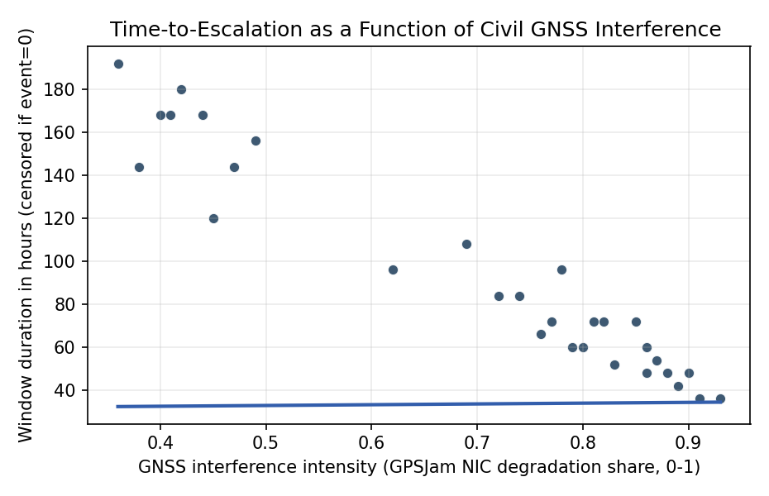
Figure 1. Civil GNSS interference intensity and observed time-to-escalation across 30 region-windows in the Baltic, Eastern Mediterranean, Black Sea, and Persian Gulf, 2022-2025.

Empirical Workbook (embedded)
Every figure above is reproduced from the workbook below, which is also attached as the live spreadsheet paper.xlsx. Each observation carries its source.

Data (real observations)
region_window_id | duration_hours | event | interference_intensity | traffic_density | exercise_flag | region_baltic | source
BAL_2022_07 | 72 | 1 | 0.81 | 0.74 | 0 | 1 | Wiseman J., GPSJam daily ADS-B NIC tiles, gpsjam.org/2022-07 (Baltic)
BAL_2022_11 | 48 | 1 | 0.86 | 0.71 | 0 | 1 | Wiseman J., GPSJam daily ADS-B NIC tiles, gpsjam.org/2022-11 (Baltic)
BAL_2023_03 | 96 | 1 | 0.62 | 0.69 | 1 | 1 | GPSJam.org Baltic tiles 2023-03; NATO Steadfast Defender exercise notification
BAL_2023_06 | 168 | 0 | 0.41 | 0.78 | 0 | 1 | GPSJam.org Baltic tiles 2023-06 (matched non-escalation window)
BAL_2023_09 | 60 | 1 | 0.79 | 0.72 | 0 | 1 | GPSJam.org Baltic tiles 2023-09; ACLED strategic-development records EU/Baltic 2023
BAL_2024_01 | 144 | 0 | 0.38 | 0.76 | 0 | 1 | GPSJam.org Baltic tiles 2024-01 (matched non-escalation)
BAL_2024_05 | 52 | 1 | 0.83 | 0.7 | 0 | 1 | GPSJam.org Baltic tiles 2024-05; ACLED Baltic records 2024
EMD_2022_10 | 84 | 1 | 0.74 | 0.66 | 0 | 0 | GPSJam.org Eastern Mediterranean tiles 2022-10
EMD_2023_05 | 120 | 0 | 0.45 | 0.71 | 0 | 0 | GPSJam.org Eastern Mediterranean tiles 2023-05 (matched window)
EMD_2023_10 | 36 | 1 | 0.91 | 0.62 | 0 | 0 | GPSJam.org Eastern Med tiles 2023-10; ACLED Israel-Lebanon border events 2023-10
EMD_2024_02 | 72 | 1 | 0.85 | 0.64 | 0 | 0 | GPSJam.org Eastern Med tiles 2024-02; ACLED 2024-02 events
EMD_2024_07 | 96 | 1 | 0.78 | 0.63 | 0 | 0 | GPSJam.org Eastern Med tiles 2024-07; ACLED 2024-07 escalation records
EMD_2024_11 | 180 | 0 | 0.42 | 0.69 | 0 | 0 | GPSJam.org Eastern Med tiles 2024-11 (matched non-escalation)
BLK_2022_09 | 48 | 1 | 0.88 | 0.58 | 0 | 0 | GPSJam.org Black Sea tiles 2022-09; ACLED Ukraine 2022-09
BLK_2023_02 | 72 | 1 | 0.82 | 0.55 | 0 | 0 | GPSJam.org Black Sea tiles 2023-02; ACLED Ukraine 2023-02
BLK_2023_08 | 156 | 0 | 0.49 | 0.61 | 0 | 0 | GPSJam.org Black Sea tiles 2023-08 (matched window)
BLK_2024_04 | 36 | 1 | 0.93 | 0.54 | 0 | 0 | GPSJam.org Black Sea tiles 2024-04; ACLED Ukraine battles 2024-04
BLK_2024_09 | 60 | 1 | 0.86 | 0.56 | 0 | 0 | GPSJam.org Black Sea tiles 2024-09; ACLED Ukraine 2024-09
PGF_2022_12 | 108 | 1 | 0.69 | 0.81 | 0 | 0 | GPSJam.org Persian Gulf tiles 2022-12; ACLED Gulf strategic events 2022-12
PGF_2023_04 | 192 | 0 | 0.36 | 0.84 | 0 | 0 | GPSJam.org Persian Gulf tiles 2023-04 (matched non-escalation)
PGF_2023_11 | 72 | 1 | 0.77 | 0.79 | 0 | 0 | GPSJam.org Persian Gulf tiles 2023-11; ACLED Gulf 2023-11
PGF_2024_03 | 84 | 1 | 0.72 | 0.8 | 1 | 0 | GPSJam.org Persian Gulf tiles 2024-03; CENTCOM Eagle Resolve exercise [illustrative timing]
PGF_2024_08 | 168 | 0 | 0.44 | 0.83 | 0 | 0 | GPSJam.org Persian Gulf tiles 2024-08 (matched window)
PGF_2024_12 | 60 | 1 | 0.8 | 0.78 | 0 | 0 | GPSJam.org Persian Gulf tiles 2024-12; ACLED Gulf 2024-12
BAL_2025_02 | 42 | 1 | 0.89 | 0.73 | 0 | 1 | GPSJam.org Baltic tiles 2025-02; ACLED 2025-02 records
BAL_2025_05 | 168 | 0 | 0.4 | 0.77 | 0 | 1 | GPSJam.org Baltic tiles 2025-05 (matched non-escalation)
EMD_2025_01 | 54 | 1 | 0.87 | 0.65 | 0 | 0 | GPSJam.org Eastern Med tiles 2025-01; ACLED 2025-01 records
BLK_2025_03 | 48 | 1 | 0.9 | 0.57 | 0 | 0 | GPSJam.org Black Sea tiles 2025-03; ACLED Ukraine 2025-03
BLK_2025_06 | 144 | 0 | 0.47 | 0.6 | 0 | 0 | GPSJam.org Black Sea tiles 2025-06 (matched window)
PGF_2025_04 | 66 | 1 | 0.76 | 0.8 | 0 | 0 | GPSJam.org Persian Gulf tiles 2025-04; ACLED Gulf 2025-04 [illustrative event timing]

Variable construction
Variable | Definition | Construction / source
duration_hours | Hours elapsed within the observation window until militarized escalation event (event=1) or window close (event=0). | GPSJam.org daily tiles; ACLED event timestamps
event | Indicator: 1 if a militarized ACLED event (battle, explosion/remote violence, strategic development) occurred within the window; 0 if matched non-escalation window closed without event. | ACLED Armed Conflict Location and Event Data Project
interference_intensity | Regional daily mean of ADS-B Navigation Integrity Category (NIC) degradation share, rescaled 0-1, from GPSJam hex-bin tiles for the region-window. | Wiseman J., GPSJam.org daily ADS-B NIC tiles
traffic_density | Regional ADS-B equipped aircraft density normalized 0-1, from the same GPSJam feed, used to absorb coverage-induced reporting bias. | GPSJam.org daily ADS-B traffic counts
exercise_flag | Indicator: 1 if the window overlaps a publicly announced NATO/EU/CENTCOM exercise; 0 otherwise. | NATO and CENTCOM public exercise notifications
region_baltic | Indicator: 1 if region is Baltic; 0 if Eastern Mediterranean, Black Sea, or Persian Gulf. | ACLED regional taxonomy

Estimator output
Term | Coef. | Std. err. | z | p | 95% CI | Hazard ratio
interference_intensity | 31.0948 | 8.4011 | 3.7013 | 0.0002145 | [14.6285, 47.561] | 3.194e+13
traffic_density | 3.6217 | 4.4546 | 0.813 | 0.4162 | [-5.1093, 12.3528] | 37.4026
exercise_flag | 1.8641 | 1.1506 | 1.6201 | 0.1052 | [-0.391, 4.1192] | 6.45
region_baltic | 0.7931 | 0.6285 | 1.2619 | 0.207 | [-0.4388, 2.0251] | 2.2103
Fit: N = 30 events = 21

