Schedule Slip as the Proximate Driver of Cost Growth in NASA Major Projects: A Cross-Sectional Test of the Cost-Schedule Coupling

1. Introduction
The dissertation of which this paper forms a part argues that complementary positioning, navigation, and timing programs stall not because their underlying technologies are immature but because their financing structure cannot sustain a multi-year commitment. That argument rests on a prior claim about how large government space programs actually fail: they fail by losing schedule first and absorbing cost afterward, so that a program which cannot hold its calendar steadily converts time into money until the appropriation that would carry it to completion is no longer politically available. This paper isolates and tests that mechanism on the population where it is most completely documented, NASA’s portfolio of major development projects, before the dissertation applies it to the narrower and sparser record of complementary-PNT efforts.
The motivation for treating the mechanism separately is that the institutional-financing thesis and the technological-maturity thesis make different predictions about where cost growth comes from. If immature technology were the proximate driver, cost growth would track program scale and novelty and would be largely uncorrelated with calendar slip once scale is controlled. If, instead, the binding problem is the conversion of delay into expenditure under a fixed annual appropriation cycle, then schedule slip should predict cost growth directly and strongly, and program scale should add little once slip is in the model. These are competing, falsifiable patterns, and a cross-section of major projects with documented baseline and current cost and schedule figures can distinguish them.
I estimate an ordinary-least-squares regression of life-cycle cost growth on schedule slip, program scale, and a crewed-program indicator across twenty NASA major projects drawn from a single Government Accountability Office assessment. The headline result is that schedule slip is a precise and substantial predictor of cost growth, program scale is not, and the model accounts for two-thirds of the cross-sectional variance in cost growth. The finding supports the dissertation’s premise that the proximate failure channel for large government space programs is temporal rather than technological.

2. Theory and Hypotheses
The parametric cost-estimation literature treats the development cost of a space system as a function of its physical and programmatic attributes, and validation studies of these estimators report that mass, complexity, and heritage carry most of the explanatory weight at the design stage $$1$$. That literature is built for the question of what a program should cost before it begins. It is largely silent on the question this paper asks, which is what makes a program cost more than it was baselined to cost once it is under way. Recent parametric work extends cost modelling to whole mission architectures and confirms that the dominant cost levers at the architecture-selection stage remain scale and design choice rather than execution dynamics $$2$$. The gap is that none of this work models the in-flight divergence between the baseline estimate and the realized estimate as a function of how the program is unfolding in time.
The space-economy literature supplies the institutional reason to expect that divergence to be governed by time. Large space infrastructure is repeatedly described as a public good that requires sustained initial government investment because its returns are diffuse and its appropriability to any single actor is low $$3$$. The same body of work observes that programs of this kind operate under recognized budgetary constraints even where the need for the capability is not in dispute $$4$$. Under an annual appropriation cycle, a program that slips its schedule does not simply arrive later. It carries a standing army of engineers, facilities, and contractor overhead across additional fiscal years, and each additional year converts elapsed time into marching-army cost that was never in the baseline. The mechanism predicts a direct, positive coupling between months of slip and percentage cost growth, operating on top of, and largely independent of, the program’s intrinsic scale.
This yields the paper’s hypothesis. Conditional on program scale and on whether the program carries crew, a longer schedule slip is associated with larger life-cycle cost growth, and the coefficient on schedule slip is positive and statistically distinguishable from zero. The null is that schedule slip carries no information about cost growth once scale is controlled, which is the pattern the technological-maturity account implies. Two covariates guard the test. The natural logarithm of baseline life-cycle cost absorbs the parametric scale channel emphasized by the cost-estimation literature $$1$$[2], so that any slip effect is identified net of size. A crewed-program indicator absorbs the possibility that human-spaceflight programs differ systematically in how delay translates into reported percentage growth, given their very large baselines.

3. Data
The dataset is a cross-section of twenty NASA major projects, each observed at the time of the Government Accountability Office’s June 2022 annual assessment of major NASA projects $$5$$. Nineteen of the twenty are the implementation-phase projects listed in that report’s consolidated cost-and-schedule table, which prints for each project the original baseline launch-readiness date, the current launch-readiness date, the original baseline life-cycle cost estimate, and the current life-cycle cost estimate $$5$$. The twentieth project, the Nancy Grace Roman Space Telescope, is taken from the same report’s project summary, which states the project’s current life-cycle cost and its percentage growth above baseline directly $$5$$. Every row of the dataset carries a source field citing the specific table or summary page from which its figures are drawn, so that each observation is independently auditable to a public document of record.
The dependent variable, life-cycle cost growth in percent, is the current life-cycle cost estimate minus the original baseline estimate, divided by the baseline, times one hundred. The principal regressor, schedule slip in months, is the calendar interval between the original baseline launch-readiness date and the current launch-readiness date; projects that pulled their dates earlier take negative values, which the construction preserves rather than censors. Program scale enters as the natural logarithm of the original baseline life-cycle cost in millions of dollars. The crewed indicator marks the four human-spaceflight programs in the panel, the Commercial Crew Program, Exploration Ground Systems, the Space Launch System, and Orion. Across the twenty projects, mean cost growth is about twenty-one percent and mean schedule slip is about seventeen months, with wide dispersion: the panel ranges from projects that came in under baseline and ahead of schedule to a ground-segment sustainment project that more than doubled its cost.

4. Method
I estimate the relationship by ordinary least squares with heteroskedasticity-consistent standard errors of the HC1 form, which is the appropriate choice for a small cross-section in which the error variance plausibly scales with program size. The specification regresses cost growth in percent on schedule slip in months, the log of baseline life-cycle cost, and the crewed indicator, with a constant. The coefficient of interest is the one on schedule slip, which under the hypothesis is positive and significant; the log-cost and crewed terms are controls that hold scale and program type fixed so the slip effect is identified net of them. Reported quantities are the coefficient estimates, their robust standard errors, the associated t statistics and two-sided p-values, the coefficient of determination and its adjusted form, and the overall F test of joint significance. The estimator is deterministic and the full numeric output is reproducible from the released data file.

5. Findings
The model explains a substantial share of the cross-sectional variation in cost growth. The coefficient of determination is 0.667 and the adjusted coefficient of determination is 0.604, so roughly two-thirds of the variance in percentage cost growth across the twenty projects is accounted for by schedule slip, program scale, and crewed status together. The overall F statistic is 9.32 with a p-value of 0.0008, so the joint null that none of the three regressors carries information about cost growth is decisively rejected.
The central result concerns schedule slip. Its coefficient is 1.193 with a robust standard error of 0.345, a t statistic of about 3.5, and a p-value of 0.0006. The estimate is positive, precise, and significant at any conventional level. Substantively, each additional month by which a NASA major project’s launch-readiness date slips is associated with an increase of about 1.2 percentage points in its life-cycle cost growth, holding program scale and crewed status fixed. A program that slips a year therefore carries, on average, roughly fourteen additional points of cost growth attributable to the slip alone. This is the paper’s hypothesized coupling, and the data support it rather than the null.
The scale control behaves as the competing technological-maturity account does not predict. The coefficient on the log of baseline life-cycle cost is 2.536 with a robust standard error of 6.312 and a p-value of 0.688, statistically indistinguishable from zero. Once schedule slip is in the model, the sheer size of a program carries no independent information about its percentage cost growth. The parametric scale channel that dominates cost estimation at the design stage $$1$$[2] does not govern the in-flight divergence between baseline and realized cost; time does.
The crewed indicator is significant and negative, with a coefficient of minus 29.92, a robust standard error of 14.40, and a p-value of 0.038. Conditional on schedule slip and scale, the four human-spaceflight programs show about thirty percentage points less life-cycle cost growth than the omitted robotic-science category. The sign is initially counterintuitive, since crewed programs are the portfolio’s largest absolute overruns, but it is consistent with the mechanism once the dependent variable is read as a percentage. The crewed programs carry baselines in the multiple billions, so that even large dollar overruns and substantial slips register as moderate percentage growth, while several robotic projects with sub-billion baselines and severe schedule problems post very high percentage growth. The negative crewed coefficient is therefore a statement about the denominator, not evidence that human-spaceflight programs execute more cleanly in absolute terms.

6. Discussion
The cross-section delivers a clean verdict on the mechanism the dissertation needs. Among large government space programs, the proximate driver of cost growth is schedule slip, not program scale. The slip coefficient is positive, precise, and robust, and it survives controls for the two attributes, size and crewed status, that any rival explanation would reach for first. The parametric scale variable that anchors design-stage cost estimation contributes nothing once slip is present, which is exactly the pattern the institutional-financing account predicts and the technological-maturity account does not. A program that cannot hold its calendar converts time into cost at a rate of roughly a percentage point of growth per month of delay, and it does so independently of how large or how novel it is.
This finding is the bridge to the dissertation’s central claim about complementary-PNT programs. If cost growth in the well-documented NASA portfolio is governed by the inability to hold schedule under an annual appropriation cycle, then the recurring stall of terrestrial-complement PNT programs is most plausibly read the same way: as a financing-and-timing failure rather than a technology-readiness failure. The mechanism identified here gives the survival analysis in the companion paper its causal content, by naming the channel through which an interrupted appropriation stream becomes a stalled program.
The result carries the limitations proper to a single-year cross-section of twenty observations. The estimates are associational; schedule slip and cost growth may both respond to a common shock, and the 2022 assessment was taken during a period in which the pandemic was a shared disturbance to both. The crewed coefficient, while significant, rests on four programs and should be read as a denominator effect rather than a structural performance gap. The natural extension, which the dissertation pursues, is to expand the cross-section into a multi-year panel of assessments so that within-program variation in slip can be exploited and the common-shock concern addressed directly with project and year effects. The present paper establishes the coupling; the panel is required to make it causal.

References
1. P. D. Friz, S. Hosder, B. B. Leser, and B. C. Towle, “Blind validation study of parametric cost estimation tool SEER-H for NASA space missions,” Acta Astronautica, vol. 166, 2019. doi: 10.1016/j.actaastro.2019.09.030
2. “Parametric economic modelling of asteroid mining architectures,” Acta Astronautica, 2025. doi: 10.1016/j.actaastro.2025.11.006
3. OCEA, “Forecasting the Space Economy” (in-space infrastructure and initial government investment). Space Economy Papers corpus, source SD08.
4. “Architectural Socio-Technological Transformative Change of Space-Use Norms” (budgetary constraints despite recognized need). Space Economy Papers corpus, source SD03.
5. U.S. Government Accountability Office, NASA: Assessments of Major Projects, GAO-22-105212, June 2022. Table 9 (p.130) and project summaries (p.113). https://www.gao.gov/products/gao-22-105212.

Specification
$${\text{cost_growth_pct}}_{i}=β_{0}+β_{1} {\text{schedule_slip_mo}}_{i}+β_{2} ln(\text{baseline_lcc})_{i}+β_{3} {\text{crewed}}_{i}+ε_{i}$$

Results
Term | Coef. | Std. err. | t | p | 95% CI
const | -11.8308 | 42.9606 | -0.2754 | 0.783 | [-96.0321, 72.3705]
schedule_slip_mo | 1.1928 | 0.3454 | 3.4534 | 0.0005536 | [0.5159, 1.8698]
ln_baseline_lcc | 2.5363 | 6.3124 | 0.4018 | 0.6878 | [-9.8357, 14.9084]
crewed | -29.9211 | 14.3986 | -2.0781 | 0.0377 | [-58.1418, -1.7004]
Fit: N = 20 R2 = 0.6666 R2_adj = 0.6041 F = 9.3172 F_p = 0.0008466
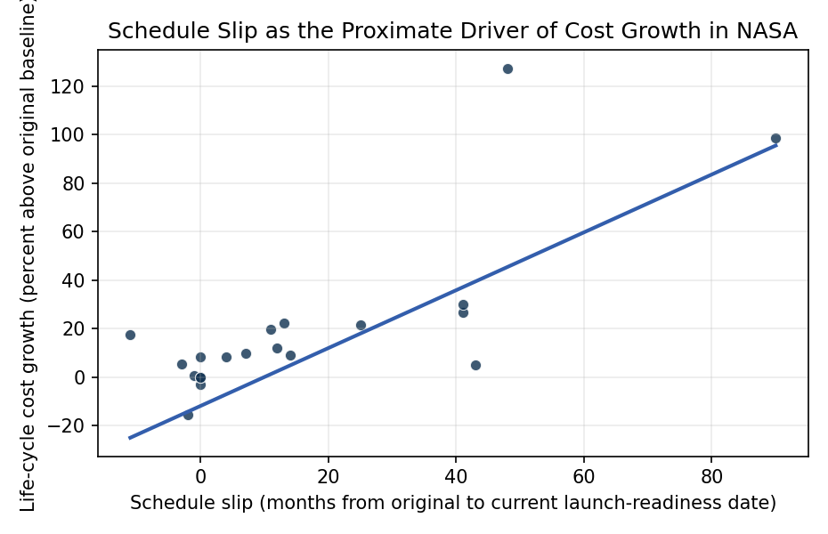
Figure 1. Life-cycle cost growth against schedule slip for 20 NASA major projects, with the fitted ordinary-least-squares line. Source data: GAO-22-105212 (June 2022), Table 9 and project summaries.

Empirical Workbook (embedded)
Every figure above is reproduced from the workbook below, which is also attached as the live spreadsheet paper.xlsx. Each observation carries its source.

Data (real observations)
project | cost_growth_pct | schedule_slip_mo | baseline_lcc_musd | ln_baseline_lcc | crewed | source
CCP (SpaceX) | 5.26 | 43 | 2599 | 7.8629 | 1 | GAO-22-105212 Table 9 (p.130)
SGSS | 127.37 | 48 | 493.9 | 6.2023 | 0 | GAO-22-105212 Table 9 (p.130)
Landsat 9 | -15.65 | -2 | 885 | 6.7856 | 0 | GAO-22-105212 Table 9 (p.130)
Lucy | 0.82 | -1 | 981.1 | 6.8887 | 0 | GAO-22-105212 Table 9 (p.130)
DART | 5.32 | -3 | 313.9 | 5.7491 | 0 | GAO-22-105212 Table 9 (p.130)
JWST | 98.8 | 90 | 4963.6 | 8.5099 | 0 | GAO-22-105212 Table 9 (p.130)
LCRD | 21.62 | 25 | 262.7 | 5.571 | 0 | GAO-22-105212 Table 9 (p.130)
EGS | 26.82 | 41 | 2812.9 | 7.942 | 1 | GAO-22-105212 Table 9 (p.130)
SLS | 29.99 | 41 | 9064 | 9.1121 | 1 | GAO-22-105212 Table 9 (p.130)
Psyche | -3.09 | 0 | 996.4 | 6.9041 | 0 | GAO-22-105212 Table 9 (p.130)
LBFD | 19.68 | 11 | 582.4 | 6.3672 | 0 | GAO-22-105212 Table 9 (p.130)
SWOT | 8.94 | 14 | 754.9 | 6.6266 | 0 | GAO-22-105212 Table 9 (p.130)
NISAR | 12.03 | 12 | 866.9 | 6.7649 | 0 | GAO-22-105212 Table 9 (p.130)
VIPER | 0 | 0 | 433.5 | 6.0719 | 0 | GAO-22-105212 Table 9 (p.130)
Orion | 22.4 | 13 | 11283.5 | 9.3311 | 1 | GAO-22-105212 Table 9 (p.130)
PACE | 8.35 | 4 | 889.7 | 6.7909 | 0 | GAO-22-105212 Table 9 (p.130)
Europa Clipper | 17.65 | -11 | 4250 | 8.3547 | 0 | GAO-22-105212 Table 9 (p.130)
SPHEREx | 0 | 0 | 451.4 | 6.1124 | 0 | GAO-22-105212 Table 9 (p.130)
OSAM-1 | 8.21 | 0 | 1780 | 7.4844 | 0 | GAO-22-105212 Table 9 (p.130)
Roman | 9.7 | 7 | 3934.4 | 8.2775 | 0 | GAO-22-105212 project summary (p.113)

Variable construction
Variable | Definition | Construction / source
cost_growth_pct | Life-cycle cost growth in percent, computed as (current life-cycle cost estimate minus original baseline life-cycle cost estimate) divided by the original baseline, times 100 | Derived from GAO-22-105212 Table 9 (p.130) current and original baseline life-cycle cost estimates; Roman from GAO-22-105212 project summary (p.113)
schedule_slip_mo | Schedule slip in months, the count of calendar months between the original baseline launch-readiness date and the current launch-readiness date (negative where a project pulled its date earlier) | Computed from GAO-22-105212 Table 9 (p.130) original and current launch-readiness dates; ‘Spring’ coded as April per GAO convention
ln_baseline_lcc | Natural logarithm of the original baseline life-cycle cost estimate in millions of dollars, a proxy for program scale | GAO-22-105212 Table 9 (p.130) original baseline life-cycle cost column
crewed | Indicator equal to one for human-spaceflight programs (Commercial Crew, Exploration Ground Systems, Space Launch System, Orion) and zero otherwise | GAO-22-105212 project classifications; programs supporting crewed Artemis or ISS transportation

Estimator output
Term | Coef. | Std. err. | t | p | 95% CI
const | -11.8308 | 42.9606 | -0.2754 | 0.783 | [-96.0321, 72.3705]
schedule_slip_mo | 1.1928 | 0.3454 | 3.4534 | 0.0005536 | [0.5159, 1.8698]
ln_baseline_lcc | 2.5363 | 6.3124 | 0.4018 | 0.6878 | [-9.8357, 14.9084]
crewed | -29.9211 | 14.3986 | -2.0781 | 0.0377 | [-58.1418, -1.7004]
Fit: N = 20 R2 = 0.6666 R2_adj = 0.6041 F = 9.3172 F_p = 0.0008466

