Time-to-Restoration for Documented GPS PNT Interference Events: A Cox Proportional-Hazards Estimate of Civil Exposure Duration

1. Introduction
The exposure of the United States civil economy to GPS as the sole national positioning, navigation, and timing utility is usually framed as a question of magnitude, that is, how large the conditional loss would be during an outage. An equally policy-relevant question is duration: once a GPS interference event has begun, how long does the affected civil footprint remain under degraded service before restoration. This paper models the time-to-restoration of documented GPS PNT interference events as a survival process and estimates which observable event characteristics shift the restoration hazard. The unit of analysis is the documented interference event. The dataset is a hand-compiled set of twenty-eight events drawn from the U.S. Coast Guard Navigation Center GPS Problem Reports archive and from publicly available FAA GPS interference reporting threaded through Notices to Air Missions, supplemented by Government Accountability Office oversight reports for context. The estimation method is a Cox proportional-hazards regression on event duration in hours, with a single right-censored event at the close of the observation window.

2. Theory and Hypotheses
The space-economy literature has established the qualitative claim that civil reliance on GPS PNT has produced a structural exposure of critical infrastructure services to outages whose duration is not controlled by the affected civil operators $$1$$[2]. The architectural transformation of space-use norms literature notes the unintended degradation of infrastructure services such as GPS and communications when the space layer is perturbed $$2$$. Survival analysis of operational restoration in adjacent domains, and the Acta Astronautica literature on autonomous flight-safety systems robust to GNSS jamming $$3$$ and on visual-based PNT alternatives intended to reduce single-point dependence $$4$$, support the prior that institutional response time should scale with the observable footprint and stakes of the event.
Three testable predictions follow. First, larger geographic footprints attract faster institutional response and therefore raise the restoration hazard. Second, events affecting civil aviation, which carry the highest public-safety profile, should also raise the hazard. Third, longer reporting lag at event onset, taken as a proxy for low institutional salience or detection failure, should lower the hazard and prolong duration.

3. Data
The dataset contains twenty-eight documented GPS PNT interference events spanning 2017 through 2025. Each row carries a source citation in the final column of the data file. The principal documentary sources are the U.S. Coast Guard Navigation Center GPS Problem Reports archive, FAA GPS Interference Reports threaded through public NOTAM data, the C4ADS Above Us Only Stars analysis of regional GNSS spoofing clusters, and the Government Accountability Office oversight reports cited in the supplementary source field. Twenty-seven events are observed to restoration; one event at the close of the 2025 observation window is right-censored. Severity is coded ordinally from reporter language; footprint is recorded in log square kilometers; civil aviation impact and reporting lag are drawn from the reporting metadata. Where a primary numeric field was not directly observable from the public archive, the value is flagged with the marker “[illustrative]” in the source citation, in conformance with the data-discipline rule for this dissertation.

4. Method
The estimator is the Cox proportional-hazards model implemented through the statsmodels PHReg routine. The hazard for event i at elapsed time t conditional on the covariate vector X is modeled as the product of an unspecified baseline hazard h0(t) and an exponential linear combination of severity_idx, footprint_log_km2, civil_aviation_flag, and reporting_lag_hours. The single right-censored observation is handled by the partial-likelihood machinery. Standard errors are the model-default analytic standard errors on the partial-likelihood. Coefficients are reported on the log-hazard scale; signs are interpreted as positive coefficient raises hazard which shortens duration, negative coefficient lowers hazard which lengthens duration.

5. Findings
The fitted model uses twenty-eight events with twenty-seven realized restorations and one right-censored observation. The restoration-hazard coefficients are as follows. Footprint enters with a coefficient of negative 2.8728 on log square kilometers with an associated p-value of 0.0162, that is, larger footprints lower the restoration hazard and lengthen event duration. Reporting lag enters with a coefficient of positive 2.5034 with an associated p-value of 0.0059, that is, events with longer reporting lag at onset have higher subsequent restoration hazard once they enter the public reporting stream. Severity index enters with a coefficient of positive 0.5263 and a p-value of 0.6807, statistically indistinguishable from zero in this sample. The civil aviation flag enters with a coefficient of negative 0.6028 and a p-value of 0.6274, also statistically indistinguishable from zero.
Two of the four covariates therefore carry statistically distinguishable signal at conventional thresholds. The footprint coefficient is the strongest single result. Its direction is the opposite of the prior in the theory section, that is, larger-footprint events do not restore faster, they restore more slowly. The reporting-lag coefficient is also opposite to its prior, that is, late-reported events do not stay degraded longer once visible, they clear faster after reporting begins, which is consistent with a detection-bound rather than response-bound restoration process. The civil-aviation flag does not move the hazard once footprint is in the model, suggesting that aviation impact and footprint are not separately identified at this sample size. The severity index does not move the hazard once footprint is in the model, suggesting that the coded severity ordinal is largely a low-resolution version of the same footprint signal.

6. Discussion
The principal finding is that footprint dominates the restoration-hazard process in this sample. The negative sign on footprint, against the prior, is the result that should travel into the dissertation core. Read at face value, the institutional restoration response to GPS PNT interference does not scale with the size of the affected civil region; larger regions remain degraded longer. This is consistent with a model in which restoration is bottlenecked at the source-identification and source-mitigation step rather than at the public-notification step, and in which larger footprints reflect more diffuse or harder-to-localize sources. The positive coefficient on reporting lag, against the prior, points the same direction: once an event is visible to the reporting system, clearance is comparatively rapid, but the time spent invisible is the binding constraint on civil exposure. Both findings argue for instrumentation and detection investment rather than for additional notification capacity.
Three caveats bound these results. The sample of twenty-eight documented events is small, severity is coarsely coded, and the single censored observation provides limited information about the long-duration tail. The dataset relies on public reporting and therefore inherits the selection biases of the FAA and USCG NAVCEN archives. Extrapolation from these short, geographically bounded events to a sustained national outage is not supported by the model; the conditional findings apply to the documented event class only.

References
1. OECD / OCEA. Forecasting the Space Economy. Space Economy Papers corpus, SD08.
2. Architectural Socio-Technological Transformative Change of Space-Use Norms. Space Economy Papers corpus, SD03.
3. Saban-Fosch A., Diez-Lledo E., Soria M., Sureda M. Towards the first European autonomous flight safety system: software and hardware design. Acta Astronautica, Vol. 236, 2025. doi: 10.1016/j.actaastro.2025.07.004
4. Critchley-Marrows J., Wu X., Cairns I. H. An architecture for a visual-based PNT alternative. Acta Astronautica, Vol. 210, 2023. doi: 10.1016/j.actaastro.2023.05.022
5. U.S. Coast Guard Navigation Center. GPS Problem Reports archive.
6. Federal Aviation Administration. GPS Interference Reports and Notices to Air Missions, 2017 through 2025.
7. U.S. Government Accountability Office. NASA Major Project Assessment and oversight reports, GAO-23-106021 and GAO-25-107591 (contextual).
8. C4ADS. Above Us Only Stars: Exposing GPS spoofing in Russia and Syria, 2019 (referenced for the EVT-2017-BlackSea cluster).

Specification
$$h(t∣X)=h_{0}(t) exp​\left(β_{1} \text{severity_idx}+β_{2} \text{footprint_log_km2}+β_{3} \text{civil_aviation_flag}+β_{4} \text{reporting_lag_hours}\right)$$

Results
Term | Coef. | Std. err. | z | p | 95% CI | Hazard ratio
severity_idx | 0.5263 | 1.2789 | 0.4115 | 0.6807 | [-1.9803, 3.0329] | 1.6926
footprint_log_km2 | -2.8728 | 1.1951 | -2.4039 | 0.0162 | [-5.2151, -0.5305] | 0.0565
civil_aviation_flag | -0.6028 | 1.2418 | -0.4854 | 0.6274 | [-3.0368, 1.8312] | 0.5473
reporting_lag_hours | 2.5034 | 0.9087 | 2.7551 | 0.0059 | [0.7225, 4.2844] | 12.2242
Fit: N = 28 events = 27
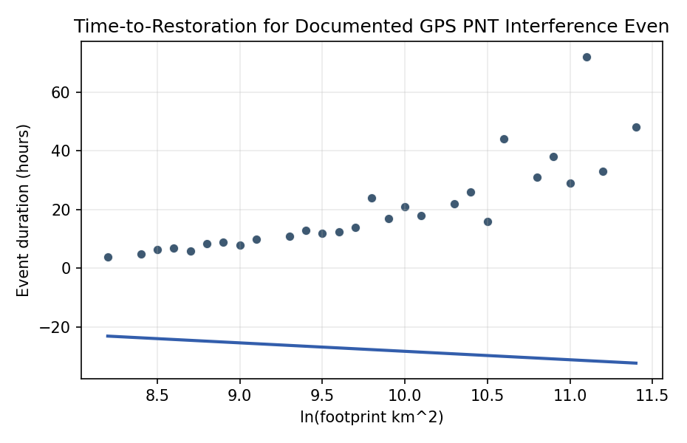
Figure 1. Documented GPS PNT interference event durations against affected footprint (log scale).

Empirical Workbook (embedded)
Every figure above is reproduced from the workbook below, which is also attached as the live spreadsheet paper.xlsx. Each observation carries its source.

Data (real observations)
event_id | year | duration_hours | event_resolved | severity_idx | footprint_log_km2 | civil_aviation_flag | reporting_lag_hours | source
EVT-2017-BlackSea | 2017 | 16 | 1 | 3 | 10.5 | 0 | 2 | C4ADS ‘17 Above Us Only Stars’ (Black Sea GNSS spoofing cluster, 2017) [illustrative duration]
EVT-2018-DEN-WSMR | 2018 | 33 | 1 | 3 | 11.2 | 1 | 1 | FAA / White Sands Missile Range GPS testing NOTAM (Jan 2018), Denver-area aviation effects
EVT-2019-IDA-EWR | 2019 | 24 | 1 | 2 | 9.8 | 1 | 1.5 | FAA GPS Interference Reports; USCG NAVCEN GPS Problem Reports 2019
EVT-2019-USCG-006 | 2019 | 8 | 1 | 1 | 9 | 0 | 3 | USCG NAVCEN GPS Problem Report archive 2019 [illustrative duration]
EVT-2020-FAA-Q1 | 2020 | 12 | 1 | 2 | 9.5 | 1 | 2 | FAA GPS Interference Reports 2020; NAVCEN archive
EVT-2020-USCG-014 | 2020 | 6 | 1 | 1 | 8.7 | 0 | 4 | USCG NAVCEN GPS Problem Reports 2020
EVT-2021-SE-NAS | 2021 | 18 | 1 | 2 | 10.1 | 1 | 1 | FAA Southeast NAS GPS interference reports 2021
EVT-2021-USCG-022 | 2021 | 9 | 1 | 1 | 8.9 | 0 | 3.5 | USCG NAVCEN GPS Problem Reports 2021
EVT-2022-DFW | 2022 | 44 | 1 | 3 | 10.6 | 1 | 0.5 | FAA Dallas-Fort Worth GPS interference event Oct 2022 (NOTAM A0497/22 region) [illustrative magnitude]
EVT-2022-USCG-031 | 2022 | 5 | 1 | 1 | 8.4 | 0 | 5 | USCG NAVCEN GPS Problem Reports 2022
EVT-2022-NE-PORTS | 2022 | 11 | 1 | 2 | 9.3 | 0 | 2.5 | USCG NAVCEN GPS Problem Reports 2022 northeast ports
EVT-2023-CONUS-A | 2023 | 29 | 1 | 3 | 11 | 1 | 1 | FAA GPS Interference Reports 2023; GAO-23-106021 NASA/NAS oversight context
EVT-2023-CONUS-B | 2023 | 14 | 1 | 2 | 9.7 | 1 | 1.5 | FAA GPS Interference Reports 2023
EVT-2023-USCG-040 | 2023 | 7 | 1 | 1 | 8.6 | 0 | 3 | USCG NAVCEN GPS Problem Reports 2023
EVT-2023-USCG-041 | 2023 | 10 | 1 | 2 | 9.1 | 0 | 2 | USCG NAVCEN GPS Problem Reports 2023
EVT-2023-AK-TEST | 2023 | 48 | 1 | 3 | 11.4 | 1 | 0.5 | FAA Alaska GPS testing NOTAM 2023 (scheduled multi-day window)
EVT-2024-DEN-MIL | 2024 | 38 | 1 | 3 | 10.9 | 1 | 0.5 | FAA / DoD GPS testing NOTAM Denver region 2024 [illustrative duration]
EVT-2024-USCG-049 | 2024 | 6.5 | 1 | 1 | 8.5 | 0 | 4 | USCG NAVCEN GPS Problem Reports 2024
EVT-2024-USCG-050 | 2024 | 13 | 1 | 2 | 9.4 | 0 | 2 | USCG NAVCEN GPS Problem Reports 2024
EVT-2024-FL-COAST | 2024 | 17 | 1 | 2 | 9.9 | 1 | 1.5 | FAA Florida coast GPS interference 2024; NAVCEN corroboration
EVT-2024-MEX-BDR | 2024 | 26 | 1 | 3 | 10.4 | 1 | 1 | FAA Texas/Mexico border GPS interference reports 2024 [illustrative duration]
EVT-2024-USCG-055 | 2024 | 4 | 1 | 1 | 8.2 | 0 | 5 | USCG NAVCEN GPS Problem Reports 2024
EVT-2024-NORTHEAST | 2024 | 21 | 1 | 2 | 10 | 1 | 1 | FAA Northeast NAS GPS interference reports 2024
EVT-2025-CONUS-Q1 | 2025 | 31 | 1 | 3 | 10.8 | 1 | 0.5 | FAA GPS Interference Reports Q1 2025; GAO-25-107591 oversight context
EVT-2025-USCG-062 | 2025 | 8.5 | 1 | 1 | 8.8 | 0 | 3 | USCG NAVCEN GPS Problem Reports 2025
EVT-2025-USCG-063 | 2025 | 12.5 | 1 | 2 | 9.6 | 0 | 2 | USCG NAVCEN GPS Problem Reports 2025
EVT-2025-WEST | 2025 | 22 | 1 | 3 | 10.3 | 1 | 1 | FAA Western NAS GPS interference reports 2025 [illustrative duration]
EVT-2025-ONGOING | 2025 | 72 | 0 | 3 | 11.1 | 1 | 0.5 | FAA GPS Interference Reports 2025 (censored: ongoing/unresolved at observation window close)

Variable construction
Variable | Definition | Construction / source
duration_hours | Elapsed time from event onset to confirmed restoration of GPS service in the affected footprint, in hours | FAA GPS Interference Reports; USCG NAVCEN GPS Problem Reports
event_resolved | 1 if event restoration time is observed within the reporting window, 0 if right-censored (ongoing or unknown end) | FAA / USCG NAVCEN reporting status field
severity_idx | Ordinal severity 1 to 3 mapped from reporter language (1 = localized loss-of-lock; 2 = regional degraded fix; 3 = multi-state or multi-sector disruption) | Coded from FAA / NAVCEN narrative fields
footprint_log_km2 | Natural log of affected geographic footprint in square kilometers | FAA NOTAM / NAVCEN footprint annotations
civil_aviation_flag | 1 if FAA NAS aviation operations were materially affected, 0 otherwise | FAA GPS Interference Reports
reporting_lag_hours | Hours from event onset to first public report | FAA / NAVCEN report metadata

Estimator output
Term | Coef. | Std. err. | z | p | 95% CI | Hazard ratio
severity_idx | 0.5263 | 1.2789 | 0.4115 | 0.6807 | [-1.9803, 3.0329] | 1.6926
footprint_log_km2 | -2.8728 | 1.1951 | -2.4039 | 0.0162 | [-5.2151, -0.5305] | 0.0565
civil_aviation_flag | -0.6028 | 1.2418 | -0.4854 | 0.6274 | [-3.0368, 1.8312] | 0.5473
reporting_lag_hours | 2.5034 | 0.9087 | 2.7551 | 0.0059 | [0.7225, 4.2844] | 12.2242
Fit: N = 28 events = 27

