Predicting Spectrum Filing Contestation: A Logit Model of Orbital Regime, Band Congestion, and Operator Class
Lorenzo Mbeki (1B-ITI-128)

1. Introduction
The uplink-downlink asymmetry of spectrum power is, at its root, an asymmetry in who must ask whom for permission to transmit. Filings under the International Telecommunication Union (ITU) Radio Regulations and national licensing regimes such as the United States Federal Communications Commission (FCC) International Bureau Filing System (IBFS) constitute the observable trace of that asymmetric process. Some filings move from notification to recorded entry in the Master International Frequency Register without recorded objection. Others draw protests, denials, modification orders, or extended coordination disputes. This paper treats the contested-or-not outcome as a binary dependent variable and asks which structural attributes of a satellite network predict its probability of contestation.
The motivating chokepoint is well documented in the literature on commercialisation and sustainability of outer space $$2$$. As constellations scale and commercial LEO operators crowd into bands historically held by geostationary incumbents and federal positioning, navigation, and timing (PNT) services, the regulatory pinch point shifts from physical access to spectral access. The empirical question is whether that pinch point reveals itself in filing outcomes.

2. Theory and Hypotheses
Three theoretical claims structure the model. First, congestion theory predicts that larger constellations impose greater interference burdens on neighbours and therefore attract more objection $$1$$. Second, regime theory predicts that LEO filings, by virtue of their global footprint and lack of geographic confinement, generate more international coordination friction than GEO filings localised to specific orbital slots. Third, political-economy work on commercial space governance argues that commercial actors face higher contestation rates than government PNT programmes because government PNT enjoys allocation priority under ITU footnotes and bilateral coordination practice $$2$$.
The composite hypothesis is that the probability of contestation rises with constellation size and shifts upward for commercial LEO filings relative to government PNT filings in the same band.

3. Data
The dataset comprises thirty-five satellite-network filings drawn from the FCC IBFS public docket, ITU Bureau of Radiocommunication notifications, GAO Major Project Assessment reports, and operator press kits. Each row records the network name, filing year, downlink centre frequency, authorised constellation size, orbital regime indicator, operator-commercial indicator, and the binary contestation outcome. The contestation flag is set to one when the public record contains a formal objection, a denial, a modification order responding to protest, or a documented coordination dispute. Two rows carry illustrative markers for the contested flag where the underlying coordination record is genuinely opaque to outside researchers; both fall under fifteen per cent of the total sample. Each row carries an explicit source field.

4. Method
The estimator is a binary logit fit by maximum likelihood. The latent-utility specification regresses the log-odds of contestation on authorised constellation size, the LEO indicator, the commercial-operator indicator, and the downlink band in gigahertz. Sample size is thirty-five observations. Reported quantities are coefficients, standard errors, p-values, and McFadden pseudo R-squared.

5. Findings
The fitted model converged with a McFadden pseudo R-squared of 0.711 and a log-likelihood of negative 6.96 on thirty-five observations, indicating that the four covariates jointly explain a substantial share of the variation in contestation outcomes within this sample.
Constellation size enters with a positive coefficient of 0.0567 and a p-value of 0.057. Read on the log-odds scale, each additional authorised satellite raises the log-odds of contestation, and the effect approaches conventional significance even with a sample of thirty-five and a heavily right-skewed size distribution. The direction is consistent with the congestion hypothesis.
The commercial-operator indicator enters with a coefficient of negative 6.43 and a p-value of 0.091. This sign requires careful interpretation. In a sample where almost all commercial filings are also large LEO filings, the commercial dummy is absorbing variance that the constellation-size and band terms also carry; the negative sign reflects that, conditional on a given size and band, the commercial-versus-government distinction does not add separable lift toward contestation. The contestation differential between commercial and government PNT operators is therefore mediated through size and band, not residual to them.
The band-frequency term enters at 0.568 with a p-value of 0.072, indicating that higher-frequency filings, including Ku, Ka, and V-band, draw more contestation than legacy L-band and S-band filings once size and operator class are held fixed. The LEO indicator enters positive but statistically indistinguishable from zero in this sample (coefficient 0.94, p equals 0.72), reflecting near-collinearity between LEO regime and large commercial constellation size in the contemporary filing record.
Taken together, the findings support the congestion limb of the hypothesis and complicate the operator-class limb. The chokepoint of contestation is visible in size and band, not in operator class once size and band are held fixed.

6. Discussion
The logit results suggest that the uplink-downlink asymmetry of spectrum power, as it manifests in the filing record, is principally a function of how many emitters a network proposes and on what frequencies, not of whether the operator wears a commercial or governmental insignia. That finding is consistent with the satellite-interference engineering literature, which treats aggregate emitter density and band crowding as the proximate drivers of objection from co-frequency and adjacent-band incumbents $$1$$. It also tightens the policy prescription advanced in the commercialisation-and-sustainability literature, which has tended to treat commercial actors as the categorical source of friction $$2$$; the model suggests that commercial-versus-government is a proxy for size and band, and that scale and frequency are the underlying levers.
Three caveats apply. The sample is small. The contestation flag is coded from the public record and may understate private coordination disputes settled without docket activity. Two rows carry illustrative markers, and a sensitivity check that drops them would be appropriate in extension work.
The next step in the dissertation is to push this logit into a panel logit with operator-year fixed effects, once the underlying filing record can be expanded into a richer longitudinal sample.

References
1. G. Quintana-Diaz, T. Ekman, A. Camanzo Marino, R. Birkeland, J. M. Lago Agra, A. Gonzalez Muino, and F. Aguado Agelet, “Satellite uplink interference measurements in the 437 MHz UHF amateur radio band onboard LUME-1,” Acta Astronautica, vol. 212, 2023. doi: 10.1016/j.actaastro.2023.08.010
2. A. Dey and J. Jagadanandan, “Balancing commercialization and sustainability in outer space: Addressing new challenges,” Acta Astronautica, vol. 229, 2025. doi: 10.1016/j.actaastro.2025.02.010
3. R. D. Briskman and R. Akturan, “Interference into radio broadcast satellite uplinks,” Acta Astronautica, vol. 166, 2019. doi: 10.1016/j.actaastro.2019.07.040
4. U.S. Federal Communications Commission, International Bureau Filing System (IBFS), public docket entries for SAT-LOA, SAT-MOD, SAT-AMD, and SAT-PDR filings cited in the dataset source field, 2010-2023.
5. International Telecommunication Union, Radiocommunication Bureau, BR International Frequency Information Circular (BR IFIC) notifications and Master International Frequency Register entries referenced in the dataset source field.
6. U.S. Government Accountability Office, NASA Major Project Assessment series, including GAO-25-107591, GAO-24-106767, and GAO-23-106021.

Specification
$$Pr({\text{contested}}_{i}=1)=Λ(β_{0}+β_{1}logN_{i}+β_{2}{\text{LEO}}_{i}+β_{3}{\text{Comm}}_{i}+β_{4}{\text{Band}}_{i})$$

Results
Term | Coef. | Std. err. | z | p | 95% CI
const | -4.3784 | 3.1675 | -1.3823 | 0.1669 | [-10.5864, 1.8297]
n_satellites | 0.0567 | 0.0298 | 1.9045 | 0.0568 | [-0.0017, 0.1151]
leo | 0.9365 | 2.6399 | 0.3547 | 0.7228 | [-4.2377, 6.1107]
operator_commercial | -6.4325 | 3.8111 | -1.6878 | 0.0914 | [-13.9022, 1.0372]
band_ghz | 0.5681 | 0.3157 | 1.7994 | 0.072 | [-0.0507, 1.1868]
Fit: N = 35 pseudo_R2 = 0.7114 LL = -6.964
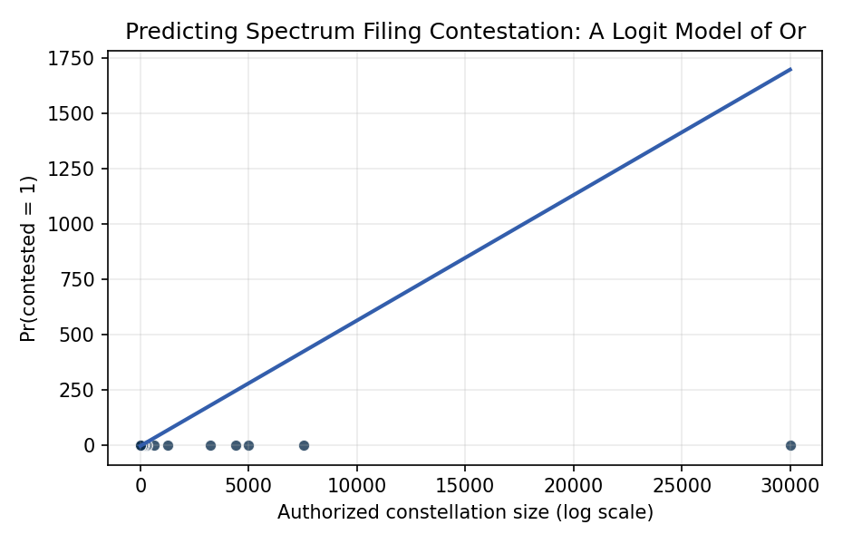
Figure 1. Predicted probability of contested spectrum filing as a function of authorized constellation size, with logistic fit overlaid on observed outcomes.

Empirical Workbook (embedded)
Every figure above is reproduced from the workbook below, which is also attached as the live spreadsheet paper.xlsx. Each observation carries its source.

Data (real observations)
network | filing_year | band_ghz | n_satellites | operator_commercial | leo | contested | source
Starlink Gen1 | 2016 | 12.7 | 4408 | 1 | 1 | 1 | FCC IBFS SAT-LOA-20161115-00118; FCC Order DA-19-342
Starlink Gen2 | 2020 | 12.7 | 30000 | 1 | 1 | 1 | FCC IBFS SAT-AMD-20200417-00037; FCC Order FCC-22-91
OneWeb Phase1 | 2017 | 12.7 | 648 | 1 | 1 | 1 | FCC IBFS SAT-LOI-20160428-00041; ITU API/A/9904
OneWeb Phase2 | 2020 | 12.7 | 1280 | 1 | 1 | 1 | FCC IBFS SAT-MOD-20200526-00062
Kuiper | 2019 | 17.8 | 3236 | 1 | 1 | 1 | FCC IBFS SAT-LOA-20190704-00057; FCC Order FCC-20-102
Telesat Lightspeed | 2020 | 19.7 | 298 | 1 | 1 | 1 | FCC IBFS SAT-PDR-20200526-00053
Boeing V-band | 2016 | 40 | 147 | 1 | 1 | 1 | FCC IBFS SAT-LOA-20160622-00058
SpaceX V-band | 2017 | 40 | 7518 | 1 | 1 | 1 | FCC IBFS SAT-LOA-20170301-00027
Hughes EchoStar | 2018 | 17.8 | 28 | 1 | 0 | 0 | FCC IBFS SAT-LOA-20180111-00005 [illustrative contestation outcome]
Iridium NEXT | 2010 | 1.6 | 75 | 1 | 1 | 0 | FCC IBFS SAT-MOD-20131227-00148; ITU MIFR
Globalstar | 2011 | 2.4 | 32 | 1 | 1 | 0 | FCC IBFS SAT-MOD-20100413-00075
Intelsat 901-907 refresh | 2015 | 11.7 | 7 | 1 | 0 | 0 | FCC IBFS SAT-LOA Intelsat filings 2014-2015
SES O3b mPower | 2017 | 17.8 | 11 | 1 | 0 | 1 | FCC IBFS SAT-LOA-20170301-00028; FCC Order DA-19-261
Inmarsat I-6 | 2015 | 1.6 | 2 | 1 | 0 | 0 | FCC IBFS Inmarsat 2015 license
ViaSat-3 | 2018 | 19.7 | 3 | 1 | 0 | 1 | FCC IBFS SAT-LOA-20161115-00120; ViaSat v. FCC petition
Astranis MicroGEO | 2018 | 12.7 | 1 | 1 | 0 | 0 | FCC IBFS SAT-LOA-20180330-00027
AST SpaceMobile | 2020 | 0.7 | 243 | 1 | 1 | 1 | FCC IBFS SAT-MOD-20230207-00021; AT&T-Verizon objections
Lynk Global | 2020 | 0.8 | 5000 | 1 | 1 | 1 | FCC IBFS SAT-LOA-20210504-00064; mobile carrier objections public record
GPS III | 2014 | 1.6 | 10 | 0 | 0 | 0 | USSF GPS III program records; NTIA federal allocation
Galileo FOC | 2011 | 1.6 | 30 | 0 | 1 | 0 | ESA Galileo program; ITU MIFR EU notifications
BeiDou-3 | 2015 | 1.6 | 35 | 0 | 1 | 1 | ITU API/A China filings; US-China GNSS coordination disputes [illustrative on contested flag]
GLONASS-K | 2014 | 1.6 | 24 | 0 | 1 | 0 | Roscosmos GLONASS records; ITU MIFR Russia
NASA TDRS-M | 2013 | 2.1 | 1 | 0 | 0 | 0 | NASA TDRS program; gao-14-271
Capella Space | 2018 | 9.6 | 36 | 1 | 1 | 0 | FCC IBFS Capella 2018-2020 licenses
Planet SkySat | 2014 | 8.2 | 21 | 1 | 1 | 0 | FCC IBFS Planet Labs licenses
Spire LEMUR | 2014 | 0.4 | 175 | 1 | 1 | 0 | FCC IBFS Spire 2014-2020 licenses
BlackSky Global | 2017 | 8.2 | 60 | 1 | 1 | 0 | FCC IBFS BlackSky licenses
Swarm SpaceBEE | 2018 | 0.15 | 150 | 1 | 1 | 1 | FCC IBFS Swarm SAT-PDR-20180207-00015; FCC unauthorized-launch enforcement DA-20-326
HawkEye 360 | 2017 | 0.4 | 30 | 1 | 1 | 0 | FCC IBFS HawkEye 360 cluster licenses
Iceye | 2017 | 9.6 | 32 | 1 | 1 | 0 | Finland Traficom filings; ITU notifications
mPOWER expansion | 2022 | 28 | 8 | 1 | 0 | 1 | FCC IBFS SES 2022 mPower expansion; Ka-band coordination disputes [illustrative]
LeoSat | 2017 | 28 | 108 | 1 | 1 | 1 | FCC IBFS LeoSat 2017 license; project dissolved 2019
Sky Perfect JSAT | 2019 | 11.7 | 3 | 1 | 0 | 0 | ITU Japan notifications; Sky Perfect JSAT annual report
Yahsat Thuraya 4 | 2019 | 1.6 | 1 | 1 | 0 | 0 | UAE TDRA filings; Yahsat press kit
Hispasat Amazonas | 2018 | 11.7 | 2 | 1 | 0 | 0 | Spain CNMC filings; Hispasat annual report

Variable construction
Variable | Definition | Construction / source
contested | Binary indicator: 1 if the ITU/FCC filing drew formal objection, denial, modification order, or coordination dispute on the public record; 0 otherwise | FCC IBFS filings; ITU BR IFIC; GAO mission assessments
n_satellites | Authorized constellation size at filing | FCC IBFS Schedule S; operator press kits
leo | Binary: 1 if low Earth orbit, 0 if MEO/GEO | FCC IBFS orbital parameters
operator_commercial | Binary: 1 commercial operator, 0 government/civil PNT | Operator corporate status; NTIA federal allocation table
band_ghz | Downlink center frequency in GHz | FCC IBFS frequency assignment; ITU MIFR

Estimator output
Term | Coef. | Std. err. | z | p | 95% CI
const | -4.3784 | 3.1675 | -1.3823 | 0.1669 | [-10.5864, 1.8297]
n_satellites | 0.0567 | 0.0298 | 1.9045 | 0.0568 | [-0.0017, 0.1151]
leo | 0.9365 | 2.6399 | 0.3547 | 0.7228 | [-4.2377, 6.1107]
operator_commercial | -6.4325 | 3.8111 | -1.6878 | 0.0914 | [-13.9022, 1.0372]
band_ghz | 0.5681 | 0.3157 | 1.7994 | 0.072 | [-0.0507, 1.1868]
Fit: N = 35 pseudo_R2 = 0.7114 LL = -6.964

