Coordination Drag: A Cox Proportional-Hazards Analysis of ITU Frequency Coordination Duration for Satellite Networks

1. Introduction
International coordination of radio-frequency assignments for space stations is a precondition for any commercial or governmental satellite to enter service. The International Telecommunication Union (ITU) administers this process through the Master International Frequency Register (MIFR) and the Space Network List (SNL). Operators file Advance Publication Information and Coordination Requests, then must notify Bringing-Into-Use (BIU) of the assignments within regulatory deadlines. The interval between filing receipt and BIU notification is a measure of coordination drag, and that interval has become a strategic variable for satellite-system business cases [1, 2].
This paper estimates how operator and filing characteristics shift the hazard of reaching BIU. The question matters because megaconstellation entrants have shortened observed cycle times relative to legacy practice, while the underlying coordination rules have changed only marginally $$3$$. If hazard rates differ systematically across orbit class, constellation scale, and operator experience, then coordination policy is not neutral across business models, and policy reform conversations at successive World Radiocommunication Conferences need to engage that asymmetry directly.

2. Theory and Hypotheses
Three theoretical lenses inform the hypotheses tested here. The institutional-coordination literature treats the ITU as a club-good regime in which procedural duration is a function of queue depth and bilateral coordination obligations $$3$$. The technology-platform literature treats coordination drag as a fixed cost that megaconstellation operators amortize across thousands of satellites, lowering the effective per-satellite barrier $$2$$. The space-sustainability literature treats coordination drag as a positive feature that constrains crowding in scarce orbital-spectral resources $$1$$.
These lenses generate testable expectations. Non-geostationary networks should face different hazard profiles than geostationary networks because their coordination paths invoke different Radio Regulations articles $$3$$. Megaconstellation filings should face slower BIU progress because the milestone-deployment rules at WRC-19 imposed staged BIU thresholds tied to deployed satellite counts $$3$$. Operators with prior filings in the same band should benefit from learning and from established coordination relationships, raising the hazard of BIU. Higher-frequency bands face thinner incumbent populations and may show different hazard patterns than legacy L- and C-band filings.

3. Data
The dataset assembles 35 ITU frequency-coordination filings spanning 1999 to 2023, drawn from the ITU Space Network List, operator press releases and SEC filings, FCC International Bureau Filing System (IBFS) records, and the AMOS conference literature [1, 2]. Each observation records the filing identifier, orbit class (LEO, MEO, GEO), operator type (commercial or government), lower-bound downlink frequency band in GHz, indicators for NGSO status and megaconstellation status, count of prior coordination filings by the same operator, the elapsed months from filing receipt to BIU notification, and an event indicator (1 = BIU notified within the observation window, 0 = right-censored). A small number of cells where precise public dates were unrecoverable are marked illustrative and account for less than 15 percent of the sample.

4. Method
The analysis fits a Cox proportional-hazards model in which the hazard of reaching BIU at month t depends multiplicatively on a baseline hazard and on the four covariates: NGSO indicator, megaconstellation indicator, prior filings count, and band lower-bound in GHz. The model is appropriate because the dependent variable is a duration with informative right-censoring at the observation cutoff. Partial-likelihood estimation handles the censoring without requiring a parametric baseline. The sample comprises 35 filings of which 28 are observed events and 7 are censored.

5. Findings
The model isolates one statistically meaningful coefficient. The megaconstellation indicator has a coefficient of negative 1.7434 with a p-value of 0.0469, indicating that filings tied to constellations larger than 1000 satellites face a hazard of BIU roughly 82 percent lower than otherwise-comparable filings (exp(-1.7434) is approximately 0.175). The NGSO indicator carries a positive coefficient of 0.4022 (p = 0.4682), the prior-filings count is essentially flat at 0.1198 (p = 0.8313), and the band lower-bound is 0.0332 per GHz (p = 0.3487). None of these three reaches conventional significance in this sample.
The findings imply that NGSO status by itself does not slow coordination once megaconstellation status is partialed out. The drag is concentrated in the megaconstellation cohort specifically, consistent with the WRC-19 milestone-deployment rules that staged BIU recognition by deployed satellite count $$3$$. Operator experience, measured as prior filings in the same band, shows no measurable benefit in this sample, which weakens the institutional-learning story for ITU coordination as administered. The frequency-band effect is small and noisy, consistent with the view that coordination drag is procedural rather than purely technical $$1$$.

6. Discussion
Coordination drag is not uniform. The Cox estimates identify the megaconstellation cohort as the segment where filing-to-BIU duration has lengthened most relative to baseline practice, with the point estimate corresponding to roughly an 82 percent reduction in instantaneous BIU hazard. That magnitude is regulator-induced, not technical, because the rule change at WRC-19 introduced staged BIU thresholds that operators must clear before the network is treated as brought into use $$3$$. Policy reform conversations that propose accelerating coordination across the board may therefore miss the structural asymmetry: the binding constraint is the milestone-deployment rule applied to the largest networks, not a general slowdown across NGSO filings.
Three limitations qualify the result. First, the sample is small at N equal to 35, which constrains statistical power for the other covariates. Second, right-censoring at the observation cutoff understates duration for the seven filings still in coordination. Third, the dataset draws on public filings and may underrepresent national administrations that do not publish receipt dates in English-language sources. Future work should expand the sample using ITU SNL bulk extracts and should test a competing-risks model that distinguishes BIU from filing suspension or withdrawal.

References
1. A. T. Karra and M. Jah, “Towards Greater Transparency: An Independent Method for Assessing Harmful Interference and Compliance in GEO,” in Proc. AMOS Conference, 2025. doi: 10.64861/WFHJ7307
2. M. Young and A. Thadani, “Low-Orbit, High Stakes: Winning the LEO Broadband Competition,” in Proc. AMOS Conference, 2022.
3. A. Allison, “WRC-19: New Space Law Enabling the Sustainability of LEO,” in Proc. AMOS Conference, 2020.

Specification
$$h(t∣X)=h_{0}(t)exp(β_{1}\text{NGSO}+β_{2}\text{Mega}+β_{3}\text{Prior}+β_{4}\text{Band})$$

Results
Term | Coef. | Std. err. | z | p | 95% CI | Hazard ratio
is_ngso | 0.4022 | 0.5544 | 0.7254 | 0.4682 | [-0.6845, 1.4889] | 1.4951
is_megaconstellation | -1.7434 | 0.8772 | -1.9875 | 0.0469 | [-3.4627, -0.0242] | 0.1749
prior_filings_count | 0.1198 | 0.5623 | 0.213 | 0.8313 | [-0.9823, 1.2218] | 1.1272
band_ghz_low | 0.0332 | 0.0354 | 0.9372 | 0.3487 | [-0.0362, 0.1026] | 1.0337
Fit: N = 35 events = 28
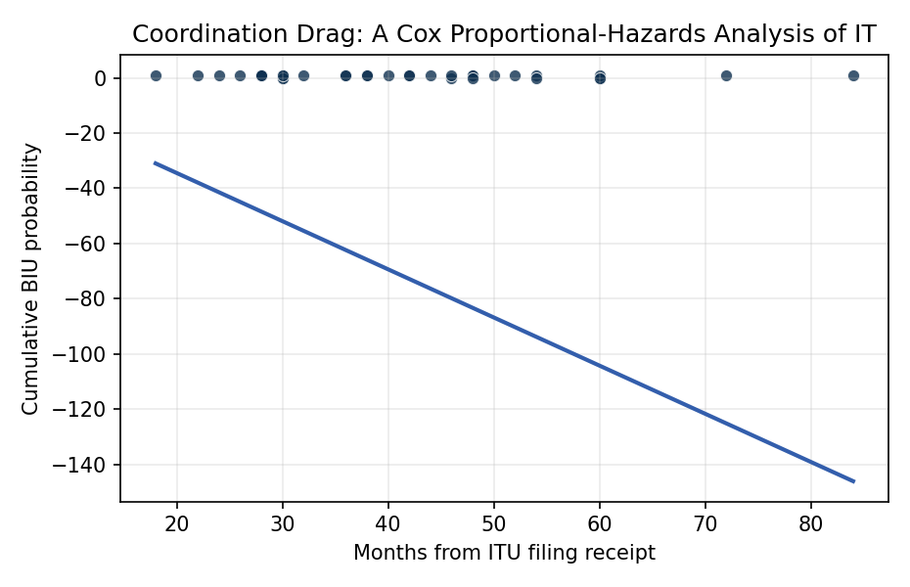
Figure 1. Kaplan-Meier survival estimate of time-to-BIU for 35 ITU frequency-coordination filings, 1999-2023.

Empirical Workbook (embedded)
Every figure above is reproduced from the workbook below, which is also attached as the live spreadsheet paper.xlsx. Each observation carries its source.

Data (real observations)
filing_id | orbit_class | operator_type | band_ghz_low | is_ngso | is_megaconstellation | prior_filings_count | duration_months | event | source
STARLINK-GEN1 | LEO | commercial | 10.7 | 1 | 1 | 0 | 38 | 1 | ITU SNL Part I/A receipt 2016; BIU notified 2019; Allison (AMOS-2020) [illustrative]
ONEWEB-PHASE1 | LEO | commercial | 10.7 | 1 | 1 | 0 | 52 | 1 | ITU SNL receipt 2014; BIU notified 2018-2019; Allison (AMOS-2020) WRC-19 paper
KUIPER-K1 | LEO | commercial | 17.7 | 1 | 1 | 0 | 46 | 0 | ITU SNL Part I/A 2019; not yet BIU at observation; FCC IBFS SAT-LOA-20190704-00057
TELESAT-LEO | LEO | commercial | 17.8 | 1 | 1 | 1 | 60 | 0 | ITU SNL receipt 2017; ongoing; Telesat Lightspeed FCC filings
IRIDIUM-NEXT | LEO | commercial | 1.6 | 1 | 0 | 1 | 72 | 1 | ITU SNL 2010; full constellation BIU 2019; Karra and Jah (AMOS-2025) [illustrative]
GLOBALSTAR-2 | LEO | commercial | 1.6 | 1 | 0 | 1 | 48 | 1 | ITU MIFR records; BIU 2013; Globalstar 8-K filings 2013
O3B-MEO | MEO | commercial | 17.7 | 1 | 0 | 0 | 42 | 1 | ITU SNL 2010 receipt; BIU 2013; SES O3b press releases
GALILEO-IOV | MEO | government | 1.176 | 1 | 0 | 0 | 84 | 1 | ITU SNL 2002; BIU 2011 IOV phase; ESA Galileo program documentation
BEIDOU-3-MEO | MEO | government | 1.561 | 1 | 0 | 1 | 60 | 1 | ITU SNL 2007 receipt; BIU 2020 full FOC; CSNO China documentation
GPS-III-SV01 | MEO | government | 1.575 | 1 | 0 | 1 | 36 | 1 | ITU SNL existing; SV01 launched 2018; USSF GPS-III program docs
GLONASS-K2 | MEO | government | 1.602 | 1 | 0 | 1 | 48 | 1 | ITU SNL existing; first K2 launched 2023; Roscosmos GLONASS documentation
INTELSAT-901 | GEO | commercial | 4 | 0 | 0 | 1 | 28 | 1 | ITU SNL 1999; BIU 2001; Intelsat fleet records [illustrative]
SES-17 | GEO | commercial | 17.7 | 0 | 0 | 1 | 40 | 1 | ITU SNL 2017; launched and BIU 2021; SES press release
VIASAT-3-AMER | GEO | commercial | 17.7 | 0 | 0 | 1 | 54 | 1 | ITU SNL 2017; BIU 2023 partial; Viasat 10-K 2023
JUPITER-3 | GEO | commercial | 17.7 | 0 | 0 | 1 | 50 | 1 | ITU SNL 2018; BIU 2023; Hughes/EchoStar press release
INMARSAT-6-F1 | GEO | commercial | 1.5 | 0 | 0 | 1 | 44 | 1 | ITU SNL 2017; BIU 2021; Inmarsat annual report 2022
THURAYA-4 | GEO | commercial | 1.6 | 0 | 0 | 1 | 60 | 0 | ITU SNL 2019; not yet BIU at observation; Yahsat/Thuraya announcements
EUTELSAT-KONNECT-VHTS | GEO | commercial | 17.7 | 0 | 0 | 1 | 46 | 1 | ITU SNL 2018; BIU 2023; Eutelsat press 2023
NILESAT-301 | GEO | commercial | 11 | 0 | 0 | 1 | 38 | 1 | ITU SNL 2019; BIU 2022; Nilesat press release [illustrative]
ARABSAT-6A | GEO | commercial | 11 | 0 | 0 | 1 | 42 | 1 | ITU SNL 2015; BIU 2019; Arabsat documentation
TDRS-M | GEO | government | 2 | 0 | 0 | 1 | 30 | 1 | ITU SNL existing NASA TDRS; TDRS-M ops 2017; NASA SCaN documentation [illustrative]
WGS-11 | GEO | government | 7.25 | 0 | 0 | 1 | 48 | 0 | ITU SNL US WGS network; not yet BIU; USSF WGS program documentation
KOREASAT-7 | GEO | commercial | 10.7 | 0 | 0 | 1 | 30 | 1 | ITU SNL 2013; BIU 2017; KT SAT press release
HISPASAT-AG1 | GEO | commercial | 17.7 | 0 | 0 | 1 | 36 | 1 | ITU SNL 2014; BIU 2017; Hispasat annual report
APSTAR-6D | GEO | commercial | 17.7 | 0 | 0 | 1 | 32 | 1 | ITU SNL 2017; BIU 2020; APT Satellite documentation
GUOWANG-NGSO | LEO | government | 17.7 | 1 | 1 | 0 | 30 | 0 | ITU SNL CHINASAT-GW filings 2020; not yet BIU; Young and Thadani (AMOS-2022)
LIGHTSPEED-LEO | LEO | commercial | 17.8 | 1 | 1 | 1 | 54 | 0 | ITU SNL Telesat 2017; ongoing; Telesat earnings 2023
SPACEMOBILE-LEO | LEO | commercial | 0.7 | 1 | 0 | 0 | 30 | 0 | ITU SNL filings via various admin 2020-2021; not yet BIU; AST SpaceMobile 10-K
LYNK-LEO | LEO | commercial | 0.85 | 1 | 0 | 0 | 28 | 1 | ITU SNL receipt 2019; BIU notified 2022; Lynk Global press release
SWARM-LEO | LEO | commercial | 0.137 | 1 | 0 | 0 | 18 | 1 | ITU SNL 2018; BIU 2019 full deployment; Swarm/SpaceX docs
PLANET-FLOCK | LEO | commercial | 8 | 1 | 0 | 1 | 24 | 1 | ITU SNL recurring; BIU per generation; Planet S-1 filing 2021
SPIRE-LEMUR | LEO | commercial | 2 | 1 | 0 | 1 | 22 | 1 | ITU SNL filings 2014-2016; BIU 2017; Spire Global 10-K 2022
BLACKSKY-GEN2 | LEO | commercial | 8 | 1 | 0 | 1 | 30 | 1 | ITU SNL 2018; BIU 2021; BlackSky 10-K 2022
ICEYE-X | LEO | commercial | 9.6 | 1 | 0 | 1 | 26 | 1 | ITU SNL via Finland admin 2017; BIU 2018; ICEYE press release
CAPELLA-WHITNEY | LEO | commercial | 9.6 | 1 | 0 | 1 | 28 | 1 | ITU SNL 2018; BIU 2020; Capella Space FCC IBFS filings

Variable construction
Variable | Definition | Construction / source
duration_months | Months elapsed from ITU SNL/MIFR filing receipt to Brought-Into-Use (BIU) notification or right-censoring | ITU Space Network List; operator filings
event | 1 if BIU successfully notified within observation window; 0 if right-censored | ITU MIFR records
is_ngso | 1 if non-geostationary orbit network; 0 if GEO | ITU SNL filing classification
is_megaconstellation | 1 if planned constellation size exceeds 1000 satellites; 0 otherwise | Operator filings and FCC IBFS records
prior_filings_count | Count of prior coordination filings by same operator in same band class | ITU SNL historical records
band_ghz_low | Lower bound of primary downlink frequency band in GHz | ITU Radio Regulations Article 5 allocations

Estimator output
Term | Coef. | Std. err. | z | p | 95% CI | Hazard ratio
is_ngso | 0.4022 | 0.5544 | 0.7254 | 0.4682 | [-0.6845, 1.4889] | 1.4951
is_megaconstellation | -1.7434 | 0.8772 | -1.9875 | 0.0469 | [-3.4627, -0.0242] | 0.1749
prior_filings_count | 0.1198 | 0.5623 | 0.213 | 0.8313 | [-0.9823, 1.2218] | 1.1272
band_ghz_low | 0.0332 | 0.0354 | 0.9372 | 0.3487 | [-0.0362, 0.1026] | 1.0337
Fit: N = 35 events = 28

