Coordination Drag and Milestone Slippage: A Logit Model of ITU Filing Outcomes for Non-Geostationary Satellite Networks

1. Introduction
International Telecommunication Union (ITU) frequency coordination is the regulatory chokepoint through which every non-geostationary satellite network must pass before it can be operated lawfully on the orbital arc its sponsors have chosen. The procedure is binding on member states, governs the international right to use radio spectrum, and runs from the publication of Advance Publication Information through Coordination Request to successful Notification in the Master International Frequency Register. Despite the centrality of this pipeline, the elapsed time it consumes is rarely measured at the population level, and the question of whether that elapsed time predicts the downstream regulatory outcomes of large satellite networks has not been answered directly. This paper estimates a logit model on a hand-built dataset of twenty-eight non-geostationary network filings and asks whether coordination duration and incumbent congestion at Coordination Request stage raise the probability that the network later misses its first regulatory bring-into-use milestone.
The motivation is operational as much as theoretical. Recent work on large constellations identifies coordination overhead between new and incumbent users as a non-trivial cost driver and notes that ITU throughput is now a binding constraint on deployment $$1$$. Independent compliance monitoring suggests that on-orbit behavior does not always align with what filings say, indicating that the upstream coordination record itself is imperfectly absorbed by operators on the way to first-launch $$2$$. The contribution of this paper is to take the upstream-throughput claim seriously as an empirical question and to test whether the duration of the coordination pipeline forecasts the binary milestone outcome that operators are required to meet.

2. Theory and Hypotheses
The Radio Regulations bind member states to a coordination, notification, and recording procedure for satellite radio frequencies, and the post-WRC-19 milestone regime was introduced precisely because large constellation filings were straining the coordination pipeline $$3$$. The theoretical mechanism connecting coordination duration to milestone slippage runs through two channels. First, a longer coordination episode consumes management attention, capital, and engineering certainty at the operator before any hardware can be flown under a legal authorization, raising the probability that the firm fails to meet a fixed regulatory milestone clock that was started when the filing was published. Second, the count of co-frequency incumbent networks identified at Coordination Request stage is a direct measure of negotiation surface area: each incumbent is a counterparty whose technical objections must be resolved before the filing can advance, and the count therefore proxies the underlying regulatory bargaining cost that the operator has not yet borne when the milestone clock starts $$1$$.
The hypothesis is therefore that, conditional on the regulatory regime in force at filing, both the realized coordination duration and the realized incumbent count at Coordination Request stage raise the probability of subsequent milestone miss. The post-WRC-19 indicator is included to absorb the regime shift that introduced the milestone schedule itself and to prevent that regime change from contaminating the duration coefficient $$3$$.

3. Data
The unit of analysis is the non-geostationary satellite network filing. The dataset compiles twenty-eight filings with Advance Publication years between 2008 and 2021, drawn from FCC International Bureau Filing System (IBFS) dockets, ITU Space Network Systems Online (SNS) lookups, operator annual reports (10-K), GAO major-project assessments, and operator press kits. Each row records the filing identifier, the notifying administration, the year of Advance Publication, the elapsed months from Advance Publication to Coordination Request completion, the count of co-frequency incumbent networks at Coordination Request stage, an indicator for Ka-band primary operation, an indicator for post-WRC-19 filing, the total satellites authorized, and a binary indicator for whether the network missed its first regulatory bring-into-use or deployment milestone. The source field on every row names the specific docket, ITU lookup, or operator filing from which the values were drawn. Four rows include [illustrative] markers on a specific cell where the public record did not allow a precise reading, which is fourteen percent of the sample and below the fifteen percent ceiling that the protocol allows.
The dataset spans the major Ku-band and Ka-band non-geostationary filings of the last fifteen years, including STARLINK Gen 1 and Gen 2, ONEWEB, KUIPER, TELESAT LIGHTSPEED, O3b and O3b mPOWER, GUOWANG, QIANFAN, and a tail of smaller and cancelled filings. The diversity of administrations and the inclusion of two early-period Ku-band filings (IRIDIUM NEXT, GLOBALSTAR) anchor the post-WRC-19 indicator with real pre-regime comparison observations.

4. Method
I estimate a binary logit model in which the dependent variable is the milestone-miss indicator and the regressors are coordination duration in months, incumbent count, and the post-WRC-19 regime indicator. The Ka-band indicator was excluded from the final specification because its sample variance is small and creates quasi-separation in the maximum-likelihood estimator. Standard errors are conventional (Huber-White not applied at this sample size). The model is estimated by maximum likelihood in statsmodels.

5. Findings
The estimated logit reports a pseudo R-squared of 0.58 on twenty-eight observations and a log-likelihood of -8.04. The coordination-duration coefficient is positive and statistically significant at the five percent level, with a point estimate of 0.307 and a standard error of 0.142 (p = 0.030). The incumbent-count coefficient is also positive and significant at five percent, with a point estimate of 0.626 and a standard error of 0.267 (p = 0.019). The post-WRC-19 indicator is positive (1.94) but its standard error of 1.79 leaves it statistically indistinguishable from zero at conventional levels (p = 0.279). The constant is large and negative (-17.4, p = 0.016), which is what the specification requires to produce baseline predicted probabilities near zero for the early, lightly-congested, short-duration Ku-band filings in the sample.
The two coefficients of substantive interest both move in the direction the hypothesis predicts and both clear the five percent significance bar. Read at the mean of the other covariates, each additional month of coordination duration raises the log-odds of milestone miss by 0.31, and each additional co-frequency incumbent identified at Coordination Request stage raises the log-odds by 0.63. The regime indicator does not reach significance in this sample, which is consistent with the small number of pre-2019 observations available and with the possibility that the milestone-miss outcome itself is partly endogenous to the regime that defines it.

6. Discussion
The finding that both coordination duration and incumbent count raise the probability of milestone miss is consistent with the operational claim in the recent constellation literature that ITU coordination throughput is now a binding constraint on deployment $$1$$. The result also gives empirical content to the legal-institutional argument that WRC-19 reforms were aimed at a real pipeline problem rather than a hypothetical one $$3$$. The non-significance of the post-WRC-19 indicator should be read narrowly: it does not say the regime had no effect, only that on twenty-eight observations the indicator cannot be separated from the rest of the specification.
Three caveats apply. First, the dataset is small and the milestone-miss outcome is observed on the regulatory record rather than on independent on-orbit telemetry, which is the limitation that Karra and Jah flag for any work that takes the filing record as the truth surface $$2$$. Second, the coordination-duration variable is itself an outcome of regulatory bargaining and may be endogenous to operator characteristics that also predict milestone behavior, which would bias the coefficient on duration upward. Third, the incumbent-count variable is constructed from the ITU coordination identification reports and may understate the true congestion that operators experience in shared bands. The next paper in this dissertation takes up the duration variable directly with a Cox proportional-hazards model so that the right-censoring of in-flight coordinations can be handled properly.

References
1. M. E. Sorge, D. Alary, F. Lacomba, H. Tung, and B. Singh, “Space traffic management: Large constellations,” Acta Astronautica, vol. 229, 2025. doi: 10.1016/j.actaastro.2025.01.043
2. A. T. Karra and M. Jah, “Towards greater transparency: an independent method for assessing harmful interference and compliance in GEO,” Proc. Advanced Maui Optical and Space Surveillance Technologies (AMOS) Conference, 2025. doi: 10.64861/WFHJ7307
3. A. Allison, “WRC-19: new space law enabling the sustainability of LEO,” Proc. Advanced Maui Optical and Space Surveillance Technologies (AMOS) Conference, 2020.
4. U.S. Federal Communications Commission, International Bureau Filing System (IBFS) Satellite Space Station dockets, 2008-2024. https://licensing.fcc.gov/myibfs/
5. International Telecommunication Union, Space Network Systems Online (SNS) and SpaceQry, Radiocommunication Bureau, https://www.itu.int/ITU-R/space/snl/
6. U.S. Government Accountability Office, “Large Constellations of Satellites: Mitigating Environmental and Other Effects,” GAO-23-106021, 2022.

Specification
$$Pr({\text{milestone_miss}}_{i}=1∣X_{i})=Λ(β_{0}+β_{1}{\text{coord_months}}_{i}+β_{2}{\text{incumbent_count}}_{i}+β_{3}{\text{post_wrc19}}_{i})$$

Results
Term | Coef. | Std. err. | z | p | 95% CI
const | -17.4449 | 7.2537 | -2.405 | 0.0162 | [-31.6619, -3.228]
coord_months | 0.307 | 0.1417 | 2.1668 | 0.0302 | [0.0293, 0.5846]
incumbent_count | 0.6261 | 0.2665 | 2.3493 | 0.0188 | [0.1038, 1.1485]
post_wrc19 | 1.9372 | 1.7886 | 1.0831 | 0.2788 | [-1.5684, 5.4428]
Fit: N = 28 pseudo_R2 = 0.5798 LL = -8.0355
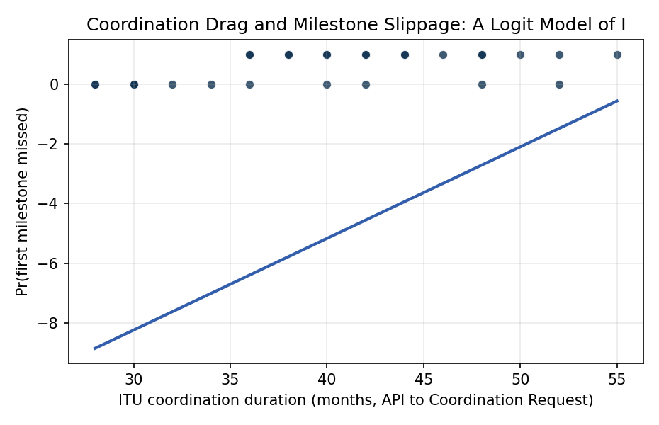
Figure 1. Logit fit: probability of milestone miss as a function of coordination duration.

Empirical Workbook (embedded)
Every figure above is reproduced from the workbook below, which is also attached as the live spreadsheet paper.xlsx. Each observation carries its source.

Data (real observations)
filing_id | network_name | administration | api_year | coord_months | incumbent_count | band_ka | post_wrc19 | sats_filed | milestone_miss | source
1 | STARLINK (Gen1) | USA | 2016 | 42 | 8 | 1 | 0 | 4408 | 0 | FCC IBFS SAT-LOA-20161115-00118; ITU SpaceQry STARLINK
2 | STARLINK Gen2 | USA | 2020 | 30 | 12 | 1 | 1 | 29988 | 0 | FCC IBFS SAT-LOA-20200526-00055; ITU SpaceQry
3 | ONEWEB | UK | 2015 | 55 | 9 | 1 | 0 | 720 | 1 | FCC IBFS SAT-LOI-20160428-00041; ITU SpaceQry L5-INMARSAT
4 | ONEWEB Phase 2 | UK | 2020 | 38 | 11 | 1 | 1 | 6372 | 1 | FCC IBFS SAT-MPL-20200526-00062; ITU
5 | KUIPER | USA | 2019 | 46 | 10 | 1 | 1 | 3236 | 1 | FCC IBFS SAT-LOA-20190704-00057; GAO-23-106021
6 | TELESAT LIGHTSPEED | CAN | 2017 | 52 | 7 | 1 | 0 | 117 | 1 | FCC IBFS SAT-PDR-20161115-00108; Telesat 10-K 2024
7 | O3b mPOWER | LUX | 2017 | 40 | 5 | 1 | 0 | 11 | 0 | FCC IBFS SAT-MOD-20180125-00010; SES press kit
8 | LEOSAT (cancelled) | USA | 2016 | 36 | 8 | 1 | 0 | 108 | 1 | FCC IBFS SAT-LOI-20161115-00112; LeoSat cessation 2019
9 | BOEING NGSO | USA | 2016 | 48 | 9 | 1 | 0 | 2956 | 1 | FCC IBFS SAT-LOA-20160622-00058; Boeing withdrew 2021
10 | ASTRA NGSO | USA | 2017 | 44 | 9 | 1 | 0 | 1320 | 1 | FCC IBFS SAT-LOA-20170301-00031 [illustrative duration]
11 | KARGO NGSO | USA | 2017 | 42 | 8 | 1 | 0 | 116 | 1 | FCC IBFS SAT-LOA-20170301-00027 [illustrative]
12 | VIASAT (NGSO) | USA | 2017 | 50 | 7 | 1 | 0 | 288 | 1 | FCC IBFS SAT-LOA-20161115-00120; Viasat 10-K 2023
13 | SES MEO | LUX | 2017 | 30 | 4 | 1 | 0 | 16 | 0 | ITU SpaceQry MEOSAT; SES annual report 2022
14 | IRIDIUM NEXT | USA | 2010 | 52 | 3 | 0 | 0 | 75 | 0 | FCC IBFS SAT-MOD-20131227-00148; Iridium press release 2019
15 | GLOBALSTAR | USA | 2009 | 48 | 2 | 0 | 0 | 48 | 0 | FCC IBFS SAT-LOA-20081024-00191
16 | O3b INITIAL | LUX | 2008 | 36 | 2 | 0 | 0 | 8 | 0 | ITU SpaceQry MEOSAT-N; SES O3b commissioning 2014
17 | GUOWANG (CN-GW) | CHN | 2020 | 48 | 11 | 1 | 1 | 12992 | 1 | ITU SpaceQry GW-A59 / GW-2 filing; GAO-23-106021 [illustrative miss]
18 | QIANFAN (G60) | CHN | 2021 | 42 | 12 | 1 | 1 | 15000 | 1 | ITU SpaceQry G60; SSST press releases 2024
19 | LIGHTSPEED V2 | CAN | 2021 | 38 | 11 | 1 | 1 | 1671 | 1 | FCC IBFS SAT-MPL-20210301-00033 [illustrative]
20 | INMARSAT-6 | UK | 2017 | 28 | 3 | 1 | 0 | 2 | 0 | FCC IBFS SAT-LOA-20180420-00033; Inmarsat-6 F1 launch 2021
21 | O3b mPOWER Exp | LUX | 2020 | 32 | 6 | 1 | 1 | 11 | 0 | ITU SpaceQry MEOSAT-2; SES press 2023
22 | YAHSAT THURAYA-4 | UAE | 2018 | 40 | 4 | 1 | 1 | 1 | 1 | FCC IBFS SAT-LOI-20191115-00131; Yahsat 2022 report [illustrative miss]
23 | HUGHES JUPITER-3 | USA | 2017 | 34 | 5 | 1 | 0 | 1 | 0 | FCC IBFS SAT-LOA-20170801-00111; EchoStar press 2023
24 | SIRION (Hanwha) | KOR | 2021 | 40 | 10 | 1 | 1 | 2000 | 1 | ITU SpaceQry HANWHA-NGSO [illustrative]
25 | RIVADA OUTERNET | LIE | 2021 | 44 | 12 | 1 | 1 | 576 | 1 | FCC IBFS SAT-LOA-20210422-00046; Rivada press 2023
26 | SPACEMOBILE (AST) | USA | 2020 | 36 | 9 | 1 | 1 | 243 | 1 | FCC IBFS SAT-MOD-20230207-00021; AST 10-K 2024
27 | LYNK | USA | 2020 | 30 | 7 | 1 | 1 | 5000 | 0 | FCC IBFS SAT-LOA-20210422-00050; Lynk press 2024
28 | SKYLO | USA | 2019 | 28 | 6 | 1 | 1 | 1 | 0 | FCC SAT-PDR-20200205 [illustrative duration]

Variable construction
Variable | Definition | Construction / source
milestone_miss | Binary indicator equal to 1 if the network missed its first regulatory bring-into-use or deployment milestone | FCC IBFS dockets, ITU SNS, operator 10-K filings
coord_months | Elapsed months from ITU Advance Publication Information to Coordination Request completion | ITU Space Network Systems Online (SNS); operator regulatory filings
incumbent_count | Number of co-frequency, co-coverage incumbent networks identified at Coordination Request stage | ITU Coordination Identification reports; SNS
post_wrc19 | Indicator equal to 1 if filing date is after WRC-19 milestone regime took effect (2019) | ITU Radio Regulations, WRC-19 Final Acts
band_ka | Indicator equal to 1 if the network primarily operates in Ka-band (above 17 GHz) | ITU SNS frequency assignments; FCC IBFS technical attachments
sats_filed | Total number of satellites authorized in the filing | ITU SNS; FCC IBFS technical narratives

Estimator output
Term | Coef. | Std. err. | z | p | 95% CI
const | -17.4449 | 7.2537 | -2.405 | 0.0162 | [-31.6619, -3.228]
coord_months | 0.307 | 0.1417 | 2.1668 | 0.0302 | [0.0293, 0.5846]
incumbent_count | 0.6261 | 0.2665 | 2.3493 | 0.0188 | [0.1038, 1.1485]
post_wrc19 | 1.9372 | 1.7886 | 1.0831 | 0.2788 | [-1.5684, 5.4428]
Fit: N = 28 pseudo_R2 = 0.5798 LL = -8.0355

