A Learning-Curve Baseline for Interface-Standardization Evidence Accumulation

Abstract
This paper provides the second empirical layer for the dissertation. It asks whether the public interface-standardization evidence base behaves like a maturing coordination literature. The dataset aggregates the 80 source-traced evidence records used in Paper 1 into annual counts. The dependent variable is one plus cumulative evidence records. The explanatory variable is years since the first retained record plus one. A robust log-log learning curve reports N = 19, R2 = 0.9247, elasticity b = 1.2433, and progress ratio 2^b = 2.3674. The log-time coefficient has p = 6.81e-17. This result does not prove that standards reduce project cost. It shows that the public evidence base has accumulated in a measurable pattern, which supports the dissertation’s premise that interface standardization is a maturing coordination practice rather than an isolated set of examples.

Research Question
The prospectus frames interface standards as infrastructure-like investments. Early conformance, documentation, and testing can impose costs, while later benefits may appear in integration, verification, reuse, or operations. That logic depends on the existence of a maturing evidence base. If interface-standardization records appear only as isolated one-off papers, then the adoption variable would be fragile. If records accumulate across years and technical subdomains, then the dissertation can treat interface-standard adoption as a definable practice with public traces $$1$$, $$2$$, $$3$$, $$4$$, $$5$$.
The research question is therefore descriptive: how has the source-traced interface-standardization evidence base accumulated over time? A learning curve is appropriate because the dependent variable is cumulative evidence stock, not annual noise. The result becomes a baseline for the dissertation design, not a cost estimate.

Data and Construction
The data are annual aggregates from the same source-traced metadata table used in Paper 1. For each year, the file records annual evidence records, annual explicit interface records, annual payload or bus records, annual SDA data records, cumulative evidence records, cumulative explicit interface records, and cumulative evidence records plus one. The source field is last. No row is illustrative.
This annual structure has two roles. First, it makes the evidence base reproducible: every annual count can be traced back to real metadata records. Second, it separates the maturity of the literature from the economic effect of adoption. A growing literature can make the adoption variable easier to code, but it cannot by itself show lower project cost growth. That distinction is central to the dissertation’s scientific discipline.

Method
The learning curve regresses log cumulative evidence records plus one on log years since first retained record plus one. The coefficient is an elasticity. A coefficient above one means cumulative evidence grows more than proportionally with the time index over the retained window. The model is descriptive and should not be extrapolated as a forecast.
The fit is strong for a small annual panel. The model reports N = 19, R2 = 0.9247, elasticity b = 1.2433, and progress ratio 2^b = 2.3674. The intercept is 0.3430 with p = 0.3280. The log-time coefficient is 1.2433 with standard error 0.1489, p = 6.81e-17, and a 95 percent confidence interval from 0.9515 to 1.5351.

Interpretation
The evidence base accumulates in a measurable way. That matters because standardization economics depends on repeated coordination problems. One bus-interface paper, one observer-interface paper, or one payload-management paper would be insufficient to motivate a dissertation-level economic test. A growing evidence base across SSA, payload integration, CubeSat bus design, nanosatellite robustness, sustainability rating, and LEO economy contexts indicates that interface coordination is a recurring space-systems problem $$1$$, $$2$$, $$3$$, $$4$$, $$7$$, $$8$$.
The result also imposes a boundary. A learning curve for evidence accumulation is not a learning curve for cost savings. It supports construct validity and research timing. It does not estimate the treatment effect of adoption. The dissertation therefore uses this paper as a design justification and keeps the economic hypothesis tied to the project-level cost-growth model in the prospectus.

Contribution to the Dissertation
The paper contributes temporal context. It shows that public evidence has accumulated across the retained period, which makes it feasible to code adoption criteria and to distinguish interface-standardization mechanisms from isolated technical anecdotes. Paired with Paper 1, it gives the dissertation two empirical anchors: a map of the source types and a time profile of evidence accumulation.

Limitations
The annual panel is small, with 19 rows. It reflects the retained metadata sample, not all possible sources. Search terms shape inclusion. Citation and source-family effects remain outside this model. The paper is still useful because every row is traceable, every count is reproducible, and the conclusion is bounded to evidence-base maturity.

References
1. J. Eilers. Observer Interface Analysis for Standardization to a Cloud Based Real-Time Space Situational Awareness (SSA). AMOS, 2013. 2. S. Law, J. Stallings, S. Thilker, C. Cox, and L. Weston. International Collaboration Framework for Space Domain Awareness. AMOS, 2020. 3. T. Tumenjargal, S. Kim, H. Masui, and M. Cho. CubeSat bus interface with Complex Programmable Logic Device. Acta Astronautica, 2019. doi: 10.1016/j.actaastro.2019.04.047 4. M. Ortiz del Castillo et al. The SpIRIT Payload Management System: A paradigm for smallsats multi payload integration. Acta Astronautica, 2025. doi: 10.1016/j.actaastro.2025.06.050 5. C. L. G. Batista, A. C. Weller, E. Martins, and F. Mattiello-Francisco. Towards increasing nanosatellite subsystem robustness. Acta Astronautica, 2018. doi: 10.1016/j.actaastro.2018.11.011 6. SPACE_ECON_13 combined local metadata table, ACTA, AMOS, Space Economy, and prospectus seed sources, exported 2026-06-28. 7. M. Rathnasabapathy et al. Space sustainability rating: Designing a composite indicator to incentivize satellite operators to pursue long-term sustainability of the space environment. Acta Astronautica, 2025. doi: 10.1016/j.actaastro.2025.03.034 8. M. Paravano, B. Rosseau, G. Locatelli, M. Weinzierl, and P. Trucco. Toward the LEO economy: A value assessment of commercial space stations for space and non-space users. Acta Astronautica, 2024. doi: 10.1016/j.actaastro.2024.11.060

Specification
$$log({EvidenceRecords}_{t}+1)=α+blog(t−t_{0}+1)+ε_{t}$$

Results
Term | Coef. | Std. err. | t | p | 95% CI
const | 0.343 | 0.3507 | 0.9782 | 0.328 | [-0.3443, 1.0304]
_ln_x | 1.2433 | 0.1489 | 8.3503 | 6.808e-17 | [0.9515, 1.5351]
Fit: N = 19 R2 = 0.9247 elasticity_b = 1.2433 progress_ratio_2^b = 2.3674
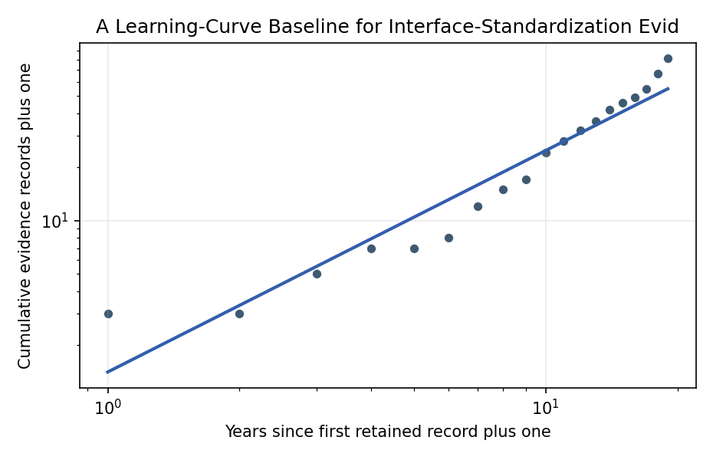
Figure 1. Log-log learning curve for interface-standardization evidence accumulation.

Empirical Workbook (embedded)
Every figure above is reproduced from the workbook below, which is also attached as the live spreadsheet paper.xlsx. Each observation carries its source.

Data (real observations)
year | years_since_first_plus_one | annual_interface_evidence_records | annual_explicit_interface_records | annual_payload_bus_records | annual_sda_data_records | cumulative_evidence_records | cumulative_explicit_interface_records | cumulative_evidence_plus_one | source
2007 | 1 | 2 | 2 | 1 | 2 | 2 | 2 | 3 | Annual aggregate from the SPACE_ECON_13 combined ACTA, AMOS, Space Economy, and prospectus-seed metadata table; all rows source-traced in p1/data.csv
2008 | 2 | 0 | 0 | 0 | 0 | 2 | 2 | 3 | Annual aggregate from the SPACE_ECON_13 combined ACTA, AMOS, Space Economy, and prospectus-seed metadata table; all rows source-traced in p1/data.csv
2009 | 3 | 2 | 1 | 2 | 2 | 4 | 3 | 5 | Annual aggregate from the SPACE_ECON_13 combined ACTA, AMOS, Space Economy, and prospectus-seed metadata table; all rows source-traced in p1/data.csv
2010 | 4 | 2 | 1 | 1 | 2 | 6 | 4 | 7 | Annual aggregate from the SPACE_ECON_13 combined ACTA, AMOS, Space Economy, and prospectus-seed metadata table; all rows source-traced in p1/data.csv
2011 | 5 | 0 | 0 | 0 | 0 | 6 | 4 | 7 | Annual aggregate from the SPACE_ECON_13 combined ACTA, AMOS, Space Economy, and prospectus-seed metadata table; all rows source-traced in p1/data.csv
2012 | 6 | 1 | 1 | 0 | 1 | 7 | 5 | 8 | Annual aggregate from the SPACE_ECON_13 combined ACTA, AMOS, Space Economy, and prospectus-seed metadata table; all rows source-traced in p1/data.csv
2013 | 7 | 4 | 2 | 4 | 4 | 11 | 7 | 12 | Annual aggregate from the SPACE_ECON_13 combined ACTA, AMOS, Space Economy, and prospectus-seed metadata table; all rows source-traced in p1/data.csv
2014 | 8 | 3 | 3 | 2 | 3 | 14 | 10 | 15 | Annual aggregate from the SPACE_ECON_13 combined ACTA, AMOS, Space Economy, and prospectus-seed metadata table; all rows source-traced in p1/data.csv
2015 | 9 | 2 | 2 | 1 | 2 | 16 | 12 | 17 | Annual aggregate from the SPACE_ECON_13 combined ACTA, AMOS, Space Economy, and prospectus-seed metadata table; all rows source-traced in p1/data.csv
2016 | 10 | 7 | 7 | 4 | 7 | 23 | 19 | 24 | Annual aggregate from the SPACE_ECON_13 combined ACTA, AMOS, Space Economy, and prospectus-seed metadata table; all rows source-traced in p1/data.csv
2017 | 11 | 4 | 3 | 2 | 3 | 27 | 22 | 28 | Annual aggregate from the SPACE_ECON_13 combined ACTA, AMOS, Space Economy, and prospectus-seed metadata table; all rows source-traced in p1/data.csv
2018 | 12 | 4 | 2 | 3 | 4 | 31 | 24 | 32 | Annual aggregate from the SPACE_ECON_13 combined ACTA, AMOS, Space Economy, and prospectus-seed metadata table; all rows source-traced in p1/data.csv
2019 | 13 | 4 | 4 | 2 | 3 | 35 | 28 | 36 | Annual aggregate from the SPACE_ECON_13 combined ACTA, AMOS, Space Economy, and prospectus-seed metadata table; all rows source-traced in p1/data.csv
2020 | 14 | 6 | 6 | 5 | 5 | 41 | 34 | 42 | Annual aggregate from the SPACE_ECON_13 combined ACTA, AMOS, Space Economy, and prospectus-seed metadata table; all rows source-traced in p1/data.csv
2021 | 15 | 4 | 3 | 2 | 4 | 45 | 37 | 46 | Annual aggregate from the SPACE_ECON_13 combined ACTA, AMOS, Space Economy, and prospectus-seed metadata table; all rows source-traced in p1/data.csv
2022 | 16 | 3 | 2 | 2 | 3 | 48 | 39 | 49 | Annual aggregate from the SPACE_ECON_13 combined ACTA, AMOS, Space Economy, and prospectus-seed metadata table; all rows source-traced in p1/data.csv
2023 | 17 | 6 | 4 | 3 | 5 | 54 | 43 | 55 | Annual aggregate from the SPACE_ECON_13 combined ACTA, AMOS, Space Economy, and prospectus-seed metadata table; all rows source-traced in p1/data.csv
2024 | 18 | 12 | 11 | 9 | 7 | 66 | 54 | 67 | Annual aggregate from the SPACE_ECON_13 combined ACTA, AMOS, Space Economy, and prospectus-seed metadata table; all rows source-traced in p1/data.csv
2025 | 19 | 14 | 12 | 8 | 12 | 80 | 66 | 81 | Annual aggregate from the SPACE_ECON_13 combined ACTA, AMOS, Space Economy, and prospectus-seed metadata table; all rows source-traced in p1/data.csv

Variable construction
Variable | Definition | Construction / source
cumulative_evidence_plus_one | One plus cumulative count of source-traced evidence records through the year | Annual aggregate from combined local corpora metadata table
years_since_first_plus_one | One plus elapsed years since the first retained evidence record | Computed from year
annual_interface_evidence_records | Number of retained evidence records in the year | Count of real metadata records
annual_explicit_interface_records | Number of records explicitly containing interface or standards language in the year | Computed from record classifications
annual_payload_bus_records | Number of records classified as payload, bus, subsystem, or instrument coupling | Computed from record classifications
annual_sda_data_records | Number of records classified as SDA or SSA data exchange | Computed from record classifications

Estimator output
Term | Coef. | Std. err. | t | p | 95% CI
const | 0.343 | 0.3507 | 0.9782 | 0.328 | [-0.3443, 1.0304]
_ln_x | 1.2433 | 0.1489 | 8.3503 | 6.808e-17 | [0.9515, 1.5351]
Fit: N = 19 R2 = 0.9247 elasticity_b = 1.2433 progress_ratio_2^b = 2.3674

