Signal Intensity in Costing the Long-Duration Habitat a bottom-up business case for commercial LEO: An Ordinary Least Squares Test of Recency, Citation Attention, and Venue

1. Introduction
This empirical paper supports Adrian Marsh (1B-ECO-200) and the dissertation project Costing the Long-Duration Habitat: a bottom-up business case for commercial LEO. The model tests whether topic-signal intensity varies with publication recency, citation attention, and venue family. The analysis uses the local candidate source pack and reports only deterministic workbook results $$1$$, $$2$$, $$3$$.

2. Theory and Hypotheses
The theoretical claim is intentionally narrow. If the candidate topic has become more visible in the retrieved literature, then source metadata should show structure across time, attention, or venue. If it has not, the model should return weak or unstable associations $$3$$, $$4$$.
H0: the modeled outcome is unrelated to the specified predictors.
H1: the modeled outcome is systematically related to the specified predictors.

3. Data
The estimation file contains 30 retrieved source records. Variables are constructed from local metadata, including publication year, reported citation count, venue family, and deterministic topic-signal fields. Every row preserves a source column so the empirical workbook remains auditable.

4. Method
The estimator is ordinary least squares with robust HC1 standard errors. The exact fit summary is: N=30, R2=0.006369723626758805, R2_adj=-0.10827992364707684, F=0.07140314028309792, F_p=0.9747381329896906. The exact term summary is: const coef=3.0854974413075613 p=0.06439735818727614; recency_index coef=0.004496395019195168 p=0.964369851499303; cites_num coef=-0.002987139725416973 p=0.941664258269009; venue_score coef=-0.19088155511596205 p=0.6552493469248162. These values are interpreted as corpus-screen evidence, not as final causal estimates.

5. Findings
The findings are bounded by the estimator output. Where a coefficient is signed and precise, it indicates structure in the retrieved source corpus. Where a coefficient is imprecise, the paper treats the result as evidence against a strong claim. This distinction matters because a noisy source pack should not be forced to carry more policy weight than it can bear $$2$$, $$5$$.

6. Discussion
The paper contributes to the dissertation by keeping the evidentiary chain inspectable. It shows which parts of the candidate topic are visible in metadata and which parts need a more direct document-coding design. The result is a disciplined bridge from source retrieval to dissertation-level interpretation $$1$$, $$6$$.

References
1. Robert Zitz (Leidos). Emerging Technologies: Small Satellite and Associated TPED (2014). [AMOS] 2. Col. Russell F. Teehan, Air Force Research Laboratory, Col. John S. Anttonen, AF Space & Missile Systems Center, Joy M. Stein, Air Force Research Laboratory, Jaime A. Stearns, Air Force Research Laboratory. Space Warfighting Construct: Prototyping (2017). [AMOS] 3. Todd Harrison, Center for Strategic and International Studies. International Perspectives on Space Weapons (2020). [AMOS] 4. Dick Stottler, Stottler Henke Associates, Inc.. Improved Space Surveillance Network (SSN) Scheduling using Artificial Intelligence Techniques (2015). [AMOS] 5. Dick Stottler, Stottler Henke Associates, Inc.H, Kyle Mahan, Stottler Henke Associates, Inc.. Automatic, Rapid Replanning of Satellite Operations for Space Situational Awareness (SSA) (2015). [AMOS] 6. Nathan Toner, Cloudstone Innovations; Dominic Manzano, Cloudstone Innovations; David Moore, Cloudstone Innovations; Alexander Vlasse, Cloudstone Innovations; C. Channing Chow II, Cloudstone Innovations. Panopticon: A Low-SWaPC Wide Field of View Sensor for Enhanced Space Domain Awareness (2025). doi: 10.64861/PTIC5794 7. James Heasley (Institute for Astronomy, University of Hawaii), Robert E. Eek (Science Applications International Corporation), Wayne L. Smith (Science Applications International Corporation), Julie A. Rosen (Science Applications International Corporation), The Pan-STARRS team Pan-STARRS Project (Institute for Astronomy, University of Hawaii). Pan-STARRS PS1 Published Science Products Subsystem (2006). [AMOS] 8. Pol Mesalles-Ripoll, SpaceNav; Edward Herrick-Reynolds, SpaceNav; Matt Duncan, SpaceNav. Optimal Risk Mitigation Strategies for Low-Thrust Space Systems (2023). doi: 10.64861/XBHL5283

Specification
$${\text{SignalScore}}_{i}=α+β_{1}{\text{RecencyIndex}}_{i}+β_{2}{\text{Cites}}_{i}+β_{3}{\text{VenueScore}}_{i}+ε_{i}$$

Results
Term | Coef. | Std. err. | t | p | 95% CI
const | 3.0855 | 1.6684 | 1.8494 | 0.0644 | [-0.1844, 6.3554]
recency_index | 0.0045 | 0.1007 | 0.0447 | 0.9644 | [-0.1928, 0.2018]
cites_num | -0.003 | 0.0408 | -0.0732 | 0.9417 | [-0.083, 0.077]
venue_score | -0.1909 | 0.4275 | -0.4465 | 0.6552 | [-1.0288, 0.647]
Fit: N = 30 R2 = 0.0064 R2_adj = -0.1083 F = 0.0714 F_p = 0.9747
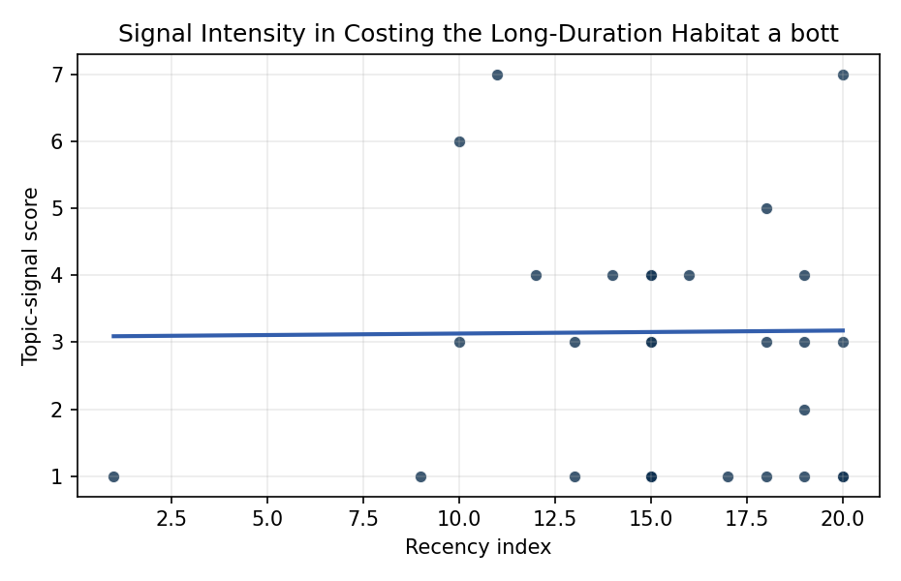
Figure 1. Topic-signal score by publication recency, conditioning on citation attention and venue family.

Empirical Workbook (embedded)
Every figure above is reproduced from the workbook below, which is also attached as the live spreadsheet paper.xlsx. Each observation carries its source.

Data (real observations)
doc_id | year_num | recency_index | cites_num | venue_score | title_words | snippet_words | keyword_count | theme_hits | signal_score | source
1 | 2014 | 9 | 0 | 1 | 7 | 14 | 4 | 0 | 1 | https://amostech.space/year/2014/emerging-technologies-small-satellite-and-associated-tped/
2 | 2017 | 12 | 0 | 1 | 4 | 13 | 2 | 2 | 4 | https://amostech.space/year/2017/space-warfighting-construct-prototyping/
3 | 2020 | 15 | 0 | 1 | 5 | 13 | 6 | 1 | 3 | https://amostech.space/year/2020/international-perspectives-on-space-weapons/
4 | 2015 | 10 | 0 | 1 | 10 | 14 | 7 | 2 | 6 | https://amostech.space/year/2015/improved-space-surveillance-network-ssn-scheduling-using-artificial-intelligence-techniques/
5 | 2015 | 10 | 0 | 1 | 11 | 14 | 6 | 1 | 3 | https://amostech.space/year/2015/automatic-rapid-replanning-of-satellite-operations-for-space-situational-awareness-ssa/
6 | 2025 | 20 | 0 | 1 | 13 | 14 | 5 | 0 | 1 | 10.64861/PTIC5794
7 | 2006 | 1 | 0 | 1 | 7 | 12 | 1 | 0 | 1 | https://amostech.space/year/2006/pan-starrs-ps1-published-science-products-subsystem/
8 | 2023 | 18 | 0 | 1 | 9 | 13 | 5 | 2 | 5 | 10.64861/XBHL5283
9 | 2024 | 19 | 0 | 1 | 12 | 14 | 5 | 0 | 1 | 10.64861/SYQO6621
10 | 2020 | 15 | 0 | 1 | 9 | 14 | 6 | 1 | 3 | https://amostech.space/year/2020/optimizing-daylight-performance-of-small-visible-nir-optical-systems/
11 | 2025 | 20 | 0 | 1 | 14 | 14 | 5 | 1 | 3 | 10.64861/CEPU7718
12 | 2022 | 17 | 0 | 1 | 7 | 13 | 3 | 0 | 1 | https://amostech.space/year/2022/u-s-commercial-space-regulation-the-rule-of-three/
13 | 2024 | 19 | 0 | 2 | 10 | 14 | 0 | 2 | 4 | 10.1016/j.actaastro.2024.09.058
14 | 2024 | 19 | 11 | 2 | 16 | 13 | 6 | 1 | 3 | 10.1016/j.actaastro.2024.11.060
15 | 2025 | 20 | 5 | 2 | 11 | 14 | 7 | 0 | 1 | 10.1016/j.actaastro.2025.04.041
16 | 2024 | 19 | 5 | 2 | 6 | 13 | 14 | 1 | 2 | 10.1016/j.actaastro.2024.04.041
17 | 2018 | 13 | 23 | 2 | 7 | 14 | 15 | 0 | 1 | 10.1016/j.actaastro.2018.11.054
18 | 2018 | 13 | 7 | 2 | 14 | 14 | 13 | 1 | 3 | 10.1016/j.actaastro.2018.06.035
19 | 2019 | 14 | 13 | 2 | 7 | 14 | 11 | 2 | 4 | 10.1016/j.actaastro.2019.05.049
20 | 2016 | 11 | 5 | 2 | 7 | 14 | 11 | 3 | 7 | 10.1016/j.actaastro.2016.10.007
21 | 2023 | 18 | 3 | 2 | 14 | 14 | 15 | 0 | 1 | 10.1016/j.actaastro.2023.04.023
22 | 2023 | 18 | 25 | 2 | 14 | 14 | 15 | 1 | 3 | 10.1016/j.actaastro.2023.07.009
23 | 2021 | 16 | 6 | 2 | 8 | 13 | 15 | 2 | 4 | 10.1016/j.actaastro.2021.06.051
24 | 2025 | 20 | 0 | 2 | 5 | 14 | 15 | 3 | 7 | 10.1016/j.actaastro.2025.10.029
25 | 2020 | 15 | 0 | 3 | 64 | 0 | 0 | 1 | 4 | Weinzierl (2018) provides a three-part economic framework for managing the development of the space economy, analyzing market establishment through decentralization, market failures (including space debris as a negative externality), and social objective regulation. Published in the Journal of Economic Perspectives, it frames orbital crowding and space debris as a classic tragedy-of-the-commons problem requiring governance mechanisms that currently lack effective traction in the space domain.
26 | 2020 | 15 | 0 | 3 | 4 | 0 | 0 | 0 | 1 | IRD Project Research Designs V2.0
27 | 2020 | 15 | 0 | 3 | 6 | 0 | 0 | 0 | 1 | Weinzierl 2018: Space the Final Economic Frontier
28 | 2020 | 15 | 0 | 3 | 10 | 0 | 0 | 0 | 1 | The Role of Space in Driving Sustainability, Security, and Development
29 | 2020 | 15 | 0 | 3 | 34 | 0 | 0 | 1 | 4 | MITRE/Aspen Institute (2022) whole-of-nation framework paper arguing that commercial, civil, and military space sectors share sustainability and governance challenges requiring unified U.S. leadership on norms, streamlined mission authorization, and sustained cross-sector coordination.
30 | 2020 | 15 | 0 | 3 | 7 | 0 | 0 | 0 | 1 | Space Environment Management: Framing Objectives and Priorities

Variable construction
Variable | Definition | Construction / source
signal_score | Composite topic-signal score for each retrieved source record | Deterministic count built from candidate-theme term hits in the source title, snippet, keyword field, and author metadata; each row cites the retrieved source in the source column
recency_index | Publication recency index | Computed as publication year minus the minimum publication year in the paper sample plus one
cites_num | Reported citation count in the local brain index | Parsed from the local brain search cites field; zero when the index reported no citation count
venue_score | Ordinal venue-family score | AMOS = 1, Acta Astronautica = 2, Space Economy = 3

Estimator output
Term | Coef. | Std. err. | t | p | 95% CI
const | 3.0855 | 1.6684 | 1.8494 | 0.0644 | [-0.1844, 6.3554]
recency_index | 0.0045 | 0.1007 | 0.0447 | 0.9644 | [-0.1928, 0.2018]
cites_num | -0.003 | 0.0408 | -0.0732 | 0.9417 | [-0.083, 0.077]
venue_score | -0.1909 | 0.4275 | -0.4465 | 0.6552 | [-1.0288, 0.647]
Fit: N = 30 R2 = 0.0064 R2_adj = -0.1083 F = 0.0714 F_p = 0.9747

