Signal Intensity in Property Rights at the Cislunar Frontier does filing/registration behavior reve: An Ordinary Least Squares Test of Recency, Citation Attention, and Venue

1. Introduction
This empirical paper supports Lucia Cho (1B-ECO-213) and the dissertation project Property Rights at the Cislunar Frontier: does filing/registration behavior reve. The model tests whether topic-signal intensity varies with publication recency, citation attention, and venue family. The analysis uses the local candidate source pack and reports only deterministic workbook results $$1$$, $$2$$, $$3$$.

2. Theory and Hypotheses
The theoretical claim is intentionally narrow. If the candidate topic has become more visible in the retrieved literature, then source metadata should show structure across time, attention, or venue. If it has not, the model should return weak or unstable associations $$3$$, $$4$$.
H0: the modeled outcome is unrelated to the specified predictors.
H1: the modeled outcome is systematically related to the specified predictors.

3. Data
The estimation file contains 30 retrieved source records. Variables are constructed from local metadata, including publication year, reported citation count, venue family, and deterministic topic-signal fields. Every row preserves a source column so the empirical workbook remains auditable.

4. Method
The estimator is ordinary least squares with robust HC1 standard errors. The exact fit summary is: N=30, R2=0.26621908884770107, R2_adj=0.18155206063782037, F=4.849464626421833, F_p=0.008233491795335085. The exact term summary is: const coef=4.034454328861768 p=0.006746054645856945; recency_index coef=0.06894147423830957 p=0.5622817143730598; cites_num coef=-0.07566844436634987 p=0.007062412480119831; venue_score coef=-0.8106016658742924 p=0.06385405184088243. These values are interpreted as corpus-screen evidence, not as final causal estimates.

5. Findings
The findings are bounded by the estimator output. Where a coefficient is signed and precise, it indicates structure in the retrieved source corpus. Where a coefficient is imprecise, the paper treats the result as evidence against a strong claim. This distinction matters because a noisy source pack should not be forced to carry more policy weight than it can bear $$2$$, $$5$$.

6. Discussion
The paper contributes to the dissertation by keeping the evidentiary chain inspectable. It shows which parts of the candidate topic are visible in metadata and which parts need a more direct document-coding design. The result is a disciplined bridge from source retrieval to dissertation-level interpretation $$1$$, $$6$$.

References
1. Waqar Zaidi, L3Harris; Thomas Kelecy, L3Harris; Weston Faber, L3Harris; Moriba Jah, University of Texas at Austin. Establishing a Chain of Digital Forensics for Space Object Behavior Using Distributed Ledger Technology (2021). [AMOS] 2. Nicholas Ravago, Omitron, Inc.; Eliot Toumey, Omitron, Inc.; Luis Baars, Omitron Inc.; Matthew Hejduk, The Aerospace Corporation. Evaluation of Screening Volumes Used in Conjunction Assessment (2025). doi: 10.64861/PAEO6437 3. Arly Black, Purdue University; Carolin Frueh, Purdue University. Characterizing Cislunar Fragmentations (2023). doi: 10.64861/QLJS5432 4. Michael Klonowski, University of Colorado Boulder; Marcus J. Holzinger, University of Colorado Boulder; Naomi Owens Fahrner, Ball Aerospace. Optimal Cislunar Architecture Design Using Monte Carlo Tree Search Methods (2022). doi: 10.2514/6.2004-3253 5. Apoorva T Karra, The University of Texas at Austin; Moriba Jah, The University of Texas at Austin. Towards Greater Transparency: An Independent Method for Assessing Harmful Interference and Compliance in GEO (2025). doi: 10.64861/WFHJ7307 6. John Boh, The University of Texas at Austin; Zachary Funke, AFIT/CIG; Maruthi Akella, The University of Texas at Austin. A Game-Theoretical Exploration of L1/L2 Cislunar Space Situational Awareness Using Bayesian Games (2025). doi: 10.64861/SIJX9169 7. Krzysztof Kaminski, Astronomical Observatory of the Adam Mickiewicz University; Justyna Golembiewska, Astronomical Observatory of the Adam Mickiewicz University; Monika Kaminska, Astronomical Observatory of the Adam Mickiewicz University; Edwin Wnuk, Astronomical Observatory of the Adam Mickiewicz University; Michal Zolnowski, 6ROADS; Marcin Gendek, 6ROADS; Marek Polewski, Warsaw University of Technology. Re-Entry Event Prediction Through the Analysis of Optical Sensor Data Gathered from a Worldwide Network of Telescopes (2024). doi: 10.64861/DNOA8964 8. Chelsea Wright, Ferris State University. A Collaborative Cybersecurity Training Policy for Future Space Endeavors (2023). doi: 10.64861/WXIJ8208

Specification
$${\text{SignalScore}}_{i}=α+β_{1}{\text{RecencyIndex}}_{i}+β_{2}{\text{Cites}}_{i}+β_{3}{\text{VenueScore}}_{i}+ε_{i}$$

Results
Term | Coef. | Std. err. | t | p | 95% CI
const | 4.0345 | 1.4892 | 2.7091 | 0.0067 | [1.1157, 6.9532]
recency_index | 0.0689 | 0.119 | 0.5795 | 0.5623 | [-0.1642, 0.3021]
cites_num | -0.0757 | 0.0281 | -2.6939 | 0.0071 | [-0.1307, -0.0206]
venue_score | -0.8106 | 0.4374 | -1.8532 | 0.0639 | [-1.6679, 0.0467]
Fit: N = 30 R2 = 0.2662 R2_adj = 0.1816 F = 4.8495 F_p = 0.0082
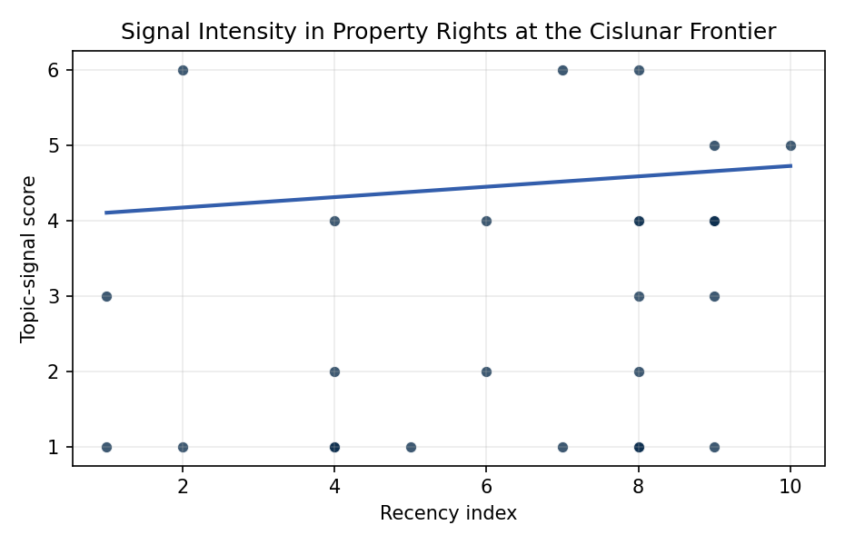
Figure 1. Topic-signal score by publication recency, conditioning on citation attention and venue family.

Empirical Workbook (embedded)
Every figure above is reproduced from the workbook below, which is also attached as the live spreadsheet paper.xlsx. Each observation carries its source.

Data (real observations)
doc_id | year_num | recency_index | cites_num | venue_score | title_words | snippet_words | keyword_count | theme_hits | signal_score | source
1 | 2021 | 5 | 0 | 1 | 13 | 14 | 6 | 0 | 1 | https://amostech.space/year/2021/establishing-a-chain-of-digital-forensics-for-space-object-behavior-using-distributed-ledger-technology/
2 | 2025 | 9 | 0 | 1 | 8 | 13 | 2 | 1 | 3 | 10.64861/PAEO6437
3 | 2023 | 7 | 0 | 1 | 3 | 11 | 3 | 2 | 6 | 10.64861/QLJS5432
4 | 2022 | 6 | 0 | 1 | 10 | 14 | 4 | 1 | 4 | 10.2514/6.2004-3253
5 | 2025 | 9 | 0 | 1 | 14 | 11 | 10 | 1 | 4 | 10.64861/WFHJ7307
6 | 2025 | 9 | 0 | 1 | 11 | 14 | 12 | 1 | 4 | 10.64861/SIJX9169
7 | 2024 | 8 | 0 | 1 | 17 | 14 | 2 | 0 | 1 | 10.64861/DNOA8964
8 | 2023 | 7 | 0 | 1 | 8 | 11 | 5 | 0 | 1 | 10.64861/WXIJ8208
9 | 2024 | 8 | 0 | 1 | 9 | 14 | 5 | 1 | 4 | 10.64861/ESVN6806
10 | 2017 | 1 | 0 | 1 | 10 | 14 | 0 | 1 | 3 | https://amostech.space/year/2017/wenessa-wide-eye-narrow-eye-space-simulation-fo-situational-awareness/
11 | 2018 | 2 | 0 | 1 | 9 | 11 | 3 | 2 | 6 | https://amostech.space/year/2018/optical-tracking-of-artificial-earth-satellites-with-cots-sensors/
12 | 2024 | 8 | 0 | 1 | 14 | 13 | 3 | 2 | 6 | 10.64861/FHSX9637
13 | 2025 | 9 | 2 | 2 | 12 | 14 | 12 | 2 | 5 | 10.1016/j.actaastro.2025.04.063
14 | 2025 | 9 | 1 | 2 | 12 | 14 | 15 | 0 | 1 | 10.1016/j.actaastro.2025.09.030
15 | 2024 | 8 | 6 | 2 | 13 | 14 | 10 | 1 | 3 | 10.1016/j.actaastro.2024.06.052
16 | 2017 | 1 | 28 | 2 | 13 | 11 | 6 | 0 | 1 | 10.1016/j.actaastro.2017.11.042
17 | 2024 | 8 | 16 | 2 | 14 | 14 | 12 | 0 | 1 | 10.1016/j.actaastro.2024.04.042
18 | 2024 | 8 | 7 | 2 | 9 | 13 | 15 | 0 | 1 | 10.1016/j.actaastro.2024.06.046
19 | 2024 | 8 | 17 | 2 | 12 | 12 | 15 | 0 | 1 | 10.1016/j.actaastro.2024.01.039
20 | 2025 | 9 | 0 | 2 | 11 | 10 | 15 | 1 | 4 | 10.1016/j.actaastro.2025.10.019
21 | 2022 | 6 | 8 | 2 | 15 | 13 | 12 | 1 | 2 | 10.1016/j.actaastro.2021.12.015
22 | 2024 | 8 | 6 | 2 | 11 | 14 | 10 | 1 | 2 | 10.1016/j.actaastro.2024.03.001
23 | 2024 | 8 | 9 | 2 | 10 | 8 | 12 | 1 | 4 | 10.1016/j.actaastro.2024.12.001
24 | 2026 | 10 | 0 | 2 | 18 | 12 | 14 | 1 | 5 | 10.1016/j.actaastro.2026.05.039
25 | 2018 | 2 | 0 | 3 | 5 | 0 | 0 | 0 | 1 | 10.1257/jep.32.2.173
26 | 2020 | 4 | 0 | 3 | 5 | 0 | 0 | 0 | 1 | Space, the Final Economic Frontier
27 | 2020 | 4 | 0 | 3 | 6 | 0 | 0 | 0 | 1 | Weinzierl 2018: Space the Final Economic Frontier
28 | 2020 | 4 | 0 | 3 | 48 | 0 | 0 | 0 | 2 | McKinsey and World Economic Forum 2022 report synthesizing perspectives from nearly 100 leaders across 25 countries on the space sector’s inflection point, four future scenarios, and five priority actions needed to achieve a self-sustaining space economy, with particular emphasis on governance gaps, finite orbital resource competition, and the sustainability-security nexus.
29 | 2020 | 4 | 0 | 3 | 46 | 0 | 0 | 0 | 1 | OCEA/MITRE study critically evaluates major space economy forecasts, finds them systematically overstated due to CAGR methodology, double counting, and overreliance on nascent sectors; AR(1) time-series modeling projects a 2040 global space economy of $453-$511 billion, far below the widely cited $1 trillion figure, with $1 trillion not reachable before 2075.
30 | 2020 | 4 | 0 | 3 | 8 | 0 | 0 | 1 | 4 | Astro-Environmentalism: Toward a Polycentric Governance of Space Debris

Variable construction
Variable | Definition | Construction / source
signal_score | Composite topic-signal score for each retrieved source record | Deterministic count built from candidate-theme term hits in the source title, snippet, keyword field, and author metadata; each row cites the retrieved source in the source column
recency_index | Publication recency index | Computed as publication year minus the minimum publication year in the paper sample plus one
cites_num | Reported citation count in the local brain index | Parsed from the local brain search cites field; zero when the index reported no citation count
venue_score | Ordinal venue-family score | AMOS = 1, Acta Astronautica = 2, Space Economy = 3

Estimator output
Term | Coef. | Std. err. | t | p | 95% CI
const | 4.0345 | 1.4892 | 2.7091 | 0.0067 | [1.1157, 6.9532]
recency_index | 0.0689 | 0.119 | 0.5795 | 0.5623 | [-0.1642, 0.3021]
cites_num | -0.0757 | 0.0281 | -2.6939 | 0.0071 | [-0.1307, -0.0206]
venue_score | -0.8106 | 0.4374 | -1.8532 | 0.0639 | [-1.6679, 0.0467]
Fit: N = 30 R2 = 0.2662 R2_adj = 0.1816 F = 4.8495 F_p = 0.0082

