Attention Accumulation in Following the Money into the Mission do venture and de-SPAC capital flows predi: A Learning-Curve Analysis of Citation Growth by Article Age

1. Introduction
This empirical paper supports Rohan Heinz (1B-ECO-186) and the dissertation project Following the Money into the Mission: do venture and de-SPAC capital flows predi. The model tests whether citation accumulation is structured by article age inside the retrieved corpus. The analysis uses the local candidate source pack and reports only deterministic workbook results $$1$$, $$2$$, $$3$$.

2. Theory and Hypotheses
The theoretical claim is intentionally narrow. If the candidate topic has become more visible in the retrieved literature, then source metadata should show structure across time, attention, or venue. If it has not, the model should return weak or unstable associations $$3$$, $$4$$.
H0: the modeled outcome is unrelated to the specified predictors.
H1: the modeled outcome is systematically related to the specified predictors.

3. Data
The estimation file contains 30 retrieved source records. Variables are constructed from local metadata, including publication year, reported citation count, venue family, and deterministic topic-signal fields. Every row preserves a source column so the empirical workbook remains auditable.

4. Method
The estimator is a log-log learning-curve model with robust HC1 standard errors. The exact fit summary is: N=30, R2=0.004795362835234074, elasticity_b=0.12495842028053097, progress_ratio_2^b=1.0904763037416725. The exact term summary is: const coef=0.5532412512328643 p=0.12129195534772774; _ln_x coef=0.12495842028053097 p=0.6427437957387345. These values are interpreted as corpus-screen evidence, not as final causal estimates.

5. Findings
The findings are bounded by the estimator output. Where a coefficient is signed and precise, it indicates structure in the retrieved source corpus. Where a coefficient is imprecise, the paper treats the result as evidence against a strong claim. This distinction matters because a noisy source pack should not be forced to carry more policy weight than it can bear $$2$$, $$5$$.

6. Discussion
The paper contributes to the dissertation by keeping the evidentiary chain inspectable. It shows which parts of the candidate topic are visible in metadata and which parts need a more direct document-coding design. The result is a disciplined bridge from source retrieval to dissertation-level interpretation $$1$$, $$6$$.

References
1. Makena Young, Center for Strategic and International Studies; Akhil Thadani, Center for Strategic and International Studies. Low-Orbit, High Stakes: Winning the LEO Broadband Competition (2022). [AMOS] 2. Eric Felt, Space Vehicles Directorate, Air Force Research Laboratory; Timothy Sejba, Advanced Systems and Development Directorate, Space & Missile Systems Center. S&T Challenges of SSA Sensor Proliferation (2018). [AMOS] 3. Michael C. Roggemann (Pacific Defense Solutions, LLC), Dennis Douglas (Pacific Defense Solutions, LLC), Eric Therkildsen (Pacific Defense Solutions, LLC), David Archambeault (Pacific Defense Solutions, LLC), Riki Maeda (Pacific Defense Solutions, LLC), David Schultz (Pacific Defense Solutions, LLC), Ben Wheeler (Pacific Defense Solutions, LLC). Daytime Image Measurement and Reconstruction for Space Situational Awareness Applications (2010). [AMOS] 4. Jeffrey Hollon, Applied Optimization, Inc.; Kimberly Kinateder, Applied Optimization; Victoria Carone, Applied Optimization, Inc.; Tamara Payne, Applied Optimization, Inc.; Markus Ernst, Applied Optimization, Inc.; Phan Dao, Applied Optimization Inc.; Charles J. Wetterer, KBR; Stephen Gregory, Stephen A. Gregory, LLC; Anthony Dentamaro, Anthony Dentamaro, LLC; James Frith, AFRL/RVSW; Scott Milster, AFRL/RVSW. Space Object Identification and Change Detection Methods for the Cislunar Orbit Regime (2022). [AMOS] 5. William McShane (Lockheed Martin). Integrated Net-Centric Data for a New Space Protection Paradigm (2012). [AMOS] 6. Connor Segal, EO Solutions & Virginia Polytechnic Institute and State University; Kevin Schroeder, Virginia Polytechnic Institute and State University. Enhancing Ground-Based Cislunar SDA: Reducing Search Area for Monitoring Small-Maneuver Earth Return Trajectories Using Poincaré Maps (2025). doi: 10.64861/ACKU6440 7. Sandra Magnus, Office of Space Commerce; Matthew Hejduk, Aerospace; Jessica Johnson, MIT Lincoln Laboratory; John Giles, MITRE Corporation; Anna Parikka, Global Science & Technology, Inc.; Christine Joseph, Office of Space Commerce; Carson Coursey, The Aerospace Corporation; Miles Lifson, The Aerospace Corporation; André Antunes de Sá, Kayhan Space; Denna Baker, LeoLabs, Inc.; Matthew Duncan, SpaceNav; Conner Grey, Slingshot Aerospace; Robert Hall, COMSPOC Corporation; Samantha Johnson, LeoLabs, Inc.; Pol Mesalles-Ripoll, SpaceNav; Daniel Oltrogge, COMSPOC Corporation; Jason Stauch, Slingshot Aerospace; Derek Strobel, Kayhan Space. The TraCSS Consolidated Pathfinder: Leveraging Commercial Capability in LEO (2024). doi: 10.64861/BAJJ5826 8. Raymond Wright, BAE Systems; Naomi Owens-Fahrner, BAE Systems; Luke Tafur, BAE Systems; Joshua Wysack, BAE Systems. Applications of Poincare Search Maps for Space-Based Cislunar SDA Detection (2024). doi: 10.64861/UAMB9924

Specification
$$ln({\text{CitesPlus1}}_{i})=α+β_{1}ln({\text{AgeIndex}}_{i})+ε_{i}$$

Results
Term | Coef. | Std. err. | t | p | 95% CI
const | 0.5532 | 0.3571 | 1.5494 | 0.1213 | [-0.1466, 1.2531]
_ln_x | 0.125 | 0.2694 | 0.4639 | 0.6427 | [-0.403, 0.6529]
Fit: N = 30 R2 = 0.0048 elasticity_b = 0.125 progress_ratio_2^b = 1.0905
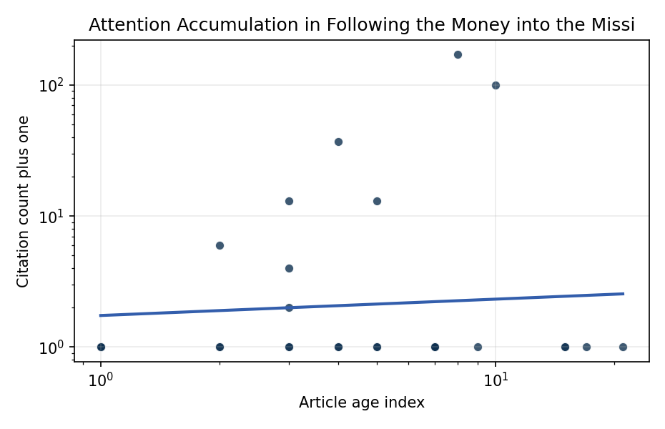
Figure 1. Citation accumulation against article age in the retrieved topic literature.

Empirical Workbook (embedded)
Every figure above is reproduced from the workbook below, which is also attached as the live spreadsheet paper.xlsx. Each observation carries its source.

Data (real observations)
doc_id | year_num | age_index | cites_num | cites_plus1 | signal_score | source
1 | 2022 | 5 | 0 | 1 | 1 | https://amostech.space/year/2022/low-orbit-high-stakes-winning-the-leo-broadband-competition/
2 | 2018 | 9 | 0 | 1 | 3 | https://amostech.space/year/2018/st-challenges-of-ssa-sensor-proliferation/
3 | 2010 | 17 | 0 | 1 | 1 | https://amostech.space/year/2010/daytime-image-measurement-and-reconstruction-for-space-situational-awareness-applications/
4 | 2022 | 5 | 0 | 1 | 2 | https://amostech.space/year/2022/space-object-identification-and-change-detection-methods-for-the-cislunar-orbit-regime/
5 | 2012 | 15 | 0 | 1 | 1 | https://amostech.space/year/2012/integrated-net-centric-data-for-a-new-space-protection-paradigm/
6 | 2025 | 2 | 0 | 1 | 8 | 10.64861/ACKU6440
7 | 2024 | 3 | 0 | 1 | 8 | 10.64861/BAJJ5826
8 | 2024 | 3 | 0 | 1 | 11 | 10.64861/UAMB9924
9 | 2012 | 15 | 0 | 1 | 2 | https://amostech.space/year/2012/physical-characterization-studies-of-near-earth-object-spacecraft-mission-targets/
10 | 2023 | 4 | 0 | 1 | 3 | 10.64861/KYFU6858
11 | 2023 | 4 | 0 | 1 | 1 | 10.64861/WXIJ8208
12 | 2006 | 21 | 0 | 1 | 1 | https://amostech.space/year/2006/adaptive-beam-director-for-a-tiled-fiber-array/
13 | 2023 | 4 | 36 | 37 | 3 | 10.1016/j.actaastro.2023.05.001
14 | 2025 | 2 | 0 | 1 | 3 | 10.1016/j.actaastro.2025.11.006
15 | 2024 | 3 | 12 | 13 | 4 | 10.1016/j.actaastro.2024.09.005
16 | 2026 | 1 | 0 | 1 | 1 | 10.1016/j.actaastro.2026.03.026
17 | 2019 | 8 | 170 | 171 | 1 | 10.1016/j.actaastro.2019.08.031
18 | 2026 | 1 | 0 | 1 | 1 | 10.1016/j.actaastro.2026.04.012
19 | 2024 | 3 | 3 | 4 | 1 | 10.1016/j.actaastro.2024.06.001
20 | 2022 | 5 | 12 | 13 | 1 | 10.1016/j.actaastro.2022.03.035
21 | 2026 | 1 | 0 | 1 | 4 | 10.1016/j.actaastro.2026.01.045
22 | 2024 | 3 | 1 | 2 | 4 | 10.1016/j.actaastro.2024.06.049
23 | 2025 | 2 | 5 | 6 | 5 | 10.1016/j.actaastro.2024.12.056
24 | 2017 | 10 | 99 | 100 | 1 | 10.1016/j.actaastro.2017.04.034
25 | 2020 | 7 | 0 | 1 | 1 | Economic Statecraft Literature Review
26 | 2020 | 7 | 0 | 1 | 1 | SFA Space Economy and Integrated Deterrence
27 | 2020 | 7 | 0 | 1 | 3 | Roadmap: Australia Economic-Technological Renaissance in Space
28 | 2020 | 7 | 0 | 1 | 1 | The Role of Space in Driving Sustainability, Security, and Development
29 | 2020 | 7 | 0 | 1 | 5 | A 2021 Johns Hopkins SAIS doctoral thesis by Nathaniel Dailey proposing an International Space Reference Architecture (ISRA) as a socio-technological transformative mechanism to resolve contemporary space governance failures – orbital debris, policy fragmentation, and space traffic management – by coupling enterprise architecture methodology with international relations constructivist theory, blockchain-enabled information sharing, and norms entrepreneurship.
30 | 2020 | 7 | 0 | 1 | 1 | Leveraging Circular Economy for Space Sustainability

Variable construction
Variable | Definition | Construction / source
cites_plus1 | Citation count plus one | Computed as the reported citation count from the local brain index plus one so the log transformation is defined for uncited records
age_index | Document age index | Computed as 2026 minus publication year plus one

Estimator output
Term | Coef. | Std. err. | t | p | 95% CI
const | 0.5532 | 0.3571 | 1.5494 | 0.1213 | [-0.1466, 1.2531]
_ln_x | 0.125 | 0.2694 | 0.4639 | 0.6427 | [-0.403, 0.6529]
Fit: N = 30 R2 = 0.0048 elasticity_b = 0.125 progress_ratio_2^b = 1.0905

