Signal Intensity in Carrying Capacity as an Economic Limit estimating the rent-maximizing satellite: An Ordinary Least Squares Test of Recency, Citation Attention, and Venue

1. Introduction
This empirical paper supports Nia Haddad (1B-ECO-227) and the dissertation project Carrying Capacity as an Economic Limit: estimating the rent-maximizing satellite. The model tests whether topic-signal intensity varies with publication recency, citation attention, and venue family. The analysis uses the local candidate source pack and reports only deterministic workbook results $$1$$, $$2$$, $$3$$.

2. Theory and Hypotheses
The theoretical claim is intentionally narrow. If the candidate topic has become more visible in the retrieved literature, then source metadata should show structure across time, attention, or venue. If it has not, the model should return weak or unstable associations $$3$$, $$4$$.
H0: the modeled outcome is unrelated to the specified predictors.
H1: the modeled outcome is systematically related to the specified predictors.

3. Data
The estimation file contains 30 retrieved source records. Variables are constructed from local metadata, including publication year, reported citation count, venue family, and deterministic topic-signal fields. Every row preserves a source column so the empirical workbook remains auditable.

4. Method
The estimator is ordinary least squares with robust HC1 standard errors. The exact fit summary is: N=30, R2=0.09377360954310765, R2_adj=-0.010790973971149143, F=1.0027852584531523, F_p=0.4072926491859611. The exact term summary is: const coef=6.6598603109671055 p=0.0036622939620990207; recency_index coef=-0.06979821889866827 p=0.704169942323762; cites_num coef=-0.04235406257237981 p=0.525858943866395; venue_score coef=-1.0459507585995826 p=0.1976185857303132. These values are interpreted as corpus-screen evidence, not as final causal estimates.

5. Findings
The findings are bounded by the estimator output. Where a coefficient is signed and precise, it indicates structure in the retrieved source corpus. Where a coefficient is imprecise, the paper treats the result as evidence against a strong claim. This distinction matters because a noisy source pack should not be forced to carry more policy weight than it can bear $$2$$, $$5$$.

6. Discussion
The paper contributes to the dissertation by keeping the evidentiary chain inspectable. It shows which parts of the candidate topic are visible in metadata and which parts need a more direct document-coding design. The result is a disciplined bridge from source retrieval to dissertation-level interpretation $$1$$, $$6$$.

References
1. Mark A. Sturza, Viasat, Inc.; Mark D. Dankberg, Viasat, Inc.; William N. Blount, Viasat, Inc.. LEO Capacity Modeling for Sustainable Design (2022). [AMOS] 2. Andrea D’Ambrosio, Massachusetts Institute of Technology; Miles Lifson, Massachusetts Institute of Technology; Daniel Jang, Massachusetts Institute of Technology; Celina Pasiecznik, Massachusetts Institute of Technology; Richard Linares, Massachusetts Institute of Technology. Projected Orbital Demand and LEO Environmental Capacity (2022). [AMOS] 3. Mark Sturza, Viasat; Mark Dankberg, Viasat; William Blount, Viasat. Resilience of LEO Constellations to Accidental and Intentional Fragmentation Events (2024). doi: 10.64861/ZFDQ4641 4. Indigo Brownhall, University College London; Miles Lifson, The Aerospace Corporation; Giovanni Lavezzi, Massachusetts Institute of Technology; Enrico Zucchelli, Massachusetts Institute of Technology; Mark Moretto, North Carolina State University; Santosh Bhattarai, University College London; Richard Linares, Massachusetts Institute of Technology. Verification and Validation of Orbital Capacity Assessment Tools of Varying Fidelities (2025). doi: 10.64861/UHIX1013 5. Harvey Reed, MITRE; Nathaniel Dailey, MITRE; Ruth Stilwell, Aerospace Policy Solutions, LLC; Brian Weeden, Secure World Foundation. Decentralized Space Information Sharing as a Key Enabler of Trust and the Preservation of Space (2021). [AMOS] 6. Kristin Shahady, University of North Dakota. The Future Risk of Space Debris and Contested Environments Increases the Intrinsic and Actual Cost of GEO Slots (2023). doi: 10.64861/DYBG6563 7. Krzysztof Arminski, Polish Space Agency; Tomasz Zubowicz, Polish Space Agency; Stefania Wolf, Polish Space Agency; Mikolaj Kruzynski, Polish Space Agency; Zygmunt Anio?, Polish Space Agency; Tymoteusz Trocki, POLSA; Edwin Wnuk, Polish Space Agency. A multi-objective approach to the optimal selection of assets for the design of an optical sensor network (2023). doi: 10.64861/EZRE5509 8. Ryan D. Coder, (Georgia Institute of Technology), Marcus J. Holzinger, (Georgia Institute of Technology). Sizing of a Raven-class Telescope Using Performance Sensitivities (2013). [AMOS]

Specification
$${\text{SignalScore}}_{i}=α+β_{1}{\text{RecencyIndex}}_{i}+β_{2}{\text{Cites}}_{i}+β_{3}{\text{VenueScore}}_{i}+ε_{i}$$

Results
Term | Coef. | Std. err. | t | p | 95% CI
const | 6.6599 | 2.2919 | 2.9059 | 0.0037 | [2.1679, 11.1518]
recency_index | -0.0698 | 0.1838 | -0.3797 | 0.7042 | [-0.4301, 0.2905]
cites_num | -0.0424 | 0.0668 | -0.6343 | 0.5259 | [-0.1732, 0.0885]
venue_score | -1.046 | 0.8118 | -1.2884 | 0.1976 | [-2.6371, 0.5452]
Fit: N = 30 R2 = 0.0938 R2_adj = -0.0108 F = 1.0028 F_p = 0.4073
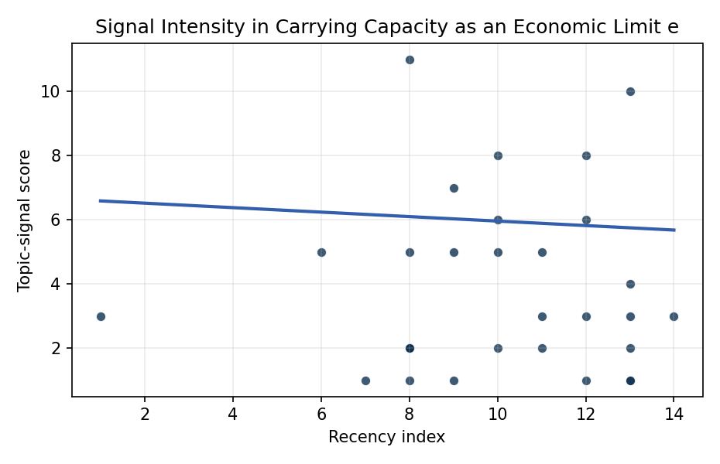
Figure 1. Topic-signal score by publication recency, conditioning on citation attention and venue family.

Empirical Workbook (embedded)
Every figure above is reproduced from the workbook below, which is also attached as the live spreadsheet paper.xlsx. Each observation carries its source.

Data (real observations)
doc_id | year_num | recency_index | cites_num | venue_score | title_words | snippet_words | keyword_count | theme_hits | signal_score | source
1 | 2022 | 10 | 0 | 1 | 6 | 14 | 6 | 3 | 8 | https://amostech.space/year/2022/leo-capacity-modeling-for-sustainable-design/
2 | 2022 | 10 | 0 | 1 | 7 | 14 | 5 | 2 | 5 | https://amostech.space/year/2022/projected-orbital-demand-and-leo-environmental-capacity/
3 | 2024 | 12 | 0 | 1 | 10 | 13 | 7 | 3 | 8 | 10.64861/ZFDQ4641
4 | 2025 | 13 | 0 | 1 | 11 | 14 | 4 | 4 | 10 | 10.64861/UHIX1013
5 | 2021 | 9 | 0 | 1 | 14 | 14 | 7 | 3 | 7 | https://amostech.space/year/2021/decentralized-space-information-sharing-as-a-key-enabler-of-trust-and-the-preservation-of-space/
6 | 2023 | 11 | 0 | 1 | 18 | 13 | 3 | 1 | 3 | 10.64861/DYBG6563
7 | 2023 | 11 | 0 | 1 | 17 | 14 | 4 | 1 | 2 | 10.64861/EZRE5509
8 | 2013 | 1 | 0 | 1 | 8 | 14 | 3 | 1 | 3 | https://amostech.space/year/2013/sizing-of-a-raven-class-telescope-using-performance-sensitivities/
9 | 2022 | 10 | 0 | 1 | 8 | 12 | 4 | 2 | 6 | https://amostech.space/year/2022/capacity-based-cislunar-space-domain-awareness-architecture-optimization/
10 | 2025 | 13 | 0 | 1 | 14 | 14 | 6 | 0 | 1 | 10.64861/DDFP2152
11 | 2023 | 11 | 0 | 1 | 14 | 14 | 6 | 2 | 5 | 10.64861/CKGQ5448
12 | 2024 | 12 | 0 | 1 | 12 | 14 | 5 | 2 | 6 | 10.64861/SYQO6621
13 | 2025 | 13 | 5 | 2 | 10 | 11 | 4 | 2 | 4 | 10.1016/j.actaastro.2025.01.069
14 | 2024 | 12 | 8 | 2 | 7 | 14 | 11 | 1 | 3 | 10.1016/j.actaastro.2024.07.022
15 | 2026 | 14 | 0 | 2 | 20 | 14 | 15 | 1 | 3 | 10.1016/j.actaastro.2026.04.012
16 | 2025 | 13 | 0 | 2 | 7 | 14 | 10 | 1 | 3 | 10.1016/j.actaastro.2025.11.006
17 | 2024 | 12 | 8 | 2 | 11 | 14 | 12 | 0 | 1 | 10.1016/j.actaastro.2024.05.018
18 | 2022 | 10 | 17 | 2 | 16 | 13 | 10 | 1 | 2 | 10.1016/j.actaastro.2022.05.022
19 | 2025 | 13 | 1 | 2 | 16 | 16 | 15 | 0 | 1 | 10.1016/j.actaastro.2025.10.028
20 | 2019 | 7 | 4 | 2 | 11 | 14 | 12 | 0 | 1 | 10.1016/j.actaastro.2019.11.029
21 | 2021 | 9 | 17 | 2 | 9 | 14 | 15 | 2 | 5 | 10.1016/j.actaastro.2021.01.009
22 | 2018 | 6 | 27 | 2 | 16 | 13 | 15 | 2 | 5 | 10.1016/j.actaastro.2018.05.040
23 | 2025 | 13 | 1 | 2 | 13 | 13 | 5 | 1 | 2 | 10.1016/j.actaastro.2025.03.025
24 | 2021 | 9 | 12 | 2 | 11 | 14 | 15 | 0 | 1 | 10.1016/j.actaastro.2021.01.050
25 | 2020 | 8 | 0 | 3 | 53 | 0 | 0 | 4 | 11 | Dailey et al. (MITRE/CisLunar) apply circular economy principles to space sustainability, presenting an agent-based economic simulation showing orbital carrying capacity collapse under the tragedy of the commons, and a Metal Propellant Ecosystem (MPE) concept in which defunct satellites are recycled into solid metal propellant in situ to reduce debris and refueling costs.
26 | 2020 | 8 | 0 | 3 | 41 | 0 | 0 | 0 | 2 | Stilwell et al. (ASCEND 2025) propose a policy-based orbital classification framework for LEO that draws on aviation airspace classification to establish performance-based entry requirements tied to congestion and collision risk, supported by econometric analysis of satellite-dependent Fortune 500/100 company financial impacts.
27 | 2020 | 8 | 0 | 3 | 6 | 0 | 0 | 0 | 1 | Stilwell et al ASCEND 2025 Orbital Classification
28 | 2020 | 8 | 0 | 3 | 7 | 0 | 0 | 1 | 2 | LEO Capacity Modeling for Sustainable Design (AMOS)
29 | 2020 | 8 | 0 | 3 | 4 | 0 | 0 | 1 | 2 | Stilwell IAC 2024 Orbital Capacity
30 | 2020 | 8 | 0 | 3 | 7 | 0 | 0 | 2 | 5 | Roadmap: Australia Economic-Technological Renaissance in Space

Variable construction
Variable | Definition | Construction / source
signal_score | Composite topic-signal score for each retrieved source record | Deterministic count built from candidate-theme term hits in the source title, snippet, keyword field, and author metadata; each row cites the retrieved source in the source column
recency_index | Publication recency index | Computed as publication year minus the minimum publication year in the paper sample plus one
cites_num | Reported citation count in the local brain index | Parsed from the local brain search cites field; zero when the index reported no citation count
venue_score | Ordinal venue-family score | AMOS = 1, Acta Astronautica = 2, Space Economy = 3

Estimator output
Term | Coef. | Std. err. | t | p | 95% CI
const | 6.6599 | 2.2919 | 2.9059 | 0.0037 | [2.1679, 11.1518]
recency_index | -0.0698 | 0.1838 | -0.3797 | 0.7042 | [-0.4301, 0.2905]
cites_num | -0.0424 | 0.0668 | -0.6343 | 0.5259 | [-0.1732, 0.0885]
venue_score | -1.046 | 0.8118 | -1.2884 | 0.1976 | [-2.6371, 0.5452]
Fit: N = 30 R2 = 0.0938 R2_adj = -0.0108 F = 1.0028 F_p = 0.4073

