Attention Accumulation in The Insurance Mirror do space-insurance premiums price orbital-debris risk befo: A Learning-Curve Analysis of Citation Growth by Article Age

1. Introduction
This empirical paper supports Nikolai Yates (1B-ECO-204) and the dissertation project The Insurance Mirror: do space-insurance premiums price orbital-debris risk befo. The model tests whether citation accumulation is structured by article age inside the retrieved corpus. The analysis uses the local candidate source pack and reports only deterministic workbook results $$1$$, $$2$$, $$3$$.

2. Theory and Hypotheses
The theoretical claim is intentionally narrow. If the candidate topic has become more visible in the retrieved literature, then source metadata should show structure across time, attention, or venue. If it has not, the model should return weak or unstable associations $$3$$, $$4$$.
H0: the modeled outcome is unrelated to the specified predictors.
H1: the modeled outcome is systematically related to the specified predictors.

3. Data
The estimation file contains 30 retrieved source records. Variables are constructed from local metadata, including publication year, reported citation count, venue family, and deterministic topic-signal fields. Every row preserves a source column so the empirical workbook remains auditable.

4. Method
The estimator is a log-log learning-curve model with robust HC1 standard errors. The exact fit summary is: N=30, R2=0.020004824610425853, elasticity_b=-0.20652419038636552, progress_ratio_2^b=0.8666226266950048. The exact term summary is: const coef=1.064019627806907 p=0.004354493651082429; _ln_x coef=-0.20652419038636552 p=0.3142265986862943. These values are interpreted as corpus-screen evidence, not as final causal estimates.

5. Findings
The findings are bounded by the estimator output. Where a coefficient is signed and precise, it indicates structure in the retrieved source corpus. Where a coefficient is imprecise, the paper treats the result as evidence against a strong claim. This distinction matters because a noisy source pack should not be forced to carry more policy weight than it can bear $$2$$, $$5$$.

6. Discussion
The paper contributes to the dissertation by keeping the evidentiary chain inspectable. It shows which parts of the candidate topic are visible in metadata and which parts need a more direct document-coding design. The result is a disciplined bridge from source retrieval to dissertation-level interpretation $$1$$, $$6$$.

References
1. Todd Harrison, Center for Strategic and International Studies. International Perspectives on Space Weapons (2020). [AMOS] 2. Dr. Darren McKnight (Integrity Applications Inc.). Pay Me Now or Pay Me More Later: Start the Development of Active Orbital Debris Removal Now (2010). [AMOS] 3. Kristin Shahady, University of North Dakota. The Future Risk of Space Debris and Contested Environments Increases the Intrinsic and Actual Cost of GEO Slots (2023). doi: 10.64861/DYBG6563 4. Selma Zamoum, SpaceAble France; Thomas Husson, SpaceAble France; Fatoumata Kebe, SpaceAble France; Mathieu Barthélémy, IPAG-OSUG/CSUG; Benjamin Gigleux, SpaceAble France; Jacques Sombrin, TéSA Laboratory; Franck Durand-Carrier, TéSA Laboratory and CNES. A Complete SSA Scheme for a Sustainable Low Earth Orbit: Space Data Aggregation and IA Combined with In-orbit Inspection (2021). [AMOS] 5. Yasir Latif, Space Protocol; Samya Bagchi, Space Protocol; Latha Madhuri Pratti, Space Protocol; Harvey Reed, MITRE; Ruth Stilwell, Aerospace Policy Solutions, LLC; Greg Furlich, University of Colorado Boulder. Towards an AI-enabled Space Battle Management System on Space Protocol’s Quantum Resilient Blockchain (2025). doi: 10.64861/CEPU7718 6. Yasir Latif, Space Protocol; Anirban Chowdhury, Space Protocol; Samya Bagchi, Space Protocol. On-chain Validation of Tracking Data Messages (TDM) Using Distributed Deep Learning on a Proof of Stake (PoS) Blockchain (2024). doi: 10.64861/OHUO6863 7. Mark Ackermann, Sandia National Laboratories, David Cox, Sandia National Laboratories, John McGraw, J.T. McGraw & Associates, Peter Zimmer, J.T. McGraw & Associates. Lens and Camera Arrays for Sky Surveys and Space Surveillance (2016). [AMOS] 8. David Wick (Sandia National Laboratories), Brett E. Bagwell (Sandia National Laboratories), William C. Sweatt (Sandia National Laboratories), William D. Cowan (Sandia National Laboratories), Olga B. Spahn (Sandia National Laboratories), Gary L. Peterson (Breault Research Organization), Ty Martinez (Naval Research Laboratory, c/oAFRL/DES), Sergio R. Restaino (Naval Research Laboratory, c/oAFRL/DES), Jonathan R. Andrews (Naval Research Laboratory, c/oAFRL/DES), Christopher C. Wilcox (Naval Research Laboratory, c/oAFRL/DES), Don M. Payne (Narrascape), Robert Romeo (Composite Mirror Applications, Inc.). Lightweight, Active Optics for Space and Near Space (2006). [AMOS]

Specification
$$ln({\text{CitesPlus1}}_{i})=α+β_{1}ln({\text{AgeIndex}}_{i})+ε_{i}$$

Results
Term | Coef. | Std. err. | t | p | 95% CI
const | 1.064 | 0.3732 | 2.8513 | 0.0044 | [0.3326, 1.7954]
_ln_x | -0.2065 | 0.2052 | -1.0064 | 0.3142 | [-0.6087, 0.1957]
Fit: N = 30 R2 = 0.02 elasticity_b = -0.2065 progress_ratio_2^b = 0.8666
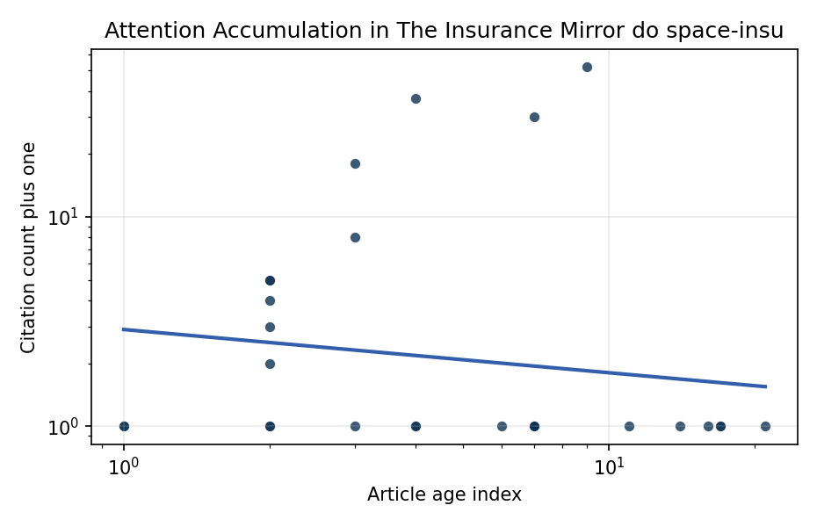
Figure 1. Citation accumulation against article age in the retrieved topic literature.

Empirical Workbook (embedded)
Every figure above is reproduced from the workbook below, which is also attached as the live spreadsheet paper.xlsx. Each observation carries its source.

Data (real observations)
doc_id | year_num | age_index | cites_num | cites_plus1 | signal_score | source
1 | 2020 | 7 | 0 | 1 | 7 | https://amostech.space/year/2020/international-perspectives-on-space-weapons/
2 | 2010 | 17 | 0 | 1 | 7 | https://amostech.space/year/2010/pay-me-now-or-pay-me-more-later-start-the-development-of-active-orbital-debris-removal-now/
3 | 2023 | 4 | 0 | 1 | 7 | 10.64861/DYBG6563
4 | 2021 | 6 | 0 | 1 | 8 | https://amostech.space/year/2021/a-complete-ssa-scheme-for-a-sustainable-low-earth-orbit-space-data-aggregation-and-ia-combined-with-in-orbit-inspection/
5 | 2025 | 2 | 0 | 1 | 7 | 10.64861/CEPU7718
6 | 2024 | 3 | 0 | 1 | 13 | 10.64861/OHUO6863
7 | 2016 | 11 | 0 | 1 | 2 | https://amostech.space/year/2016/lens-and-camera-arrays-for-sky-surveys-and-space-surveillance/
8 | 2006 | 21 | 0 | 1 | 4 | https://amostech.space/year/2006/lightweight-active-optics-for-space-and-near-space/
9 | 2011 | 16 | 0 | 1 | 6 | https://amostech.space/year/2011/commercially-hosted-payloads-for-debris-monitoringand-mission-assurance-in-geo/
10 | 2010 | 17 | 0 | 1 | 6 | https://amostech.space/year/2010/electrodynamic-debris-eliminator-edde-design-operation-and-ground-support/
11 | 2013 | 14 | 0 | 1 | 8 | https://amostech.space/year/2013/lightforce-photon-pressure-collision-avoidance-efficiency-assessment-on-an-entire-catalogue-of-space-debris/
12 | 2023 | 4 | 0 | 1 | 8 | 10.64861/LBPZ7861
13 | 2020 | 7 | 29 | 30 | 3 | 10.1016/j.actaastro.2020.11.040
14 | 2025 | 2 | 4 | 5 | 3 | 10.1016/j.actaastro.2025.01.031
15 | 2025 | 2 | 3 | 4 | 7 | 10.1016/j.actaastro.2025.06.029
16 | 2026 | 1 | 0 | 1 | 3 | 10.1016/j.actaastro.2026.03.026
17 | 2025 | 2 | 1 | 2 | 7 | 10.1016/j.actaastro.2025.06.067
18 | 2024 | 3 | 17 | 18 | 5 | 10.1016/j.actaastro.2024.01.039
19 | 2018 | 9 | 51 | 52 | 6 | 10.1016/j.actaastro.2018.03.017
20 | 2025 | 2 | 2 | 3 | 10 | 10.1016/j.actaastro.2025.04.063
21 | 2024 | 3 | 7 | 8 | 5 | 10.1016/j.actaastro.2024.11.050
22 | 2025 | 2 | 4 | 5 | 5 | 10.1016/j.actaastro.2025.09.070
23 | 2023 | 4 | 36 | 37 | 5 | 10.1016/j.actaastro.2023.05.001
24 | 2026 | 1 | 0 | 1 | 5 | 10.1016/j.actaastro.2026.02.013
25 | 2020 | 7 | 0 | 1 | 4 | McKinsey and World Economic Forum 2022 report synthesizing perspectives from nearly 100 leaders across 25 countries on the space sector’s inflection point, four future scenarios, and five priority actions needed to achieve a self-sustaining space economy, with particular emphasis on governance gaps, finite orbital resource competition, and the sustainability-security nexus.
26 | 2020 | 7 | 0 | 1 | 3 | Space Sustainability Rating Composite Indicator
27 | 2025 | 2 | 0 | 1 | 3 | 10.1016/j.actaastro.2025.03.034
28 | 2020 | 7 | 0 | 1 | 4 | Stilwell et al. (ASCEND 2025) propose a policy-based orbital classification framework for LEO that draws on aviation airspace classification to establish performance-based entry requirements tied to congestion and collision risk, supported by econometric analysis of satellite-dependent Fortune 500/100 company financial impacts.
29 | 2020 | 7 | 0 | 1 | 6 | Weinzierl (2018) provides a three-part economic framework for managing the development of the space economy, analyzing market establishment through decentralization, market failures (including space debris as a negative externality), and social objective regulation. Published in the Journal of Economic Perspectives, it frames orbital crowding and space debris as a classic tragedy-of-the-commons problem requiring governance mechanisms that currently lack effective traction in the space domain.
30 | 2020 | 7 | 0 | 1 | 1 | Pay Me Now or Pay Me More Later: Start ADR Now (AMOS)

Variable construction
Variable | Definition | Construction / source
cites_plus1 | Citation count plus one | Computed as the reported citation count from the local brain index plus one so the log transformation is defined for uncited records
age_index | Document age index | Computed as 2026 minus publication year plus one

Estimator output
Term | Coef. | Std. err. | t | p | 95% CI
const | 1.064 | 0.3732 | 2.8513 | 0.0044 | [0.3326, 1.7954]
_ln_x | -0.2065 | 0.2052 | -1.0064 | 0.3142 | [-0.6087, 0.1957]
Fit: N = 30 R2 = 0.02 elasticity_b = -0.2065 progress_ratio_2^b = 0.8666

