Signal Intensity in Disruption from Below is the smallsat/rideshare bus a Christensen low-end disru: An Ordinary Least Squares Test of Recency, Citation Attention, and Venue

1. Introduction
This empirical paper supports Greta Strand (1B-ECO-223) and the dissertation project Disruption from Below: is the smallsat/rideshare bus a Christensen low-end disru. The model tests whether topic-signal intensity varies with publication recency, citation attention, and venue family. The analysis uses the local candidate source pack and reports only deterministic workbook results $$1$$, $$2$$, $$3$$.

2. Theory and Hypotheses
The theoretical claim is intentionally narrow. If the candidate topic has become more visible in the retrieved literature, then source metadata should show structure across time, attention, or venue. If it has not, the model should return weak or unstable associations $$3$$, $$4$$.
H0: the modeled outcome is unrelated to the specified predictors.
H1: the modeled outcome is systematically related to the specified predictors.

3. Data
The estimation file contains 30 retrieved source records. Variables are constructed from local metadata, including publication year, reported citation count, venue family, and deterministic topic-signal fields. Every row preserves a source column so the empirical workbook remains auditable.

4. Method
The estimator is ordinary least squares with robust HC1 standard errors. The exact fit summary is: N=30, R2=0.42175457287790263, R2_adj=0.3550339466715068, F=8.672949244628327, F_p=0.0003719986091501786. The exact term summary is: const coef=5.083168715634308 p=7.605733978021624e-08; recency_index coef=0.11341499136246169 p=0.07188420876483026; cites_num coef=-0.007909968613391102 p=0.09877372851446231; venue_score coef=-1.923533898093268 p=6.707671548340307e-07. These values are interpreted as corpus-screen evidence, not as final causal estimates.

5. Findings
The findings are bounded by the estimator output. Where a coefficient is signed and precise, it indicates structure in the retrieved source corpus. Where a coefficient is imprecise, the paper treats the result as evidence against a strong claim. This distinction matters because a noisy source pack should not be forced to carry more policy weight than it can bear $$2$$, $$5$$.

6. Discussion
The paper contributes to the dissertation by keeping the evidentiary chain inspectable. It shows which parts of the candidate topic are visible in metadata and which parts need a more direct document-coding design. The result is a disciplined bridge from source retrieval to dissertation-level interpretation $$1$$, $$6$$.

References
1. Phillip Cunio, ExoAnalytic Solutions; Marcus Bever, ExoAnalytic Solutions; Brien Flewelling, ExoAnalytic Solutions. Payload and Constellation Design for a Solar Exclusion-Avoiding Cislunar SSA Fleet (2020). [AMOS] 2. Greg Furlich, University of Colorado Boulder; Angie Crews, University of Colorado Boulder; Steve Rossland, University of Colorado Boulder; John Marino, University of Colorado Boulder; Anthony Mayo, Millennial Software; Douglas Kim, SpaceMap; Peter Ryu, SpaceMap; Chris Tschan, Data Fusion & Neural Networks; Max Brown, Data Fusion & Neural Networks; Ethan Crawford, Data Fusion & Neural Networks; Matthew Leonard, Aloha Autonomy; Rithwik Neelakantan, Digantara; Sheena L. Winder, Kall Morris Inc.; Jack McGuigan, Observable Space; Jesse Williams, GTC Analytics; Brian Goodwin, RAIC Labs; Jubilee Prasad Rao, R4C Tech; Jimson Huang, Purdue University; Sean Ruda, Purdue University; Jack Al-Kahwati, Stardrive Inc.; Yasir Latif, Space Protocol; Samya Bagchi, Space Protocol; Latha Madhuri Pratti, Space Protocol; Cindy Chin, Planetary Systems AI; Mack Reed, Planetary Systems AI; Samantha Louque, Virginia Tech Applied Research Center; Melissa Hills, Virginia Tech Applied Research Center; Dan Pribulick, ICR; Major Travis Pond, SDA Tools, Applications, Processing Lab, SSC, USSF; Scott Brodeur, SDA Tools, Applications, Processing Lab, SSC, USSF; David Kurtenbach, SDA Tools, Applications, Processing Lab, SSC, USSF; Roger Altobelli, SDA Tools, Applications, Processing Lab, SSC, USSF. Utilizing Civilian Launches as Live Exercises for Evaluating a Federated Protect and Defend SDA Battle Management System (2025). doi: 10.64861/PFBR4795 3. David Robie, General Atomics Electromagnetic Systems; Aaron Freeman, General Atomics Electromagnetics; Robert Peterkin, General Atomics. MicroSat Laser Communication Terminals and IR Imaging Payloads for Space-Based Applications (2020). [AMOS] 4. Operational Collision Risk Management – Evaluating and Mitigating High-Risk Conjunction Events Matthew Duncan (SpaceNav), Joshua Wysack (SpaceNav). Operational Collision Risk Management –Evaluating and Mitigating High-Risk Conjunction Events (2011). [AMOS] 5. Alexander Macmanus, University of Warwick & Defence Science Technology Laboratory (Dstl); Don Pollacco, University of Warwick; Paul Chote, University of Warwick; Calum Meredith, Defence Science Technology Laboratory (Dstl). Dual-band Characterisation of Low-Earth Orbit Satellites Using Machine Learning Techniques (2025). doi: 10.64861/QSBT6539 6. Richard Stottler, Stottler Henke Associates, Inc.; Gregory Howe, Stottler Henke Associates, Inc.. Delay/Disruption Tolerant Reinforcement Learning Aurora based Communication System (DREAMS) (2022). [AMOS] 7. Max Geissbuhler, Slingshot Aerospace; Nicholas Noyes, Slingshot Aerospace; Jesse Gutknecht, Slingshot Aerospace; Tyler Mancini, Slingshot Aerospace; Jeffrey Shaddix, Slingshot Aerospace; Belinda Marchand, Slingshot Aerospace. Rapid Tracking, Characterization, and Cataloguing of Multi-Payload Launches to Low Earth Orbit (2025). doi: 10.64861/DXXP4768 8. Keith Morris (Lockheed Martin Space Systems Company), Chris Rice (Lockheed Martin Space Systems Company). Concepts for an Enhanced CubeSat GEO Space Situational Awareness Architecture (2014). [AMOS]

Specification
$${\text{SignalScore}}_{i}=α+β_{1}{\text{RecencyIndex}}_{i}+β_{2}{\text{Cites}}_{i}+β_{3}{\text{VenueScore}}_{i}+ε_{i}$$

Results
Term | Coef. | Std. err. | t | p | 95% CI
const | 5.0832 | 0.9455 | 5.3762 | 7.606e-08 | [3.23, 6.9363]
recency_index | 0.1134 | 0.063 | 1.7999 | 0.0719 | [-0.0101, 0.2369]
cites_num | -0.0079 | 0.0048 | -1.6508 | 0.0988 | [-0.0173, 0.0015]
venue_score | -1.9235 | 0.3871 | -4.9696 | 6.708e-07 | [-2.6822, -1.1649]
Fit: N = 30 R2 = 0.4218 R2_adj = 0.355 F = 8.6729 F_p = 0.000372
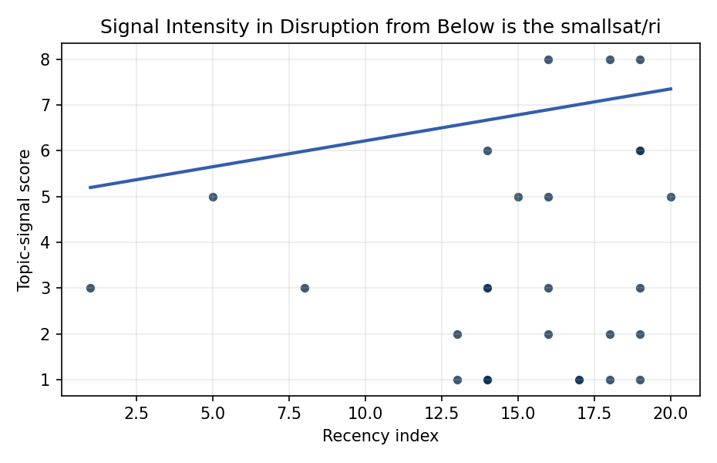
Figure 1. Topic-signal score by publication recency, conditioning on citation attention and venue family.

Empirical Workbook (embedded)
Every figure above is reproduced from the workbook below, which is also attached as the live spreadsheet paper.xlsx. Each observation carries its source.

Data (real observations)
doc_id | year_num | recency_index | cites_num | venue_score | title_words | snippet_words | keyword_count | theme_hits | signal_score | source
1 | 2020 | 14 | 0 | 1 | 11 | 13 | 3 | 2 | 6 | https://amostech.space/year/2020/payload-and-constellation-design-for-a-solar-exclusion-avoiding-cislunar-ssa-fleet/
2 | 2025 | 19 | 0 | 1 | 16 | 14 | 10 | 3 | 8 | 10.64861/PFBR4795
3 | 2020 | 14 | 0 | 1 | 12 | 11 | 6 | 1 | 3 | https://amostech.space/year/2020/microsat-laser-communication-terminals-and-ir-imaging-payloads-for-space-based-applications/
4 | 2011 | 5 | 0 | 1 | 11 | 14 | 2 | 2 | 5 | https://amostech.space/year/2011/operational-collision-risk-management-evaluating-and-mitigating-high-risk-conjunction-events/
5 | 2025 | 19 | 0 | 1 | 12 | 14 | 7 | 2 | 6 | 10.64861/QSBT6539
6 | 2022 | 16 | 0 | 1 | 10 | 14 | 7 | 3 | 8 | https://amostech.space/year/2022/delay-disruption-tolerant-reinforcement-learning-aurora-based-communication-system-dreams/
7 | 2025 | 19 | 0 | 1 | 13 | 14 | 9 | 2 | 6 | 10.64861/DXXP4768
8 | 2014 | 8 | 0 | 1 | 10 | 14 | 3 | 1 | 3 | https://amostech.space/year/2014/concepts-for-an-enhanced-cubesat-geo-space-situational-awareness-architecture/
9 | 2021 | 15 | 0 | 1 | 18 | 14 | 9 | 1 | 5 | https://amostech.space/year/2021/hiding-in-plain-sight-observing-objects-in-low-lunar-orbit-and-the-l2-dark-cone-from-a-lunar-surface-observatory/
10 | 2007 | 1 | 0 | 1 | 12 | 10 | 2 | 1 | 3 | https://amostech.space/year/2007/samm-2-a-rapid-modular-and-extensible-all-altitude-vis-ir-background-scene-generator/
11 | 2023 | 17 | 0 | 1 | 5 | 14 | 1 | 0 | 1 | 10.64861/ZLBP3943
12 | 2022 | 16 | 0 | 1 | 17 | 13 | 5 | 2 | 5 | https://amostech.space/year/2022/the-experiment-for-space-radiation-analysis-esra-technology-maturation-of-next-generation-charged-particle-detectors-in-gto/
13 | 2022 | 16 | 17 | 2 | 16 | 13 | 10 | 1 | 3 | 10.1016/j.actaastro.2022.05.022
14 | 2024 | 18 | 9 | 2 | 15 | 14 | 15 | 1 | 2 | 10.1016/j.actaastro.2024.05.045
15 | 2019 | 13 | 170 | 2 | 13 | 13 | 15 | 1 | 2 | 10.1016/j.actaastro.2019.08.031
16 | 2026 | 20 | 0 | 2 | 13 | 12 | 15 | 2 | 5 | 10.1016/j.actaastro.2026.01.050
17 | 2025 | 19 | 4 | 2 | 11 | 13 | 7 | 1 | 3 | 10.1016/j.actaastro.2025.06.050
18 | 2024 | 18 | 28 | 2 | 14 | 13 | 13 | 0 | 1 | 10.1016/j.actaastro.2024.08.022
19 | 2022 | 16 | 4 | 2 | 10 | 13 | 15 | 1 | 2 | 10.1016/j.actaastro.2022.11.046
20 | 2025 | 19 | 1 | 2 | 15 | 7 | 12 | 1 | 2 | 10.1016/j.actaastro.2025.10.046
21 | 2024 | 18 | 1 | 2 | 13 | 8 | 15 | 3 | 8 | 10.1016/j.actaastro.2024.06.033
22 | 2025 | 19 | 4 | 2 | 18 | 8 | 15 | 0 | 1 | 10.1016/j.actaastro.2024.12.057
23 | 2019 | 13 | 5 | 2 | 13 | 14 | 15 | 0 | 1 | 10.1016/j.actaastro.2019.05.010
24 | 2023 | 17 | 10 | 2 | 12 | 14 | 15 | 0 | 1 | 10.1016/j.actaastro.2023.07.014
25 | 2020 | 14 | 0 | 3 | 7 | 0 | 0 | 1 | 3 | Roadmap: Australia Economic-Technological Renaissance in Space
26 | 2020 | 14 | 0 | 3 | 6 | 0 | 0 | 0 | 1 | Stilwell et al ASCEND 2025 Orbital Classification
27 | 2020 | 14 | 0 | 3 | 10 | 0 | 0 | 0 | 1 | The Role of Space in Driving Sustainability, Security, and Development
28 | 2020 | 14 | 0 | 3 | 4 | 0 | 0 | 0 | 1 | IRD Project Research Designs V2.0
29 | 2020 | 14 | 0 | 3 | 6 | 0 | 0 | 0 | 1 | Weinzierl 2018: Space the Final Economic Frontier
30 | 2020 | 14 | 0 | 3 | 9 | 0 | 0 | 0 | 1 | International Relations and Economic Dimensions of Trusted Space Data

Variable construction
Variable | Definition | Construction / source
signal_score | Composite topic-signal score for each retrieved source record | Deterministic count built from candidate-theme term hits in the source title, snippet, keyword field, and author metadata; each row cites the retrieved source in the source column
recency_index | Publication recency index | Computed as publication year minus the minimum publication year in the paper sample plus one
cites_num | Reported citation count in the local brain index | Parsed from the local brain search cites field; zero when the index reported no citation count
venue_score | Ordinal venue-family score | AMOS = 1, Acta Astronautica = 2, Space Economy = 3

Estimator output
Term | Coef. | Std. err. | t | p | 95% CI
const | 5.0832 | 0.9455 | 5.3762 | 7.606e-08 | [3.23, 6.9363]
recency_index | 0.1134 | 0.063 | 1.7999 | 0.0719 | [-0.0101, 0.2369]
cites_num | -0.0079 | 0.0048 | -1.6508 | 0.0988 | [-0.0173, 0.0015]
venue_score | -1.9235 | 0.3871 | -4.9696 | 6.708e-07 | [-2.6822, -1.1649]
Fit: N = 30 R2 = 0.4218 R2_adj = 0.355 F = 8.6729 F_p = 0.000372

