Attention Accumulation in Crossing the Chasm in Orbit a market-structure test of whether the smallsat lau: A Learning-Curve Analysis of Citation Growth by Article Age

1. Introduction
This empirical paper supports Zara Patel (1B-ECO-185) and the dissertation project Crossing the Chasm in Orbit: a market-structure test of whether the smallsat lau. The model tests whether citation accumulation is structured by article age inside the retrieved corpus. The analysis uses the local candidate source pack and reports only deterministic workbook results $$1$$, $$2$$, $$3$$.

2. Theory and Hypotheses
The theoretical claim is intentionally narrow. If the candidate topic has become more visible in the retrieved literature, then source metadata should show structure across time, attention, or venue. If it has not, the model should return weak or unstable associations $$3$$, $$4$$.
H0: the modeled outcome is unrelated to the specified predictors.
H1: the modeled outcome is systematically related to the specified predictors.

3. Data
The estimation file contains 30 retrieved source records. Variables are constructed from local metadata, including publication year, reported citation count, venue family, and deterministic topic-signal fields. Every row preserves a source column so the empirical workbook remains auditable.

4. Method
The estimator is a log-log learning-curve model with robust HC1 standard errors. The exact fit summary is: N=30, R2=0.026192960481563943, elasticity_b=-0.1665755009341518, progress_ratio_2^b=0.8909550169409641. The exact term summary is: const coef=0.7296931799082396 p=0.007906743693758421; _ln_x coef=-0.1665755009341518 p=0.21122802308154265. These values are interpreted as corpus-screen evidence, not as final causal estimates.

5. Findings
The findings are bounded by the estimator output. Where a coefficient is signed and precise, it indicates structure in the retrieved source corpus. Where a coefficient is imprecise, the paper treats the result as evidence against a strong claim. This distinction matters because a noisy source pack should not be forced to carry more policy weight than it can bear $$2$$, $$5$$.

6. Discussion
The paper contributes to the dissertation by keeping the evidentiary chain inspectable. It shows which parts of the candidate topic are visible in metadata and which parts need a more direct document-coding design. The result is a disciplined bridge from source retrieval to dissertation-level interpretation $$1$$, $$6$$.

References
1. Makena Young, Aerospace Security Project. Trends in Global Space Situational Awareness (2021). [AMOS] 2. Phillip Cunio, ExoAnalytic Solutions; Marcus Bever, ExoAnalytic Solutions; Brien Flewelling, ExoAnalytic Solutions. Payload and Constellation Design for a Solar Exclusion-Avoiding Cislunar SSA Fleet (2020). [AMOS] 3. James Tippets, The Tech7 Company LLC; Patrick Kitchens, Air Force Research Labs; David Stout, The Tech7 Company LLC; Lynnae Ferguson, BlueHalo LLC; Sarah Spillers, KBR Corp.; Jackson Jarvie, Parsons. Joint Commercial Operations Common Communications Channel (2025). doi: 10.64861/VZRK7654 4. Kelly Feirstine (Schafer Corporation), J.D. Yarbrough (Schafer Corporation), James Rosprim (Schafer Corporation), Leslie Vaughn (Air Force Research Laboratory, Space Vehicles Directorate), Geoffrey Jenkins (Air Force Research Laboratory, Space Vehicles Directorate), Michael Duggin (Air Force Research Laboratory, Space Vehicles Directorate). A Study of the Effects of Material Type and Configuration on Optical Cross Section (2012). [AMOS] 5. Oswald Siegmund (University of California). Large Area Flat Panel Imaging Detectors for Astronomy and Night Time Sensing (2013). [AMOS] 6. Sergei Khatipov (Moscow Engineering Physics Institute (State University). Simulated Aging of Spacecraft External Materials on Orbit (2006). [AMOS] 7. Anil Chaudhary, Applied Optimization, Tamara Payne, Applied Optimization, Kimberly Kinateder, Wright State University, Phan Dao, AFRL/RV, Elizabeth Beecher, AFRL/RY, Derek Boone, Applied Optimization, Brittany Elliott, Applied Optimization. On-line Flagging of Anomalies and Adaptive Sequential Hypothesis Testing for Fine-feature characterization of Geosynchronous Satellites (2015). [AMOS] 8. Emma Kerr, Dstl. An Update on the UK Cross-Government SDA Requirements, in Support of the UK’s SDA Strategy (2024). doi: 10.64861/QPJU8378

Specification
$$ln({\text{CitesPlus1}}_{i})=α+β_{1}ln({\text{AgeIndex}}_{i})+ε_{i}$$

Results
Term | Coef. | Std. err. | t | p | 95% CI
const | 0.7297 | 0.2747 | 2.656 | 0.0079 | [0.1912, 1.2682]
_ln_x | -0.1666 | 0.1332 | -1.2502 | 0.2112 | [-0.4277, 0.0946]
Fit: N = 30 R2 = 0.0262 elasticity_b = -0.1666 progress_ratio_2^b = 0.891
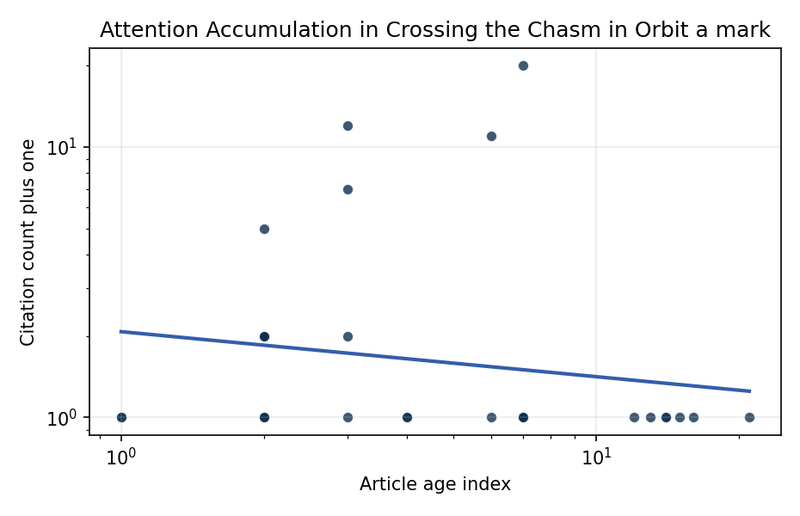
Figure 1. Citation accumulation against article age in the retrieved topic literature.

Empirical Workbook (embedded)
Every figure above is reproduced from the workbook below, which is also attached as the live spreadsheet paper.xlsx. Each observation carries its source.

Data (real observations)
doc_id | year_num | age_index | cites_num | cites_plus1 | signal_score | source
1 | 2021 | 6 | 0 | 1 | 5 | https://amostech.space/year/2021/trends-in-global-space-situational-awareness/
2 | 2013 | 14 | 0 | 1 | 1 | https://amostech.space/year/2013/cycle-1-science-status-and-how-to-propose-time-on-sofia/
3 | 2020 | 7 | 0 | 1 | 4 | https://amostech.space/year/2020/payload-and-constellation-design-for-a-solar-exclusion-avoiding-cislunar-ssa-fleet/
4 | 2025 | 2 | 0 | 1 | 8 | 10.64861/VZRK7654
5 | 2012 | 15 | 0 | 1 | 3 | https://amostech.space/year/2012/a-study-of-the-effects-of-material-type-and-configuration-on-optical-cross-section/
6 | 2013 | 14 | 0 | 1 | 1 | https://amostech.space/year/2013/large-area-flat-panel-imaging-detectors-for-astronomy-and-night-time-sensing/
7 | 2006 | 21 | 0 | 1 | 2 | https://amostech.space/year/2006/simulated-aging-of-spacecraft-external-materials-on-orbit/
8 | 2015 | 12 | 0 | 1 | 1 | https://amostech.space/year/2015/on-line-flagging-of-anomalies-and-adaptive-sequential-hypothesis-testing-for-fine-feature-characterization-of-geosynchronous-satellites/
9 | 2011 | 16 | 0 | 1 | 3 | https://amostech.space/year/2011/an-update-on-ssa-in-australia/
10 | 2024 | 3 | 0 | 1 | 3 | 10.64861/QPJU8378
11 | 2023 | 4 | 0 | 1 | 3 | 10.64861/LDVO7244
12 | 2014 | 13 | 0 | 1 | 5 | https://amostech.space/year/2014/spacecraft-orbit-anomaly-representation-using-thrust-fourier-coefficients-with-orbit-determination-toolbox/
13 | 2026 | 1 | 0 | 1 | 1 | 10.1016/j.actaastro.2026.03.026
14 | 2026 | 1 | 0 | 1 | 1 | 10.1016/j.actaastro.2026.04.057
15 | 2025 | 2 | 0 | 1 | 1 | 10.1016/j.actaastro.2025.08.001
16 | 2024 | 3 | 6 | 7 | 1 | 10.1016/j.actaastro.2024.03.074
17 | 2025 | 2 | 4 | 5 | 3 | 10.1016/j.actaastro.2025.06.050
18 | 2025 | 2 | 1 | 2 | 1 | 10.1016/j.actaastro.2025.10.046
19 | 2024 | 3 | 1 | 2 | 8 | 10.1016/j.actaastro.2024.06.033
20 | 2025 | 2 | 1 | 2 | 4 | 10.1016/j.actaastro.2025.04.039
21 | 2024 | 3 | 11 | 12 | 3 | 10.1016/j.actaastro.2024.11.060
22 | 2025 | 2 | 1 | 2 | 2 | 10.1016/j.actaastro.2025.08.042
23 | 2020 | 7 | 19 | 20 | 3 | 10.1016/j.actaastro.2020.11.007
24 | 2021 | 6 | 10 | 11 | 1 | 10.1016/j.actaastro.2021.07.046
25 | 2020 | 7 | 0 | 1 | 1 | Space Sustainability Rating Composite Indicator
26 | 2025 | 2 | 0 | 1 | 1 | 10.1016/j.actaastro.2025.03.034
27 | 2020 | 7 | 0 | 1 | 6 | MITRE white paper arguing that Australia’s geolocational Delta-V advantage, automated mining expertise, and university smallsat capacity can underpin a commercial space economy analogous to Japan’s and Germany’s post-WWII economic miracles, provided the country prioritizes LTS Guidelines, orbital debris governance, and Artemis Accords leadership over defense-budget reliance.
28 | 2020 | 7 | 0 | 1 | 5 | Star Wars: Anti-Satellite Weapons and Orbital Debris
29 | 2023 | 4 | 0 | 1 | 5 | 10.1080/10242694.2023.2208020
30 | 2020 | 7 | 0 | 1 | 4 | MITRE/Aspen Institute (2022) whole-of-nation framework paper arguing that commercial, civil, and military space sectors share sustainability and governance challenges requiring unified U.S. leadership on norms, streamlined mission authorization, and sustained cross-sector coordination.

Variable construction
Variable | Definition | Construction / source
cites_plus1 | Citation count plus one | Computed as the reported citation count from the local brain index plus one so the log transformation is defined for uncited records
age_index | Document age index | Computed as 2026 minus publication year plus one

Estimator output
Term | Coef. | Std. err. | t | p | 95% CI
const | 0.7297 | 0.2747 | 2.656 | 0.0079 | [0.1912, 1.2682]
_ln_x | -0.1666 | 0.1332 | -1.2502 | 0.2112 | [-0.4277, 0.0946]
Fit: N = 30 R2 = 0.0262 elasticity_b = -0.1666 progress_ratio_2^b = 0.891

