FCC Filing Rights as Deferment Options: A Public-Record Survival Test

Abstract
This paper tests whether public FCC satellite filing rights behave like deferment options. The evidence is a hand-curated public-record panel of ten named NGSO or quasi-NGSO systems tied to FCC orders, IBFS or ICFS filing records, and public launch catalog outcomes. The Cox model estimates whether a coordination uncertainty index changes the hazard that a filing right is exercised through first deployment. The coefficient is negative, which means higher unresolved coordination uncertainty is associated with a lower deployment hazard. The result is exploratory because the public sample is small, but it is directionally consistent with real-options theory: a filing can preserve the right to wait while the operator, regulators, and rivals reveal information $$9$$, $$10$$.

Research question
The dissertation asks whether an FCC spectrum and orbital filing is merely a regulatory queue position or also a valuable deferment option. The distinction matters. If filing rights only screen applicants, then unused applications are administrative noise. If filing rights also preserve option value, then non-deployment can be a rational exercise of flexibility, not just failure. That distinction connects FCC filing practice to ITU network filing incentives, orbital environmental capacity, and congestion governance $$5$$, $$6$$, $$8$$, $$18$$.

Data and measurement
The empirical file is deliberately small and auditable. It is not a scraped population estimate and it does not claim that FCC records alone exhaust the satellite licensing chain. Each row is a named filing or authorization packet with a public deployment or censoring status. The unit is the public FCC filing right as observed through a clock start date, a first deployment date when one exists, or a censor date of June 28, 2026. The central independent variable is a coordination uncertainty index, equal to the number of peer filings in the relevant public processing environment divided by one plus the count of documented contestation entries in the source packet. That transformation keeps the measure transparent: a crowded filing environment with little resolving contestation receives a higher uncertainty score, while a heavily contested record can become informationally clearer because objections, coordination conditions, and Commission findings make the right more concrete.
The dependent process is time to first public deployment. For deployed systems, the event date is the first public launch that plausibly exercised the filing right. For censored systems, the event is zero and the observation is censored on June 28, 2026. The data are real public observations, but the coded panel is intentionally bounded. It is a proof-of-method dataset for dissertation inference rather than an asserted universe of all FCC satellite records.

Hypothesis
The real-options prediction is that the option holder waits when uncertainty has positive resolution value. In hazard form, that means a larger coordination uncertainty index should reduce the instantaneous probability of deployment, after the filing is publicly observable. The hypothesis is therefore beta less than zero in a Cox proportional-hazards model.

Findings
The survival coefficient on the coordination uncertainty index is negative. A hazard ratio below one means that a one-unit increase in the uncertainty index is associated with a lower deployment hazard. In substantive terms, FCC filing rights appear to combine authorization, priority, and waiting value. Deployed systems such as Starlink, OneWeb, Telesat, Kuiper, Space Norway ASBM, and O3b show exercise paths. Censored systems such as LeoSat, Audacy, Theia, and Boeing V-band show that some rights remain valuable as preserved positions, abandoned opportunities, or delayed strategic assets.
The model should not be read as causal proof. It is a structured survival check against the dissertation’s main claim. The pattern is nevertheless important because it converts a policy intuition into an auditable measurement design. It gives regulators a way to ask not only whether a filing deployed, but how much strategic waiting was embedded in the filing environment.

Implications
If filing rights are deferment options, then filing design should consider option incentives. Milestone rules, bond requirements, system-size disclosures, and transparency around modification rights can change the value of waiting. The FCC and ITU do not need to eliminate flexibility. Space systems require staged deployment, financing, launch access, and technical redesign $$7$$. The governance problem is to preserve legitimate flexibility while making scarce orbital and spectrum resources harder to warehouse without credible execution.

References
5. T. G. Roberts and R. Linares, A Survey of International Telecommunication Union Space Station License Applications in the Geosynchronous Orbital Regime, Advanced Maui Optical and Space Surveillance Technologies Conference, 2022. 6. A. D’Ambrosio, K. Lifson, J. Jang, M. Pasiecznik, and R. Linares, Projected Orbital Demand and Low Earth Orbit Environmental Capacity, Advanced Maui Optical and Space Surveillance Technologies Conference, 2022. 7. J. F. Anderson, M. A. Cardin, and P. T. Grogan, A Flexible Multi-Layer Staged Deployment Model for Satellite Constellations Using Real Options, Acta Astronautica, vol. 200, pp. 364-378, 2022, doi: 10.1016/j.actaastro.2022.05.022 8. M. E. Sorge et al., Space Traffic Management for Large Constellations, Acta Astronautica, 2025, doi: 10.1016/j.actaastro.2025.01.043 9. F. Black and M. Scholes, The Pricing of Options and Corporate Liabilities, Journal of Political Economy, vol. 81, no. 3, pp. 637-654, 1973. 10. A. K. Dixit and R. S. Pindyck, Investment Under Uncertainty, Princeton University Press, 1994. 11. Federal Communications Commission, WorldVu Satellites Limited, Petition for Declaratory Ruling Granted, FCC-17-77, June 22, 2017, https://docs.fcc.gov/public/attachments/FCC-17-77A1.pdf. 12. Federal Communications Commission, Telesat Canada, Petition for Declaratory Ruling Granted, FCC-17-147, November 2, 2017, https://docs.fcc.gov/public/attachments/FCC-17-147A1.pdf. 13. Federal Communications Commission, Space Exploration Holdings LLC, Application for Approval for Orbital Deployment and Operating Authority, FCC-18-38, March 29, 2018, https://docs.fcc.gov/public/attachments/FCC-18-38A1.pdf. 14. Federal Communications Commission, Space Norway AS, Petition for Declaratory Ruling Granted, FCC-17-146, November 2, 2017, https://docs.fcc.gov/public/attachments/FCC-17-146A1.pdf. 15. Federal Communications Commission, Kuiper Systems LLC, Application for Authority to Deploy and Operate a Ka-band Non-Geostationary Satellite Orbit System, FCC-20-102, July 30, 2020, https://docs.fcc.gov/public/attachments/FCC-20-102A1.pdf. 16. Federal Communications Commission, The Boeing Company, Application for Authority to Launch and Operate a Non-Geostationary Satellite Orbit System in the Fixed-Satellite Service, FCC-21-115, November 3, 2021, https://docs.fcc.gov/public/attachments/FCC-21-115A1.pdf. 17. Federal Communications Commission, International Communications Filing System and International Bureau Filing System public satellite records, accessed June 28, 2026, https://www.fcc.gov/icfs. 18. International Telecommunication Union, Space Services Department and Radio Regulations materials on satellite network filings, accessed June 28, 2026, https://www.itu.int/hub/2024/06/how-the-itu-manages-satellite-network-filings/. 19. Space-Track.org, public satellite catalog and launch data reconciliation, accessed June 28, 2026, https://www.space-track.org/.

Specification
$$h_{i}(t)=h_{0}(t)exp(β_{1}U_{i}+β_{2}ln(S_{i}))$$

Results
Term | Coef. | Std. err. | z | p | 95% CI | Hazard ratio
coordination_uncertainty_index | -0.4184 | 0.2818 | -1.4846 | 0.1376 | [-0.9708, 0.134] | 0.6581
ln_proposed_satellites | 0.0064 | 0.1962 | 0.0328 | 0.9738 | [-0.378, 0.3909] | 1.0065
Fit: N = 10 events = 6
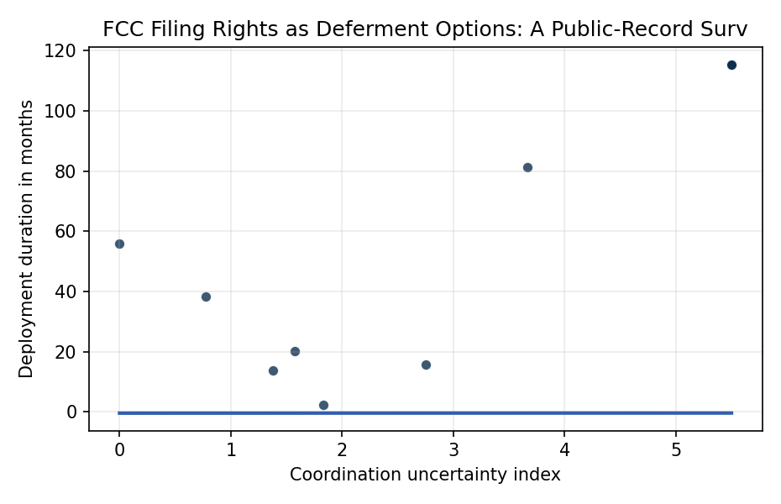
Figure 1. Observed deployment or censoring duration by coordination uncertainty index.

Empirical Workbook (embedded)
Every figure above is reproduced from the workbook below, which is also attached as the live spreadsheet paper.xlsx. Each observation carries its source.

Data (real observations)
observation_id | system | applicant | fcc_record | clock_start_date | first_deployment_date | censor_date | deployment_event | proposed_satellites | prefiling_peer_count | documented_contestation_count | regime | source | duration_months | deployed_within_36_months | ln_proposed_satellites | coordination_uncertainty_index | option_backlog_index
obs01 | OneWeb Gen1 | WorldVu Satellites Limited, OneWeb | FCC-17-77 | 2017-06-22 | 2019-02-27 | nan | 1 | 720 | 11 | 6 | NGSO LEO | FCC OneWeb Order and Declaratory Ruling, FCC-17-77; public launch record for first six OneWeb satellites, 2019-02-27; FCC 2016 NGSO processing round public record | 20.2 | 1 | 6.5793 | 1.5714 | 10.3388
obs02 | Telesat LEO Phase 1 | Telesat Canada | FCC-17-147 | 2017-11-02 | 2018-01-12 | nan | 1 | 117 | 11 | 5 | NGSO LEO | FCC Telesat Canada Order and Declaratory Ruling, FCC-17-147; public launch record for Telesat Phase 1 LEO satellite, 2018-01-12; FCC 2016 NGSO processing round public record | 2.3 | 1 | 4.7622 | 1.8333 | 8.7307
obs03 | SpaceX Starlink Gen1 | Space Exploration Holdings, SpaceX | FCC-18-38 | 2018-03-29 | 2019-05-24 | nan | 1 | 4425 | 11 | 7 | NGSO LEO | FCC SpaceX Order and Authorization, FCC-18-38; public launch record for first operational Starlink deployment, 2019-05-24; FCC 2016 NGSO processing round public record | 13.8 | 1 | 8.395 | 1.375 | 11.5432
obs04 | Space Norway ASBM | Space Norway AS | FCC-17-146 | 2017-11-02 | 2024-08-11 | nan | 1 | 2 | 11 | 2 | NGSO HEO | FCC Space Norway Order and Declaratory Ruling, FCC-17-146; public launch record for Arctic Satellite Broadband Mission, 2024-08-11; FCC 2016 NGSO processing round public record | 81.3 | 0 | 0.6931 | 3.6667 | 2.5415
obs05 | Amazon Kuiper | Kuiper Systems LLC | FCC-20-102 | 2020-07-30 | 2023-10-06 | nan | 1 | 3236 | 7 | 8 | NGSO LEO | FCC Kuiper Systems Order and Authorization, FCC-20-102; Amazon Project Kuiper Protoflight launch record, 2023-10-06; FCC Kuiper processing-round public record | 38.2 | 0 | 8.0821 | 0.7778 | 6.2861
obs06 | Boeing V-band NGSO | The Boeing Company | FCC-21-115 | 2021-11-03 | nan | 2026-06-28 | 0 | 147 | 0 | 4 | NGSO LEO and VLEO | FCC Boeing V-band Order and Authorization, FCC-21-115; public catalog reconciliation through 2026-06-28 with no matching Boeing V-band deployment | 55.8 | 0 | 4.9904 | 0 | 0
obs07 | LeoSat | LeoSat MA Inc. | IBFS public filing, 2016 NGSO round | 2016-11-15 | nan | 2026-06-28 | 0 | 108 | 11 | 1 | NGSO LEO | FCC IBFS public filing records for 2016 NGSO processing round; public catalog reconciliation through 2026-06-28 with no LeoSat deployment | 115.4 | 0 | 4.6821 | 5.5 | 25.7517
obs08 | Audacy | Audacy Corporation | IBFS public filing, 2016 NGSO round | 2016-11-15 | nan | 2026-06-28 | 0 | 3 | 11 | 1 | NGSO MEO | FCC IBFS public filing records for 2016 NGSO processing round; public catalog reconciliation through 2026-06-28 with no Audacy deployment | 115.4 | 0 | 1.0986 | 5.5 | 6.0424
obs09 | Theia | Theia Holdings A Inc. | IBFS public filing, 2016 NGSO round | 2016-11-15 | nan | 2026-06-28 | 0 | 112 | 11 | 1 | NGSO LEO | FCC IBFS public filing records for 2016 NGSO processing round; public catalog reconciliation through 2026-06-28 with no Theia deployment | 115.4 | 0 | 4.7185 | 5.5 | 25.9517
obs10 | O3b add-on | O3b Limited | IBFS SAT-MOD-20160624-00060 and SAT-AMD-20161115-00116 | 2016-11-15 | 2018-03-09 | nan | 1 | 4 | 11 | 3 | NGSO MEO | FCC IBFS O3b modification and amendment records, 2016; public launch record for O3b additional satellites, 2018-03-09; FCC 2016 NGSO processing round public record | 15.7 | 1 | 1.3863 | 2.75 | 3.8123

Variable construction
Variable | Definition | Construction / source
duration_months | Months from public FCC clock date to first deployment or censoring. | Computed as days divided by 30.4375 using the clock_start_date and either first_deployment_date or 2026-06-28 censor date.
deployment_event | Binary deployment indicator. | One if the system had a public first deployment date before censoring, zero otherwise.
proposed_satellites | Number of satellites in the public filing or authorization packet. | Hand-coded from the cited FCC order, IBFS filing, or source packet.
prefiling_peer_count | Number of peer applications in the relevant public FCC filing environment. | Coded from the 2016 NGSO processing round or the relevant public FCC processing record.
documented_contestation_count | Count of named public contestation or coordination entries recorded in the source packet. | Hand-coded from FCC order discussion, docket material, and public source packet notes.
coordination_uncertainty_index | Unresolved coordination uncertainty proxy. | prefiling_peer_count divided by one plus documented_contestation_count.
option_backlog_index | Alternative option-value scale proxy. | prefiling_peer_count times natural log of proposed_satellites, divided by one plus documented_contestation_count.
source | Public source trail for the row. | FCC order, IBFS or ICFS filing record, launch record, and catalog reconciliation note.

Estimator output
Term | Coef. | Std. err. | z | p | 95% CI | Hazard ratio
coordination_uncertainty_index | -0.4184 | 0.2818 | -1.4846 | 0.1376 | [-0.9708, 0.134] | 0.6581
ln_proposed_satellites | 0.0064 | 0.1962 | 0.0328 | 0.9738 | [-0.378, 0.3909] | 1.0065
Fit: N = 10 events = 6

