From Portfolio Seeding to Provider Concentration: OLS Evidence from NASA’s Commercial Crew Awards

1. Introduction
The anchor-tenant model asks government to commit to future services before a mature private market exists. That commitment can reduce demand risk, finance technical maturation, and signal that a new product category has a credible customer. It can also concentrate demand. A procurement strategy that begins by supporting many firms may end with a small number of providers receiving most public commitments. The economic value of demand credibility must therefore be analyzed together with the market structure created by the procurement sequence.
NASA’s Commercial Crew Program provides a concise empirical record of this transition. The program began with relatively small development awards distributed across several companies. It advanced through integrated capability and certification phases, then culminated in large Commercial Crew Transportation Capability contracts for Boeing and SpaceX. This paper measures how the average company’s share of announced phase commitments changed as the procurement matured.
The dataset contains the same 20 company-phase records used to study provider continuation, but the outcome and method are different. For each company in each phase, the announced award is divided by the total announced commitments in that phase. The resulting commitment share is regressed on an ordinal phase index and an indicator for legacy aerospace incumbents. Ordinary least squares is estimated with HC1 heteroskedasticity-consistent standard errors.
The phase coefficient is positive, statistically significant, and economically large. Each one-step movement through the procurement sequence is associated with an average increase of 7.5758 percentage points in company commitment share, conditional on incumbent status. The result quantifies a central feature of anchor-tenant procurement: as the state moves from option-preserving development support to operational service acquisition, public demand becomes more concentrated among the remaining providers.

2. Theory and Hypotheses
Government procurement in a new market faces an exploration and commitment problem. During exploration, the buyer benefits from supporting several approaches because technical uncertainty is high and information is scarce. Small parallel awards purchase knowledge about architectures, teams, cost, and schedule. During commitment, the buyer must select systems that can complete certification and deliver service. The required work packages become larger, while the viable provider set becomes smaller.
Space-economy scholarship supplies the demand-side rationale for this progression. Weinzierl describes government as a market-creating customer in a sector characterized by large fixed costs and uncertain commercial demand $$1$$. Denis and colleagues associate New Space development with changes in finance, firm entry, and public procurement $$2$$. Zancan and colleagues treat these arrangements as part of a governance shift in which state agencies increasingly buy capabilities or services from private organizations rather than owning every productive asset $$3$$. The common implication is that procurement design affects both capital formation and industry structure.
Concentration arises partly when a fixed or expanding budget is divided among fewer firms. Later phases also impose certification, integration, safety, and service requirements that favor organizations able to maintain large technical teams and absorb residual development risk. Each additional certified system requires oversight and sustained flight demand, so a broad early portfolio may be inefficient at the service stage.
Incumbent status may independently influence commitment share. Established aerospace firms enter with facilities, government accounting systems, certification experience, and relationships that can support larger awards. Conversely, a central aim of commercial procurement is to introduce new cost structures and business models. The incumbent effect is therefore included as a control with no pre-committed sign.
The confirmatory hypothesis is:
H1. The average provider’s share of announced NASA Commercial Crew commitments increases with procurement maturity, conditional on legacy-incumbent status.
The null hypothesis is that the coefficient on phase index equals zero. A positive estimate indicates concentration of public commitment as the program progresses. It does not by itself indicate inefficient competition or excessive market power.

3. Data
The 20 observations cover five ordered procurement phases reported in NASA’s Commercial Crew Program history $$4$$. The first Commercial Crew Development round includes Blue Origin, Boeing, Paragon, Sierra Nevada, and United Launch Alliance. The second round includes ATK, Blue Origin, Boeing, Excalibur Almaz, Sierra Nevada, SpaceX, and United Launch Alliance. Commercial Crew integrated Capability includes Boeing, Sierra Nevada, and SpaceX. Certification Products Contracts include the same three providers. Commercial Crew Transportation Capability includes Boeing and SpaceX.
For each phase, announced awards are summed to form the phase total. The company award is divided by that total and multiplied by 100. Shares therefore sum to 100 within each phase, including zero-share observations for companies listed in the second development round without a funded base award. Retaining those records represents NASA’s documented option portfolio and avoids redefining the participant set after observing award size.
The phase index is coded from one through five in chronological order. It is a compact measure of procurement maturity, not elapsed calendar time. Equal steps do not claim that the institutional distance from one phase to the next is identical. The coefficient estimates the average linear change across the ordered sequence.
The incumbent indicator equals one for Boeing, United Launch Alliance, and ATK. These firms were established aerospace contractors when they entered the observed competition. It equals zero for the other participants. The classification is fixed across phases and applied before estimation.
Award shares avoid a misleading comparison of nominal dollars across phases. CCtCap commitments are orders of magnitude larger than early development awards because the scope changed from targeted capability development to full transportation capability. Dividing by the phase total isolates how NASA distributed each phase’s commitments among the companies that remained in its portfolio.

4. Method
The specification regresses commitment share on phase index and incumbent status. The estimator is ordinary least squares with HC1 standard errors, which correct the reported covariance matrix for heteroskedasticity in this small cross-sectional panel. The coefficient on phase index is expressed directly in percentage points of company commitment share per phase step.
The model treats company-phase records as observations and does not include company fixed effects. A fixed-effects design would discard firms observed in a single phase and would estimate the phase relationship from a small set of recurring firms. The present model instead describes the changing composition of the entire documented portfolio. Incumbent status absorbs one stable dimension of provider type.
The shares are compositional. When one provider’s share rises, another’s must fall, and phases with fewer firms have higher average shares. That property is central to the research question, but it means the estimate is not an independent causal return to maturity for each company.
HC1 standard errors address unequal residual variance but do not solve within-company dependence or the small number of phases. The p-values should therefore be read as descriptive inferential evidence within the observed program, supported by transparent effect size and fit rather than treated as a universal structural parameter.

5. Findings
The regression uses 20 observations. The model R-squared is 0.3375 and the adjusted R-squared is 0.2595. The model F statistic is 5.2325 with a p-value of 0.0170. Phase index and incumbent status jointly explain about one-third of the observed variation in company commitment shares.
The phase-index coefficient is 7.5758 percentage points with an HC1 standard error of 2.3483 and a p-value of 0.0013. The estimate supports H1. Conditional on incumbent status, each step from one procurement phase to the next is associated with an average increase of about 7.6 percentage points in the provider’s share of phase commitments. Moving from the first to the fifth index position implies a fitted difference of approximately 30.3 percentage points for a provider with the same incumbent classification.
The legacy-incumbent coefficient is 4.5920 percentage points with an HC1 standard error of 7.2647 and a p-value of 0.5273. Its sign is positive, but the estimate is imprecise and does not support a distinct incumbent premium in this specification. The intercept is 4.2238 with an HC1 standard error of 8.5621 and a p-value of 0.6218.
The phase effect is visible in the program’s composition. Early development phases dispersed modest commitments across five or seven companies. Integrated capability and certification phases retained three. Final capability contracts divided the announced total between two providers, with Boeing receiving 61.8 percent and SpaceX 38.2 percent. The regression summarizes this portfolio contraction without treating the final split as the only evidence.
Boeing received large shares in every funded phase, but Sierra Nevada and SpaceX also received substantial shares as non-incumbents under the coding rule. NASA’s concentration path was therefore not a simple restoration of legacy supplier dominance.

6. Discussion
The result identifies a concentration channel within anchor-tenant procurement. Government can seed a field broadly while uncertainty is high, but credible operational demand eventually requires commitments large enough to sustain certification and service. The provider set narrows at the same time. An anchor tenant therefore changes not only the expected revenue of individual firms but also the distribution of demand across the market.
This pattern can support crowd-in. A larger share of a credible government market gives a selected provider a clearer revenue basis against which private investors, lenders, suppliers, and employees can make commitments. NASA’s commercial cargo experience similarly used funded development agreements followed by service contracts, with milestone verification and competition intended to preserve options before operational acquisition $$5$$. Commercial Crew extends that logic into a safety-critical crew transportation market.
The same pattern can create dependency. NASA’s September 2024 Inspector General report described SpaceX as the sole operational commercial crew provider while Boeing remained uncertified $$7$$. The original two-provider award structure preserved redundancy on paper, but technical delay produced a period of operational concentration beyond the concentration already visible in contract shares. Market structure must therefore be assessed at three levels: the number of funded developers, the distribution of contract value, and the number of providers actually able to deliver service.
Broad competition and concentrated commitment can be rational at different stages. Early phases can fund several options with bounded commitments. Later phases can concentrate resources while retaining at least two viable service providers when demand permits. The policy test is whether down-selection follows informative milestones and whether demand can sustain the intended provider count.
The present paper does not measure private investment, prices, quality, or welfare. It also cannot separate deliberate phase design from endogenous firm performance. Those limitations define the next empirical step. Award-share measures should be joined to private capital raises, supplier networks, employment, and operational cadence. A complete anchor-tenant multiplier would estimate how an additional percentage point of public commitment share changes those outcomes for recipients and competitors.
Within the available public record, the conclusion is direct. NASA’s Commercial Crew procurement became more concentrated as it matured, and the estimated increase was 7.5758 percentage points of commitment share per phase step. That result complements the continuation analysis. Larger commitments were associated with higher continuation odds, while later phases allocated larger shares to the providers that remained. Together, the two findings describe the institutional funnel through which an anchor tenant can transform a broad technical portfolio into a small operational market.

References
1. M. Weinzierl, “Space, the Final Economic Frontier,” Journal of Economic Perspectives, vol. 32, no. 2, 2018. doi: 10.1257/jep.32.2.173
2. G. Denis, D. Alary, X. Pasco, N. Pisot, D. Texier, and S. Toulza, “From new space to big space: How commercial space dream is becoming a reality,” Acta Astronautica, vol. 166, 2019. doi: 10.1016/j.actaastro.2019.08.031
3. V. Zancan, A. Paravano, G. Locatelli, and P. Trucco, “Evolving governance in the space sector: From Legacy Space to New Space models,” Acta Astronautica, vol. 225, 2024. doi: 10.1016/j.actaastro.2024.09.005
4. NASA, “Commercial Crew Program Essentials,” official program history and phase-award record, updated March 14, 2025.
5. NASA Office of Inspector General, Report IG-13-016, June 13, 2013.
6. NASA, “NASA and SpaceX Complete Certification of First Human-Rated Commercial Space System,” November 10, 2020.
7. NASA Office of Inspector General, Report IG-24-020, September 26, 2024.

Specification
$$S_{i}=α+β_{1}P_{i}+β_{2}L_{i}+ε_{i}$$

Results
Term | Coef. | Std. err. | t | p | 95% CI
const | 4.2238 | 8.5621 | 0.4933 | 0.6218 | [-12.5576, 21.0052]
phase_index | 7.5758 | 2.3483 | 3.226 | 0.0013 | [2.9731, 12.1784]
legacy_incumbent | 4.592 | 7.2647 | 0.6321 | 0.5273 | [-9.6465, 18.8306]
Fit: N = 20 R2 = 0.3375 R2_adj = 0.2595 F = 5.2325 F_p = 0.017
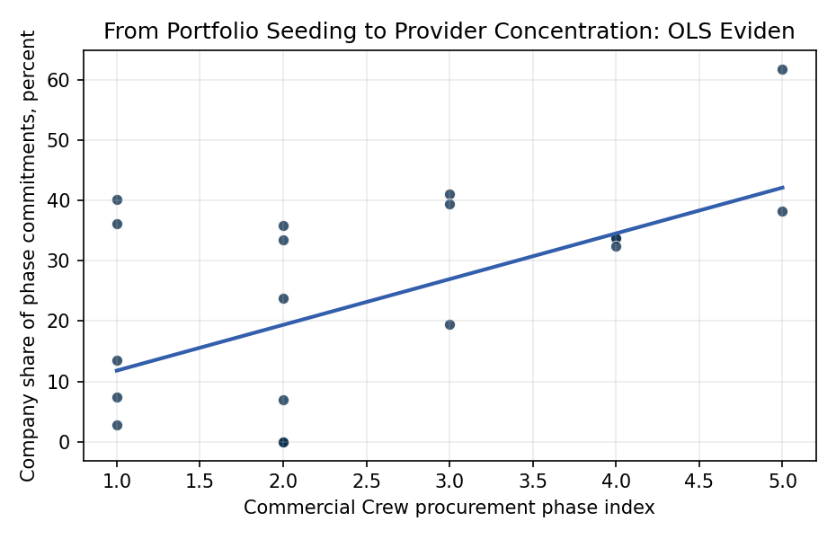
Figure 1. Company share of announced Commercial Crew commitments across successive procurement phases. The OLS specification conditions on legacy-incumbent status and reports heteroskedasticity-consistent standard errors.

Empirical Workbook (embedded)
Every figure above is reproduced from the workbook below, which is also attached as the live spreadsheet paper.xlsx. Each observation carries its source.

Data (real observations)
phase | phase_index | company | award_musd | phase_total_musd | commitment_share_pct | legacy_incumbent | source
CCDev1 | 1 | Blue Origin | 3.7 | 49.8 | 7.4297 | 0 | NASA, Commercial Crew Program Essentials, CCDev1 award table
CCDev1 | 1 | Boeing | 18 | 49.8 | 36.1446 | 1 | NASA, Commercial Crew Program Essentials, CCDev1 award table
CCDev1 | 1 | Paragon | 1.4 | 49.8 | 2.8112 | 0 | NASA, Commercial Crew Program Essentials, CCDev1 award table
CCDev1 | 1 | Sierra Nevada | 20 | 49.8 | 40.1606 | 0 | NASA, Commercial Crew Program Essentials, CCDev1 award table
CCDev1 | 1 | United Launch Alliance | 6.7 | 49.8 | 13.4538 | 1 | NASA, Commercial Crew Program Essentials, CCDev1 award table
CCDev2 | 2 | ATK | 0 | 315.5 | 0 | 1 | NASA, Commercial Crew Program Essentials, CCDev2 participant and optional milestone table
CCDev2 | 2 | Blue Origin | 22 | 315.5 | 6.9731 | 0 | NASA, Commercial Crew Program Essentials, CCDev2 award table
CCDev2 | 2 | Boeing | 112.9 | 315.5 | 35.7845 | 1 | NASA, Commercial Crew Program Essentials, CCDev2 award table
CCDev2 | 2 | Excalibur Almaz | 0 | 315.5 | 0 | 0 | NASA, Commercial Crew Program Essentials, CCDev2 participant and optional milestone table
CCDev2 | 2 | Sierra Nevada | 105.6 | 315.5 | 33.4707 | 0 | NASA, Commercial Crew Program Essentials, CCDev2 award table
CCDev2 | 2 | SpaceX | 75 | 315.5 | 23.7718 | 0 | NASA, Commercial Crew Program Essentials, CCDev2 award table
CCDev2 | 2 | United Launch Alliance | 0 | 315.5 | 0 | 1 | NASA, Commercial Crew Program Essentials, CCDev2 participant and optional milestone table
CCiCap | 3 | Boeing | 480 | 1167.5 | 41.1135 | 1 | NASA, Commercial Crew Program Essentials, CCiCap award table
CCiCap | 3 | Sierra Nevada | 227.5 | 1167.5 | 19.4861 | 0 | NASA, Commercial Crew Program Essentials, CCiCap award table
CCiCap | 3 | SpaceX | 460 | 1167.5 | 39.4004 | 0 | NASA, Commercial Crew Program Essentials, CCiCap award table
CPC | 4 | Boeing | 9.993 | 29.582 | 33.7807 | 1 | NASA, Commercial Crew Program Essentials, CPC award table
CPC | 4 | Sierra Nevada | 10 | 29.582 | 33.8043 | 0 | NASA, Commercial Crew Program Essentials, CPC award table
CPC | 4 | SpaceX | 9.589 | 29.582 | 32.415 | 0 | NASA, Commercial Crew Program Essentials, CPC award table
CCtCap | 5 | Boeing | 4200 | 6800 | 61.7647 | 1 | NASA, Commercial Crew Program Essentials, CCtCap award table
CCtCap | 5 | SpaceX | 2600 | 6800 | 38.2353 | 0 | NASA, Commercial Crew Program Essentials, CCtCap award table

Variable construction
Variable | Definition | Construction / source
commitment_share_pct | Company award as a percentage of the total announced awards in the observed Commercial Crew phase | Computed from award values in NASA Commercial Crew Program Essentials
phase_index | Ordinal procurement maturity index from CCDev1 equals 1 through CCtCap equals 5 | Constructed from NASA’s chronological Commercial Crew phase sequence
legacy_incumbent | Binary indicator for Boeing, United Launch Alliance, or ATK as established aerospace incumbents at program entry | Company classification applied before estimation from the participant identities in the NASA record

Estimator output
Term | Coef. | Std. err. | t | p | 95% CI
const | 4.2238 | 8.5621 | 0.4933 | 0.6218 | [-12.5576, 21.0052]
phase_index | 7.5758 | 2.3483 | 3.226 | 0.0013 | [2.9731, 12.1784]
legacy_incumbent | 4.592 | 7.2647 | 0.6321 | 0.5273 | [-9.6465, 18.8306]
Fit: N = 20 R2 = 0.3375 R2_adj = 0.2595 F = 5.2325 F_p = 0.017

