From Seed Award to Operational Service: A Logit Test of Continuation in NASA’s Commercial Crew Portfolio

1. Introduction
Government purchase commitments occupy an unusual position in the commercial space economy. They are procurement actions, but they also communicate information to investors, suppliers, employees, and competing agencies. A public buyer can reduce demand uncertainty by naming a service, establishing milestones, and committing funds before a private market is mature. The anchor-tenant thesis holds that this demand commitment makes private investment more attractive because it converts a speculative technical capability into a prospective revenue stream. The opposing concern is that public commitments can merely select favored firms, concentrate demand, or substitute public money for capital that would otherwise be disciplined by private customers.
NASA’s Commercial Crew Program supplies a bounded record in which the first link in that causal chain can be examined. The program moved through successive competitive phases, beginning with small capability-development awards and ending with fixed-price crew transportation capability contracts. NASA published the participating companies and announced award values for each phase. The record therefore permits a direct question: did larger NASA commitments predict whether a provider continued to the next phase, after accounting for the provider’s accumulated participation?
This paper estimates that relationship with a binary logit model on 20 company-phase observations spanning Commercial Crew Development round one, Commercial Crew Development round two, Commercial Crew integrated Capability, Certification Products Contracts, and Commercial Crew Transportation Capability. The outcome is advancement to the next phase. For the final phase, advancement is defined as operational certification by the September 2024 cutoff established in the NASA Office of Inspector General record. The explanatory variables are the natural logarithm of one plus the announced award in millions of dollars and the number of earlier program phases in which the company participated.
The result is consistent with the first step of an anchor-tenant mechanism. The coefficient on logged award value is positive and statistically distinguishable from zero at the 5 percent level. Larger public commitments were associated with higher odds of continuation, conditional on prior participation. The result does not establish that private capital was crowded in. It establishes a narrower proposition that must hold before the broader claim can be credible: the scale of government commitment predicted survival through the public procurement funnel.

2. Theory and Hypotheses
The economic literature on commercial space treats government demand as more than an additive component of sector output. Weinzierl argues that public action can help create markets when private actors face high fixed costs, uncertain demand, and long development horizons $$1$$. Denis and colleagues describe the New Space transition as a combination of entrepreneurial entry, private financing, and changing state procurement practices $$2$$. Zancan and colleagues place contracts, grants, prizes, and other institutional arrangements within the governance transition from legacy state production toward mixed public-private models $$3$$. These accounts share a causal intuition: a credible state customer can alter the expected payoff to completing a costly technical system.
Three mechanisms connect award scale to provider continuation. First, an award finances work that would otherwise consume unrestricted corporate capital. Milestone payments can sustain engineering teams, test campaigns, and certification activities through periods when commercial revenue remains remote. Second, an award certifies administrative and technical credibility. Selection by NASA communicates that a provider has passed an external review, which can improve access to partners, employees, and financing even when the award covers only part of development cost. Third, larger awards tend to accompany a more substantial work package. That scale can deepen organizational commitment and make withdrawal more costly.
Prior participation creates an ambiguous countervailing mechanism. Repeated participation may represent accumulated knowledge, relationships, and program-specific capability. If so, the coefficient should be positive. Yet participation can also record exposure without ultimate selection. Firms may remain in early phases because NASA is preserving options, while later phases impose sharper down-selection. Conditional on award value, a high count of prior appearances could therefore identify firms that have remained in the portfolio without becoming the preferred operational provider.
The primary hypothesis concerns commitment scale:
H1. The logged value of a NASA Commercial Crew award is positively associated with the probability that a provider advances to the next program phase or achieves operational certification.
The null hypothesis is that the coefficient on logged award value is zero. The model includes prior participation as a control rather than as a separate confirmatory hypothesis because its theoretical sign is not determinate.

3. Data
The unit of analysis is the company-phase observation. The dataset contains 20 observations drawn from NASA’s published Commercial Crew phase tables $$4$$. Five observations come from the first Commercial Crew Development round, seven from the second round, three from Commercial Crew integrated Capability, three from Certification Products Contracts, and two from Commercial Crew Transportation Capability. Each row identifies the phase, company, announced award, participation history, continuation outcome, and source.
Award values are reported in nominal millions of dollars. Zero values are retained where NASA listed a company as a participant eligible for unfunded or optional milestone work but did not announce a funded base award in the phase table. This choice preserves the full documented competitive portfolio instead of selecting only funded observations. The logarithmic transformation uses ln(1 + award), which admits zero-award observations and reduces the influence of the sharp scale change between early seed awards and final service-capability contracts.
The continuation outcome equals one when the company appears in the next phase. The final phase requires a different terminal rule because there is no subsequent competition in the observed sequence. SpaceX is coded one because NASA certified its human-rated commercial system in November 2020 $$6$$. Boeing is coded zero because NASA’s Inspector General reported in September 2024 that Starliner had not completed certification and that SpaceX remained NASA’s sole operational commercial crew transportation provider $$7$$. The cutoff is fixed to that report date. It does not assert that Boeing can never complete certification.
The award record is unusually transparent, but the sample is small and program-specific. Observations are not independent firms sampled from a broad population. Several companies recur across phases, and the procurement design itself changes over time. The data are therefore suited to a parsimonious associational test, not a high-dimensional causal model.

4. Method
The binary outcome is estimated with maximum-likelihood logit. The linear predictor contains logged award value and prior participation. In substantive terms, the model asks whether two providers with the same number of previous program appearances had different continuation odds when NASA committed different award amounts.
The log transformation means the coefficient is an elasticity-like effect on log odds rather than an effect per nominal dollar. A one-unit increase in ln(1 + award) multiplies the odds of continuation by the exponential of the coefficient. A doubling of a positive award changes the linear predictor by approximately the coefficient times ln(2), with small deviations caused by the added one for low values.
The specification is intentionally spare. Adding phase fixed effects would absorb much of the variation in award scale because later phases are larger by construction. Adding company fixed effects is infeasible for firms observed once and problematic in a small binary panel. The model instead conditions on observed participation history and treats the estimate as a portfolio-level continuation association. Standard errors are the model-based maximum-likelihood estimates reported by the repository estimator.

5. Findings
The model uses all 20 observations. Its McFadden pseudo-R-squared is 0.2321, and the maximized log likelihood is -9.9431. These measures indicate that the two predictors improve fit over an intercept-only model, while leaving substantial outcome variation unexplained.
The coefficient on logged award value is 0.6604 with a standard error of 0.3101 and a p-value of 0.0332. The sign supports H1, and the p-value is below the pre-specified 0.05 threshold. Exponentiating the coefficient gives an odds ratio of 1.9356. Thus, a one-unit increase in ln(1 + award) is associated with roughly 94 percent higher odds of continuation, holding prior participation constant. For an approximate doubling of a positive award, the change in log odds is 0.4578 and the implied odds multiplier is about 1.5805.
Prior participation has a coefficient of -0.8334, a standard error of 0.5780, and a p-value of 0.1493. Its negative sign is compatible with the down-selection interpretation, but the estimate is not statistically distinguishable from zero at conventional levels. The intercept is -0.4503 with a standard error of 0.8767 and a p-value of 0.6075.
These findings should be read in their scale and institutional context. Early rounds contained multiple small awards intended to preserve technical options. Later rounds committed far larger sums to fewer providers. The positive award coefficient therefore captures both within-portfolio resource differences and the program’s movement toward operational procurement. It is evidence that commitment scale and continuation were linked, not proof that the money alone caused advancement.

6. Discussion
The finding sharpens the anchor-tenant argument by separating two propositions that are often blended. One proposition is financial: public demand causes private investors to supply more capital. The other is organizational: larger public commitments increase the probability that a provider persists through development and reaches an operational market. This paper tests the second proposition. Its positive estimate identifies a continuation channel through which crowd-in could occur.
The program history also shows why purchase commitments should not be evaluated only by whether a single firm succeeds. NASA’s earlier commercial cargo experience used funded agreements and milestone verification to retain multiple technical approaches before service acquisition $$5$$. Commercial Crew followed a comparable portfolio logic, but the number of providers declined as commitments grew. An anchor tenant may therefore perform two economic functions at different stages. It can seed variety when uncertainty is high, then concentrate resources when certification and service reliability require scale.
That sequence creates a policy tension. Portfolio seeding encourages entry and experimentation. Down-selection can create credible revenue for the survivors, but it can also reduce bargaining options and create dependency on a small provider set. The positive association between award scale and continuation is beneficial if NASA is selecting capable systems and enabling them to cross the development gap. It is less reassuring if award scale merely reflects information NASA already possessed about likely winners. The present design cannot distinguish those channels.
The small sample, repeated firms, changing phase objectives, and final-phase cutoff limit external validity. Future work should join the award record to Form D filings, venture rounds, employment, patents, and supplier transactions. Such a panel could test whether the continuation channel documented here is followed by measurable private capital formation. It could also estimate spillovers on non-selected competitors and suppliers. Until that evidence is assembled, the defensible conclusion is bounded: within NASA’s Commercial Crew portfolio, larger announced commitments predicted higher provider continuation odds after accounting for prior participation.

References
1. M. Weinzierl, “Space, the Final Economic Frontier,” Journal of Economic Perspectives, vol. 32, no. 2, 2018. doi: 10.1257/jep.32.2.173
2. G. Denis, D. Alary, X. Pasco, N. Pisot, D. Texier, and S. Toulza, “From new space to big space: How commercial space dream is becoming a reality,” Acta Astronautica, vol. 166, 2019. doi: 10.1016/j.actaastro.2019.08.031
3. V. Zancan, A. Paravano, G. Locatelli, and P. Trucco, “Evolving governance in the space sector: From Legacy Space to New Space models,” Acta Astronautica, vol. 225, 2024. doi: 10.1016/j.actaastro.2024.09.005
4. NASA, “Commercial Crew Program Essentials,” official program history and phase-award record, updated March 14, 2025.
5. NASA Office of Inspector General, Report IG-13-016, June 13, 2013.
6. NASA, “NASA and SpaceX Complete Certification of First Human-Rated Commercial Space System,” November 10, 2020.
7. NASA Office of Inspector General, Report IG-24-020, September 26, 2024.

Specification
$$logit\{P(A_{i}=1)\}=α+β_{1}ln(1+G_{i})+β_{2}H_{i}$$

Results
Term | Coef. | Std. err. | z | p | 95% CI
const | -0.4503 | 0.8766 | -0.5137 | 0.6075 | [-2.1685, 1.2679]
log1p_award_musd | 0.6604 | 0.3101 | 2.1294 | 0.0332 | [0.0526, 1.2683]
prior_participations | -0.8334 | 0.578 | -1.4419 | 0.1493 | [-1.9661, 0.2994]
Fit: N = 20 pseudo_R2 = 0.2321 LL = -9.9431
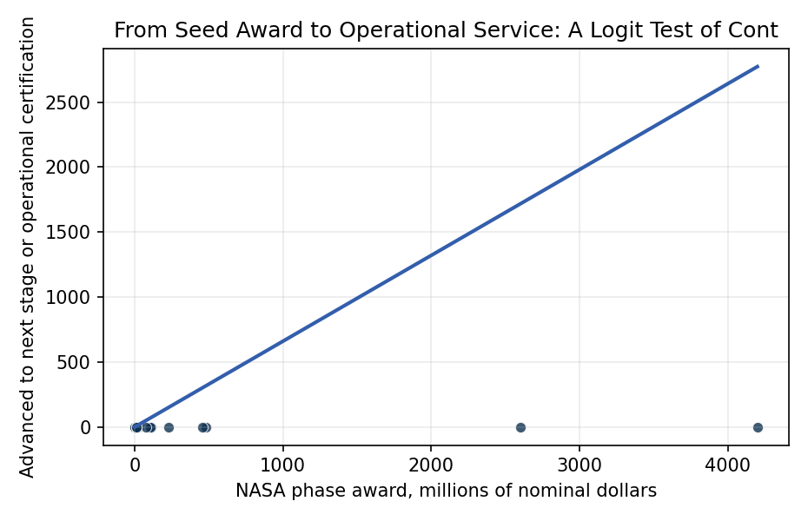
Figure 1. Provider continuation against announced NASA Commercial Crew award value. The fitted logit conditions on the provider’s prior participation in the program.

Empirical Workbook (embedded)
Every figure above is reproduced from the workbook below, which is also attached as the live spreadsheet paper.xlsx. Each observation carries its source.

Data (real observations)
phase | phase_index | company | award_musd | log1p_award_musd | prior_participations | advanced_next_stage | source
CCDev1 | 1 | Blue Origin | 3.7 | 1.5476 | 0 | 1 | NASA, Commercial Crew Program Essentials, CCDev1 award table
CCDev1 | 1 | Boeing | 18 | 2.9444 | 0 | 1 | NASA, Commercial Crew Program Essentials, CCDev1 award table
CCDev1 | 1 | Paragon | 1.4 | 0.8755 | 0 | 0 | NASA, Commercial Crew Program Essentials, CCDev1 award table
CCDev1 | 1 | Sierra Nevada | 20 | 3.0445 | 0 | 1 | NASA, Commercial Crew Program Essentials, CCDev1 award table
CCDev1 | 1 | United Launch Alliance | 6.7 | 2.0412 | 0 | 1 | NASA, Commercial Crew Program Essentials, CCDev1 award table
CCDev2 | 2 | ATK | 0 | 0 | 0 | 0 | NASA, Commercial Crew Program Essentials, CCDev2 participant and optional milestone table
CCDev2 | 2 | Blue Origin | 22 | 3.1355 | 1 | 0 | NASA, Commercial Crew Program Essentials, CCDev2 award table
CCDev2 | 2 | Boeing | 112.9 | 4.7353 | 1 | 1 | NASA, Commercial Crew Program Essentials, CCDev2 award table
CCDev2 | 2 | Excalibur Almaz | 0 | 0 | 0 | 0 | NASA, Commercial Crew Program Essentials, CCDev2 participant and optional milestone table
CCDev2 | 2 | Sierra Nevada | 105.6 | 4.6691 | 1 | 1 | NASA, Commercial Crew Program Essentials, CCDev2 award table
CCDev2 | 2 | SpaceX | 75 | 4.3307 | 0 | 1 | NASA, Commercial Crew Program Essentials, CCDev2 award table
CCDev2 | 2 | United Launch Alliance | 0 | 0 | 1 | 0 | NASA, Commercial Crew Program Essentials, CCDev2 participant and optional milestone table
CCiCap | 3 | Boeing | 480 | 6.1759 | 2 | 1 | NASA, Commercial Crew Program Essentials, CCiCap award table
CCiCap | 3 | Sierra Nevada | 227.5 | 5.4318 | 2 | 1 | NASA, Commercial Crew Program Essentials, CCiCap award table
CCiCap | 3 | SpaceX | 460 | 6.1334 | 1 | 1 | NASA, Commercial Crew Program Essentials, CCiCap award table
CPC | 4 | Boeing | 9.993 | 2.3972 | 3 | 1 | NASA, Commercial Crew Program Essentials, CPC award table
CPC | 4 | Sierra Nevada | 10 | 2.3979 | 3 | 0 | NASA, Commercial Crew Program Essentials, CPC award table
CPC | 4 | SpaceX | 9.589 | 2.3598 | 2 | 1 | NASA, Commercial Crew Program Essentials, CPC award table
CCtCap | 5 | Boeing | 4200 | 8.3431 | 4 | 0 | NASA, Commercial Crew Program Essentials, CCtCap award table; NASA OIG IG-24-020, Boeing remained uncertified as of September 2024
CCtCap | 5 | SpaceX | 2600 | 7.8637 | 3 | 1 | NASA, Commercial Crew Program Essentials, CCtCap award table; NASA, NASA and SpaceX Complete Certification of First Human-Rated Commercial Space System, November 10, 2020

Variable construction
Variable | Definition | Construction / source
advanced_next_stage | Binary indicator that the company advanced to the next Commercial Crew phase, or achieved operational certification for the final CCtCap phase by September 2024 | NASA Commercial Crew Program Essentials; NASA certification announcement; NASA OIG IG-24-020
log1p_award_musd | Natural logarithm of one plus the company’s announced NASA award amount in millions of nominal dollars | Award values transcribed from NASA Commercial Crew Program Essentials
prior_participations | Count of earlier Commercial Crew phases in which the company appeared before the observed award | Constructed from the chronological NASA phase and participant record

Estimator output
Term | Coef. | Std. err. | z | p | 95% CI
const | -0.4503 | 0.8766 | -0.5137 | 0.6075 | [-2.1685, 1.2679]
log1p_award_musd | 0.6604 | 0.3101 | 2.1294 | 0.0332 | [0.0526, 1.2683]
prior_participations | -0.8334 | 0.578 | -1.4419 | 0.1493 | [-1.9661, 0.2994]
Fit: N = 20 pseudo_R2 = 0.2321 LL = -9.9431

