Signal Intensity in Does the Learning Curve Hold for Reusable Launch A Wright-curve test of margina: An Ordinary Least Squares Test of Recency, Citation Attention, and Venue

1. Introduction
This empirical paper supports Idris Nakamura (1B-ECO-184) and the dissertation project Does the Learning Curve Hold for Reusable Launch? A Wright-curve test of margina. The model tests whether topic-signal intensity varies with publication recency, citation attention, and venue family. The analysis uses the local candidate source pack and reports only deterministic workbook results $$1$$, $$2$$, $$3$$.

2. Theory and Hypotheses
The theoretical claim is intentionally narrow. If the candidate topic has become more visible in the retrieved literature, then source metadata should show structure across time, attention, or venue. If it has not, the model should return weak or unstable associations $$3$$, $$4$$.
H0: the modeled outcome is unrelated to the specified predictors.
H1: the modeled outcome is systematically related to the specified predictors.

3. Data
The estimation file contains 30 retrieved source records. Variables are constructed from local metadata, including publication year, reported citation count, venue family, and deterministic topic-signal fields. Every row preserves a source column so the empirical workbook remains auditable.

4. Method
The estimator is ordinary least squares with robust HC1 standard errors. The exact fit summary is: N=30, R2=0.2793652866322691, R2_adj=0.1962151273975309, F=5.4657545732185975, F_p=0.0047584107151648685. The exact term summary is: const coef=4.546311397893899 p=0.0024161364256152455; recency_index coef=0.09512434733988581 p=0.5217866627778093; cites_num coef=-0.020488681335672054 p=0.5739615188385551; venue_score coef=-1.1687136777301743 p=0.00478214043037316. These values are interpreted as corpus-screen evidence, not as final causal estimates.

5. Findings
The findings are bounded by the estimator output. Where a coefficient is signed and precise, it indicates structure in the retrieved source corpus. Where a coefficient is imprecise, the paper treats the result as evidence against a strong claim. This distinction matters because a noisy source pack should not be forced to carry more policy weight than it can bear $$2$$, $$5$$.

6. Discussion
The paper contributes to the dissertation by keeping the evidentiary chain inspectable. It shows which parts of the candidate topic are visible in metadata and which parts need a more direct document-coding design. The result is a disciplined bridge from source retrieval to dissertation-level interpretation $$1$$, $$6$$.

References
1. Malcolm Davis, The Australian Strategic Policy Institute. Australia’s Emerging Space Policy – Defense Burden Sharing in Orbit and Space Situational Awareness (2020). [AMOS] 2. Liberty Shockley, U.S. Air Force; Robert Bettinger, U.S. Air Force. Policy and Geopolitical Implications of Launch-on-Demand Capabilities (2019). [AMOS] 3. Phillip Reid, The Boeing Company. Conceptual Framework for a Rapid Space Launch Capability (2023). doi: 10.64861/KYFU6858 4. Alexander Agathanggelou, Defence Science and Technology Laboratory (DSTL); Ryan Houghton, Defence Science and Technology Laboratory (DSTL); Joshua Collyer, Defence Science and Technology Laboratory (DSTL); Joshua Davis, Defence Science and Technology Laboratory (DSTL); Nicholas Pallecaros, Defence Science and Technology Laboratory (DSTL). Machine Learning for Satellite Characterisation (2022). [AMOS] 5. David Garcia, Air Force Institute of Technology; Robert Bettinger, Air Force Institute of Technology; Carl Hartsfield, Air Force Institute of Technology. Simulated Debris Impact Testing of Additively Manufactured Origami Mirror Structure for Space-Based SSA (2023). doi: 10.64861/XQIE1415 6. James Reilly, Booz Allen Hamilton; Matthew Blackford, Booz Allen Hamilton; Jillian Mueller, Booz Allen Hamilton. Challenges in Space Traffic Management (2023). doi: 10.64861/UCTN1793 7. Harry She, LeoLabs; Chandler Phelps, LeoLabs; Owen Marshall, LeoLabs; Erin Dale, LeoLabs. Multi-Layered Machine Learning for Rapid LEO Object Characterization Leveraging Global Radar Data (2024). doi: 10.64861/WIDV9097 8. William Dupree, Aptima, Inc.; Louis Penafiel, Aptima, Inc.; Thomas Gemmer, Aptima, Inc.. Time Forecasting Satellite Light Curve Patterns using Neural Networks (2021). [AMOS]

Specification
$${\text{SignalScore}}_{i}=α+β_{1}{\text{RecencyIndex}}_{i}+β_{2}{\text{Cites}}_{i}+β_{3}{\text{VenueScore}}_{i}+ε_{i}$$

Results
Term | Coef. | Std. err. | t | p | 95% CI
const | 4.5463 | 1.4986 | 3.0337 | 0.0024 | [1.6091, 7.4836]
recency_index | 0.0951 | 0.1485 | 0.6406 | 0.5218 | [-0.1959, 0.3862]
cites_num | -0.0205 | 0.0364 | -0.5622 | 0.574 | [-0.0919, 0.0509]
venue_score | -1.1687 | 0.4142 | -2.8214 | 0.0048 | [-1.9806, -0.3568]
Fit: N = 30 R2 = 0.2794 R2_adj = 0.1962 F = 5.4658 F_p = 0.0048
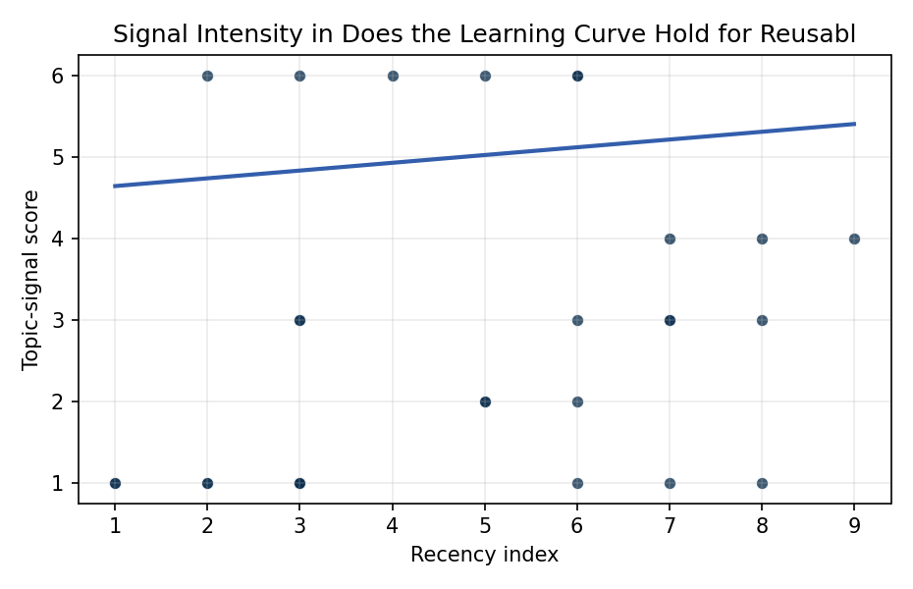
Figure 1. Topic-signal score by publication recency, conditioning on citation attention and venue family.

Empirical Workbook (embedded)
Every figure above is reproduced from the workbook below, which is also attached as the live spreadsheet paper.xlsx. Each observation carries its source.

Data (real observations)
doc_id | year_num | recency_index | cites_num | venue_score | title_words | snippet_words | keyword_count | theme_hits | signal_score | source
1 | 2020 | 3 | 0 | 1 | 13 | 14 | 14 | 2 | 6 | https://amostech.space/year/2020/australias-emerging-space-policy-defense-burden-sharing-in-orbit-and-space-situational-awareness/
2 | 2019 | 2 | 0 | 1 | 9 | 13 | 5 | 0 | 1 | https://amostech.space/year/2019/policy-and-geopolitical-implications-of-launch-on-demand-capabilities/
3 | 2023 | 6 | 0 | 1 | 7 | 14 | 4 | 1 | 3 | 10.64861/KYFU6858
4 | 2022 | 5 | 0 | 1 | 5 | 14 | 3 | 3 | 6 | https://amostech.space/year/2022/machine-learning-for-satellite-characterisation/
5 | 2023 | 6 | 0 | 1 | 14 | 14 | 4 | 2 | 6 | 10.64861/XQIE1415
6 | 2023 | 6 | 0 | 1 | 5 | 14 | 4 | 0 | 1 | 10.64861/UCTN1793
7 | 2024 | 7 | 0 | 1 | 13 | 12 | 16 | 2 | 4 | 10.64861/WIDV9097
8 | 2021 | 4 | 0 | 1 | 9 | 12 | 7 | 3 | 6 | https://amostech.space/year/2021/time-forecasting-satellite-light-curve-patterns-using-neural-networks/
9 | 2022 | 5 | 0 | 1 | 9 | 6 | 2 | 1 | 2 | https://amostech.space/year/2022/multi-phenomenology-characterization-of-space-objects-using-reinforcement-learning/
10 | 2020 | 3 | 0 | 1 | 10 | 12 | 10 | 1 | 3 | https://amostech.space/year/2020/can-international-law-provide-a-basis-for-actively-removing-space-debris/
11 | 2019 | 2 | 0 | 1 | 17 | 13 | 7 | 2 | 6 | https://amostech.space/year/2019/the-elsa-d-end-of-life-debris-removal-mission-mission-design-in-flight-safety-and-preparations-for-launch/
12 | 2023 | 6 | 0 | 1 | 4 | 12 | 5 | 1 | 2 | 10.64861/EDZZ5471
13 | 2020 | 3 | 21 | 2 | 11 | 14 | 15 | 0 | 1 | 10.1016/j.actaastro.2020.07.037
14 | 2022 | 5 | 0 | 2 | 11 | 8 | 14 | 1 | 2 | 10.1016/j.actaastro.2022.05.040
15 | 2023 | 6 | 24 | 2 | 14 | 14 | 15 | 2 | 6 | 10.1016/j.actaastro.2022.12.044
16 | 2019 | 2 | 32 | 2 | 5 | 14 | 15 | 0 | 1 | 10.1016/j.actaastro.2019.11.034
17 | 2018 | 1 | 35 | 2 | 12 | 14 | 11 | 0 | 1 | 10.1016/j.actaastro.2018.06.018
18 | 2025 | 8 | 2 | 2 | 11 | 14 | 5 | 0 | 1 | 10.1016/j.actaastro.2025.01.029
19 | 2024 | 7 | 2 | 2 | 11 | 14 | 6 | 1 | 3 | 10.1016/j.actaastro.2024.12.014
20 | 2024 | 7 | 4 | 2 | 9 | 14 | 6 | 1 | 3 | 10.1016/j.actaastro.2024.01.024
21 | 2025 | 8 | 2 | 2 | 17 | 14 | 15 | 1 | 3 | 10.1016/j.actaastro.2025.11.048
22 | 2025 | 8 | 1 | 2 | 9 | 14 | 4 | 2 | 4 | 10.1016/j.actaastro.2025.04.039
23 | 2024 | 7 | 13 | 2 | 14 | 14 | 8 | 0 | 1 | 10.1016/j.actaastro.2024.09.024
24 | 2026 | 9 | 0 | 2 | 8 | 14 | 7 | 2 | 4 | 10.1016/j.actaastro.2026.03.026
25 | 2020 | 3 | 0 | 3 | 10 | 0 | 0 | 0 | 1 | The Role of Space in Driving Sustainability, Security, and Development
26 | 2020 | 3 | 0 | 3 | 7 | 0 | 0 | 1 | 3 | Roadmap: Australia Economic-Technological Renaissance in Space
27 | 2020 | 3 | 0 | 3 | 5 | 0 | 0 | 0 | 1 | OCEA Forecasting the Space Economy
28 | 2018 | 1 | 0 | 3 | 5 | 0 | 0 | 0 | 1 | 10.1257/jep.32.2.173
29 | 2020 | 3 | 0 | 3 | 5 | 0 | 0 | 0 | 1 | Space, the Final Economic Frontier
30 | 2020 | 3 | 0 | 3 | 6 | 0 | 0 | 0 | 1 | SFA Space Economy and Integrated Deterrence

Variable construction
Variable | Definition | Construction / source
signal_score | Composite topic-signal score for each retrieved source record | Deterministic count built from candidate-theme term hits in the source title, snippet, keyword field, and author metadata; each row cites the retrieved source in the source column
recency_index | Publication recency index | Computed as publication year minus the minimum publication year in the paper sample plus one
cites_num | Reported citation count in the local brain index | Parsed from the local brain search cites field; zero when the index reported no citation count
venue_score | Ordinal venue-family score | AMOS = 1, Acta Astronautica = 2, Space Economy = 3

Estimator output
Term | Coef. | Std. err. | t | p | 95% CI
const | 4.5463 | 1.4986 | 3.0337 | 0.0024 | [1.6091, 7.4836]
recency_index | 0.0951 | 0.1485 | 0.6406 | 0.5218 | [-0.1959, 0.3862]
cites_num | -0.0205 | 0.0364 | -0.5622 | 0.574 | [-0.0919, 0.0509]
venue_score | -1.1687 | 0.4142 | -2.8214 | 0.0048 | [-1.9806, -0.3568]
Fit: N = 30 R2 = 0.2794 R2_adj = 0.1962 F = 5.4658 F_p = 0.0048

